**I) Introduction to Networks**

**1) Network models**

**Unicast, Multicast, Broacast, Anycast**

Unicast is the communication that there is only one receiver. This is one-to-one communication.

Multicast is the communication that there is one more receiver. Only the members of the multicast group receive the multicast traffic.

Broadcast is also the communication that there is one more receiver but this time, all the receivers receive broadcast traffic.

Anycast is the communication that is developed with IPv6. With anycast, the traffic is received by the nearest receiver in a group of the receivers that has the same IP.

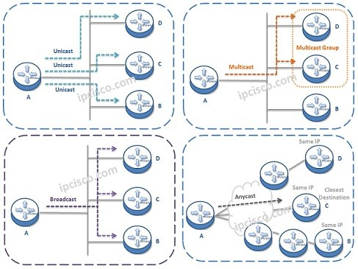

**Network Types**

* RFID: Radio-frequency identification uses electromagnetic fields to automatically identify and track tags attached to objects. An RFID system consists of a tiny radio transponder, a radio receiver and transmitter.
* Wi-Fi is the wireless technology used to connect computers, tablets, smartphones and other devices to the internet
* The internet connects users from all over the world in a single massive network. Devices on the internet can talk to one another using the global infrastructure. Ethernet connects devices in a local area network (LAN), which is a much smaller collection of interconnected devices.
* LAN: local area networks: room, building, campus
* MAN: metropolitan area networks: 10km, city
* WAN: wide area networks: 100km, 1000km, country, continent
* LAN < MAN < WAN in terms of coverage

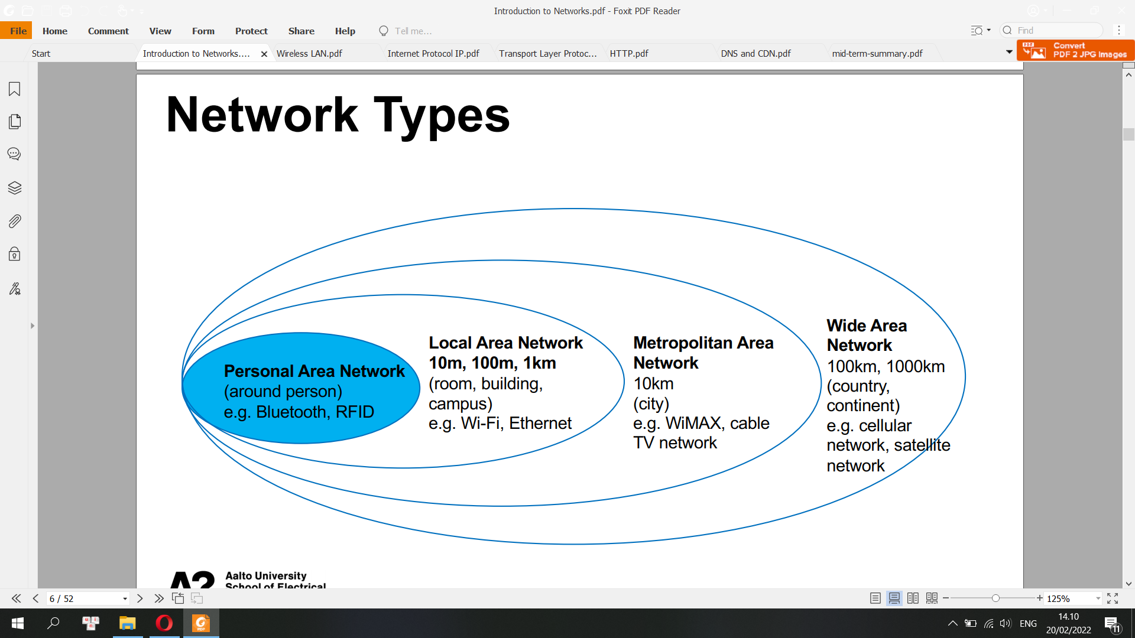

* ISP: Internet service provider: Elisa, Telia, DNA
* IXP: Internet exchange Point
* A protocol is an agreement between the communicating parties on how communication is to proceed
* The interface defines which primitive operations and services the lower layer makes available to the upper one.
* OSI: The Open Systems Interconnection model is a conceptual model that characterises and standardises the communication functions of a telecommunication or computing system without regard to its underlying internal structure and technology.
* The Internet protocol suite, commonly known as TCP/IP, is the set of communications protocols used in the Internet and similar computer networks. The current foundational protocols in the suite are the Transmission Control Protocol and the Internet Protocol

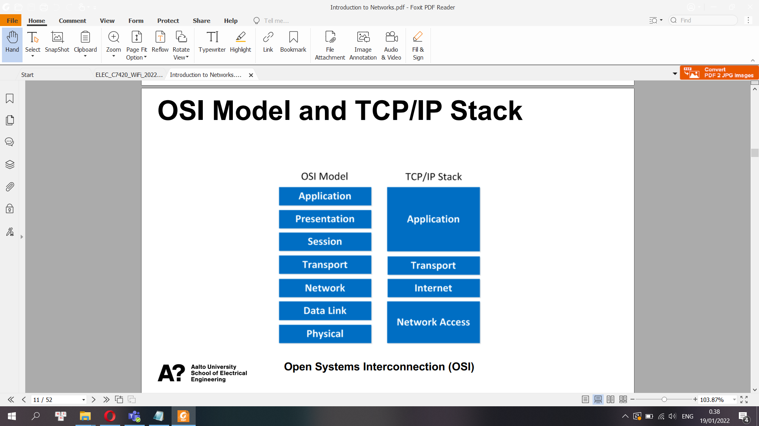

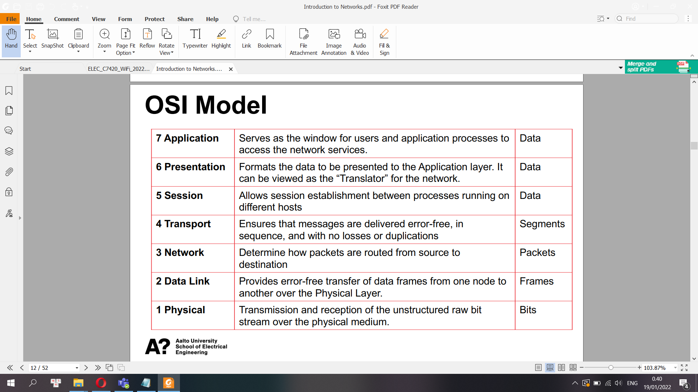

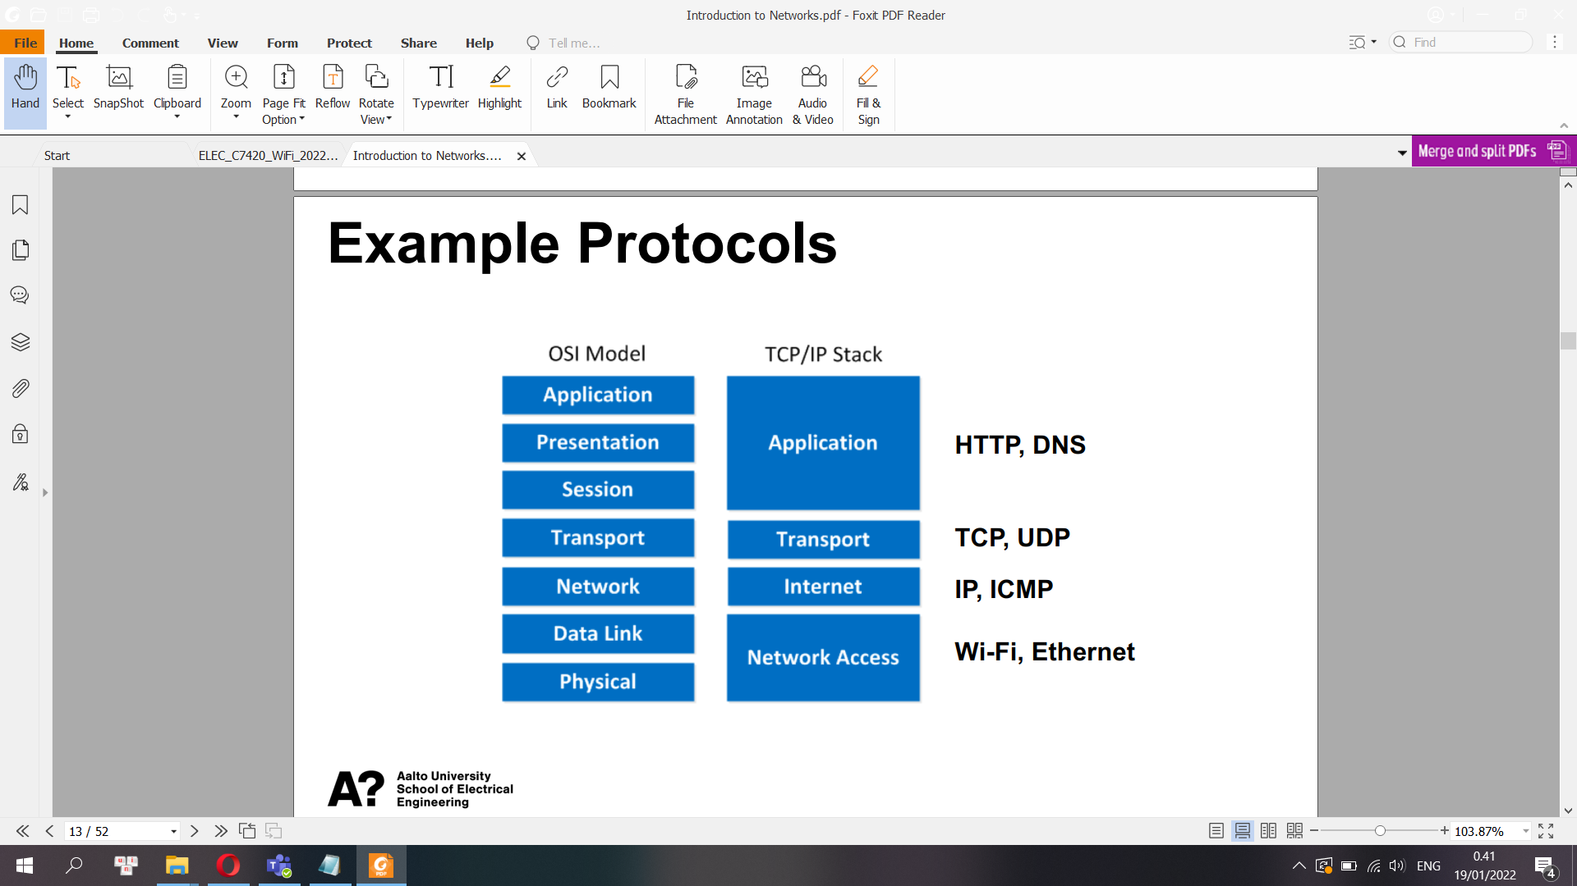

DNS: The Domain Name System is the hierarchical and decentralized naming system used to identify computers, services, and other resources reachable through the Internet or other Internet Protocol networks. The resource records contained in the DNS associate domain names with other forms of information  
HTTP: The Hypertext Transfer Protocol is an application layer protocol in the Internet protocol suite model for distributed, collaborative, hypermedia information systems

UDP:In computer networking, the User Datagram Protocol is one of the core members of the Internet protocol suite. With UDP, computer applications can send messages, in this case referred to as datagrams, to other hosts on an Internet Protocol network.

ICMP: The Internet Control Message Protocol is a supporting protocol in the Internet protocol suite. It is used by network devices, including routers, to send error messages and operational information

PDU: In telecommunications, a protocol data unit is a single unit of information transmitted among peer entities of a computer network. A PDU is composed of protocol-specific control information and user data

Data Encapsulation: The process of adding headers and trailers to data

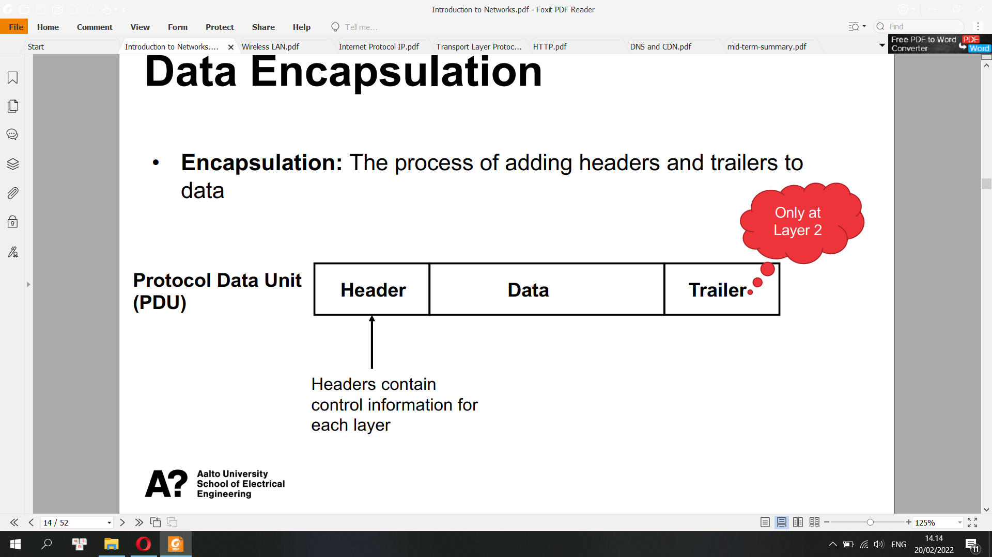

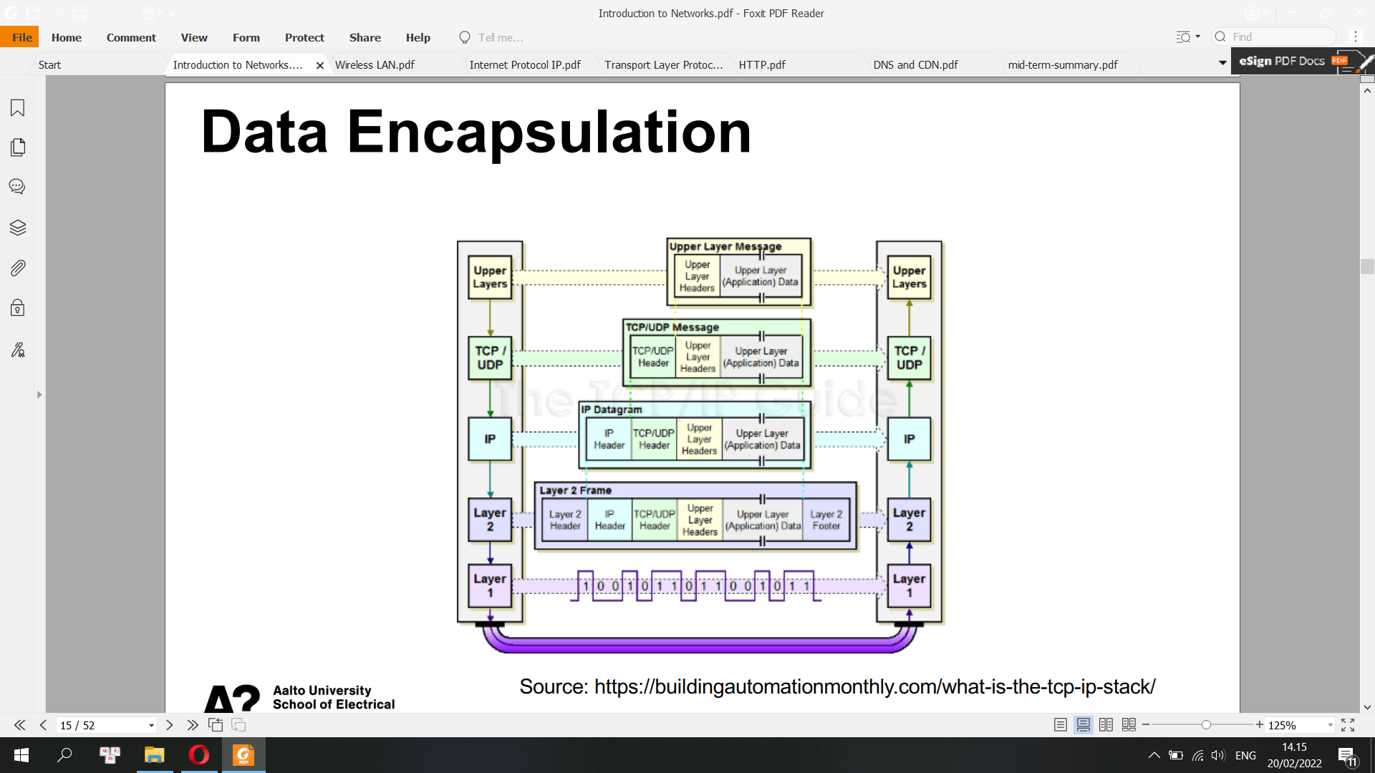

**2) Ethernet**

* Ethernet (/ˈiːθərnɛt/) is a family of wired computer networking technologies commonly used in local area networks (LAN), metropolitan area networks (MAN) and wide area networks (WAN)

Network Access Layer (Layer 1& 2 in OSI Model) e.g. 802.3 Ethernet, 802.11 Wi-Fi, 802.15.4 ZigBee

IEEE: The Institute of Electrical and Electronics Engineers is a professional association for electronic engineering and electrical engineering with its corporate office in New York City

* Hardware of Ethernet

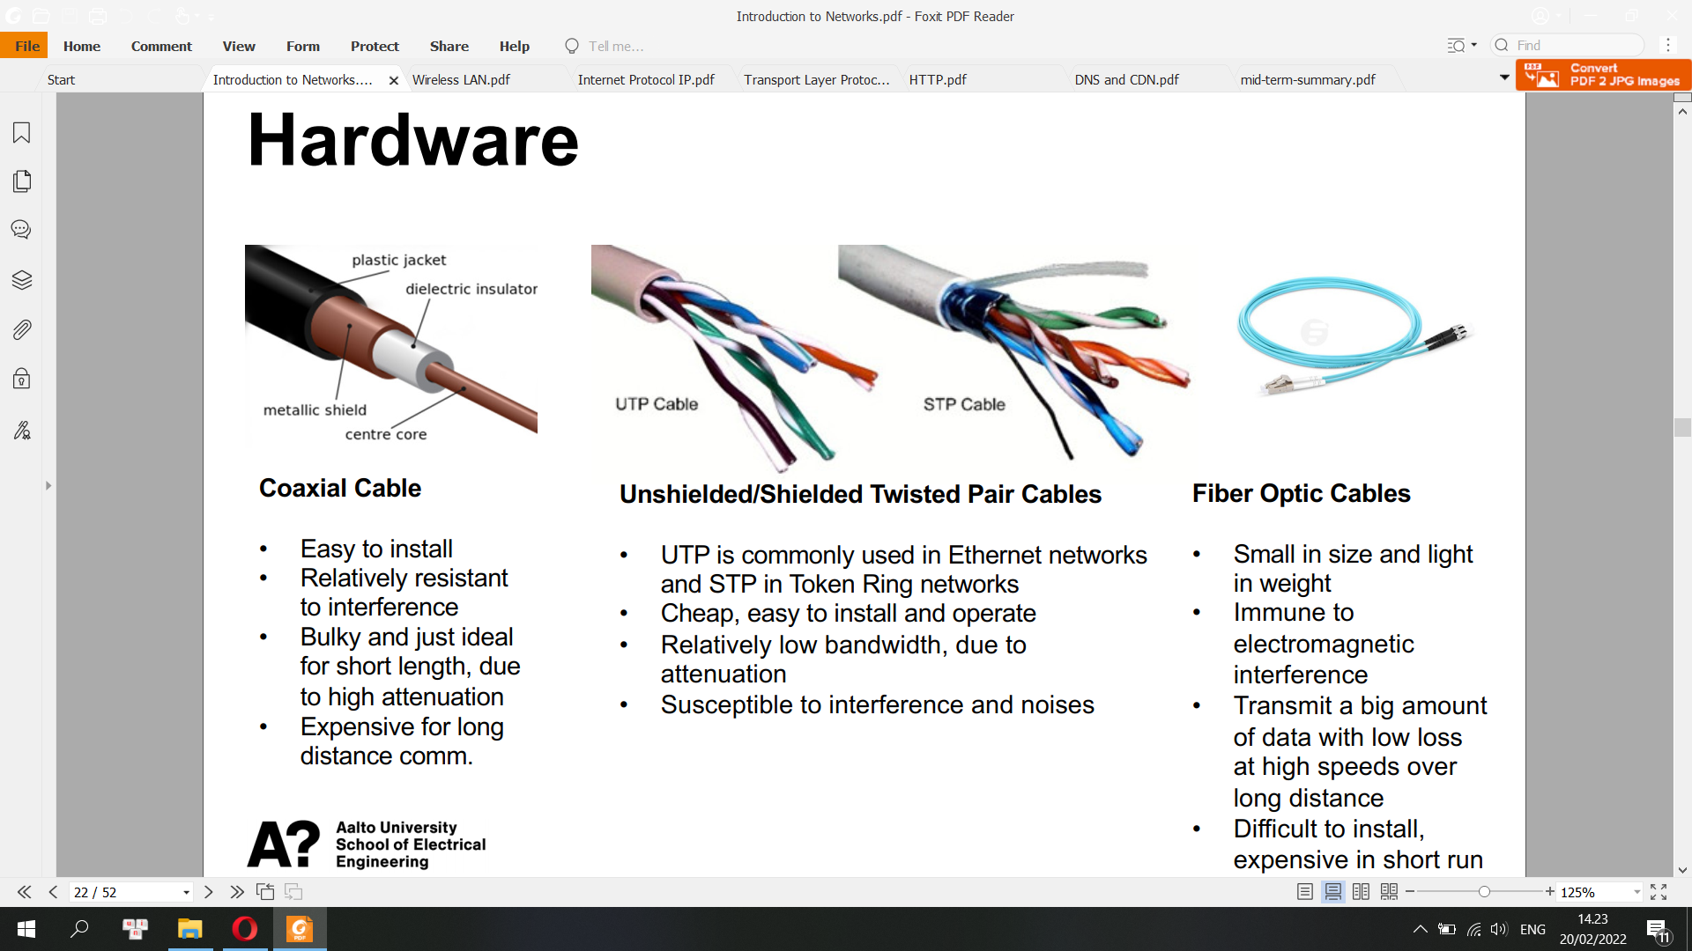

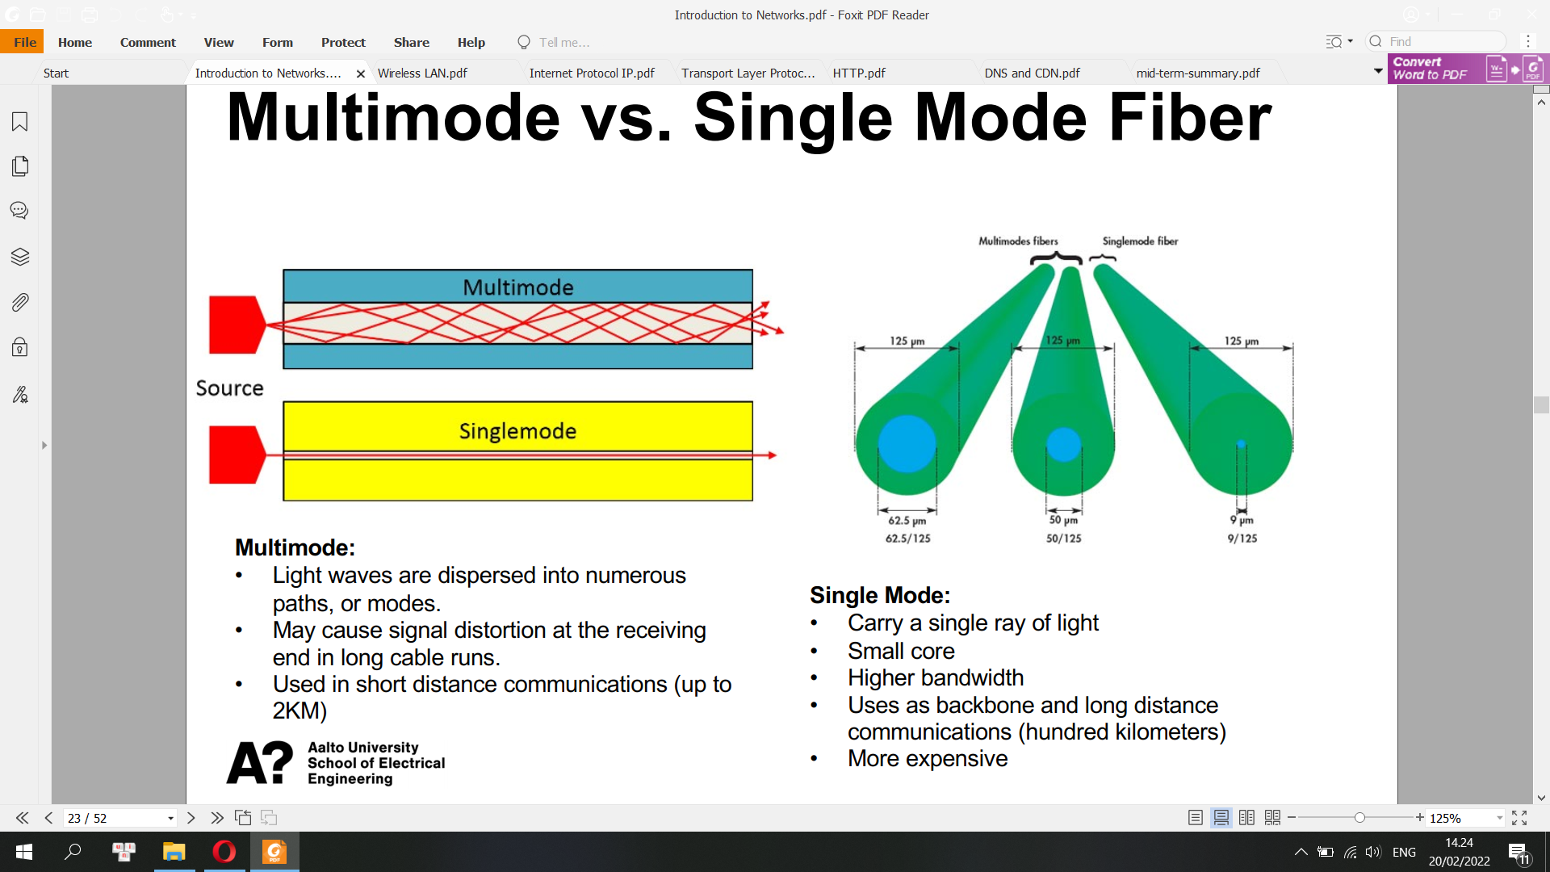

Gigabit Ethernet

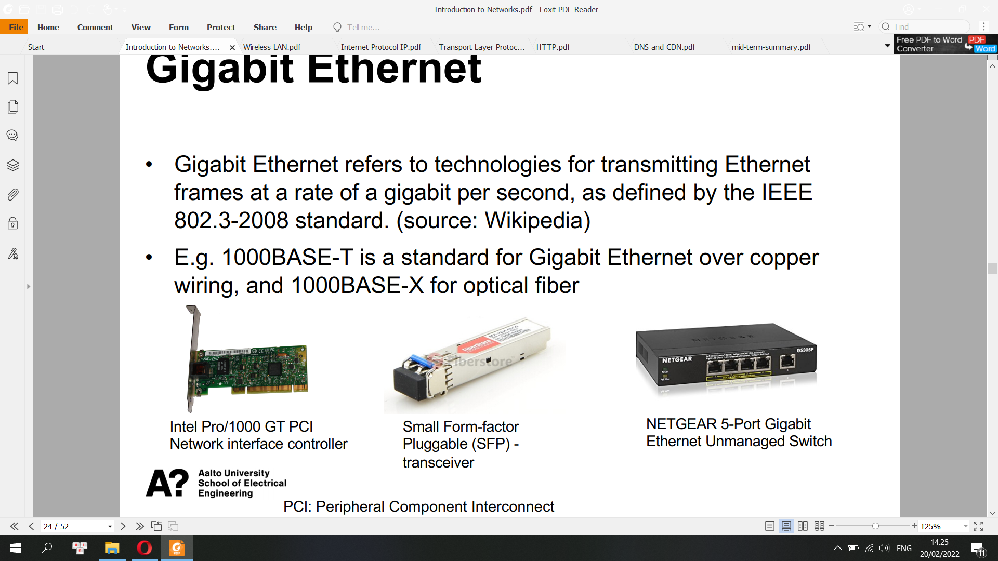

**Data Link Layer (Layer 2) has two sub-layers.**

**• IEEE 802.2 Logical Link Control (LLC)**

LLC: In the IEEE 802 reference model of computer networking, the logical link control data communication protocol layer is the upper sublayer of the data link layer of the seven-layer OSI model. The LLC sublayer acts as an interface between the media access control sublayer and the network layer.

**• IEEE 802.3 Media Access Control (MAC)**

MAC: In IEEE 802 LAN/MAN standards, the medium access control sublayer is the layer that controls the hardware responsible for interaction with the wired, optical or wireless transmission medium. The MAC sublayer and the logical link control sublayer together make up the data link layer.

A MAC address is a unique identifier assigned to a network interface controller (NIC) by manufacturer

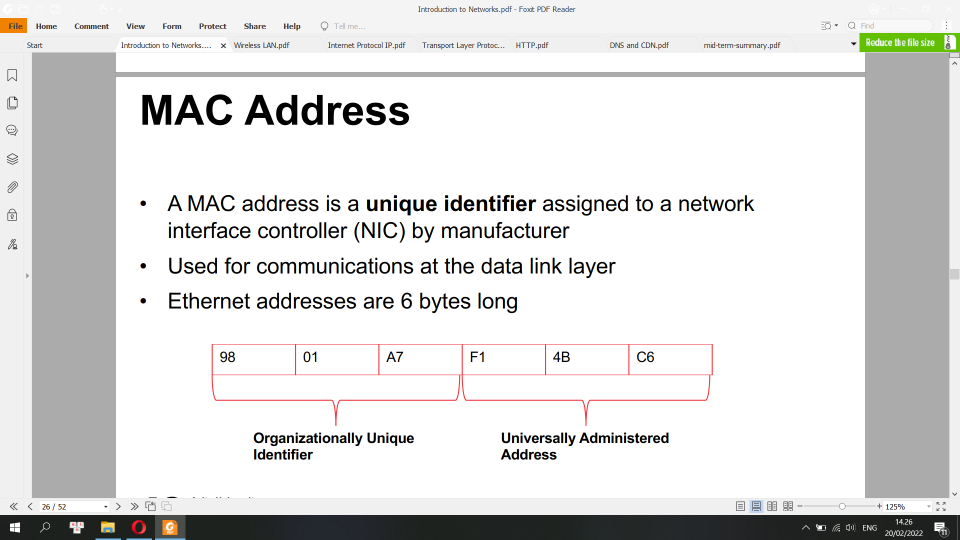

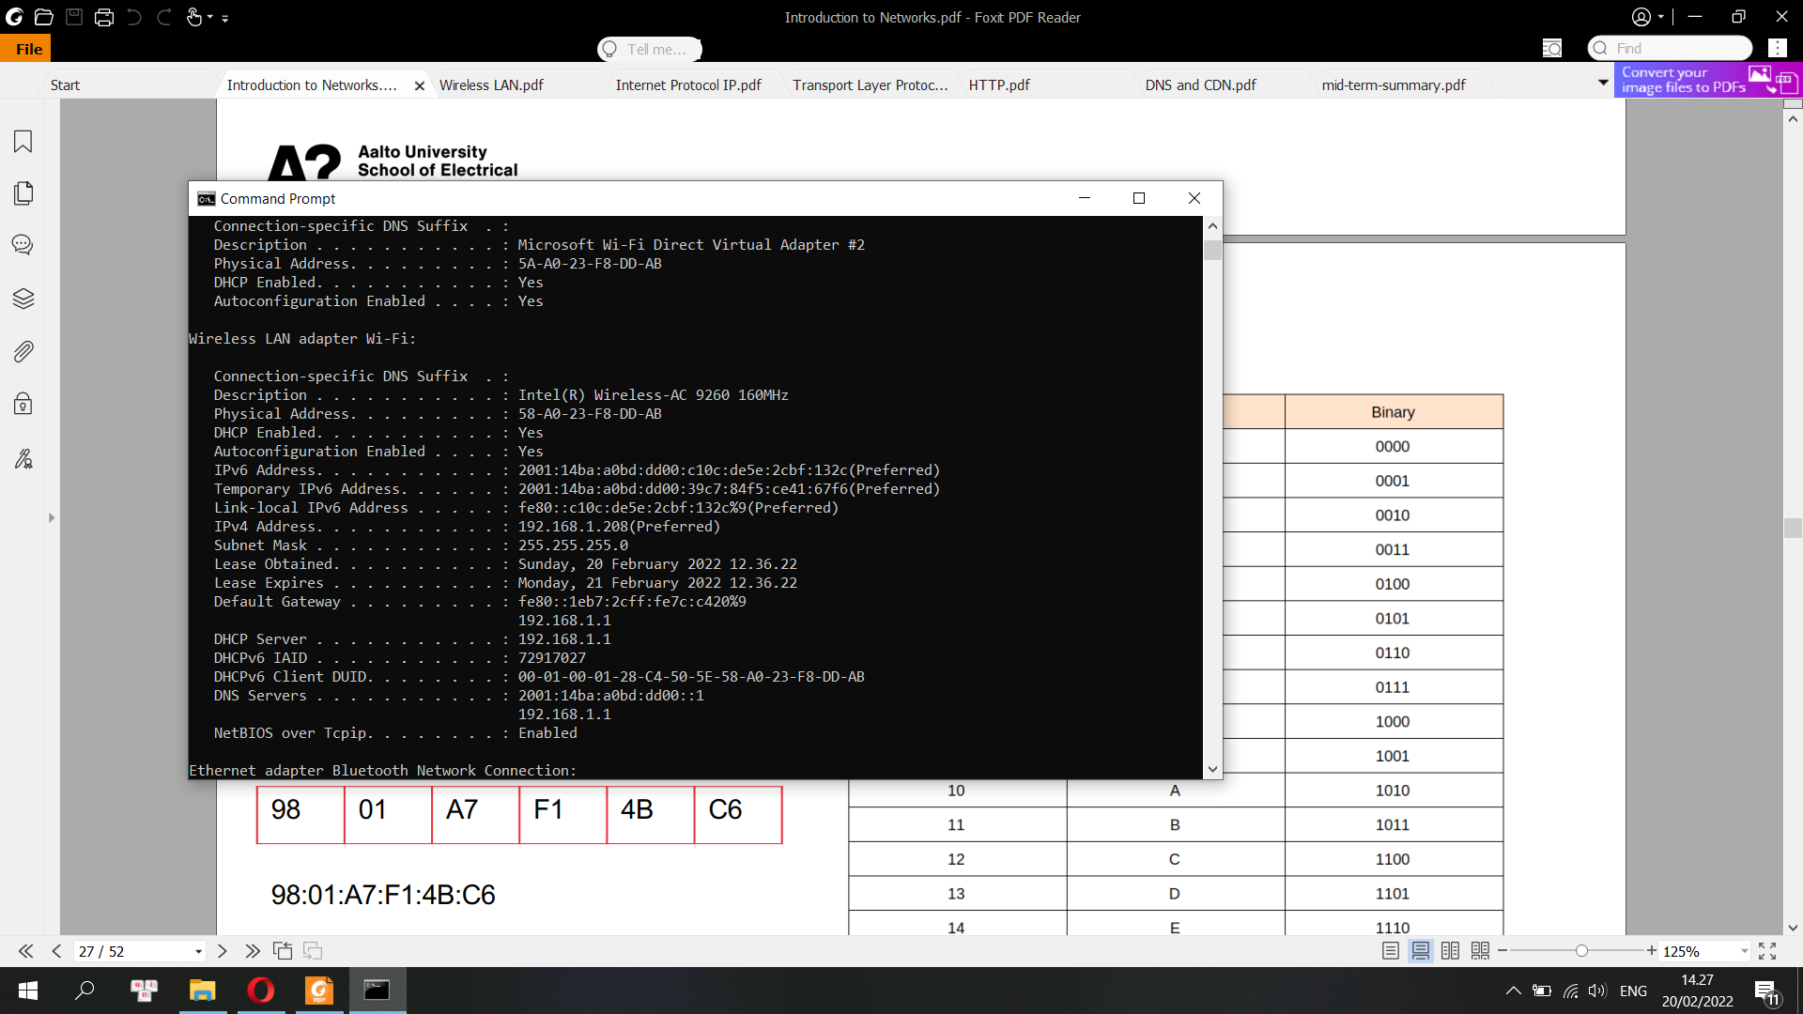

Physical address 58-A0… is the MAC address of this laptop.

**Packet-based Data Transmission**

Ethernet Frame

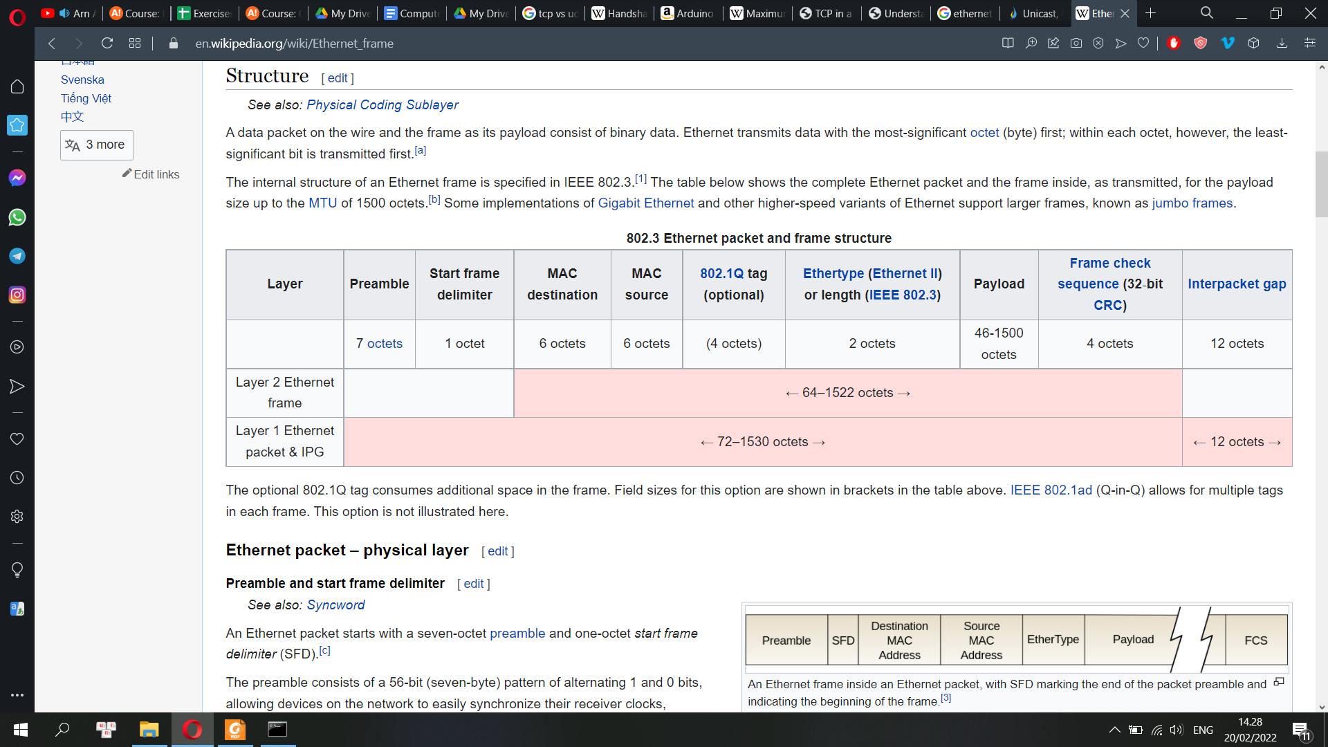

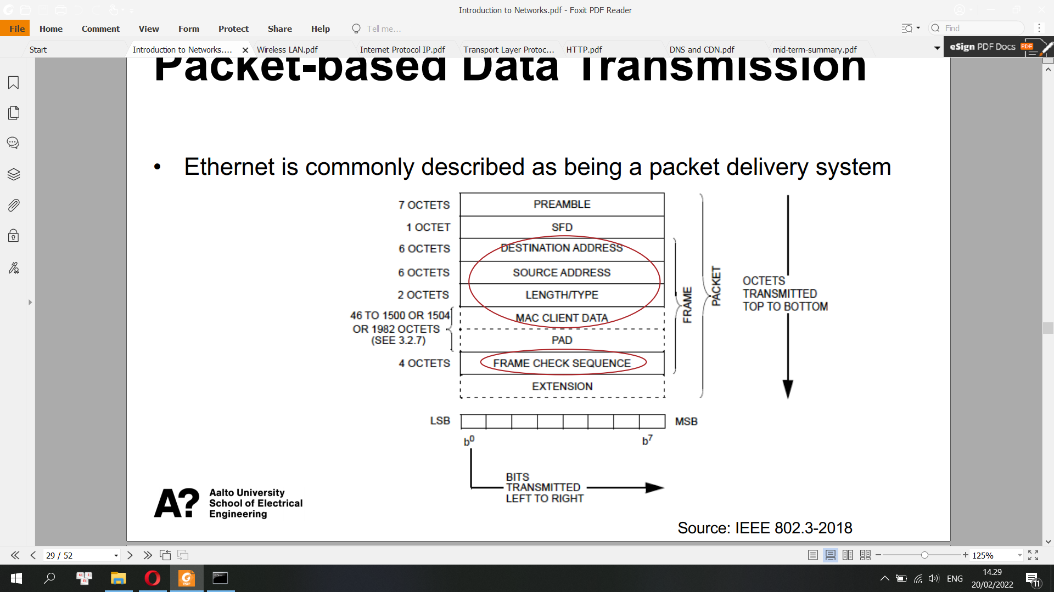

A preamble is a signal used in network communications to synchronize transmission timing between two or more systems. In general, preamble is a synonym for "introduction."

Preamble is a bit sequence used for physical medium stabilization and synchronization.

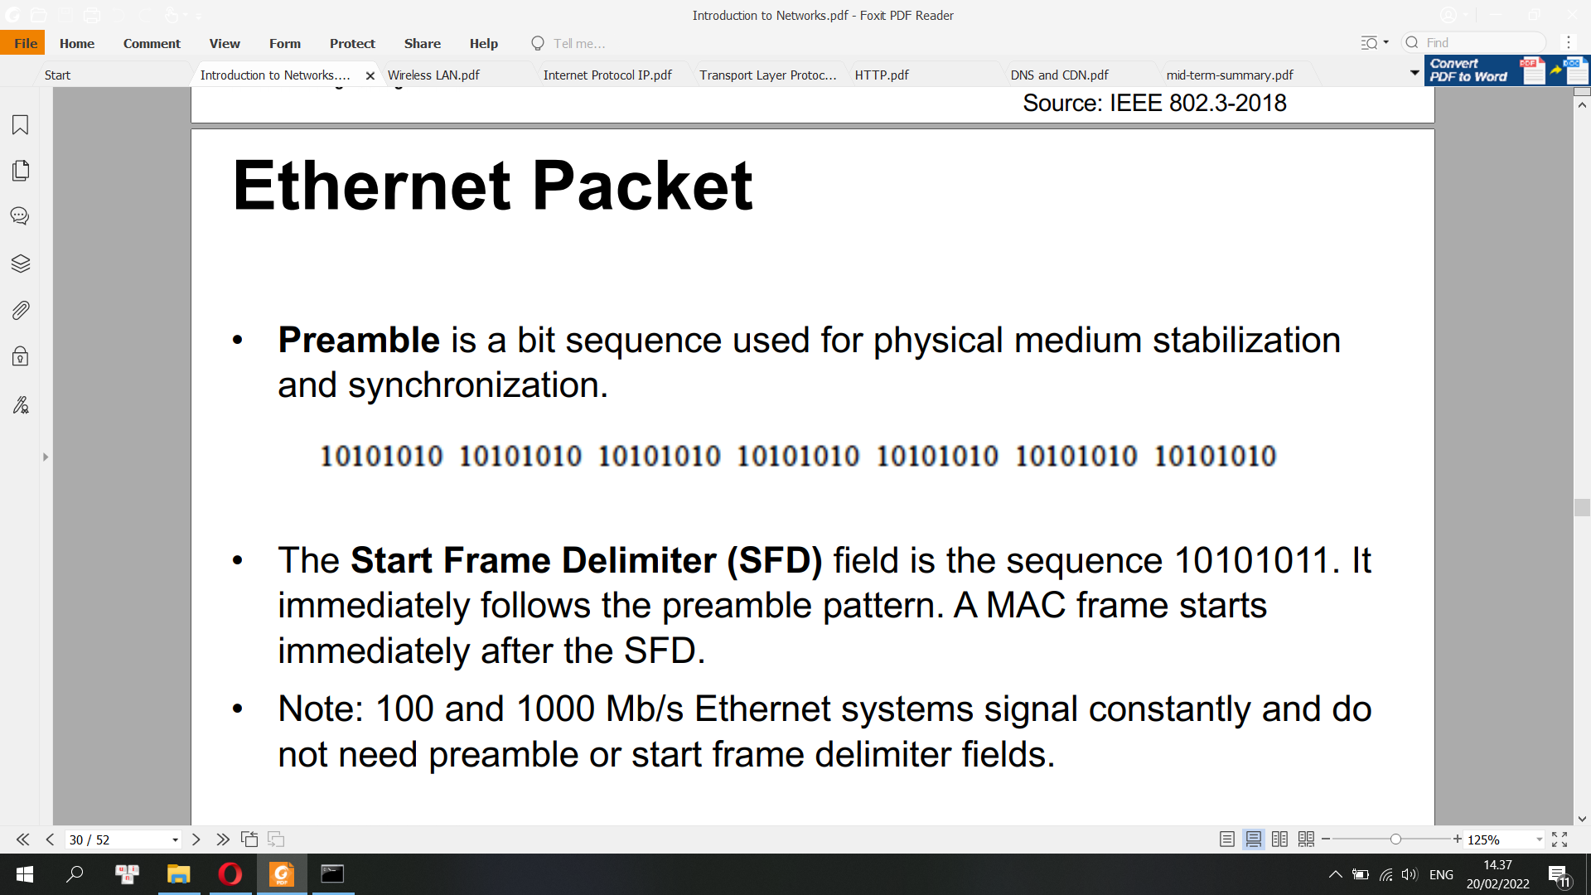

SFD: The Start Frame Delimiter (SFD) field is the sequence 10101011. It immediately follows the preamble pattern. A MAC frame starts immediately after the SFD. Note: 100 and 1000 Mb/s Ethernet systems signal constantly and do not need preamble or start frame delimiter fields.

* **Ethernet Frame**

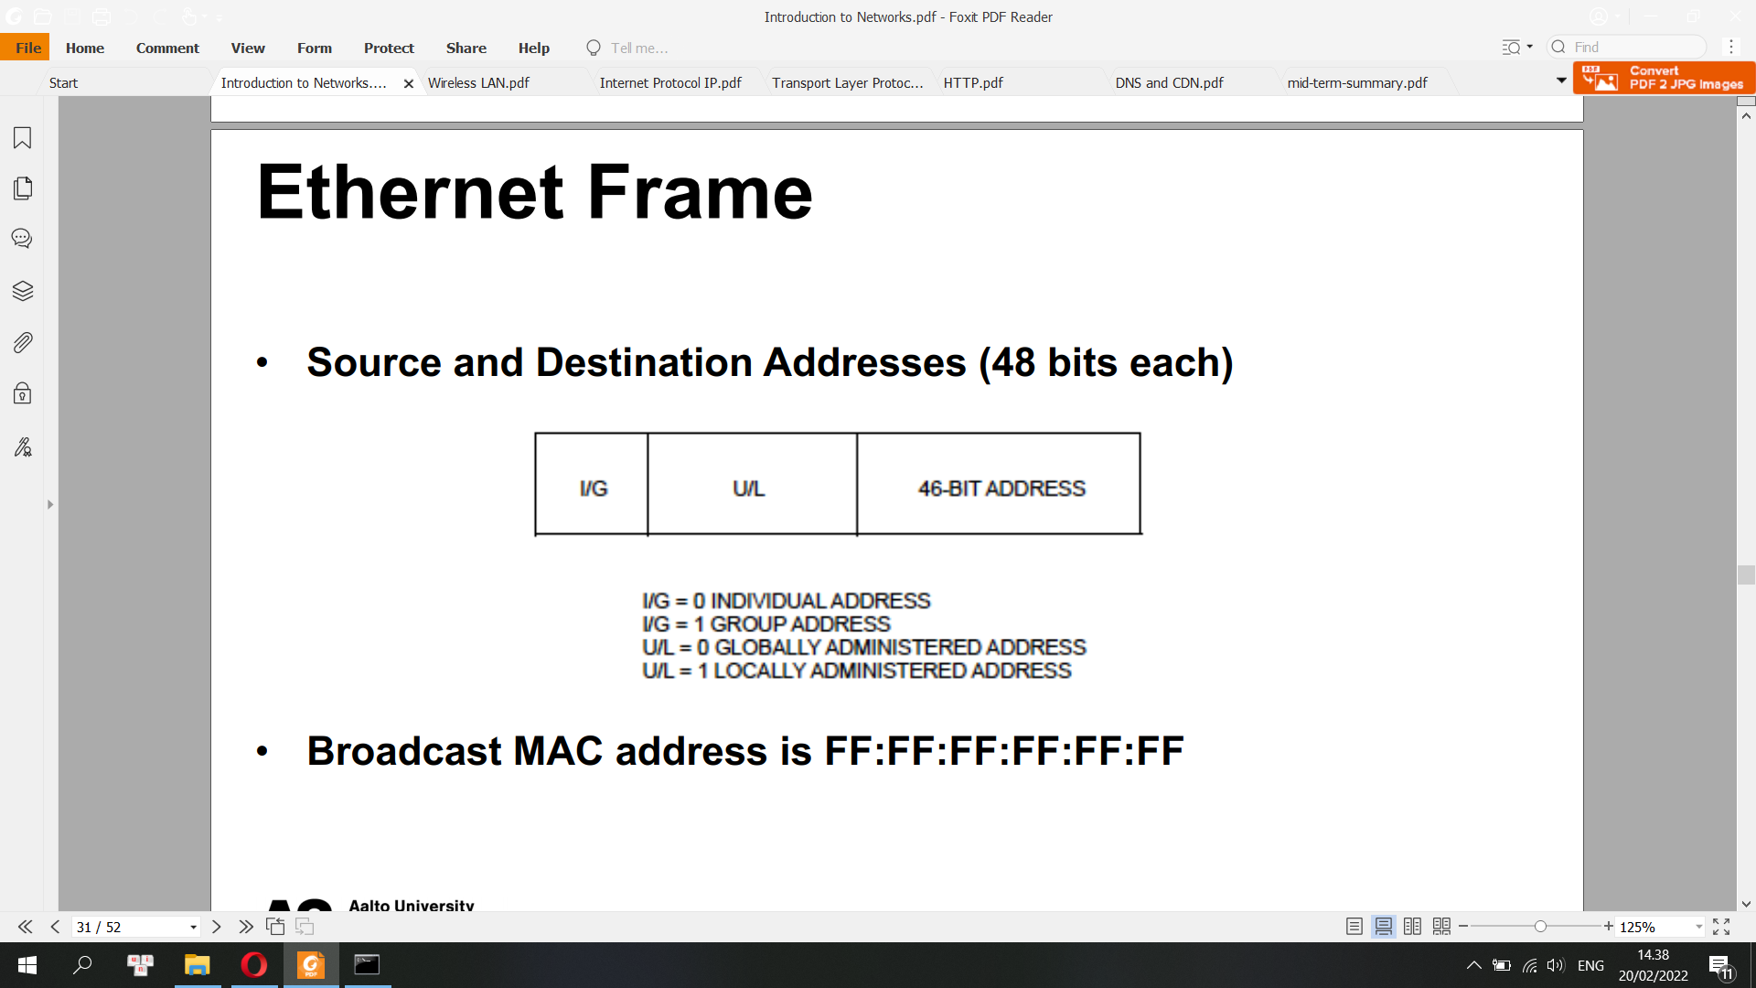

Length/Type Field: the number of MAC client data octets contained in the following MAC Client Data field, if the field value < or = 1500 decimal. Otherwise, the Ethertype of the MAC client protocol (e.g. 1500 basic frames, 1504 Q-tagged frames, 1982 envelop frames)

• PAD field: A minimum MAC frame size is required for correct CSMA/CD protocol operation

The length of PAD is max [0, minFrameSize – (clientDatasize + 2 x addressSize + 48)] bits.

minFrameSize is typically 64 octets

• Frame Check Sequence (FCS) contains a 4-octet CRC (cyclic redundancy check) value.

The CRC value is computed as a function of the contents of the protected fields of the MAC frame (from destination address to Pad)

All frames and the bits, bytes, and fields contained within them, are susceptible to errors from a variety of sources. The FCS field contains a number that is calculated by the source node based on the data in the frame. This number is added to the end of a frame that is sent. When the destination node receives the frame the FCS number is recalculated and compared with the FCS number included in the frame. If the two numbers are different, an error is assumed and the frame is discarded.

The FCS provides error detection only. Error recovery must be performed through separate means. [Ethernet](https://en.wikipedia.org/wiki/Ethernet), for example, specifies that a damaged frame should be discarded and does not specify any action to cause the frame to be retransmitted. Other protocols, notably the [Transmission Control Protocol](https://en.wikipedia.org/wiki/Transmission_Control_Protocol) (TCP), can notice the data loss and initiate retransmission and error recovery.

• An Extension Field is added, if required (for 1000Mb/s half duplex operation only)

In computing and telecommunications, the payload is the part of transmitted data that is the actual intended message. Headers and metadata are sent only to enable payload delivery. In the context of a computer virus or worm, the payload is the portion of the malware which performs malicious action.

**Invalid MAC Frame**

A MAC frame is invalid when it meets at least one of the following

conditions:

• The frame length is inconsistent with a length value specified in the length/type field

• It is not an integral number of octets in length

• The bits of the incoming frame (exclusive of the FCS field itself) do not generate a CRC value identical to the one received

Invalid frames should not be passed to the LLC or MAC sublayers.

**Two Operating Modes of MAC SubLayer**

• Half Duplex: A host can only send or receive at one time: CSMA/CD

• Full Duplex: A host can send and receive simultaneously. No collision.

• Duplex configuration: either manually set or auto negotiated by connected devices

• Duplex mismatch -> poor performance

**Hubs and Switches**

Hub and Switch are both network connecting devices. Hub works at physical layer and is responsible to transmit the signal to port to respond where the signal was received whereas Switch enable connection setting and terminating based on need. ... Hub works in Physical Layer. Switch works in Data Link Layer.

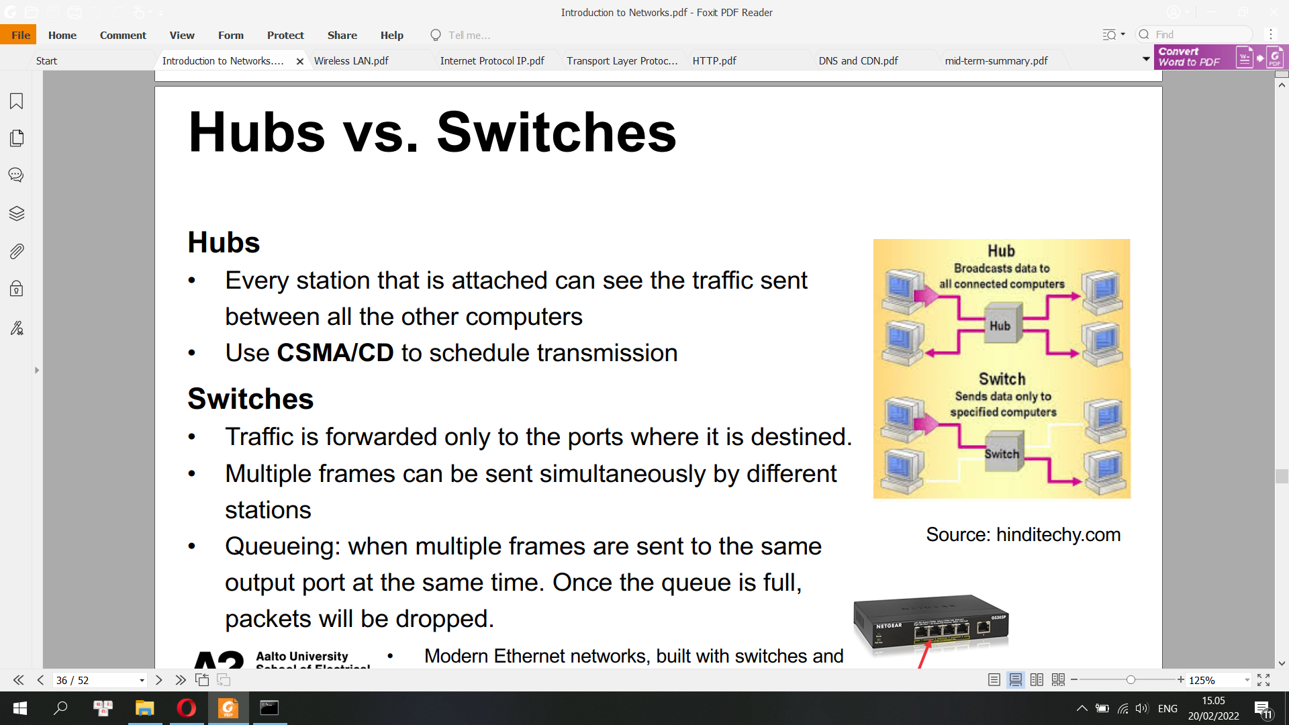

**CSMA/CD**

CSMA: Carrier-sense multiple access is a media access control protocol in which a node verifies the absence of other traffic before transmitting on a shared transmission medium, such as an electrical bus or a band of the electromagnetic spectrum

Carrier Sense Multiple Access with Collision Detection (CSMA/CD) defines how Ethernet frames get onto an Ethernet network

• CSMA/CD is designed to allow fair access by all transmission devices to shared network channels.

• The Physical Layer performs the task of generating the signals on the medium that represent the bits of the frame. Only one signal at a time can be transmitted on an Ethernet network

• Simultaneously, the Physical Layer monitors the medium and generates the collision detect signal, which in the contention-free case, remains off for the duration of the frame.

• Whenever two stations transmitted at the same time, the signals would collide; frames that collide must be retransmitted

In order to minimize collision loss, each station implemented the following:

• Every Ethernet device listens to hear if another device is already transmitting. When the medium is clear, frame transmission is initiated (after a brief interframe delay).

• While transmitting, continually monitor the carrier sense signal provided by the physical layer to detect collisions; if a collision is detected, cease transmitting

• If a collision occurs, use a backoff-and-retransmit strategy

1-persistent, p-persistent, non-persistent

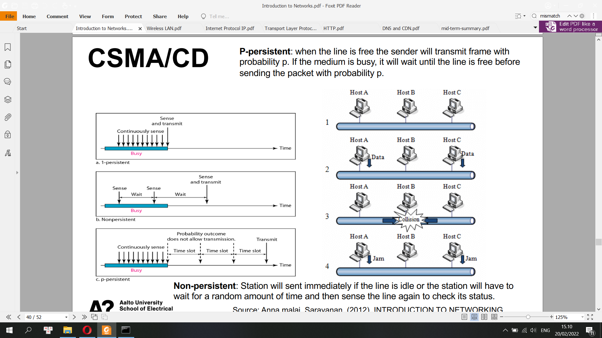

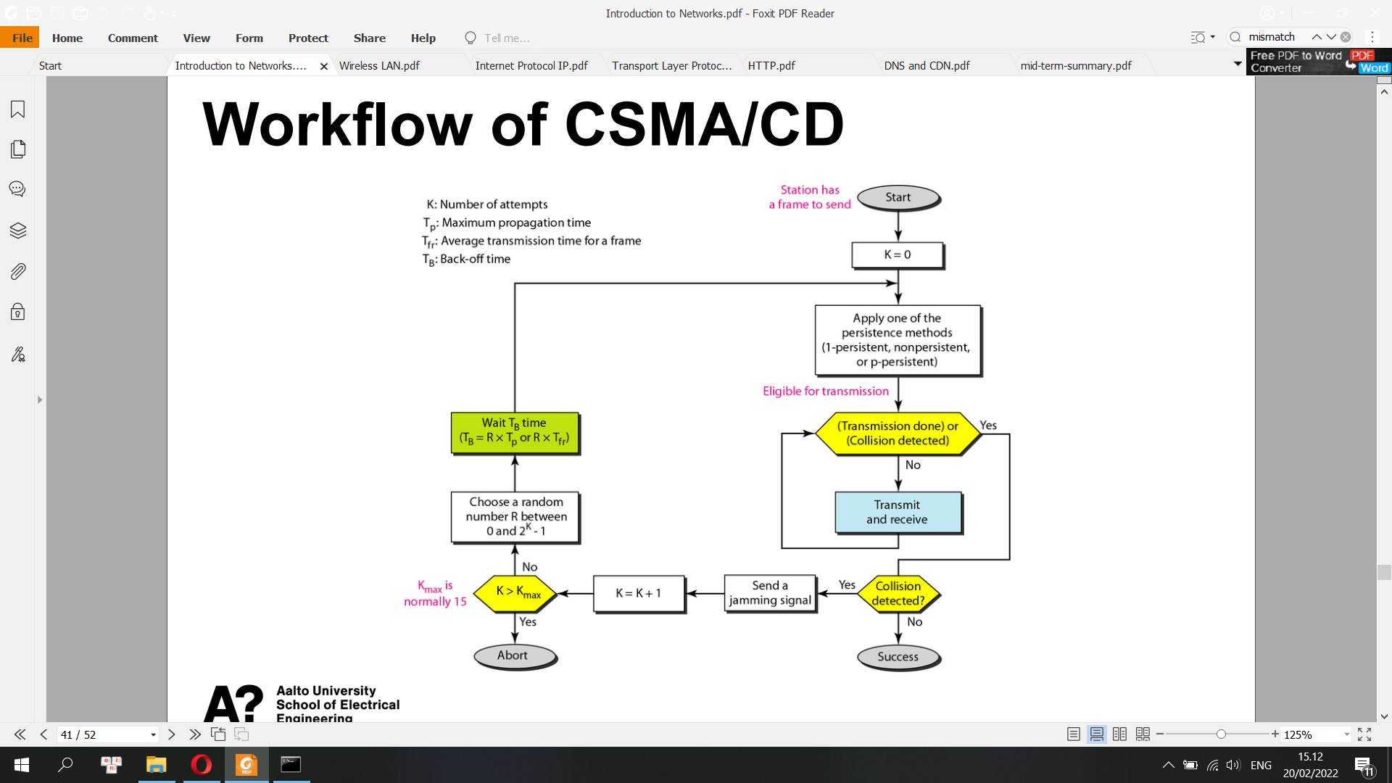

Backoff-and-retransmit

• Transmit Media Access Management component of the MAC sublayer enforces the collision by transmitting a bit sequence called jam.

• Terminate the transmission and schedule another transmission attempt after a randomly selected time interval.

• In case of repeated collision, adjust the medium load by backing off (voluntarily delaying its own retransmission to reduce its load on the medium)

Datagram Forwarding

Header: destination address

Forwarding Table

<destination, next_hop>

Address Learning

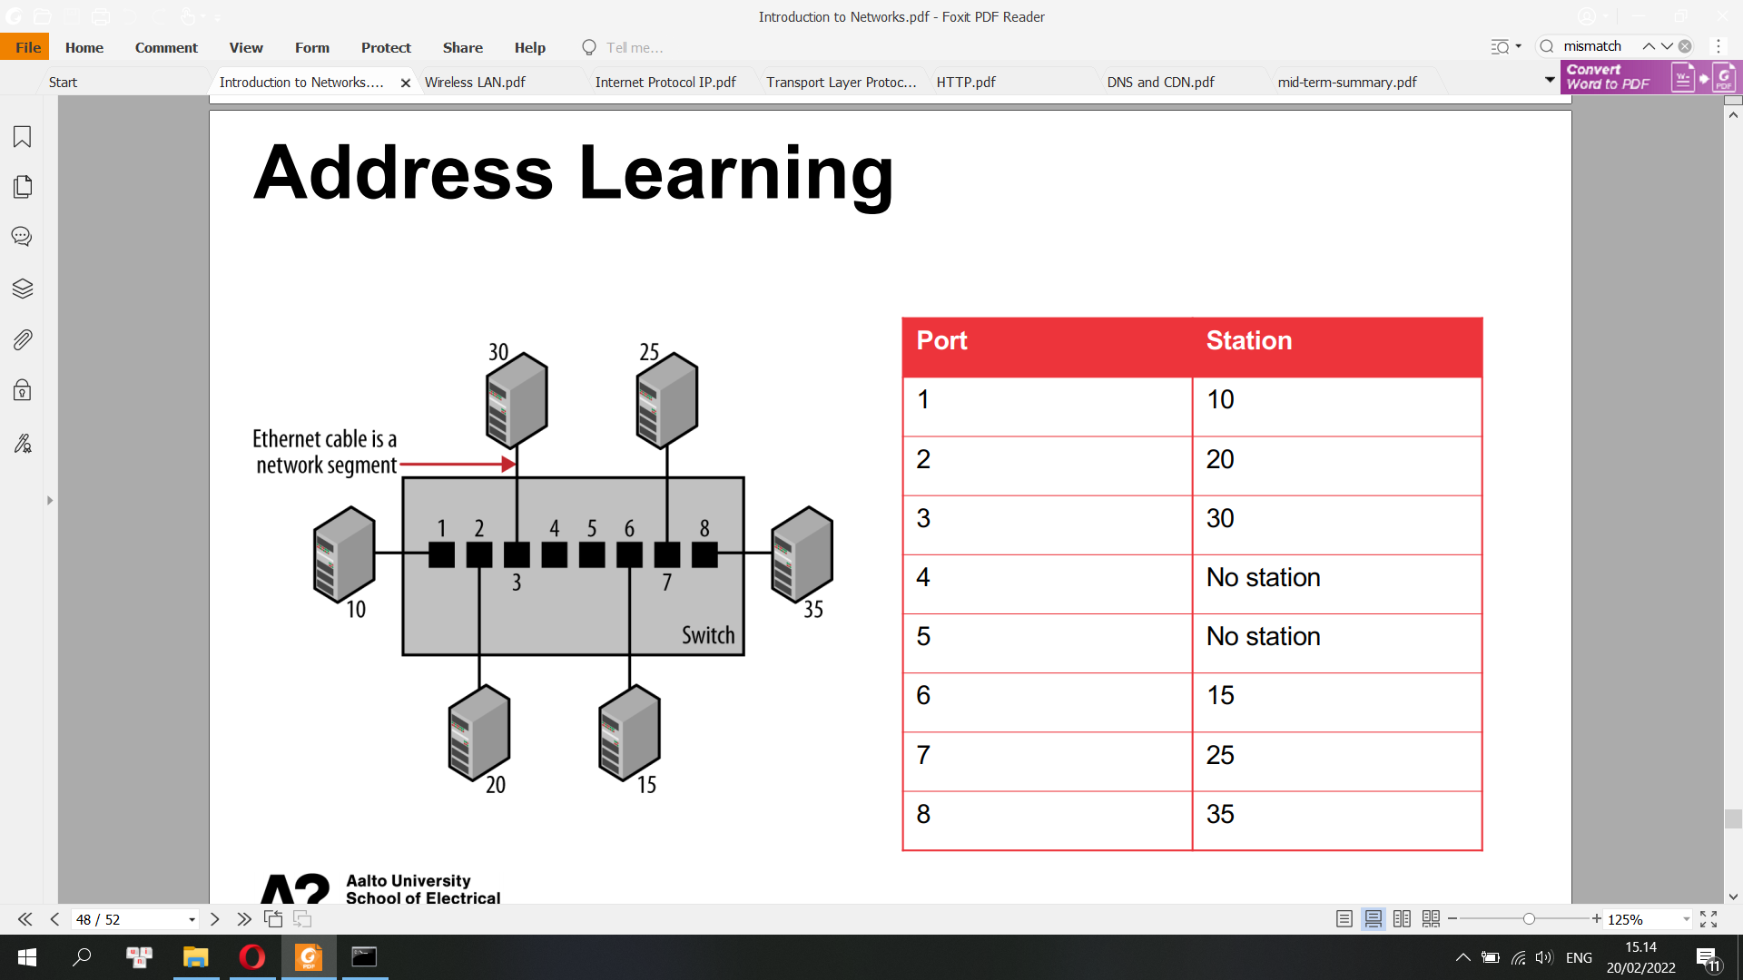

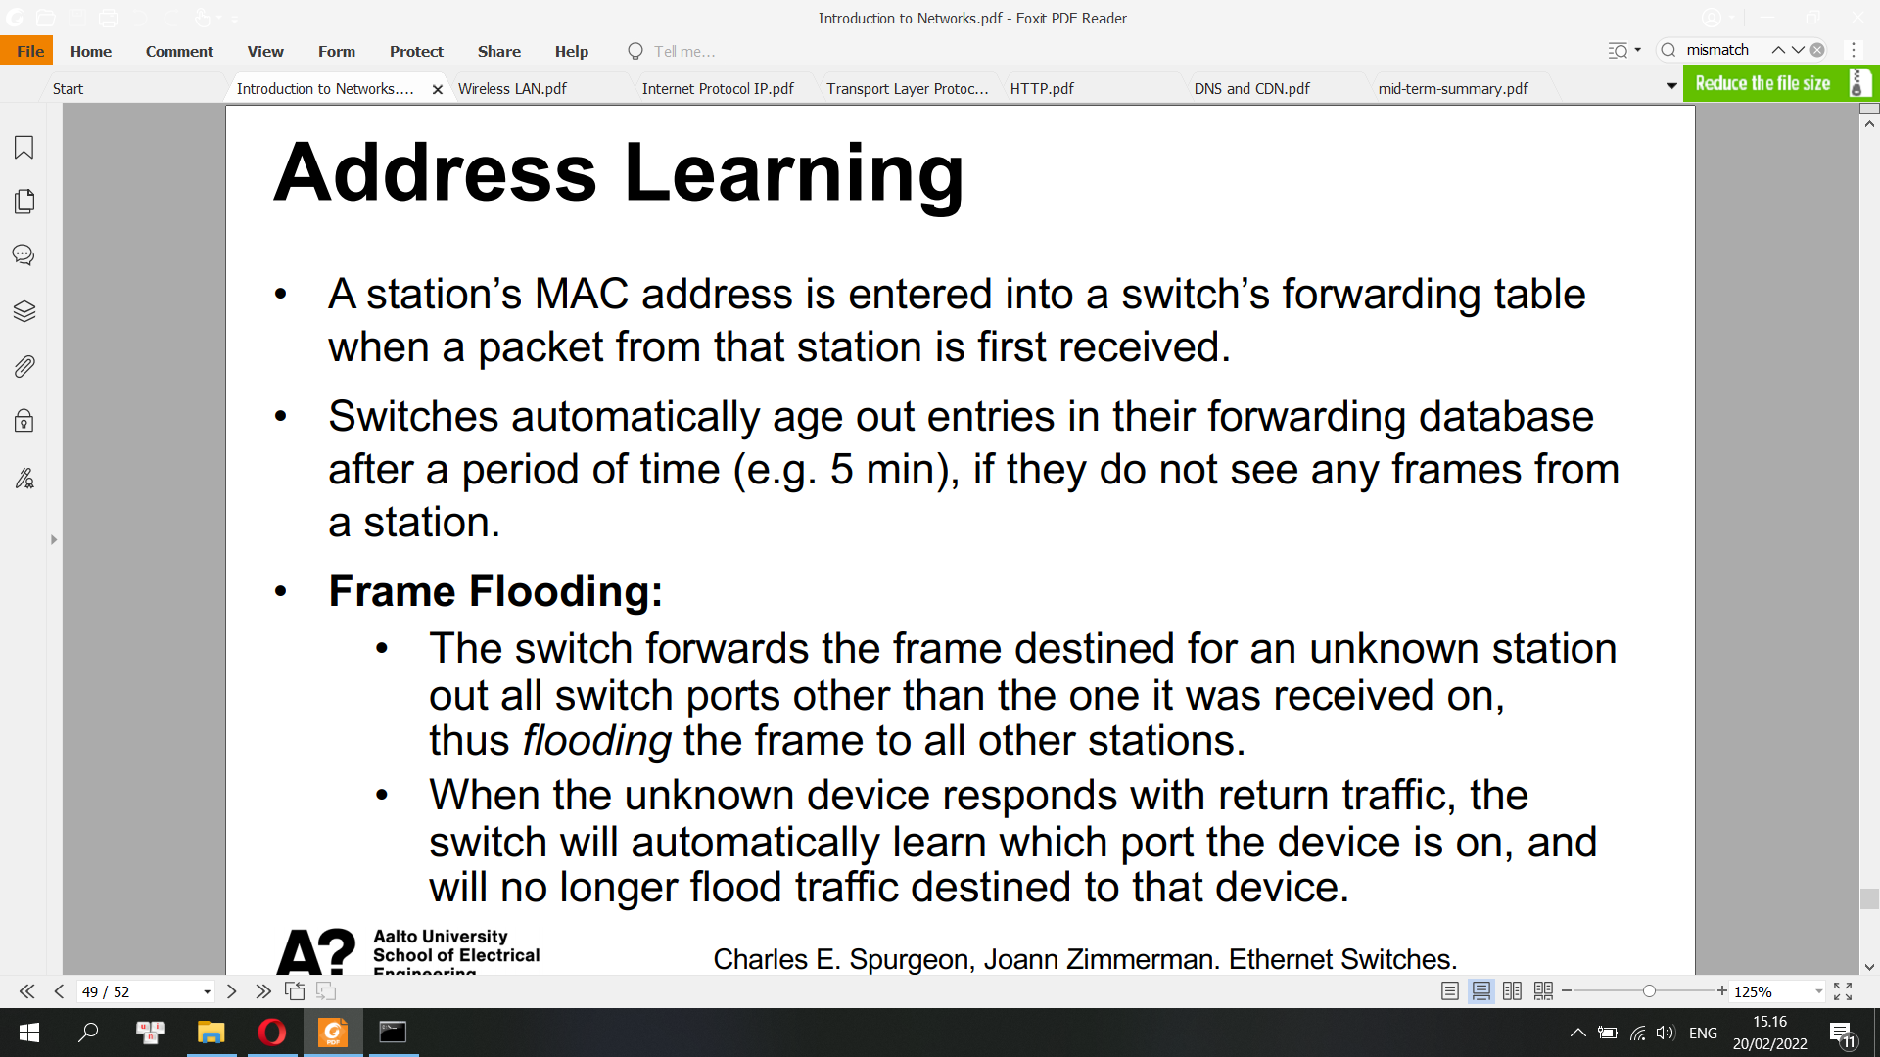

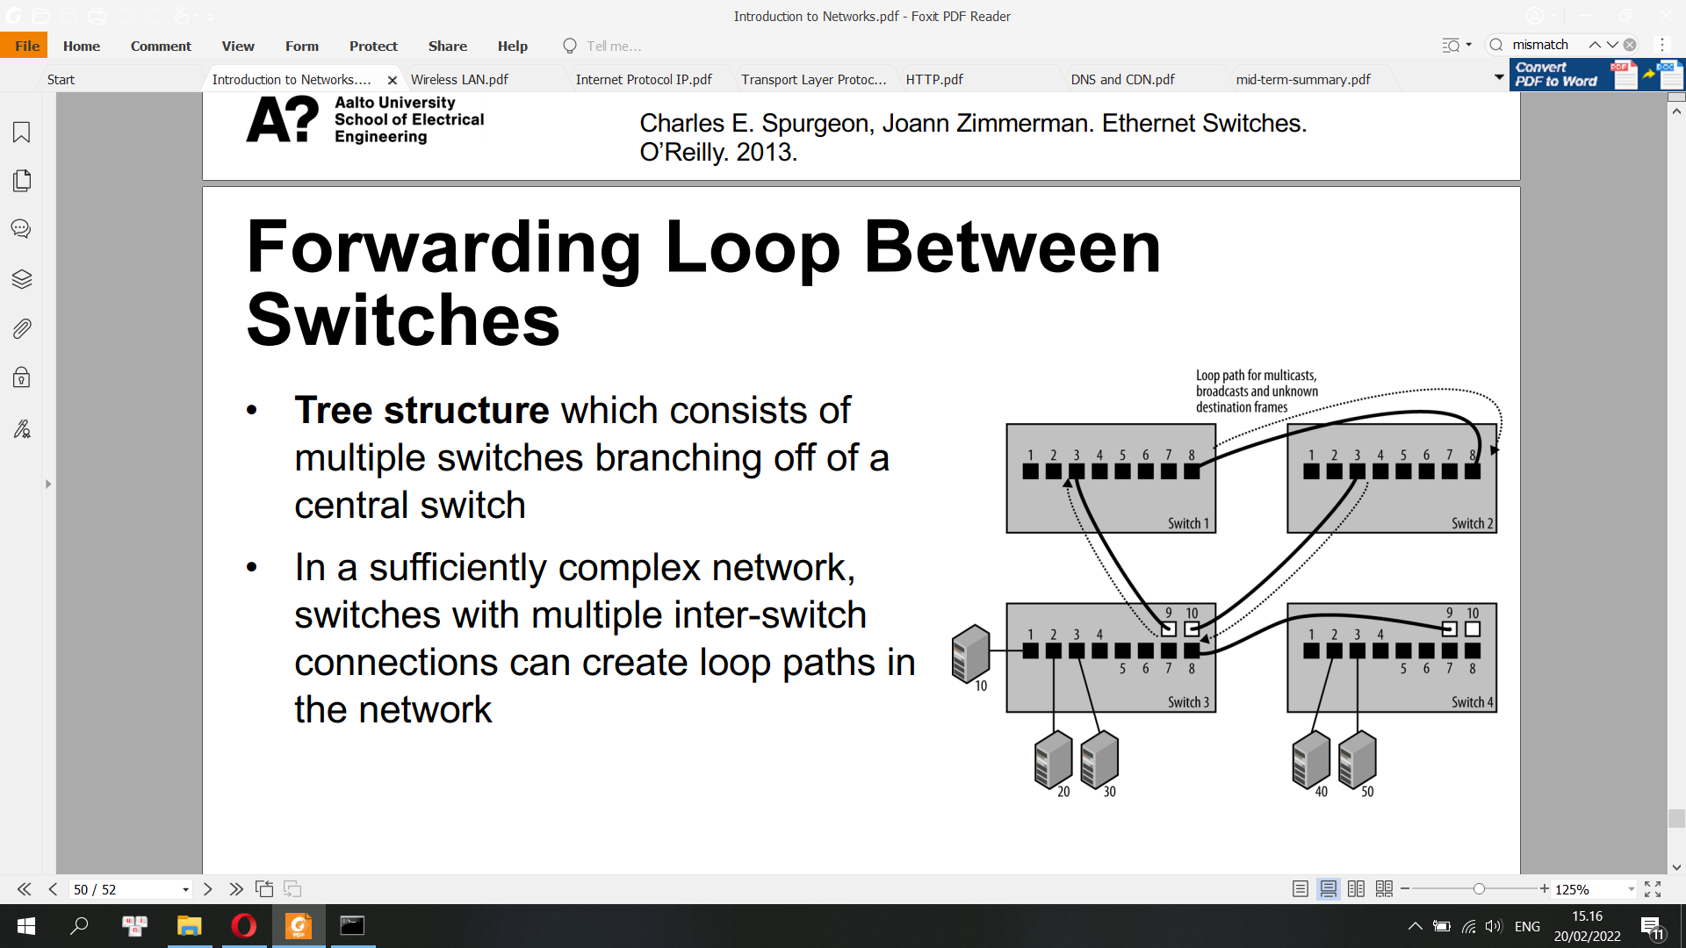

**3) Self-test: Network models**

**• Unicast vs. Multicast vs. Broadcast: check above**

**• Can you remember the name of each layer in the OSI model?: check above. Abbreviation:**For OSI model: APSTNDP: application presentation session transport network data-link physical

For TCP-IP model: ATIN : application | transport | internet | network-access



**• What is MAC address?: check above**

**• Full duplex vs. Half duplex:**

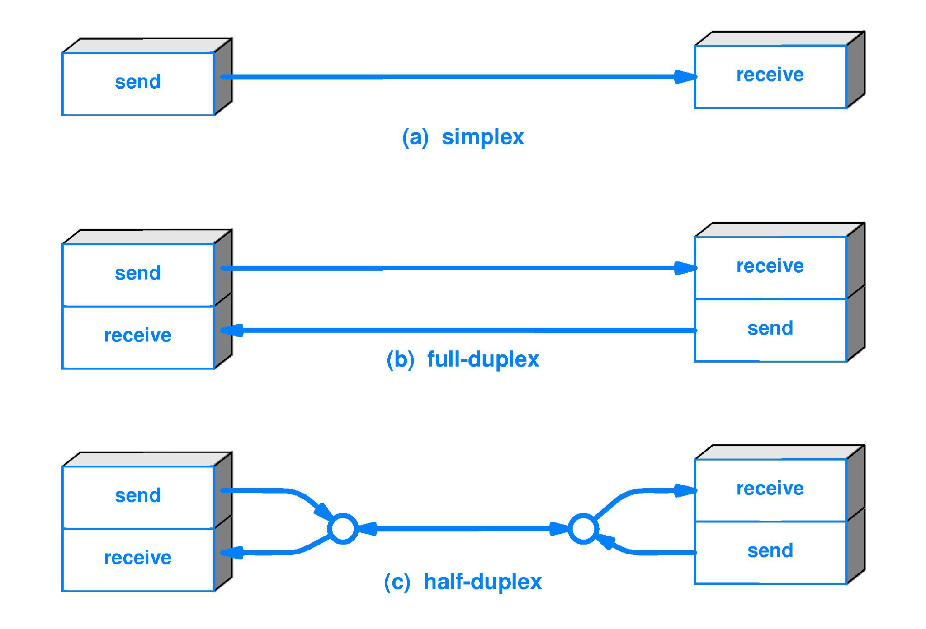

A full-duplex device is capable of bi-directional network data transmissions at the same time. Half-duplex devices can only transmit in one direction at one time. With half-duplex mode, data can move in two directions, but not at the same time.

**• Hub vs. Switches: check above**

**• How does CSMA/CD work?: check above**

**• How to create a switch’s forwarding table?**

Layer 2 switches (bridges) have a MAC address table that contains a MAC address and physical port number. Switches follow this simple algorithm for forwarding frames:

When a frame is received, the switch compares the SOURCE MAC address to the MAC address table. If the SOURCE is unknown, the switch adds it to the table along with the physical port number the frame was received on. In this way, the switch learns the MAC address and physical connection port of every transmitting device.

The switch then compares the DESTINATION MAC address with the table. If there is an entry, the switch forwards the frame out the associated physical port. If there is no entry, the switch sends the frame out all its physical ports, except the physical port that the frame was received on (Flooding). If the DESTINATION is on the same port as the SOURCE (if they're both on the same segment), the switch will not forward the frame.)

Note that the switch does not learn the destination MAC until it receives a frame from that device.

**• What do you think are the advantages and disadvantages of CSMA/CD?**

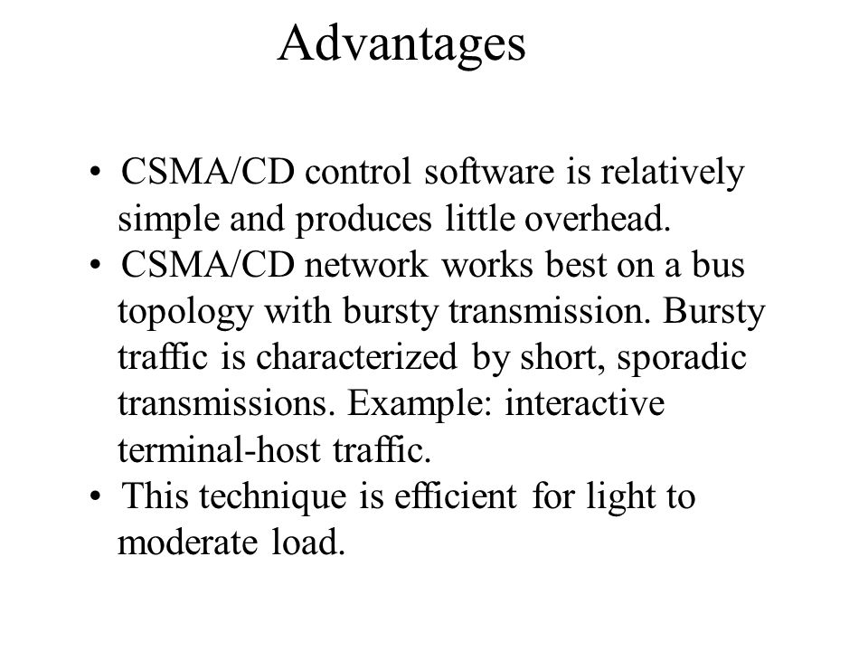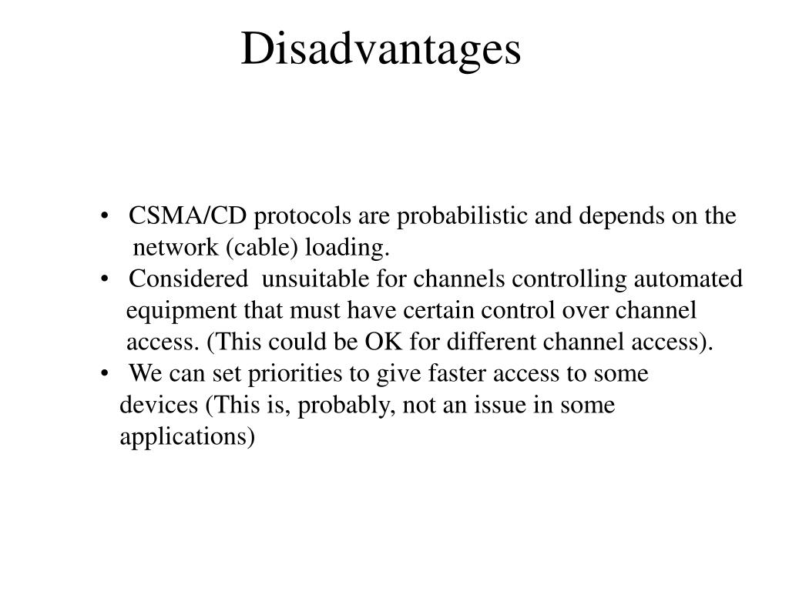

**• Is a Hub half duplex or full-duplex? Can switches support full-duplex?**

A hub is always Half Duplex, so only one device at a time can communicate. A switch can handle Full Duplex communication, so multiple computers can talk with each other simultaneously through a switch

**II) Wireless LAN**

Radio Frequency (RF): RF waves are electromagnetic waves generated when an alternating current goes through a conductive material

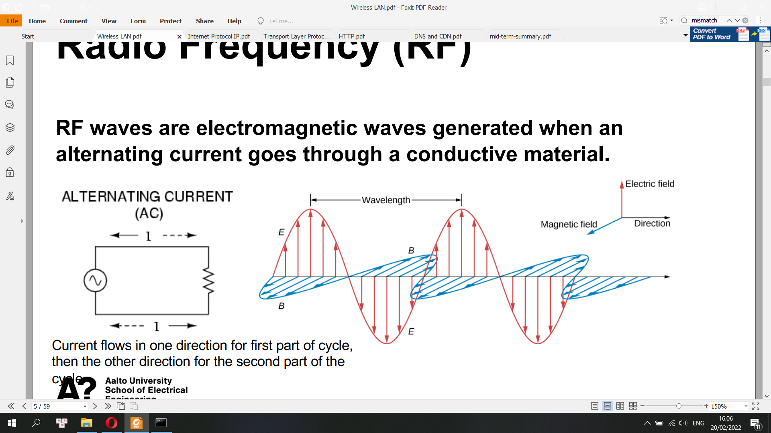

Received Signal Strength Indicator (RSSI): a measurement of how well your device can hear a signal from an access point or router

• Frequency (Hz): how many cycles per second

• Wavelength

• Amplitude

• An antenna is a device used to emit and receive RF waves.

**Path Loss**

• The reduction in power density of an electromagnetic wave as it propagates through space

• Causes:

• Propagation losses caused by the natural expansion of the radio wave front in free space

• Absorption losses (e.g. when radio signals pass through dense materials such as walls)

• Diffraction losses

• And etc.

**Diffraction**

• Diffraction is the bending of a wave as it either passes through a barrier or passes through an opening.

• Frequency, wavelength and speed of waves do not change.

• Direction of propagation and the pattern of waves can change.

**RF Waves**

• RF waves travel at the speed of light in free space

Speed of light (c) = frequency x wavelength

• When frequency increases, wavelength decreases

• Coverage area: the area in which receiving stations can successfully receive and “understand” the signal

- Depends on frequency and transmit power

• RF spectrum: the range of frequencies that are available

**Wi-Fi Bands**

• A band is a range of frequencies that can be used (e.g. 2.412-2.462 GHz)

• A band can be divided into smaller chunks of frequency called channels (e.g. 20MHz or 40MHz wide)

• Wi-Fi bands (2.4GHz, 5GHz) may be shared with other types of communication device

E.g. Bluetooth (2.4GHz), Radar (5GHz)

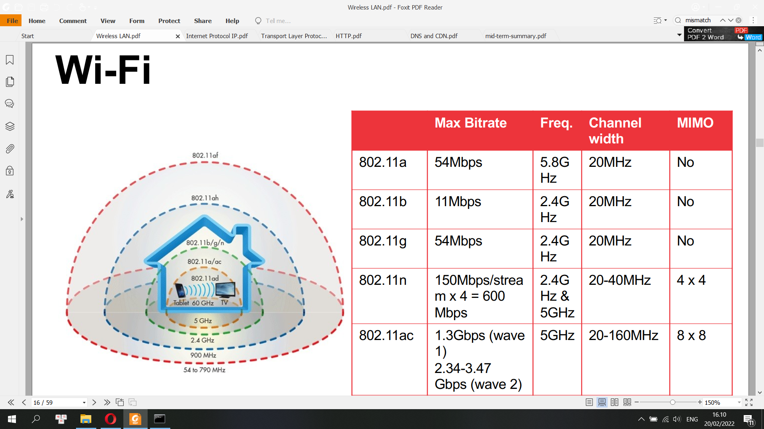

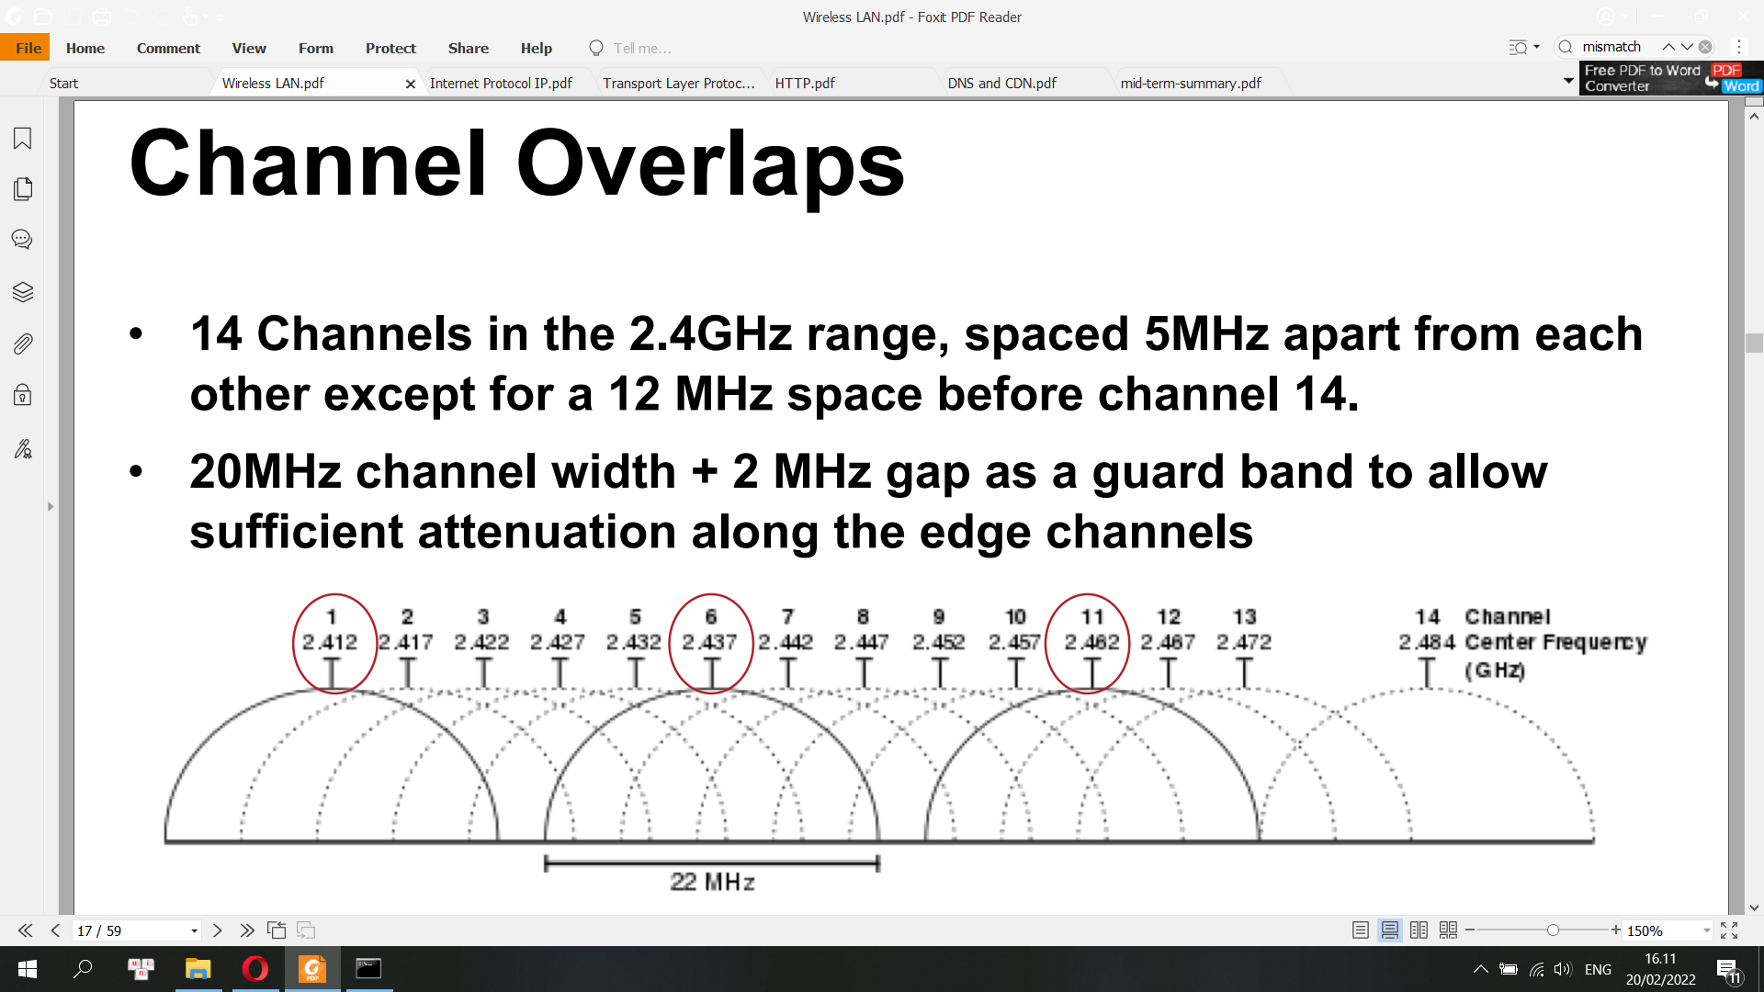

RF Interference

• Anything which modifies, or disrupts a signal as it travels along a channel between a source and a receiver.

• It is an unwanted signal that occurs at the same time and frequency as a data signal.

• It causes wireless receivers to sporadically make mistakes when decoding packets, which results in retransmissions of data.

• Co-Channel interference results when there are numerous devices all competing for time to talk on the same channel.

• Adjacent-Channel interference occurs when devices from overlapping channels are trying to talk over each other.

**Measurement Metrics**

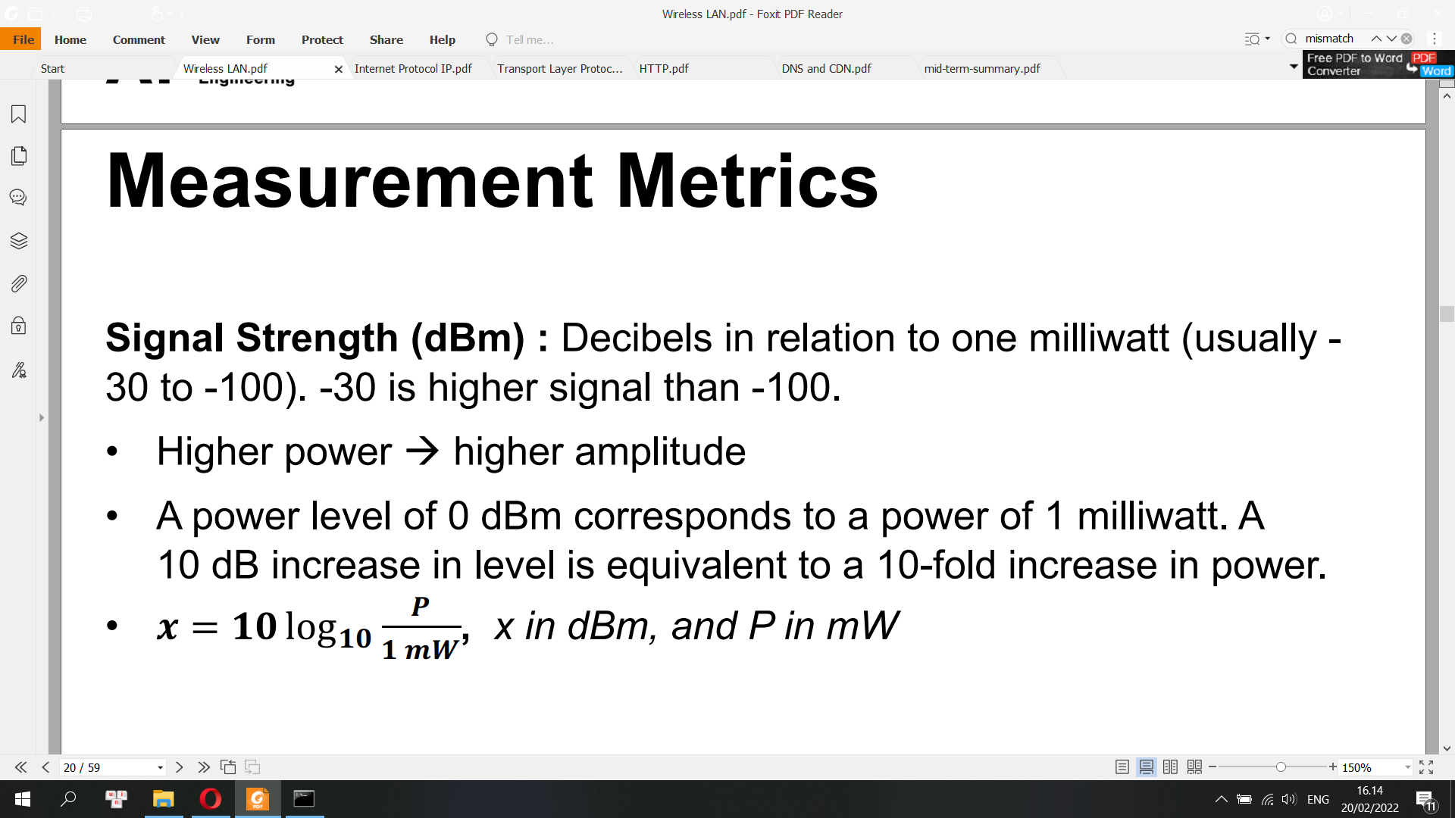

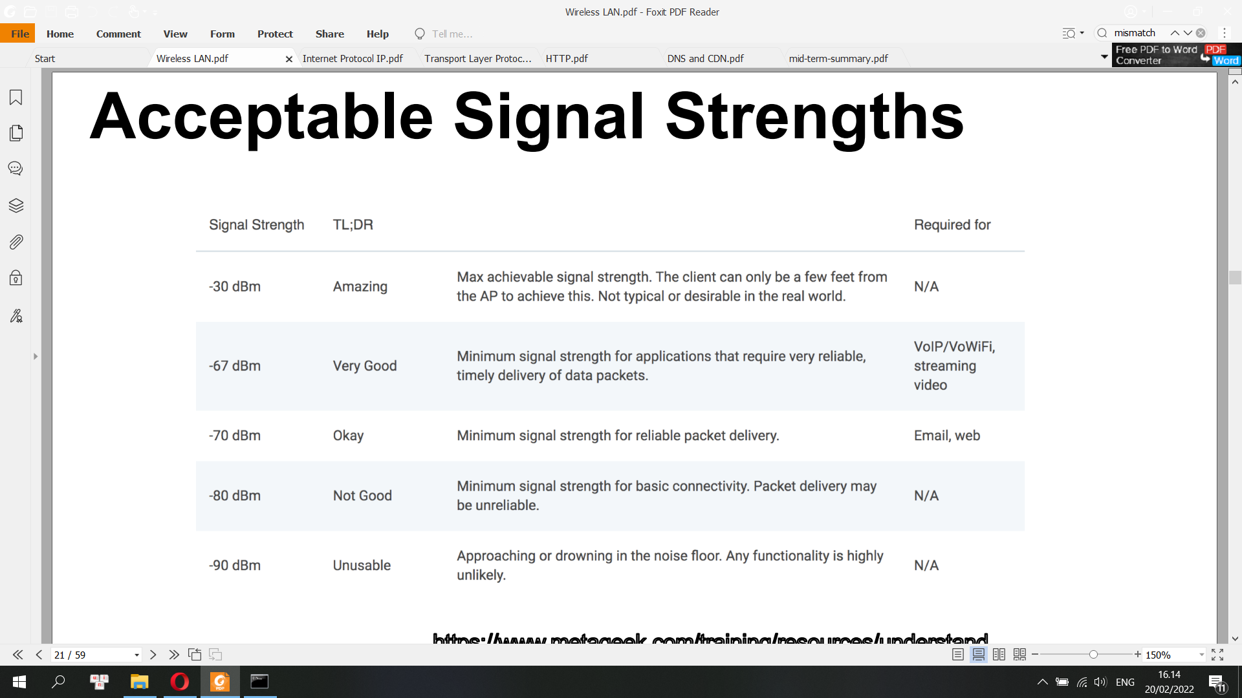

• RSSI is a relative index, while dBm is an absolute number representing power levels in mW

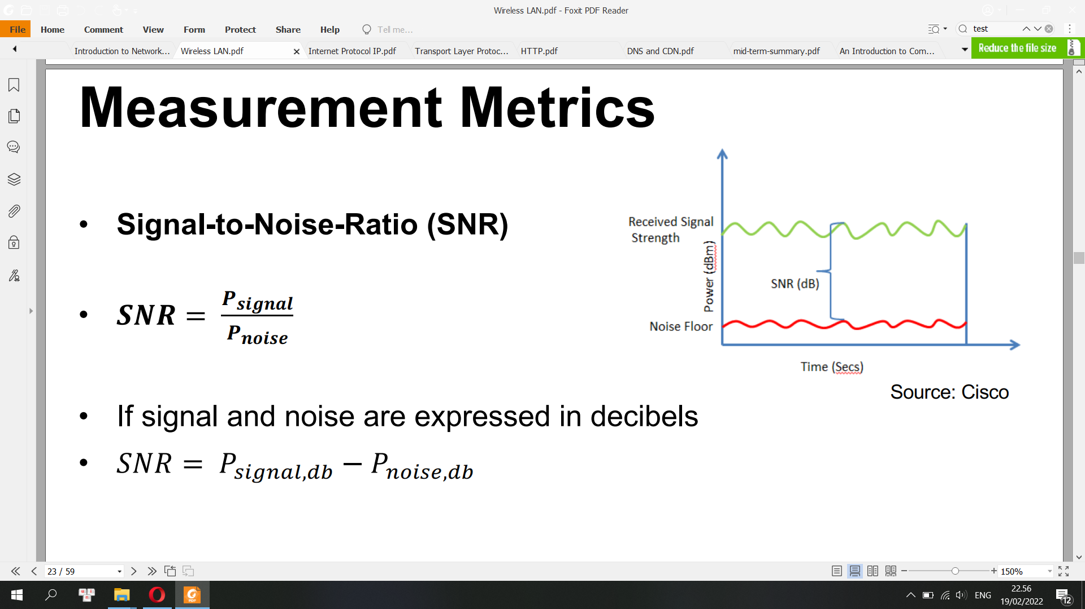

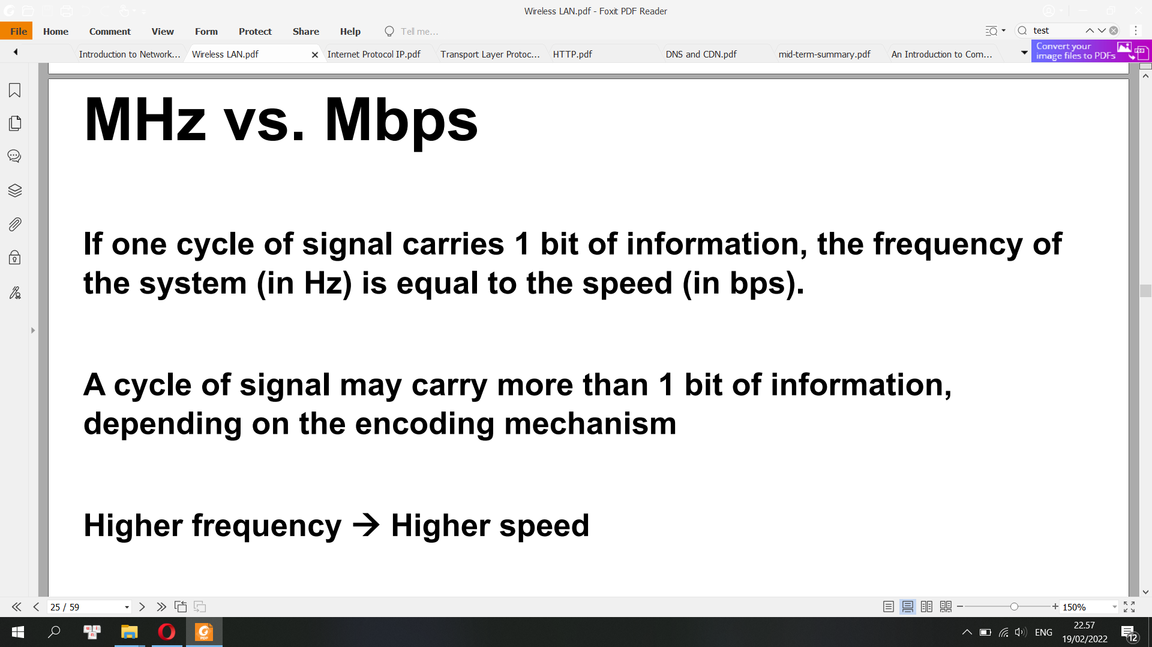

**Modulation**

• Change a characteristic of the radio signal to represent data

• Schemes:

• Amplitude modulation

• Frequency modulation (shifting between two frequencies called frequency shift keying)

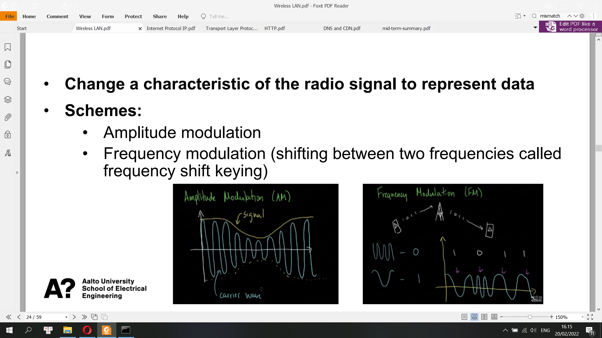

MHz vs. Mbps

If one cycle of signal carries 1 bit of information, the frequency of the system (in Hz) is equal to the speed (in bps).

A cycle of signal may carry more than 1 bit of information, depending on the encoding mechanism

Higher frequency -> Higher speed

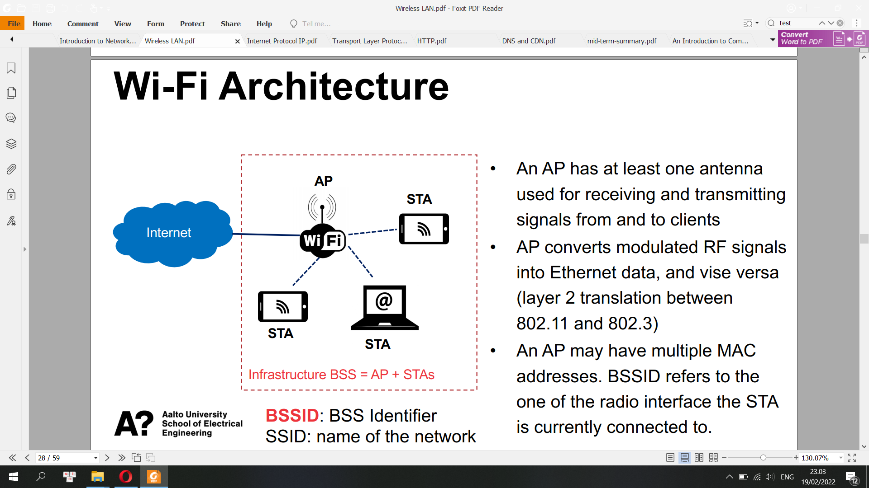

Basic Service Set Identifier (BSS) is the basic building block of an IEEE 802.11 LAN. The

members of a BSS can communication with each other directly

Service Set IDentifier (SSID)

In IEEE 802.11 wireless local area networking standards (including Wi-Fi), a service set is a group of wireless network devices which share a service set identifier (SSID)—typically the natural language label that users see as a network name. (For example, all of the devices that together form and use a Wi‑Fi network called Foo are a service set.) A service set forms a logical network of nodes operating with shared link-layer networking parameters; they form one logical network segment.

A service set is either a basic service set (BSS) or an extended service set (ESS).

A basic service set is a subgroup, within a service set, of devices that share physical-layer medium access characteristics (e.g. radio frequency, modulation scheme, security settings) such that they are wirelessly networked. The basic service set is defined by a basic service set identifier (BSSID) shared by all devices within it. The BSSID is a 48-bit label that conform to MAC-48 conventions. While a device may have multiple BSSIDs, usually each BSSID is associated with at most one basic service set at a time.

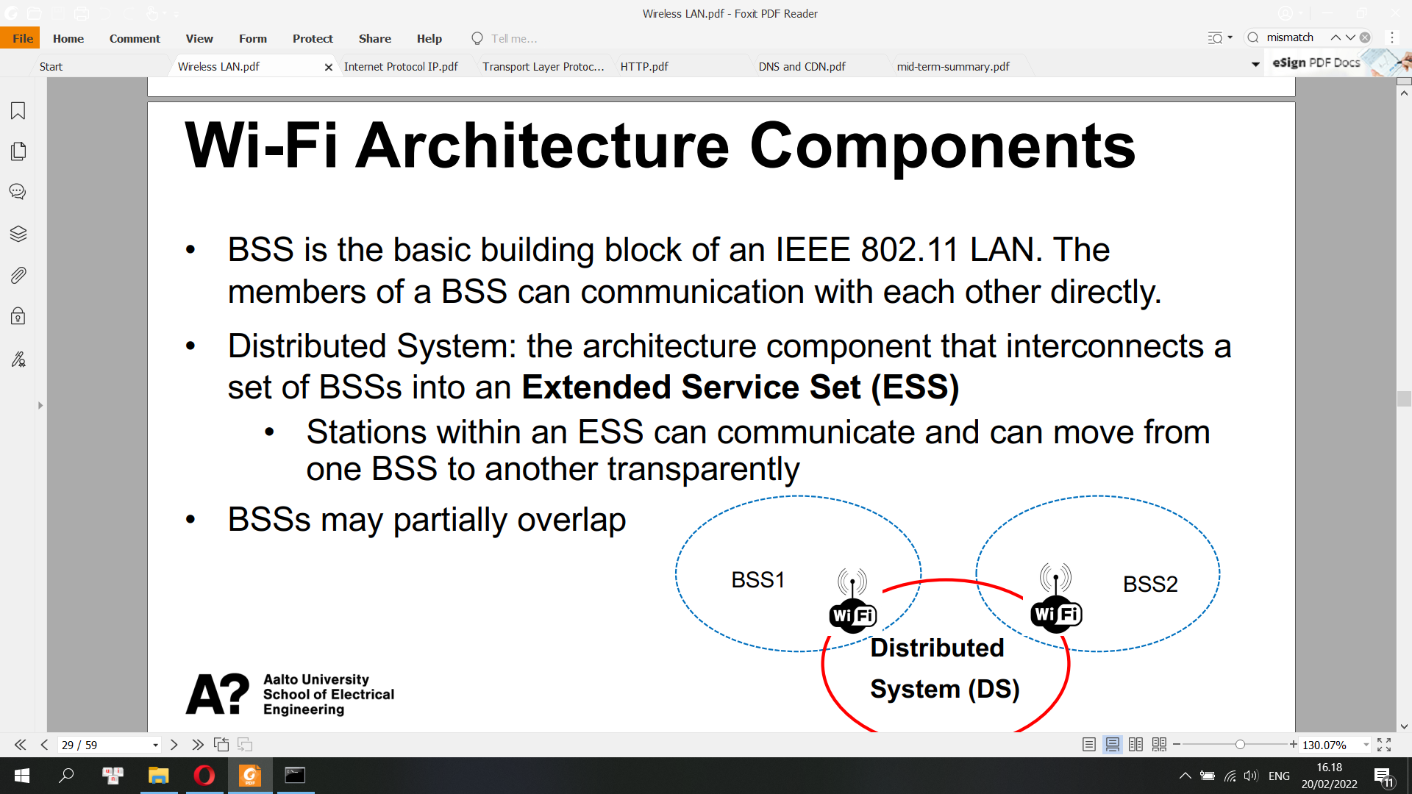

Mac Frame

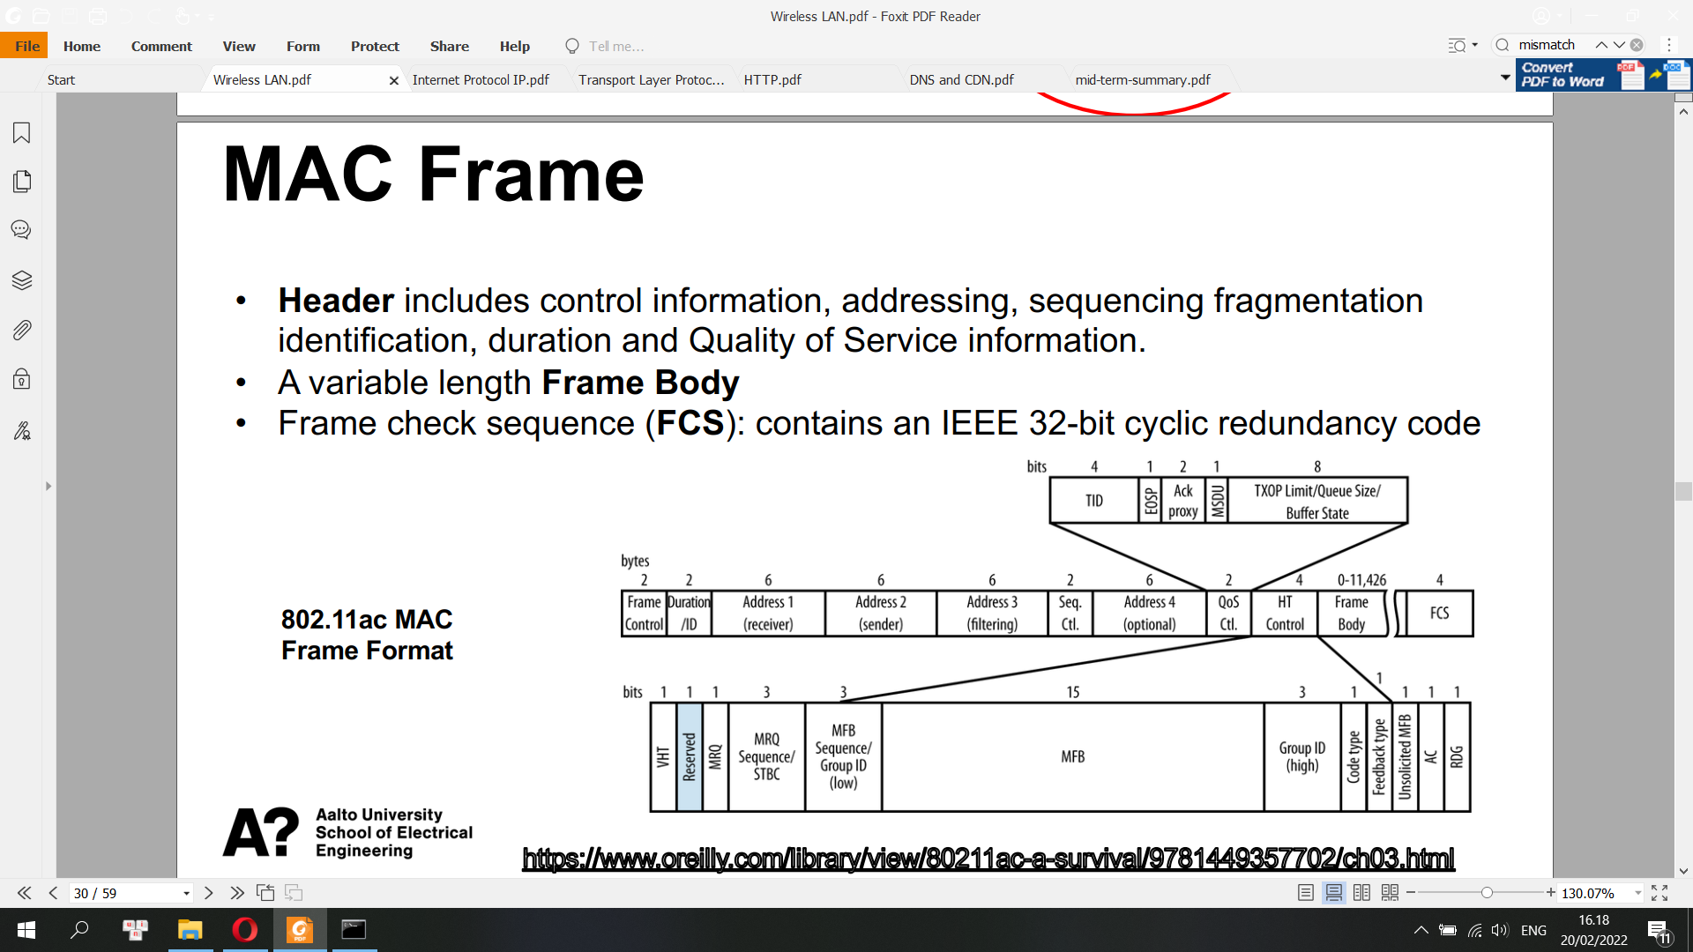

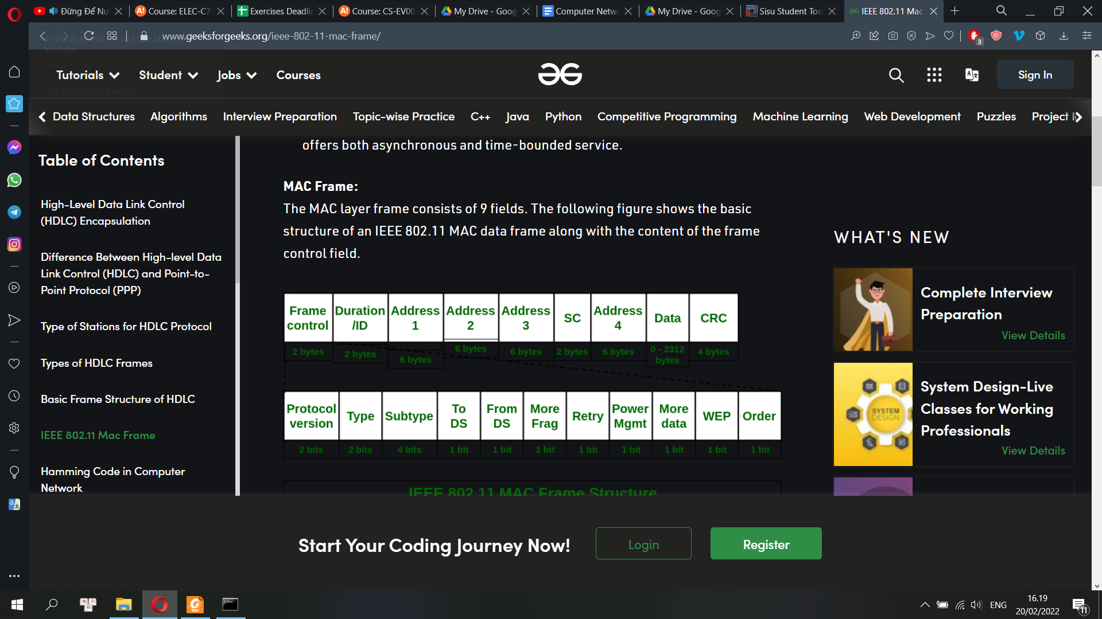

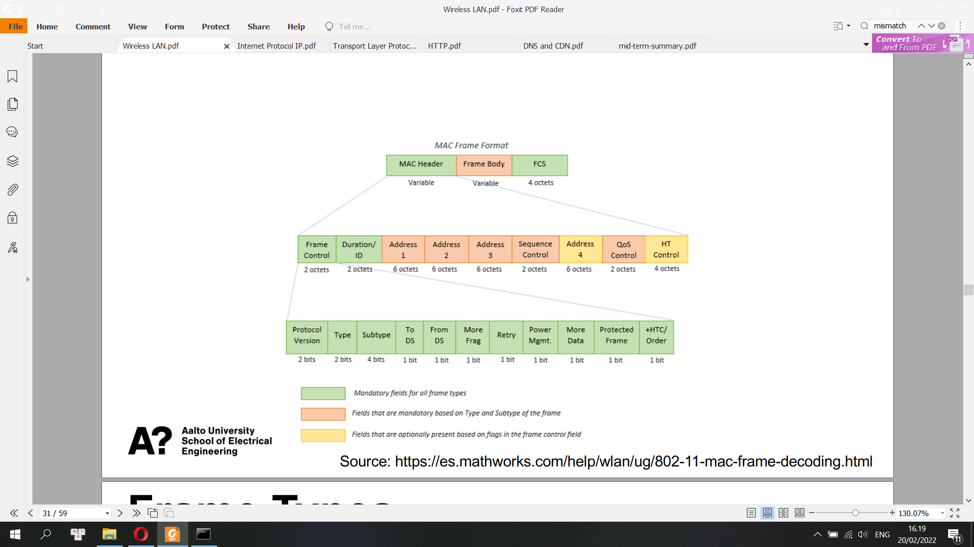

Frame Types

**• Management Frames (00), Control (01), Data (10)**

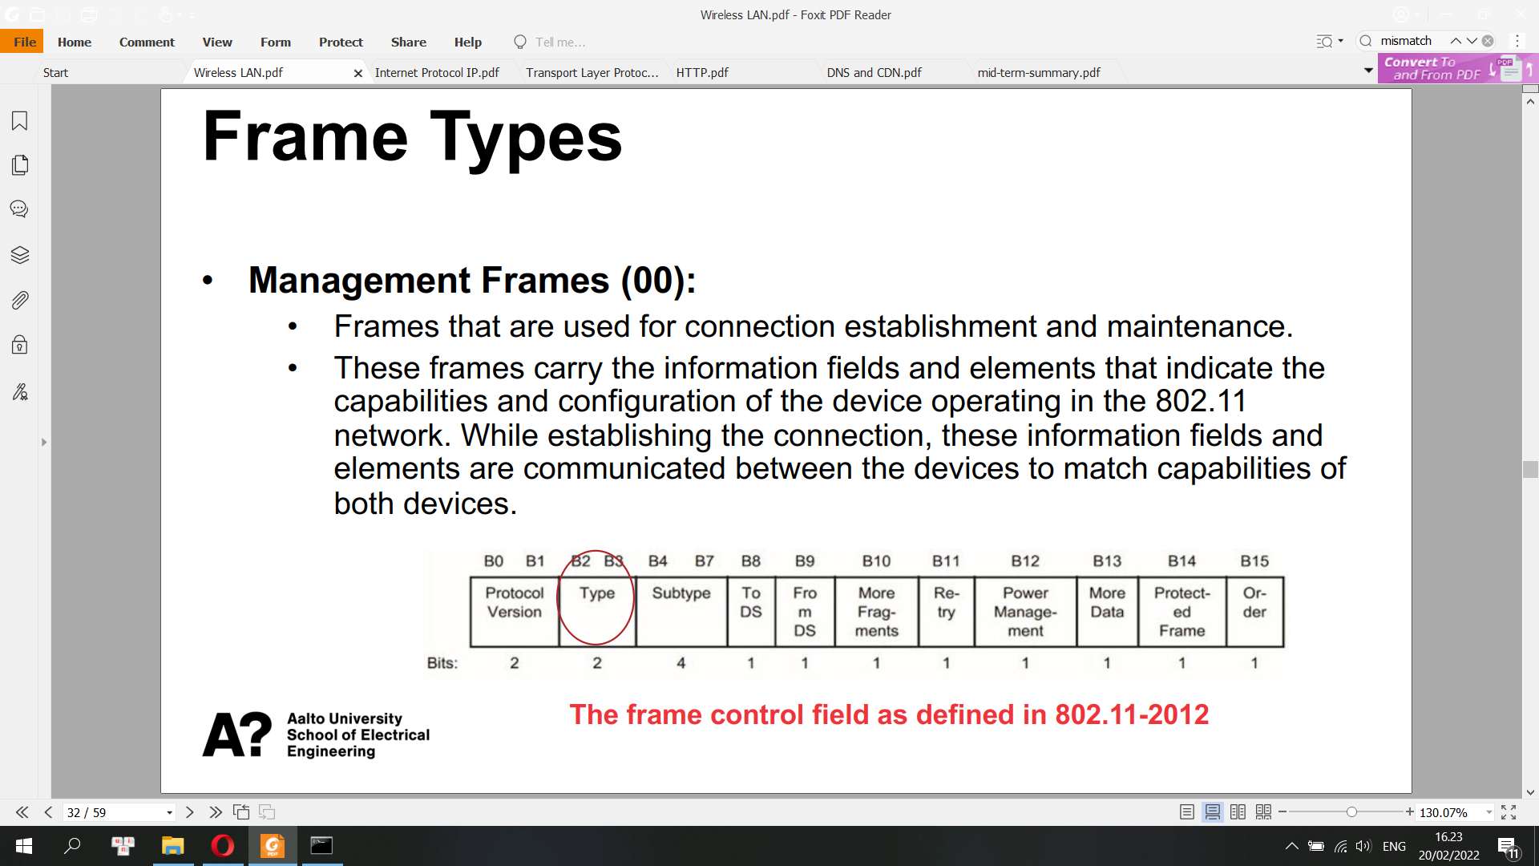

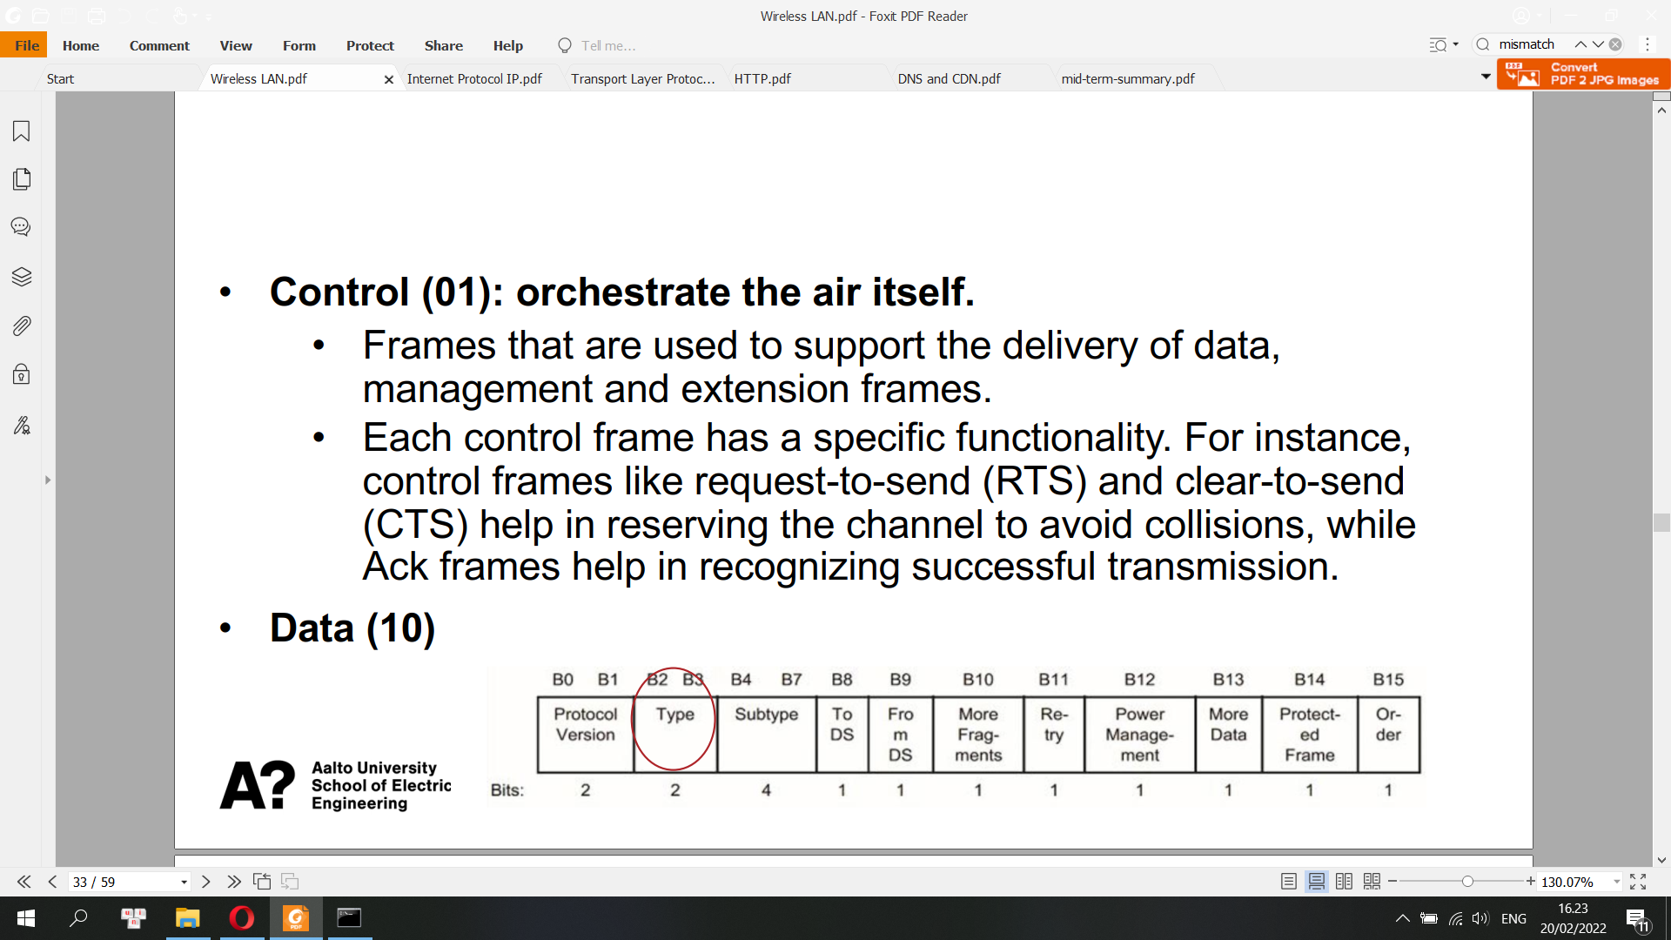

Subtype

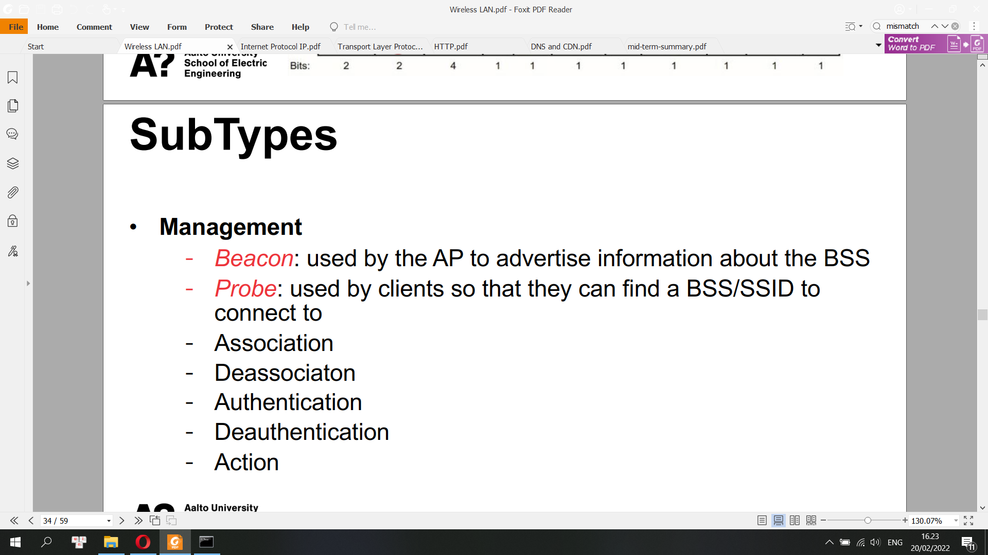

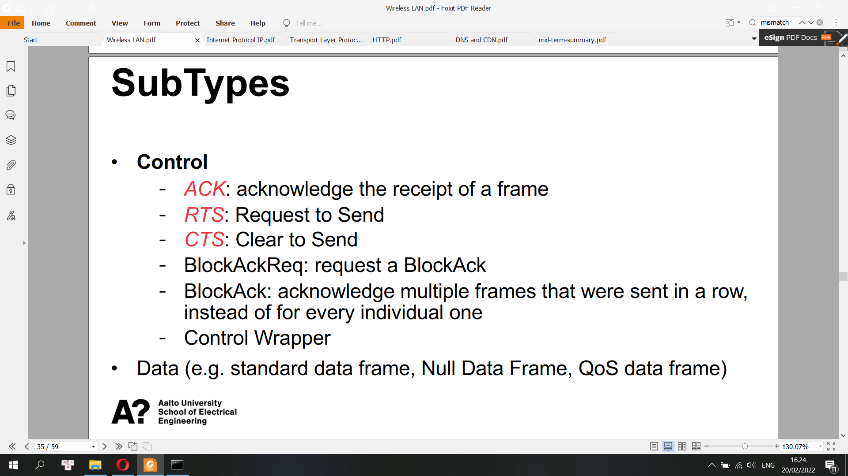

How to inform the presence of APs?

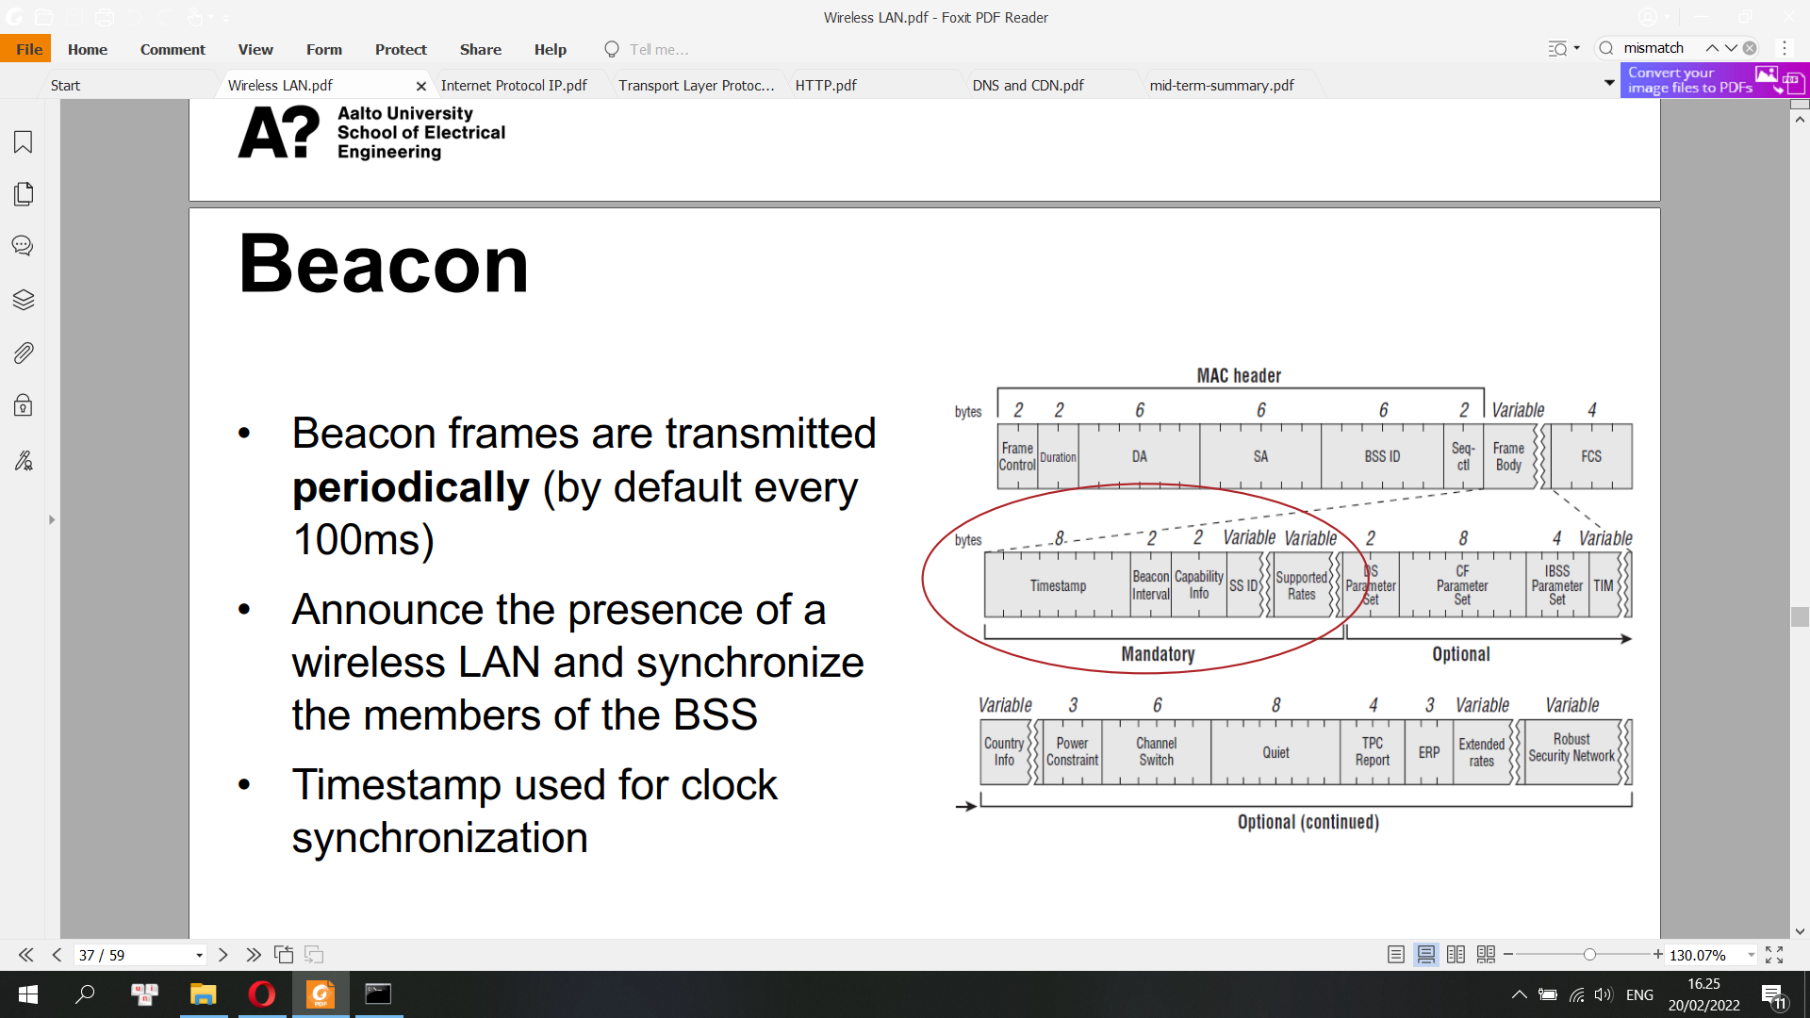

Beacon frame is one of the management frames in IEEE 802.11 based WLANs. It contains all the information about the network. Beacon frames are transmitted periodically, they serve to announce the presence of a wireless LAN and to synchronise the members of the service set. Beacon frames are transmitted by the access point (AP) in an infrastructure basic service set (BSS). In IBSS network beacon generation is distributed among the stations.

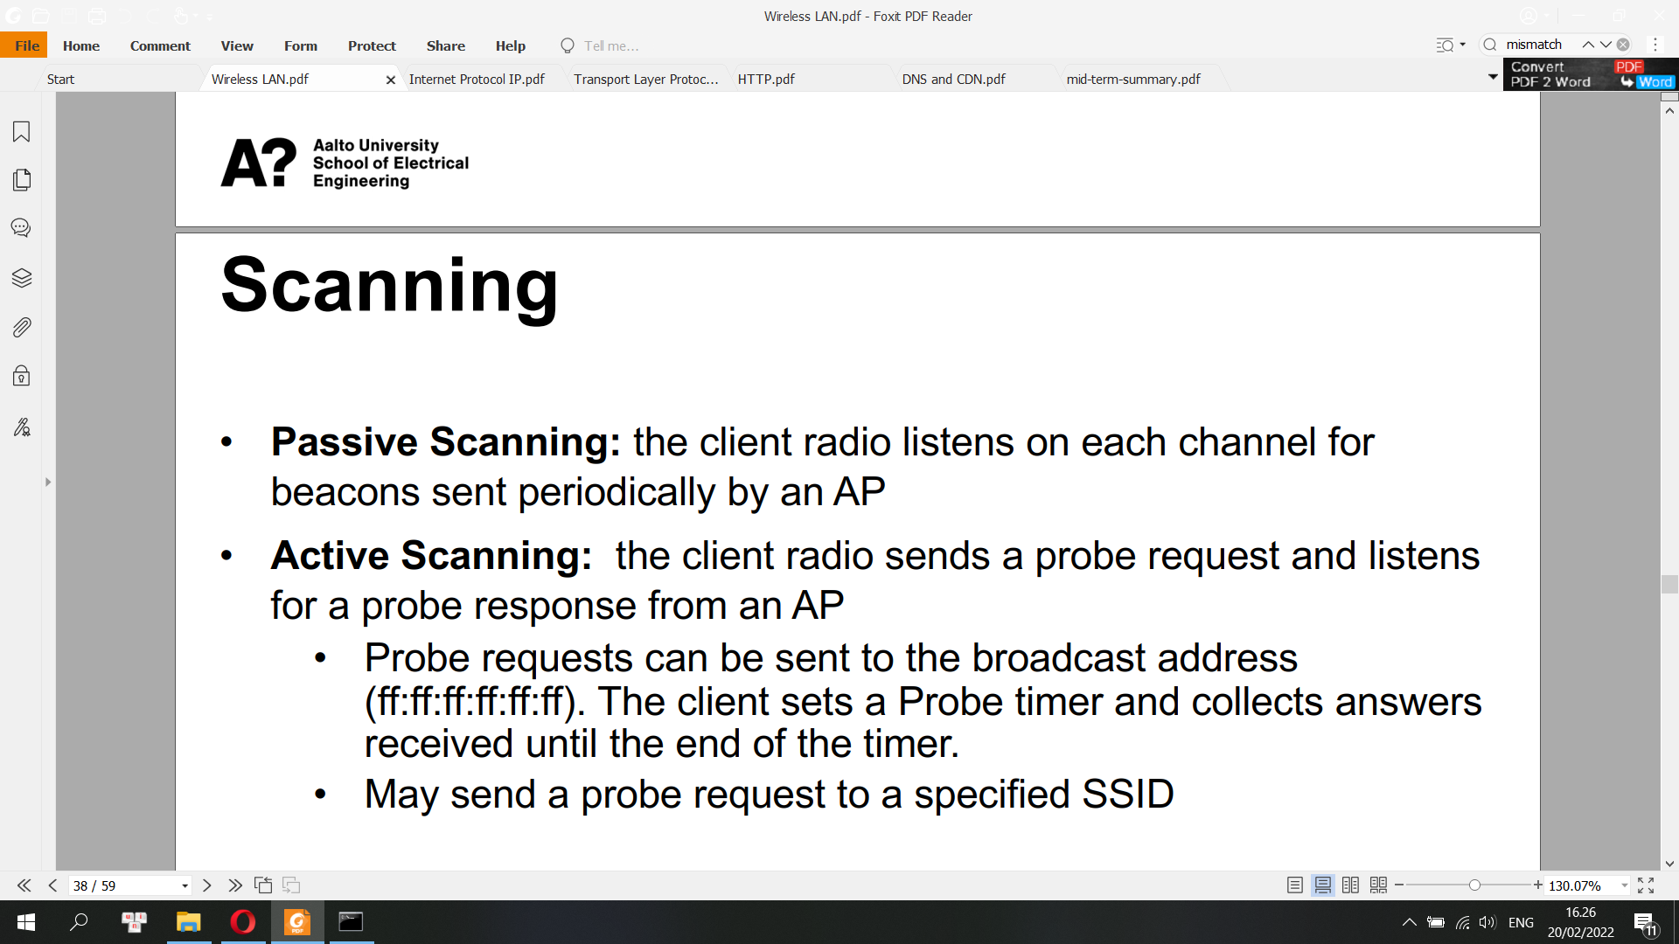

Association Service

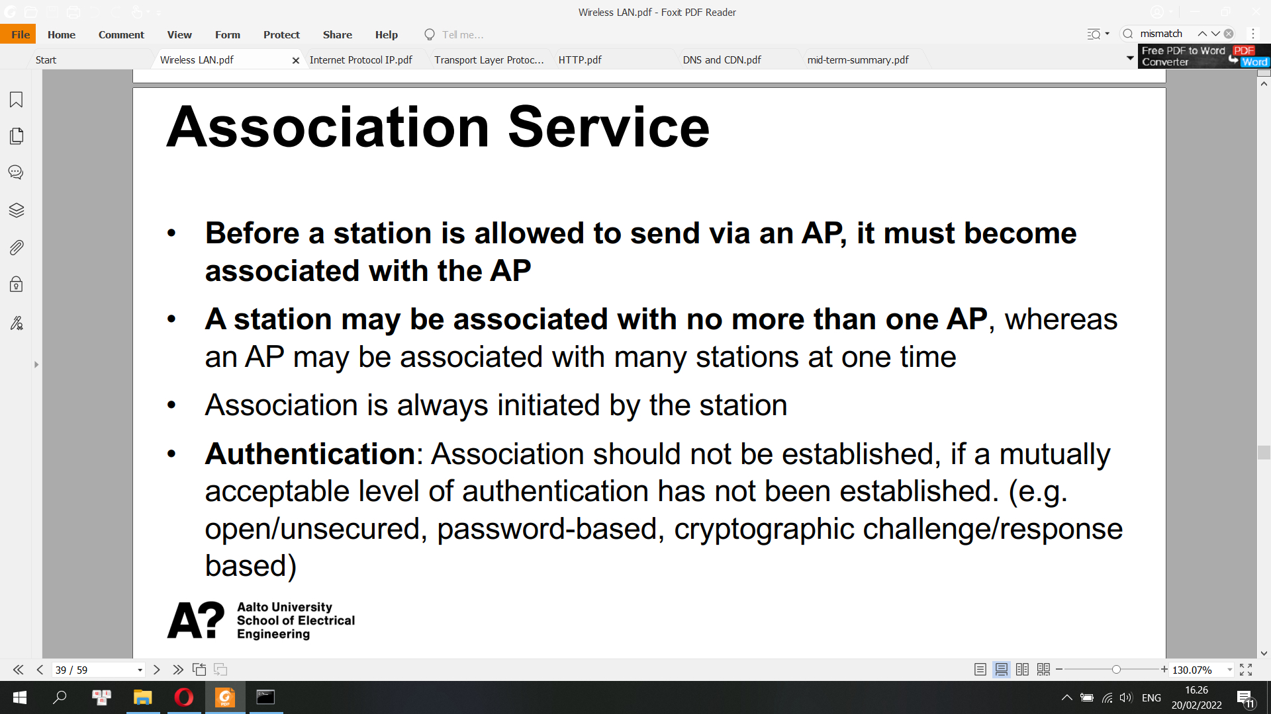

Reassociation and Deassociation

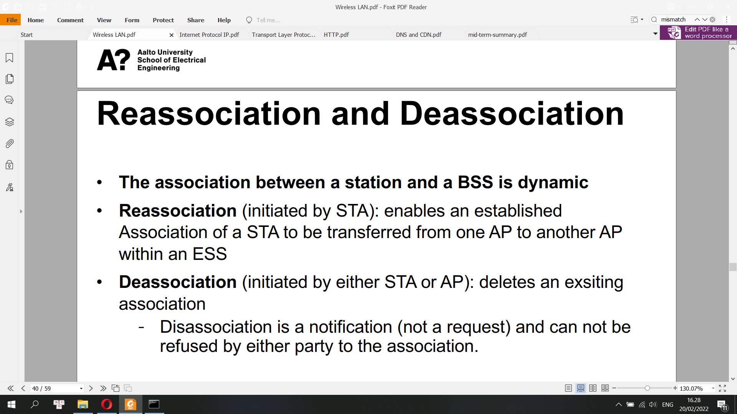

Association allows the AP/router to record each mobile device so that frames are properly delivered. Association only occurs on wireless infrastructure networks, not in peer-peer mode. A station can only associate with one AP/router at a time.

Devices that connect to WiFi network are called stations (STA). Connection to Wi-Fi is provided by an access point (AP), that acts as a hub for one or more stations. The access point on the other end is connected to a wired network.

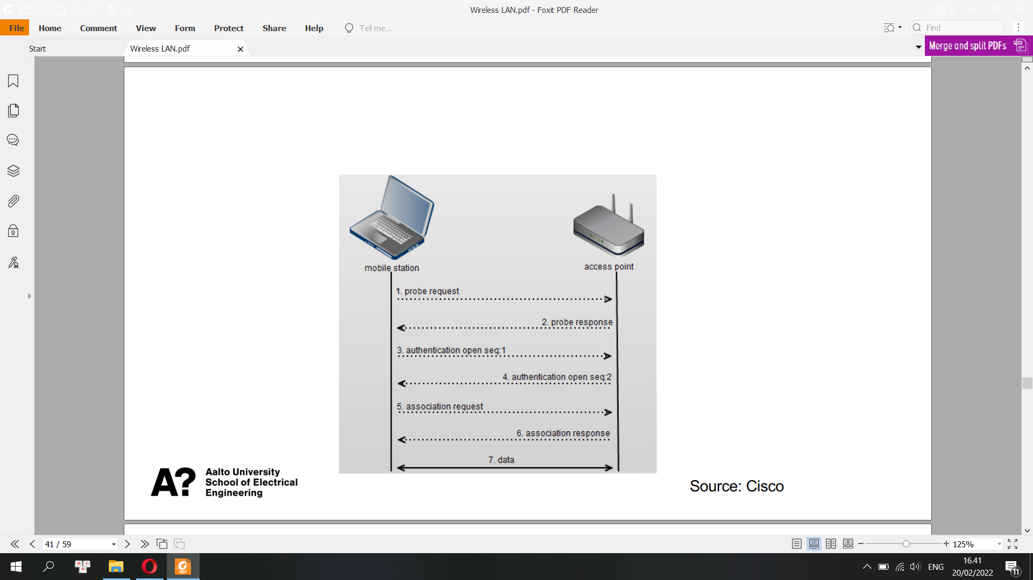

Difference from Ethernet

• Limited coverage area

• Shared transmission medium (radio)

• Dynamic topology

• Wi-Fi APs are half-duplex

• Unprotected from outside signals

• Less reliable than wired PHY

**Collision**

• A packet collision is defined as any case where a node is receiving more than one packet at a time, resulting in neither packet being correctly received.

• Carrier Sense: before transmission, a node first listens to the shared medium to determine whether another node is transmitting.

• Collision Avoidance: if another node was heard, we wait for a period of time (usually random) for the node to stop transmitting before listening again for a free communications channel

**Hidden Node Problem**

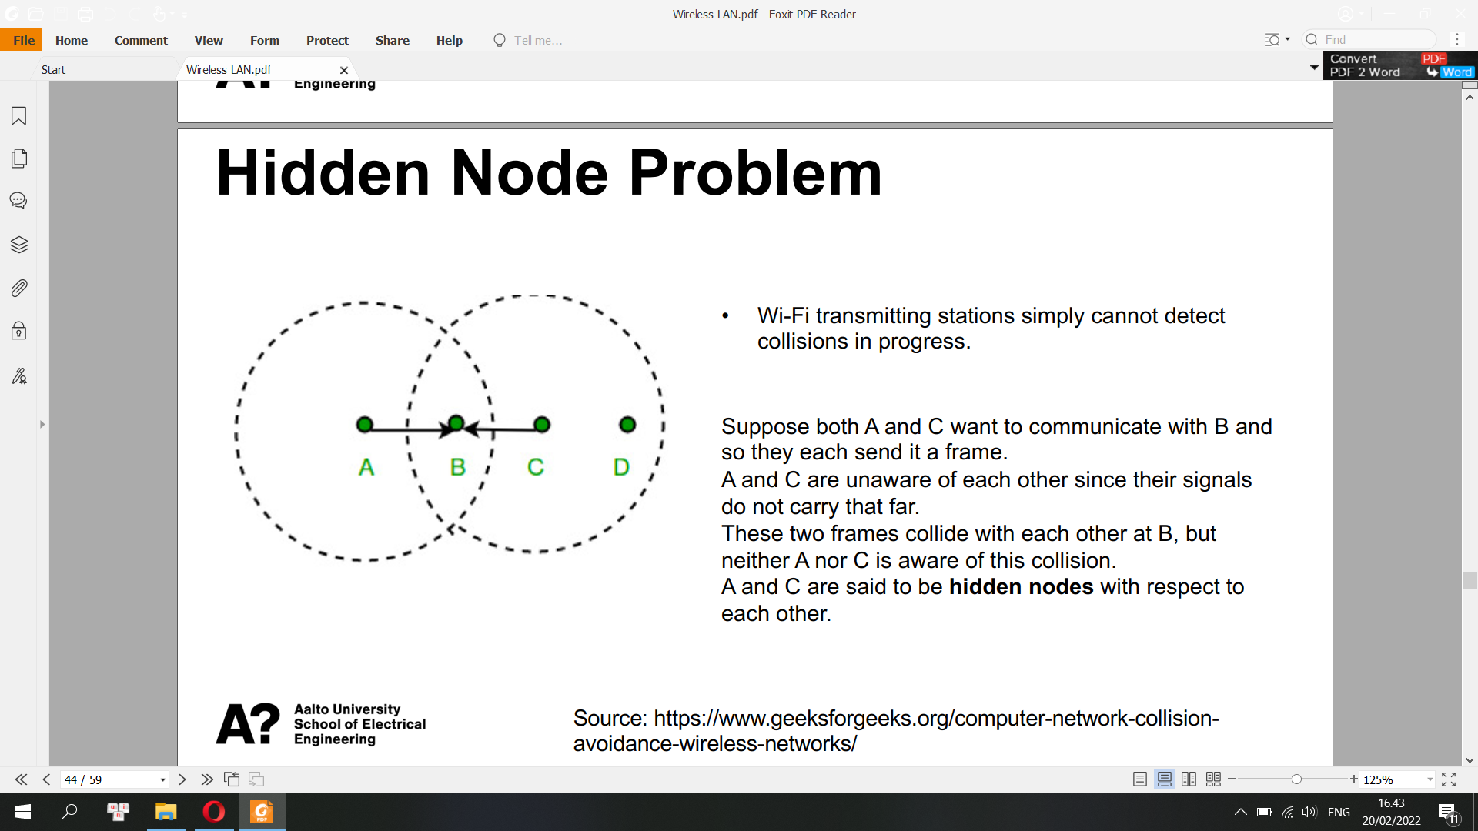

**Distributed Coordination Function (DCF)**

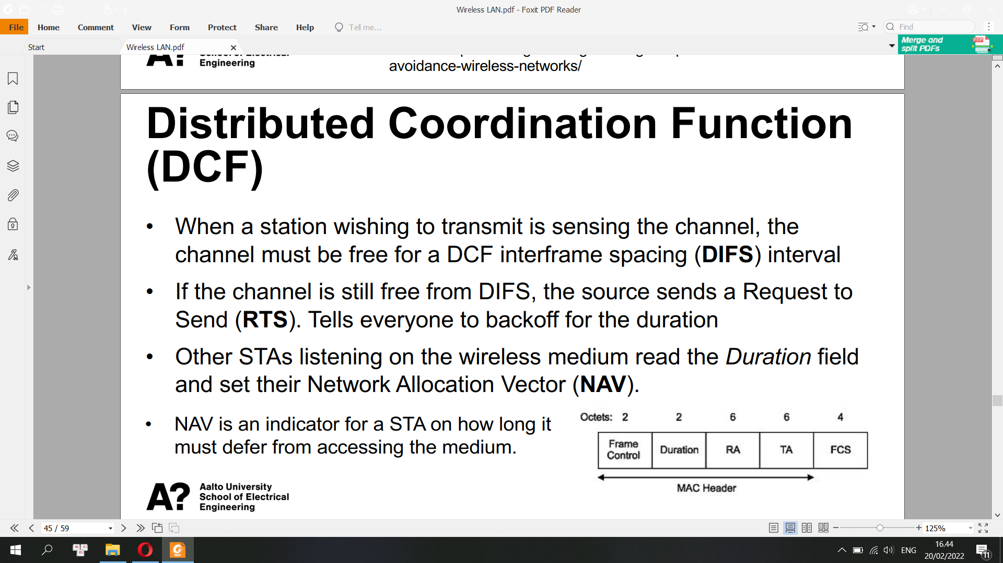

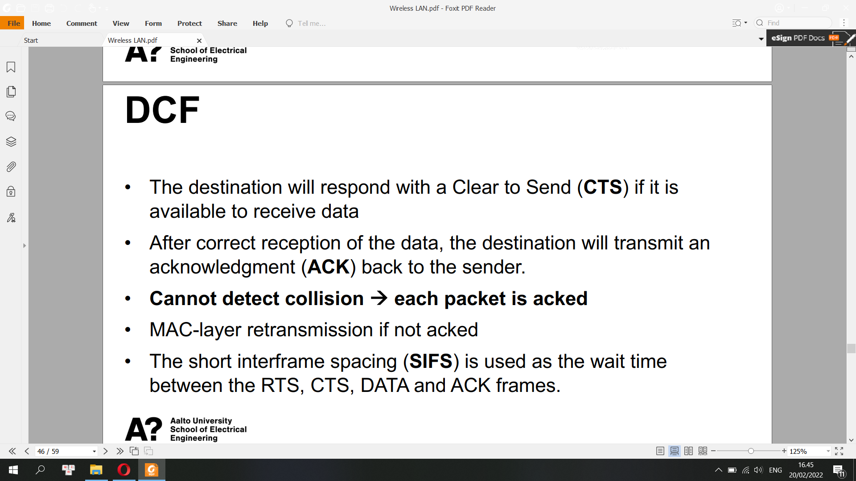

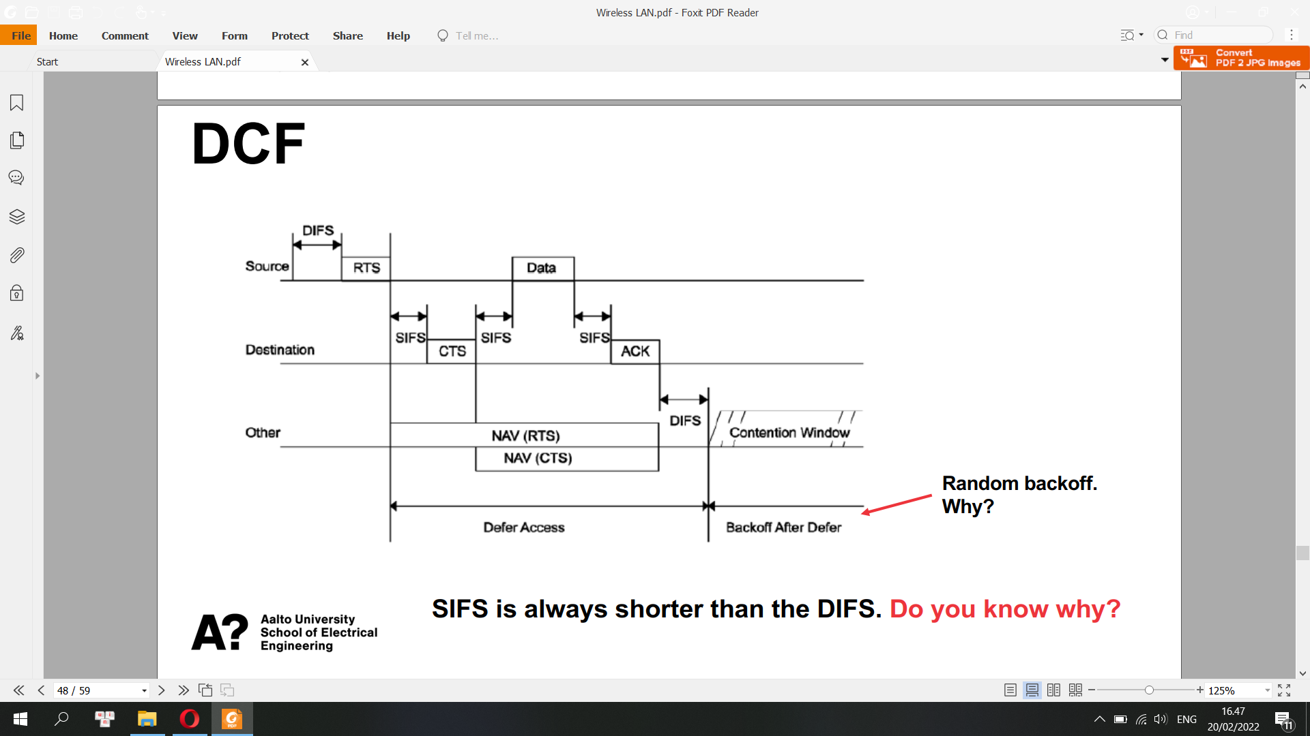

**Random Backoff**

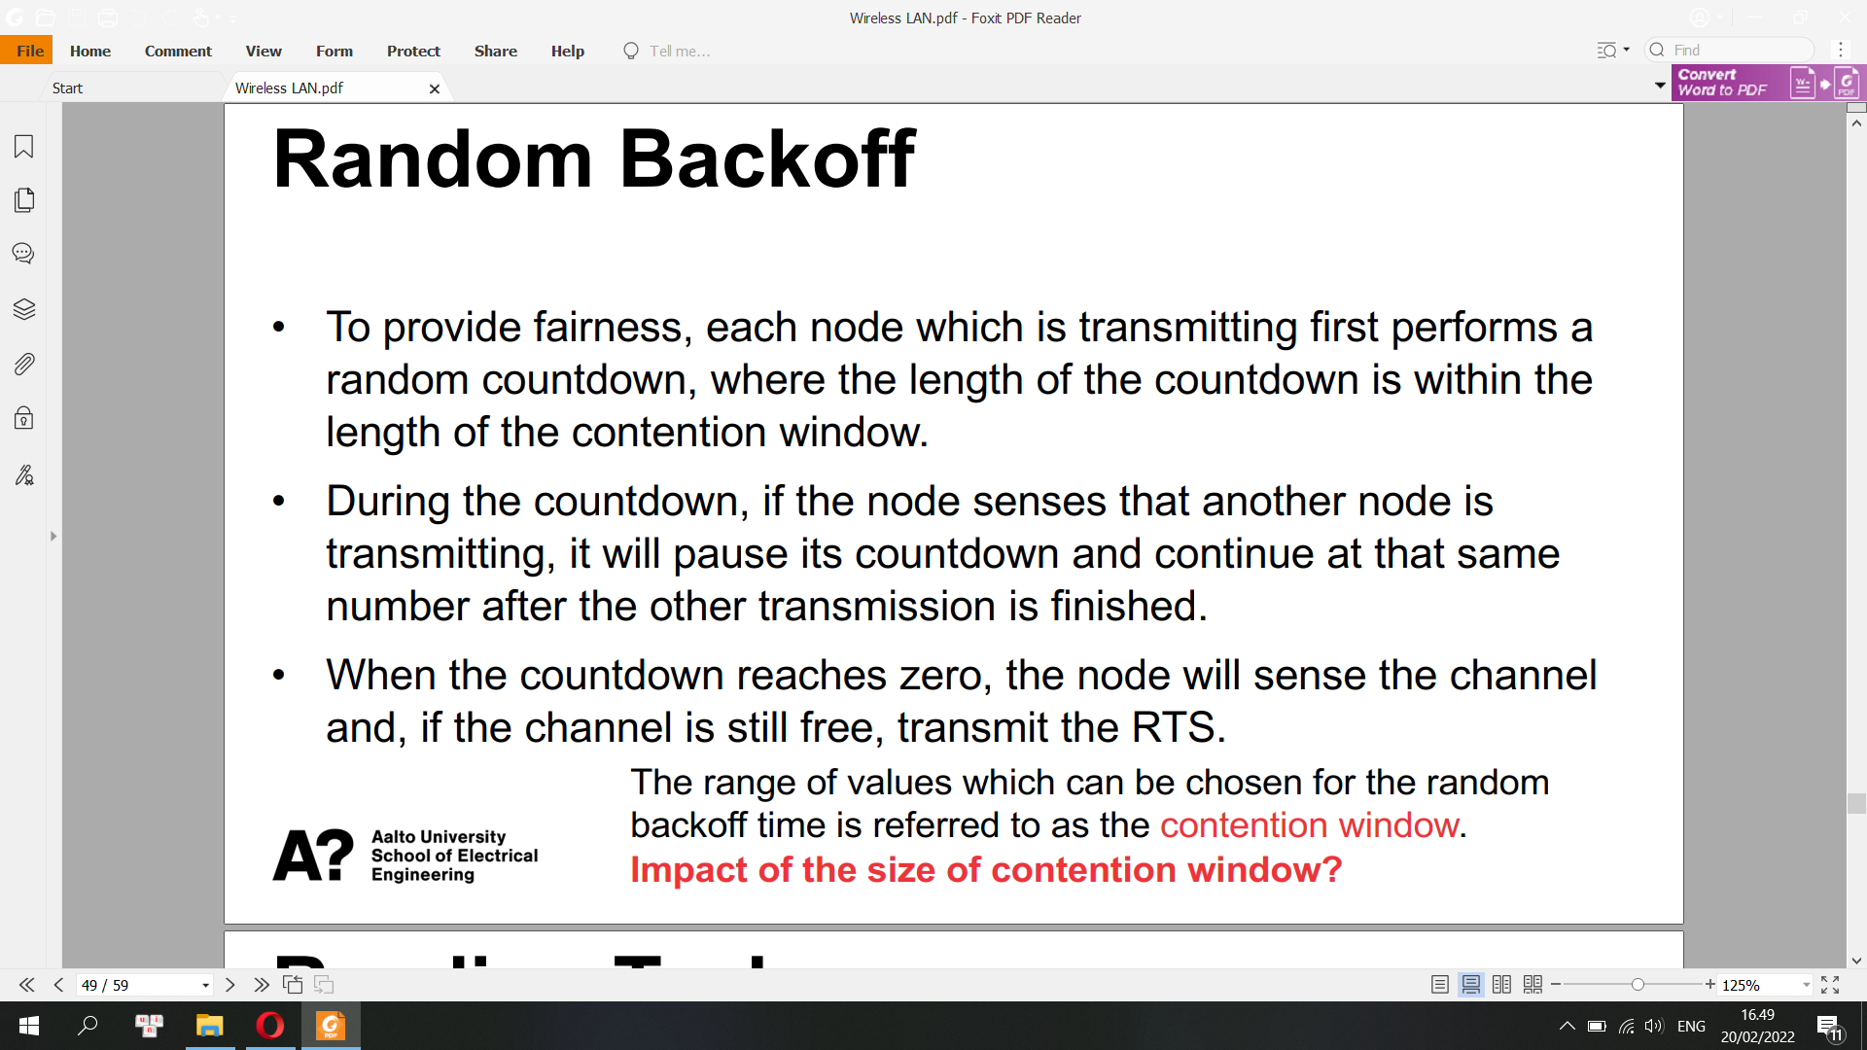

**Round Trip Time (RTT)**

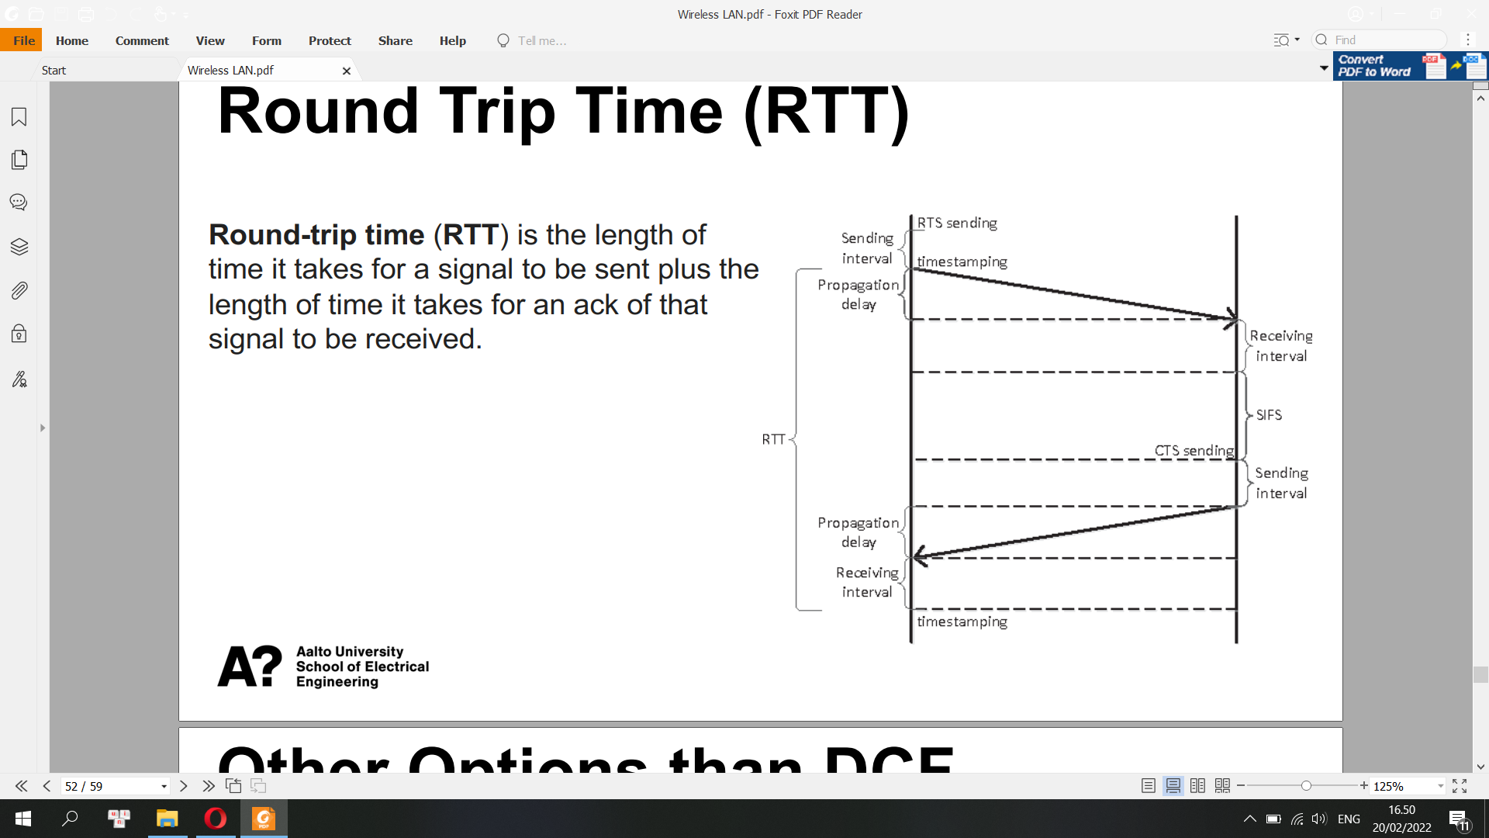

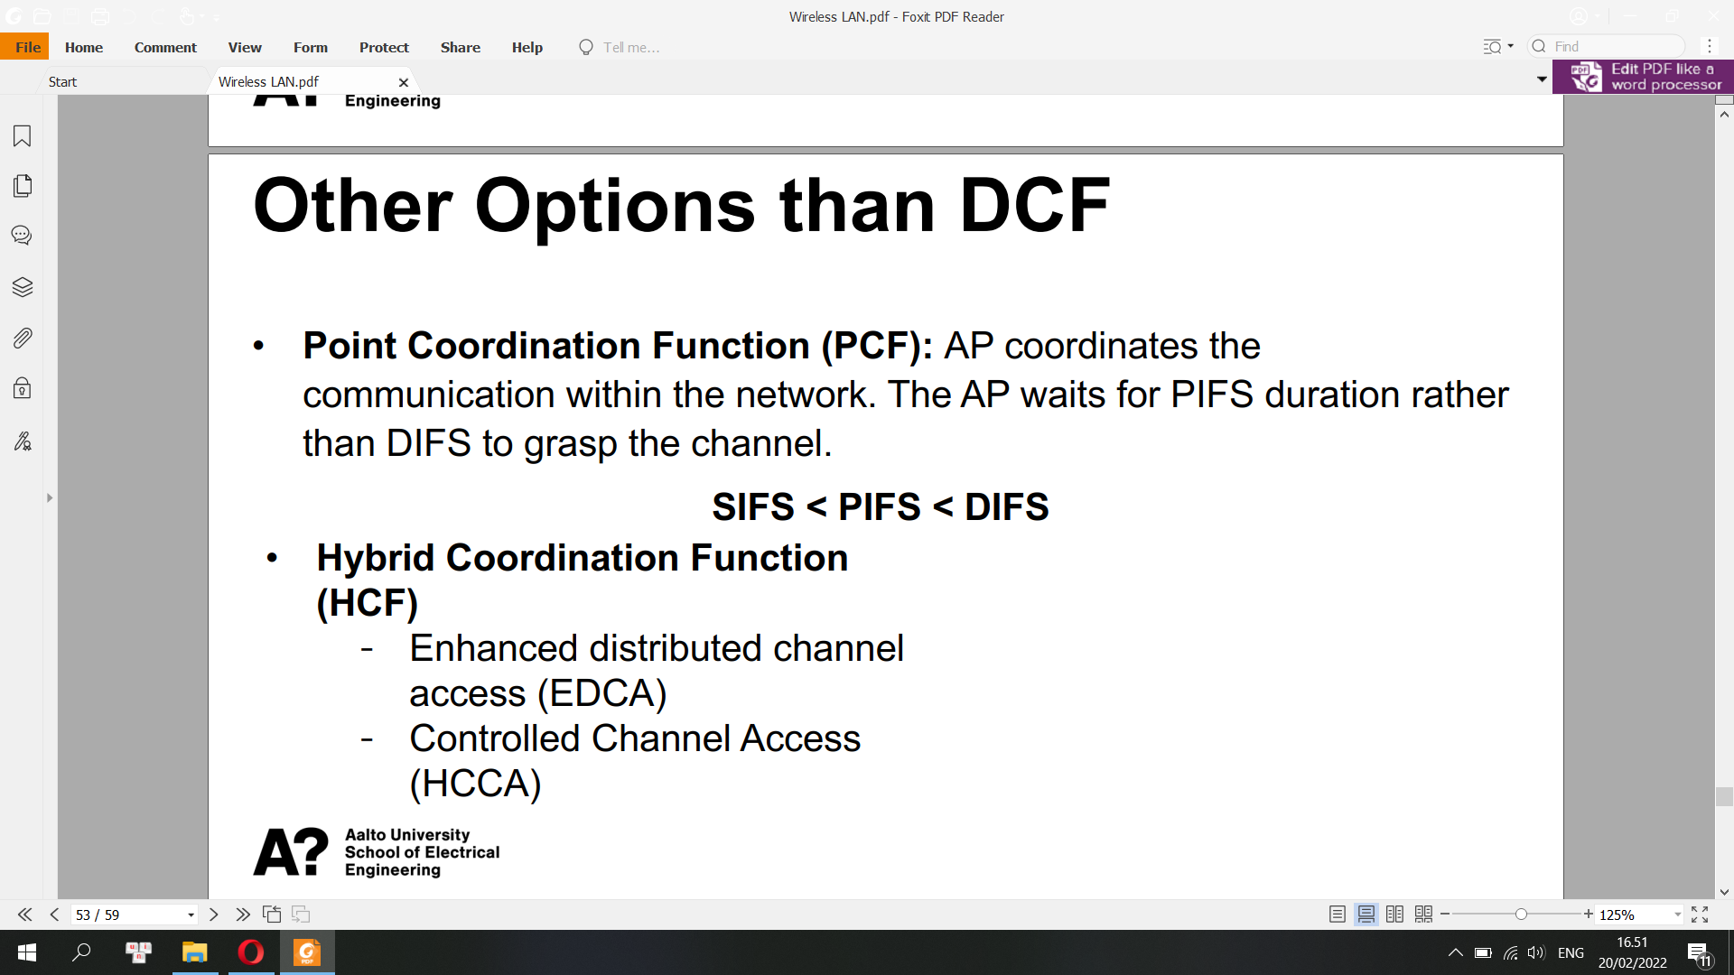

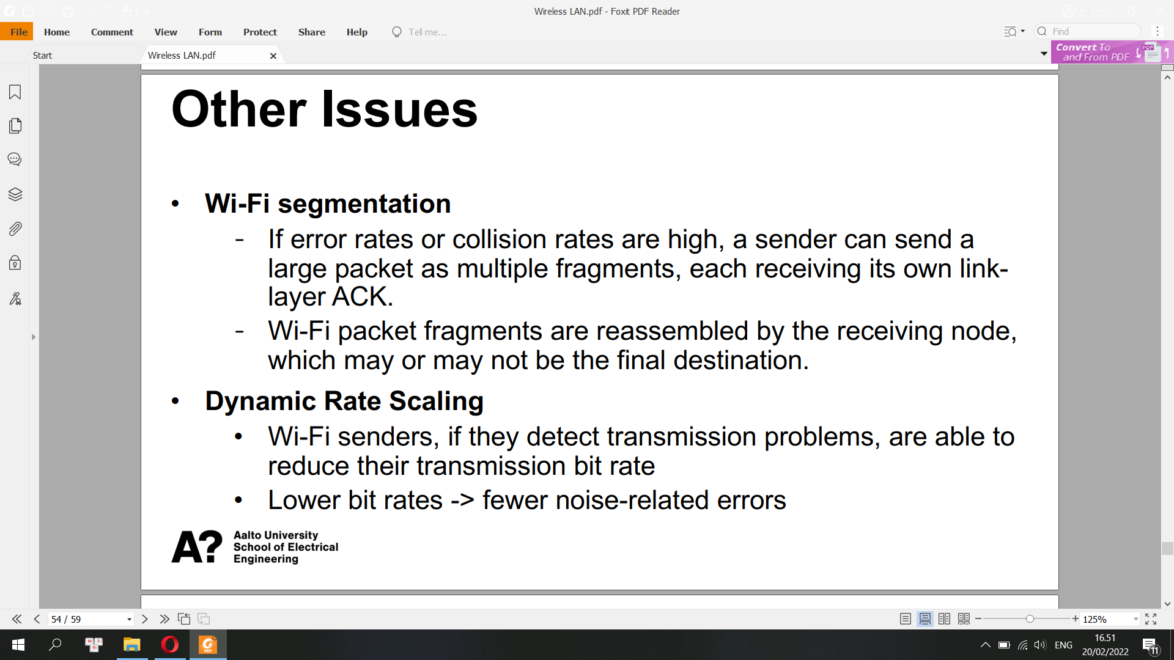

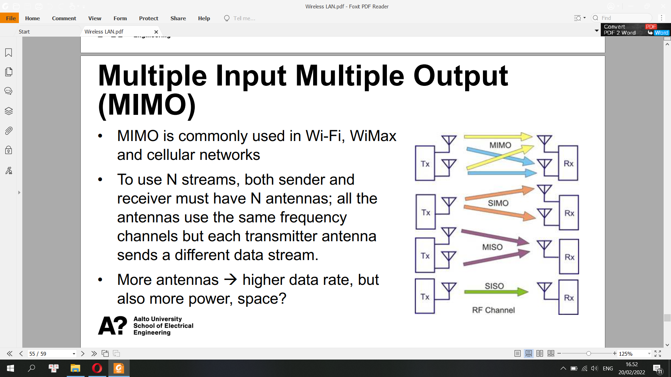

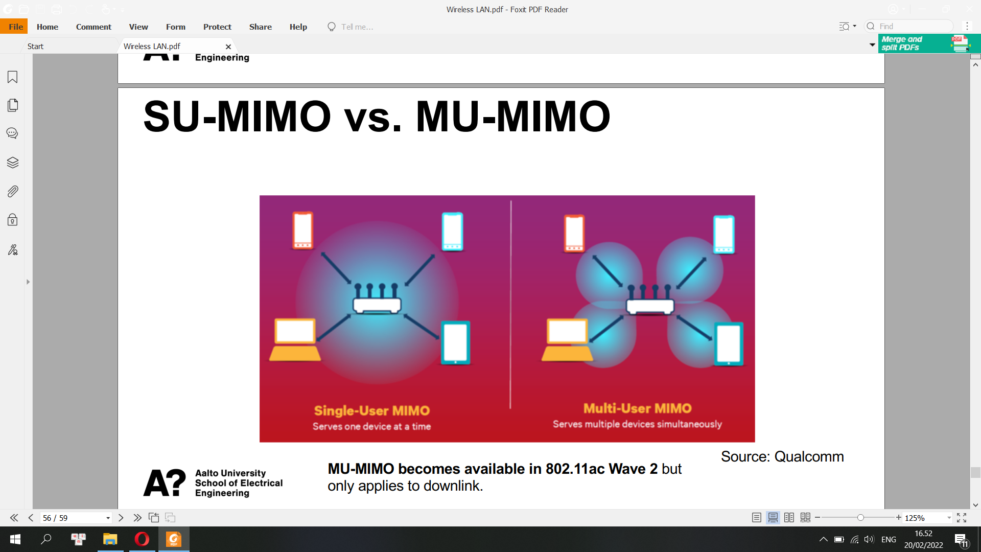

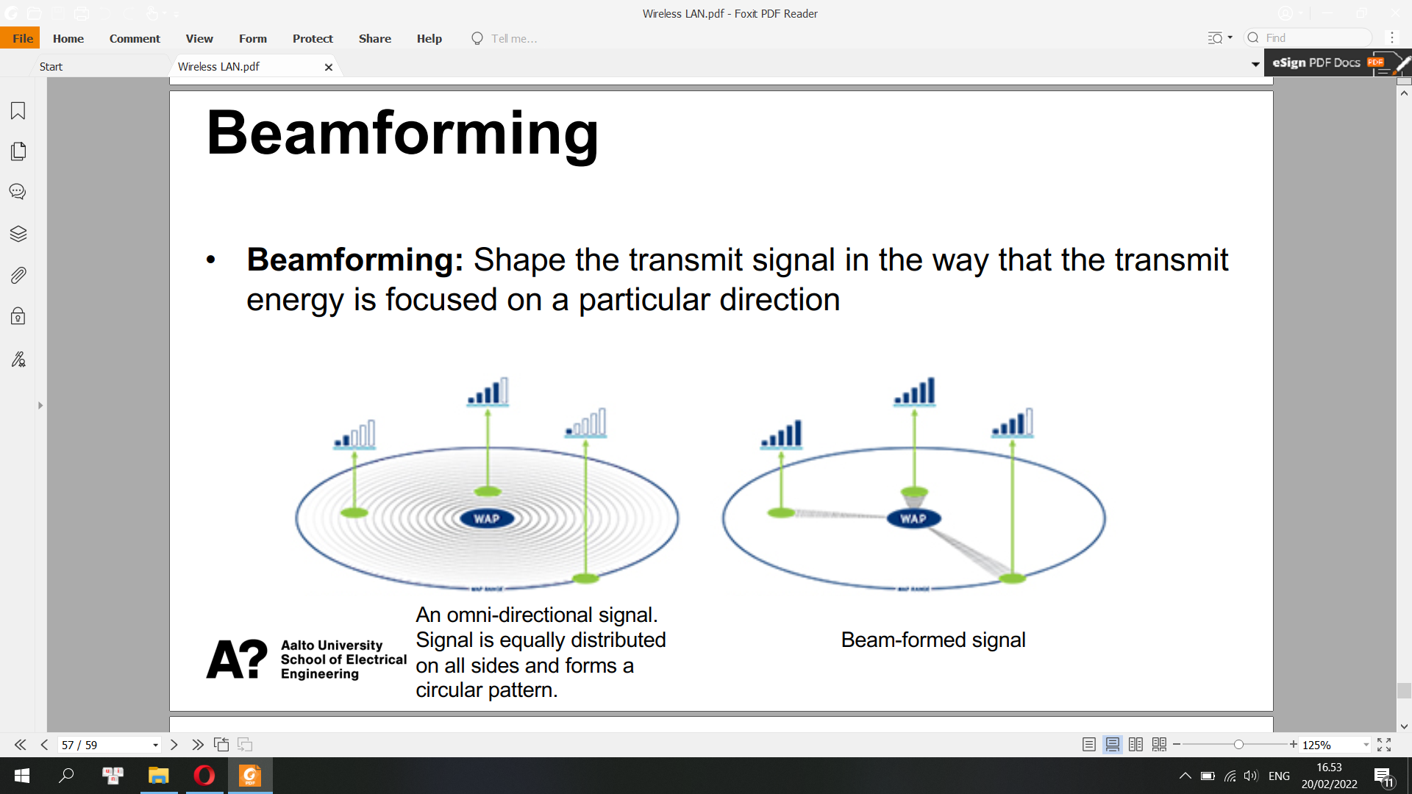

Beamforming uses antenna arrays to dynamically alter the transmission pattern of the AP, and the transmission pattern can be changed on a per-frame basis.

**Self-test: Wireless LAN**

**• What is frequency, wavelength and amplitude of RF wave? What is the relationship between frequency and wavelength?**

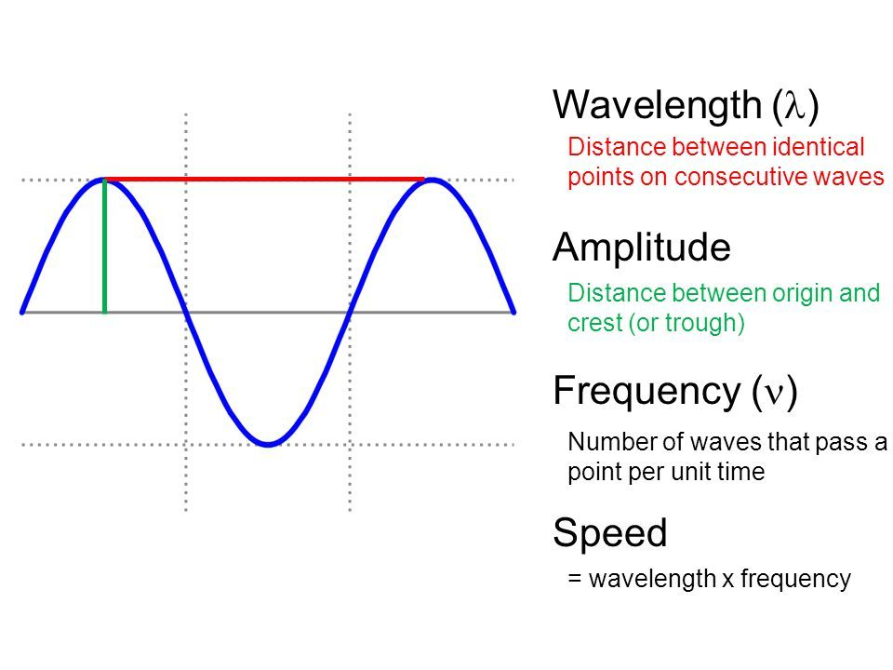

**• Does higher frequency mean higher or lower data rate? Does it mean larger or smaller coverage?**

Higher frequency means higher data rate and larger bandwidth/coverage

**• In case of Wi-Fi, what is BSS? What is beacon used for? How does active scanning work? How to associate with a Wi-Fi AP?**

Basic Service Set (BSS), as the name suggests, is basically a network topology that allows all wireless devices to communicate with each other through a common medium i.e. AP (Access point). It also manages these wireless devices or clients. It basically provides a building block to all wireless LAN (Local Area Network). BSS basically contains only one AP that is connected to all stations i.e. all wireless devices within the network. Here, AP is a common access point that acts as a medium and creates WLAN (Wireless Local Area Network).

AP allows all wireless devices to get connected to a wired network and start communicating with each other. Therefore, AP is considered a master that controls all wireless devices or stations with BSS or WLAN. BSS contains only one AP, but it may contain one or more stations. BBS is generally considered simplest if it contains one AP and one station. Before connecting to a wireless network, wireless device or station need to send an association request to AP and then AP checks whether the client fit any of the following criteria or not

- beacon: check above

- active scanning: A client can use two scanning methods: active and passive. During an active scan, the client radio transmits a probe request and listens for a probe response from an AP. With a passive scan, the client radio listens on each channel for beacons sent periodically by an AP.

- Wifi-AP association:

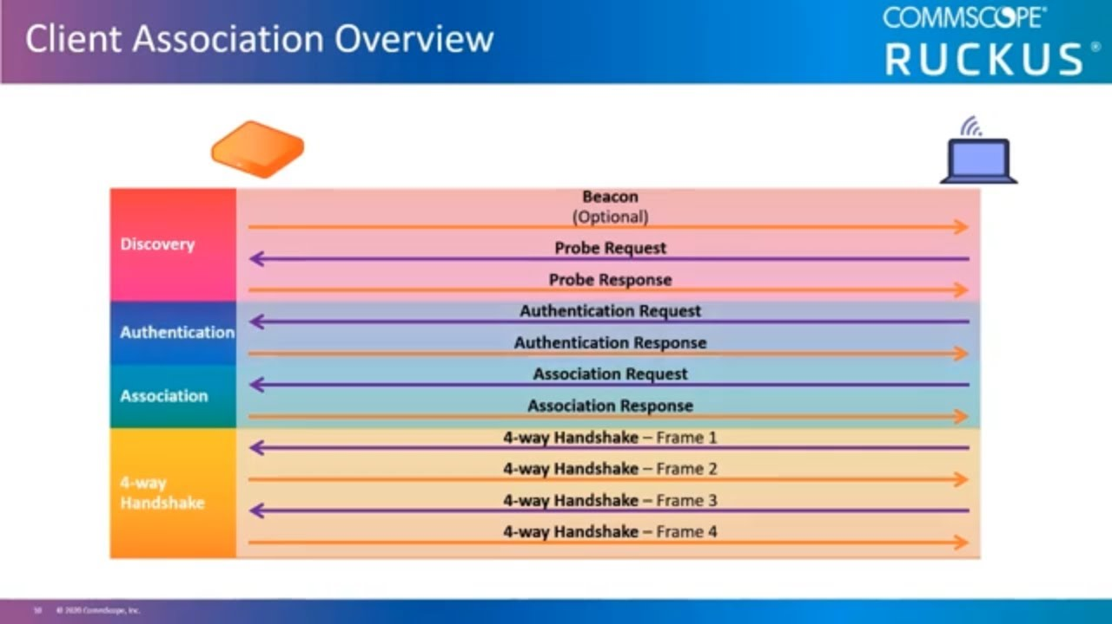

**• What is hidden node problem?: check above**

**• Is Wi-Fi half-duplex or hall-duplex? If you can explain how CSMA/CA work, that is even better**

WiFi is a half duplex form of data transmission, which is to say, data packets are sent back and forth in sequence. It happens so quickly that it mimics seamless, two-way data transmission, but in fact, data cannot be both sent and received simultaneously.  
Collision Avoidance (CSMA/CA) avoids collisions by listening for a transmission signal before sending data. If a signal is detected, the sender starts a counter with a random value and then waits. Once this counter runs down, the sender will try again. This process repeats until the sender can send the data.   
CSMA/CA is used with Wifi and it's useful. Since "air" is generally a shared medium, no two stations must transmit simultaneously.

=> Wifi is half duplex due to CSMA/CA

**• SIFS is always shorter than the DIFS. Do you know why?**

DIFS = distributed inter frame spacing, a new transmission can begin only after DIFS

of idle time. PIFS = spacing after which point coordinator can take over. SIFS = spacing between transmission and ACK, between polling and response.

Having PIFS < DIFS allows point coordinator to take over and separate contention-free and contention periods. Having SIFS smaller than both PIFS and DIFS prevents ACK and important

control packets from getting killed.

=> SIFS is always shorter than DIFS

**• Impact of the size of contention window?**

Contention Window – It is the amount of time divided into slots.A station which is ready to send frames chooses random number of slots as wait time.

The intention with different priority classes is to use a smaller contention window to get faster access to the channel for high-priority traffic while low-priority traffic uses a larger contention window, increasing the likelihood of high-priority data being transmitted before low-priority data.

1. Carrier Sense Multiple Access with Collision Detection (CSMA/CD) –

In this method, a station monitors the medium after it sends a frame to see if the transmission was successful. If successful, the station is finished, if not, the frame is sent again.

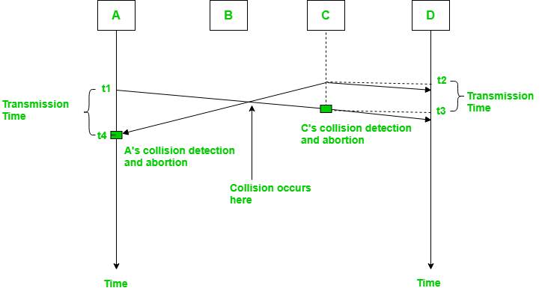

In the diagram, A starts send the first bit of its frame at t1 and since C sees the channel idle at t2, starts sending its frame at t2. C detects A’s frame at t3 and aborts transmission. A detects C’s frame at t4 and aborts its transmission. Transmission time for C’s frame is therefore t3-t2 and for A’s frame is t4-t1 .

So, the frame transmission time (Tfr) should be at least twice the maximum propagation time (Tp). This can be deduced when the two stations involved in collision are maximum distance apart.

Process –

The entire process of collision detection can be explained as follows:

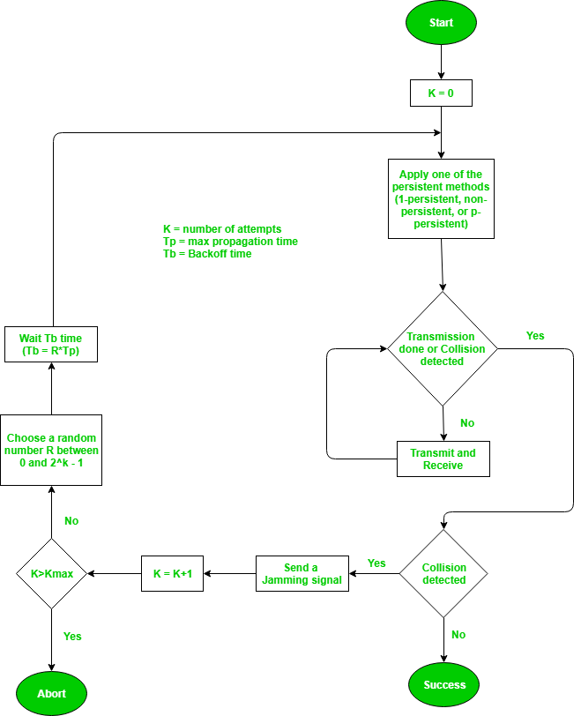

Throughput and Efficiency – The throughput of CSMA/CD is much greater than pure or slotted ALOHA.

For 1-persistent method throughput is 50% when G=1.

For non-persistent method throughput can go upto 90%.

2. Carrier Sense Multiple Access with Collision Avoidance (CSMA/CA) –

The basic idea behind CSMA/CA is that the station should be able to receive while transmitting to detect a collision from different stations. In wired networks, if a collision has occurred then the energy of received signal almost doubles and the station can sense the possibility of collision. In case of wireless networks, most of the energy is used for transmission and the energy of received signal increases by only 5-10% if a collision occurs. It can’t be used by the station to sense collision. Therefore CSMA/CA has been specially designed for wireless networks.

These are three types of strategies:

InterFrame Space (IFS) – When a station finds the channel busy, it waits for a period of time called IFS time. IFS can also be used to define the priority of a station or a frame. Higher the IFS, lower is the priority.

Contention Window – It is the amount of time divided into slots.A station which is ready to send frames chooses random number of slots as wait time.

Acknowledgments – The positive acknowledgments and time-out timer can help guarantee a successful transmission of the frame.

Process –

The entire process for collision avoidance can be explained as follows:

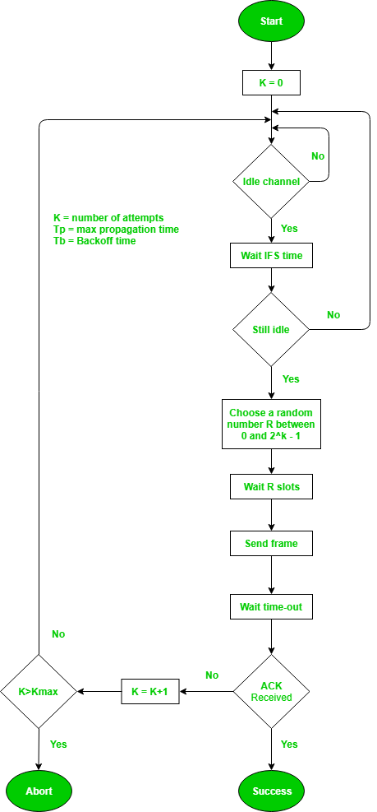

**Internet Protocol (IP)**

**IP Addresses**

• An IP address identifies a host or network interface on a network, and provides the location of the host in the network

• Each device that wants to communicate with other devices on a TCP/IP network needs to have an IP address configured

In contrast to MAC address, an IP address is a logical address. It can be configured manually or obtained from a DHCP (Dynamic Host Configuration Protocol) server

An IPv4 address consists of 4 octets (32 bits)

[ octet ] . [ octet ] . [ octet ] . [ octet ]

1000 1000.1110 0011.1110 1101.0110 1000 à 136.227.237.104

• Each number can be 0 to 255

Number of IPv4: 4 otctets: 4 x 8 = 32 bits

=> 2^32 different IPv4 addresses = 4,294,967,296

DHCP (Dynamic Host Configuration Protocol): The Dynamic Host Configuration Protocol is a network management protocol used on Internet Protocol networks for automatically assigning IP addresses and other communication parameters to devices connected to the network using a client–server architecture

• Subnetting: dividing a network into two or more smaller networks.

• Purposes of subnetting

Reducing the size of the broadcast domain

Increasing routing efficiency

Enhancing the security of the network

IPv4 Subnet Mask

• An IP address is divided into two parts: network and host parts.

• Subnet mask is used for determining the network part and the host part of an IP address.

• A subnet mask consists of 32 bits. The 1s in the subnet mask represent a network part, the 0s a host part.

• A subnet mask must always be a series of 1s followed by a series of

0s. E.g. 255.255.0.0, 255.0.0.0.

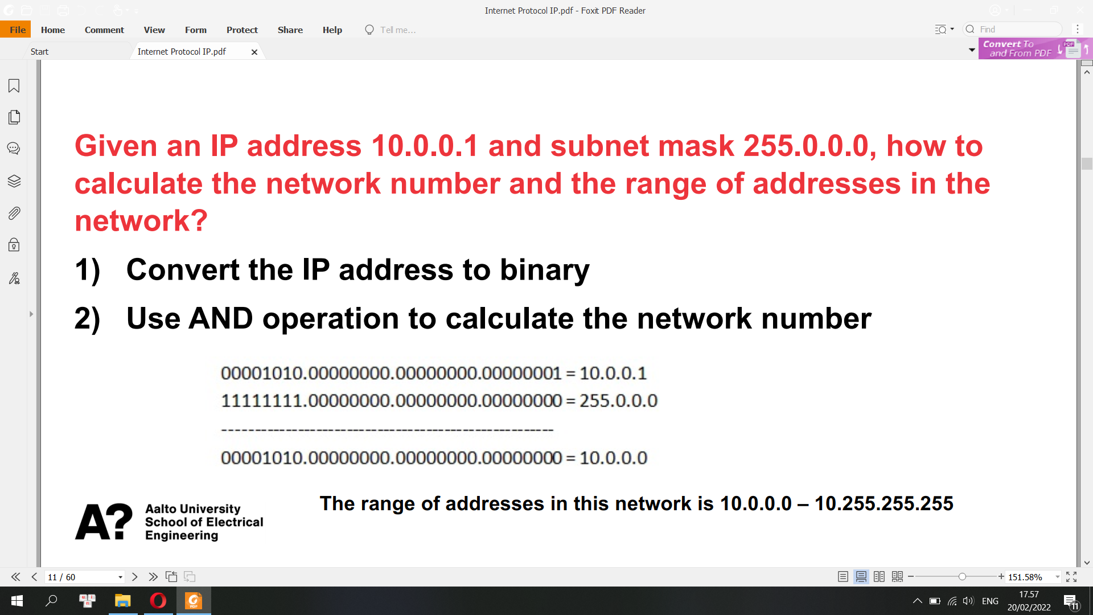

Classless Inter-Domain Routing (CIDR or supernetting) is a way to combine several class-C address ranges into a single network or route. This method of routing adds class-C Internet Protocol (IP) addresses. These addresses are given out by Internet Service Providers (ISPs) for use by their customers

VLSM stands for Variable Length Subnet Mask where the subnet design uses more than one mask in the same network which means more than one mask is used for different subnets of a single class A, B, C or a network. It is used to increase the usability of subnets as they can be of variable size

CIDR is based on variable-length subnet masking (VLSM) to allow allocation and routing based on arbitrary-length prefixes

**Special Addresses**

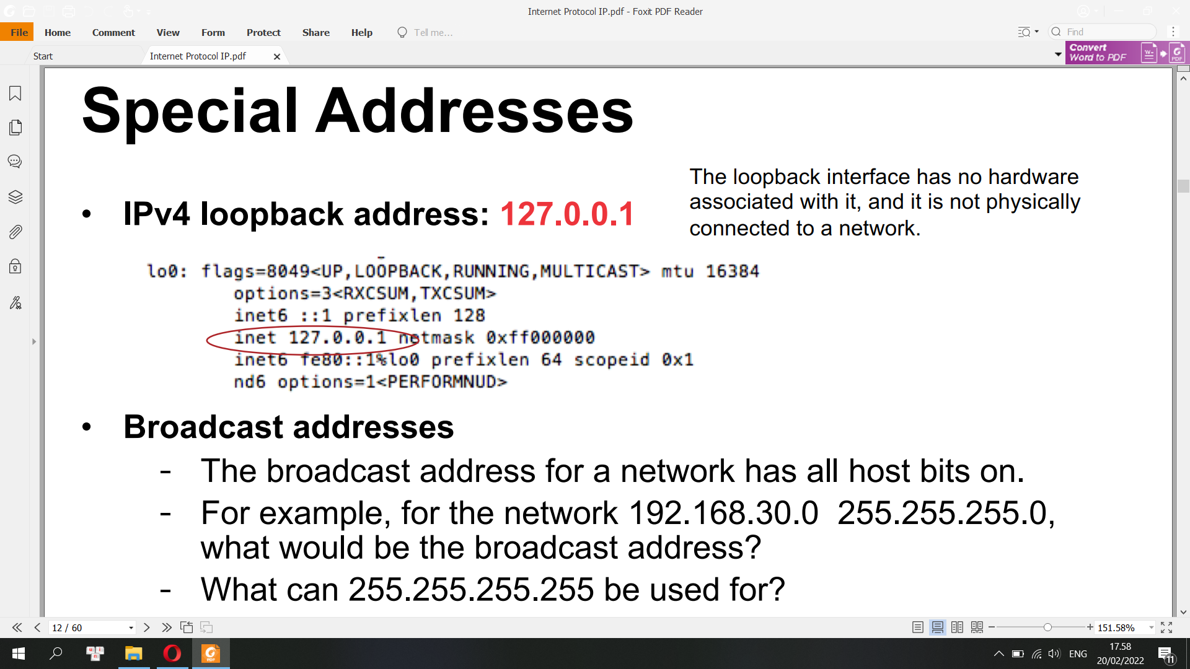

Classes of IPv4 addresses:

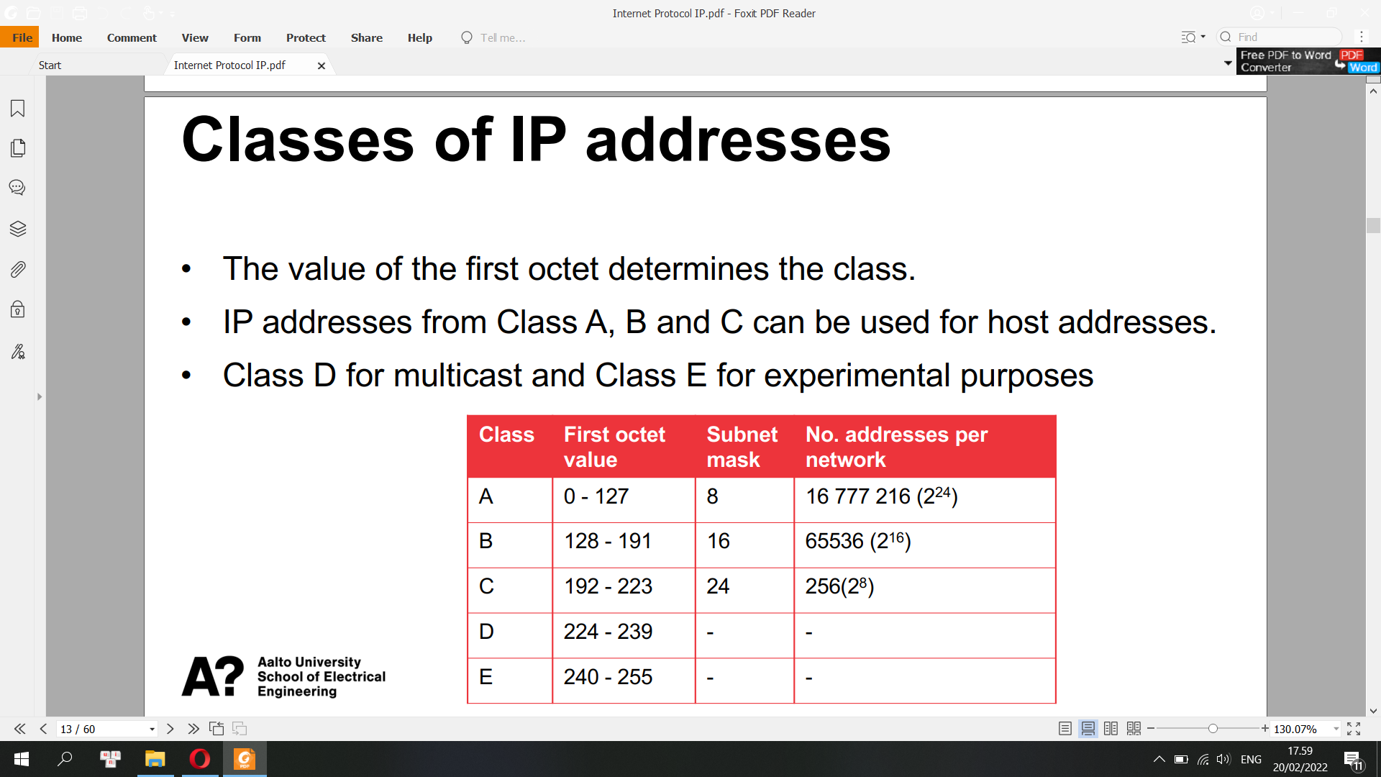

Prefix

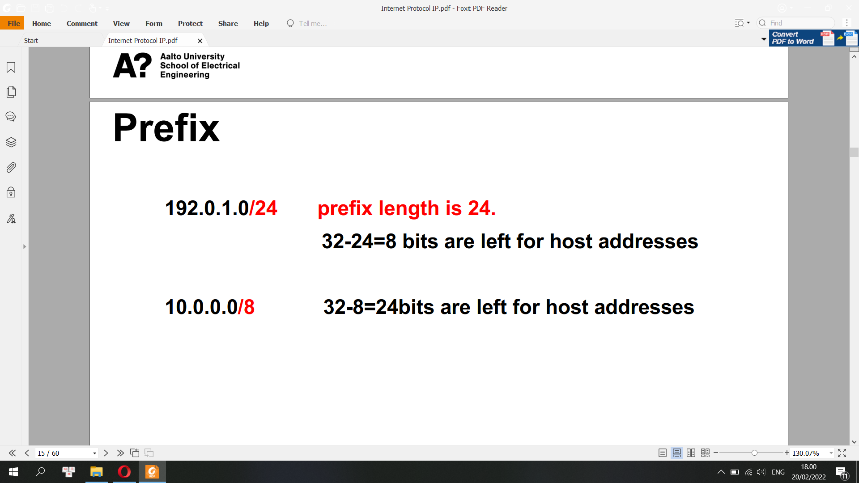

IP address: 136.227.237.104/27

What is the subnet mask?

255.255.255.224, where 224 = 11100000

Number of useable IPv4 host addresses

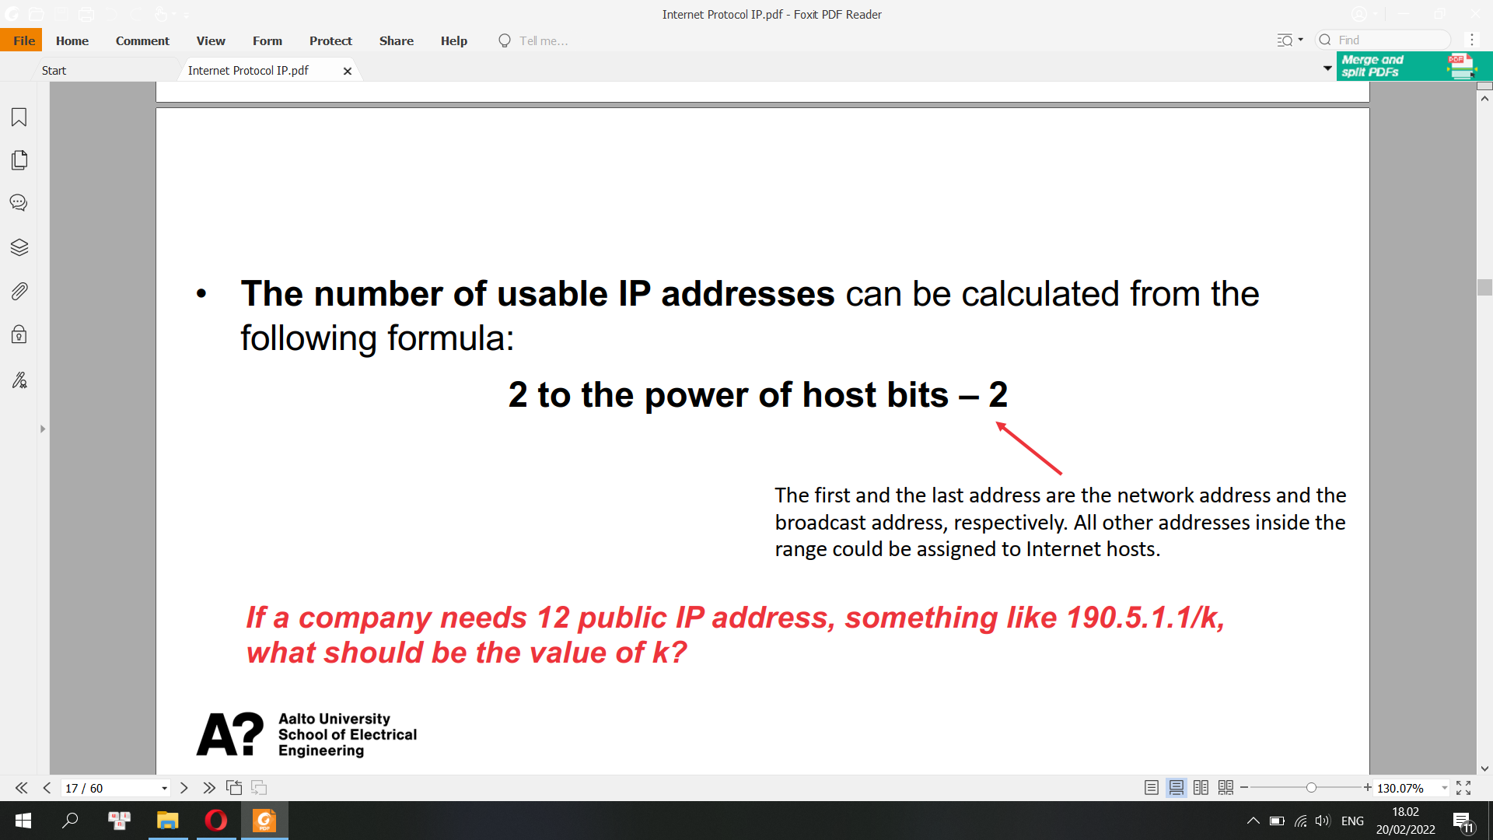

Private Addresses

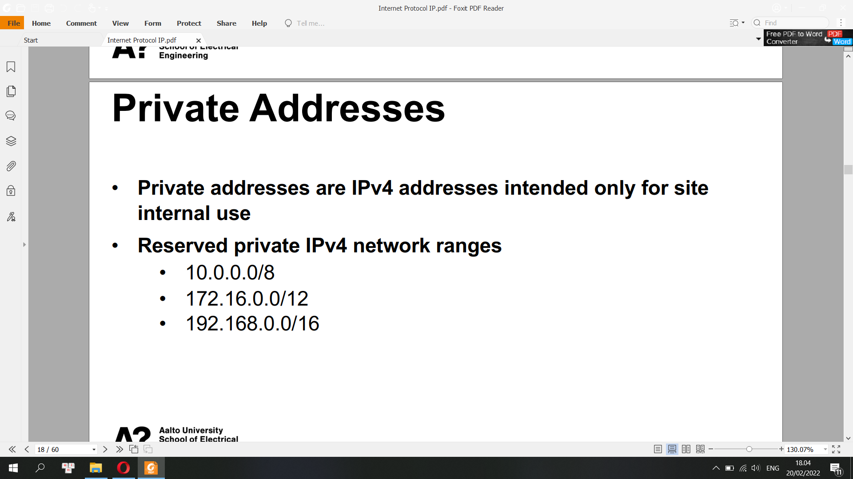

**IPv4 Header**

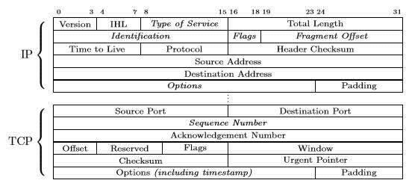

Version: IP version field, set to 4 for IPv4.

Internet Header Length

IHL is the number of 32-bit words making up the header field. The minimum available number is 5, as the first 20 bytes are mandatory.

Differentiated Services Code Point (DSCP). It specifies the type of service for differentiated services, such as voice over IP.

Explicit Congestion Notification (ECN)

When supported, ECN carries a network congestion notification without dropping packets or wasting bandwidth.

Total Length

It’s the total size of the datagram, including both header and data parts.

Identification

It’s mainly used to indicate a group of fragments if the datagram is fragmented.

Flags

Different combinations of the flags control the fragmentation and indicate fragmented datagrams.

We assume the don’t fragment flag is set when the destination can’t assembly the fragmented packet. Therefore, the packet is dropped if the flags mark the datagram as not to be fragmented, but it must be.

Fragment Offset

It contains the offset of a fragmented packet.

Time to Live (TTL)

The number of hops a packet lives. Each router on the way decrements the TTL field. If it reaches 0, the packet is discarded. This way, looping packets are eliminated.

Protocol

It’s the protocol for the data part like TCP or UDP.

Protocol: identifies the content of the packet body

1: an ICMP packet

4: an encapsulated IPv4 packet

6: a TCP packet

17: a UDP packet

41: an encapsulated IPv6 packet

50: an encapsulating security payload

Header Checksum

It’s a checksum for error detection, covering only the header field. Each router checks this value and discards the packet if an error is detected.

The data part’s checksum is not calculated.

Source Address

Source host IPv4 address.

Destination Address

Destination host IPv4 address.

Options

Additional options are stored in this field when present.

**IPv6 addresses**

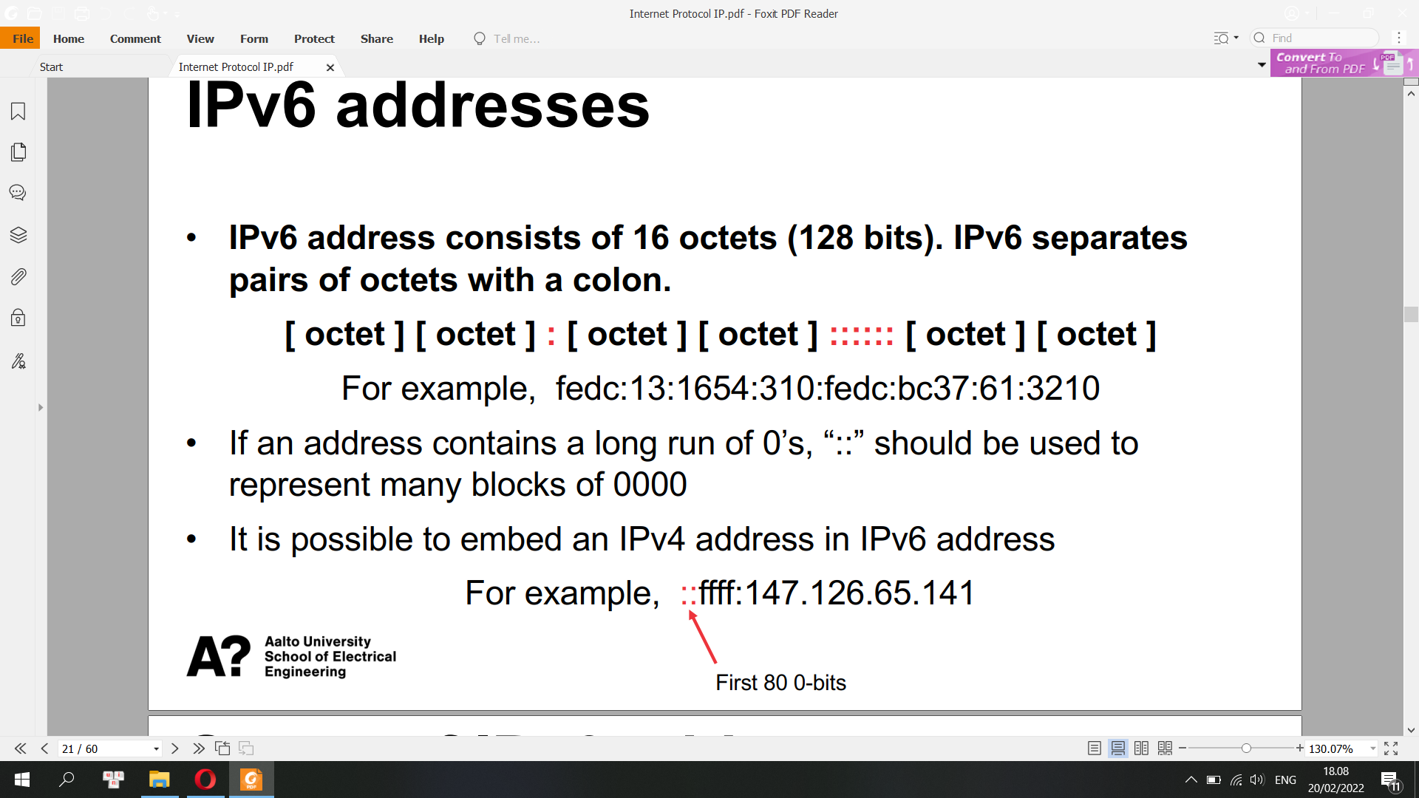

Number of IPv6: 16 octet: 4 x 16 = 128 bits

=> 2^128 different IPv6 addresses = 340,282,366,920,938,463,463,374,607,431,768,211,456

**Scope of IPv6 addresses**

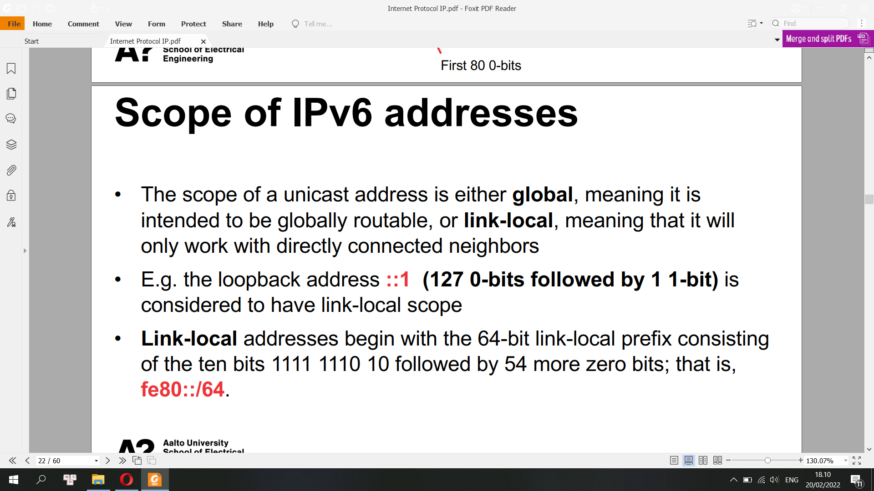

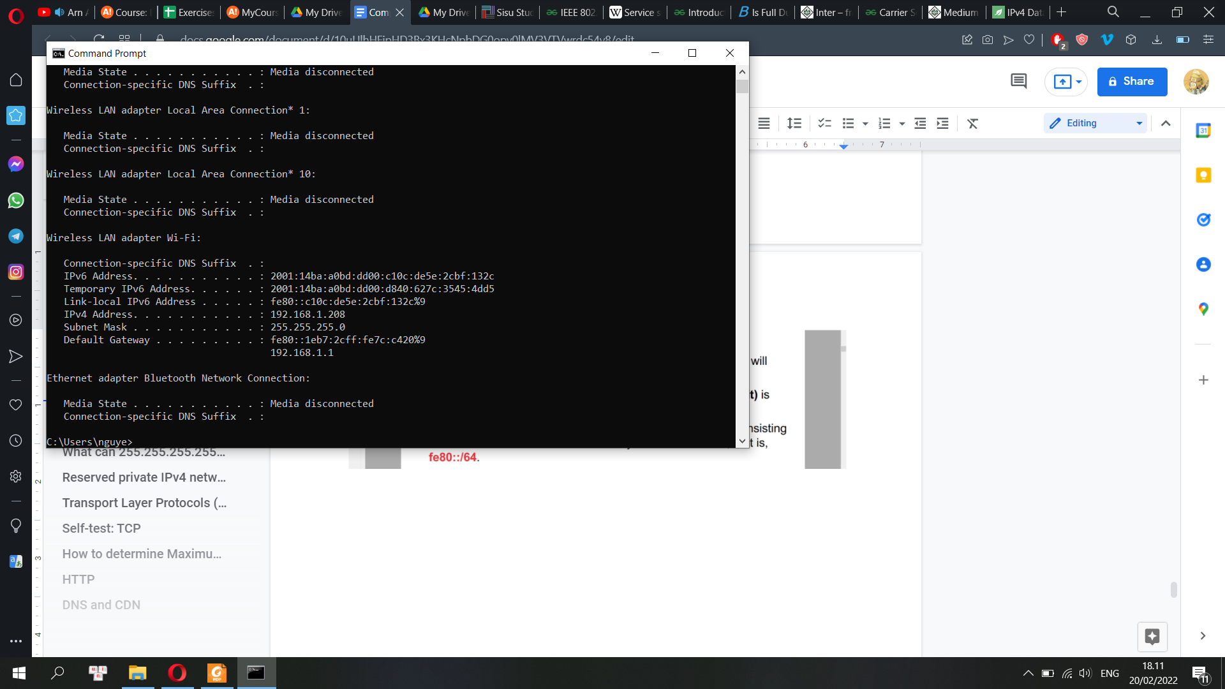

where % sign is the scope id

Predefined and Reserved Scopes

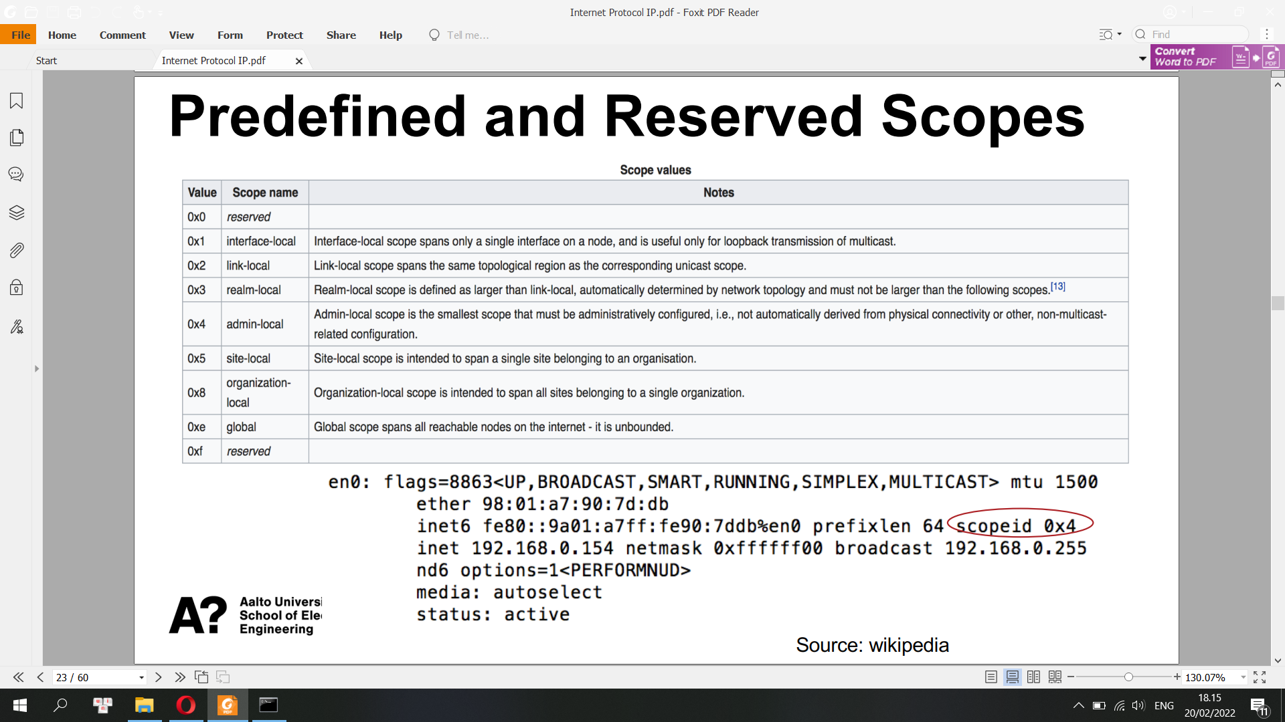

IPv6 Interface Identifier

• Most IPv6 addresses can be divided into a 64-bit network prefix

and a 64-bit “host” portion. These host-portion bits are known

officially as the interface identifier

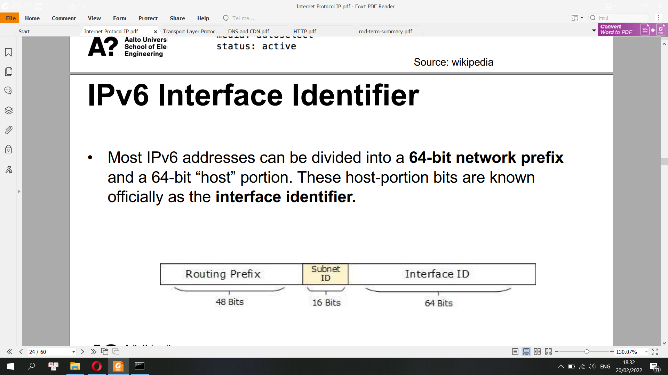

AnyCast

IPv6 has introduced Anycast mode of packet routing. In this mode,

multiple interfaces over the Internet are assigned same Anycast IP

address. Routers, while routing, send the packet to the nearest

destination.

IPv6 does not support broadcast

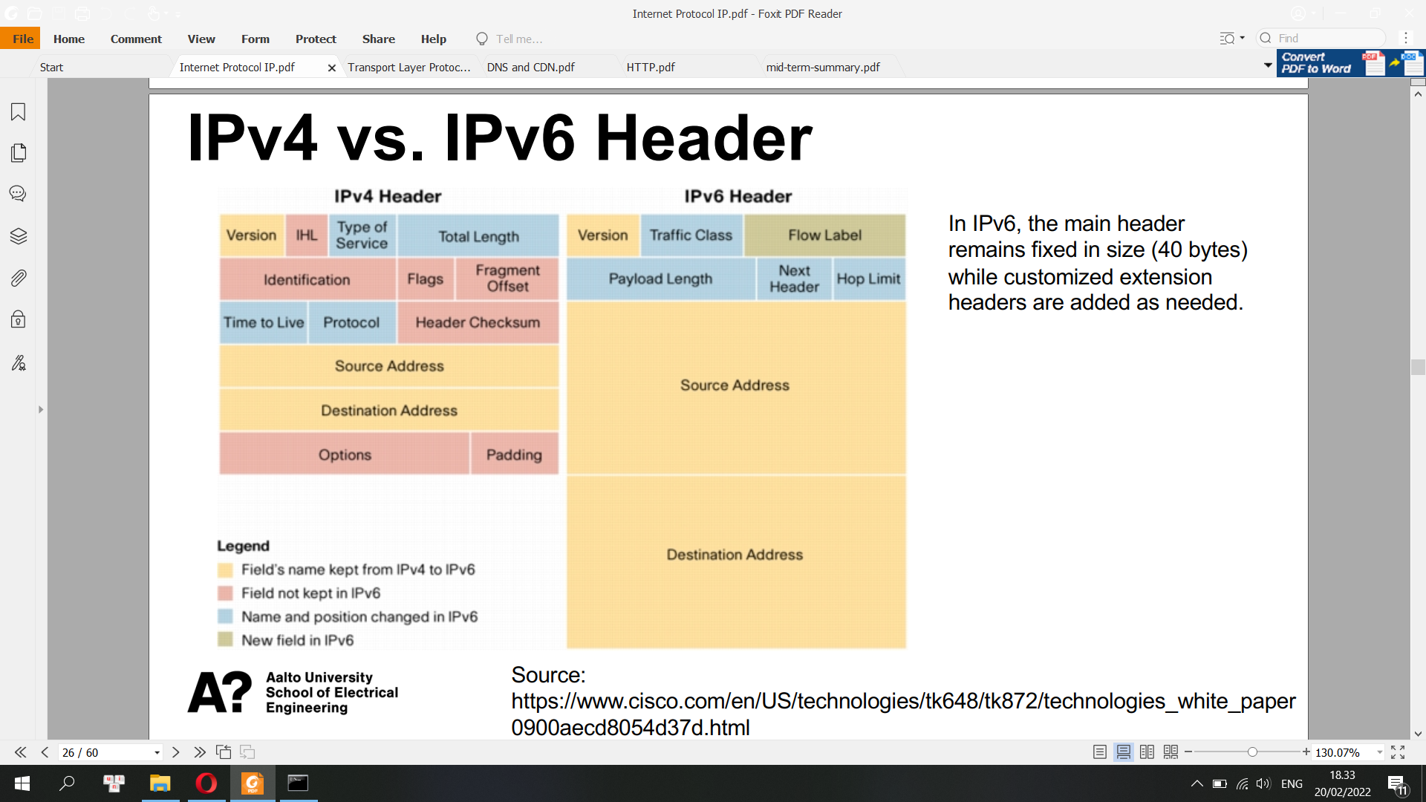

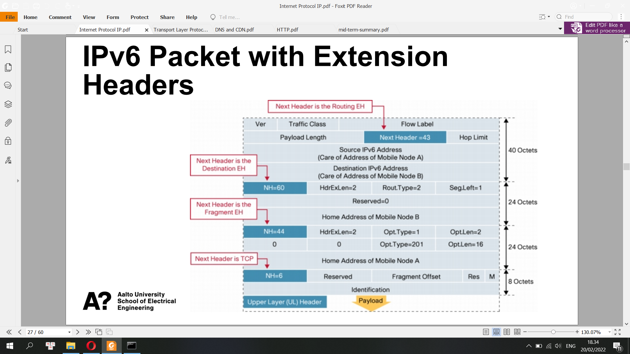

**IP Routing**

IP routing is the process of sending packets from a host on one network to another host on a different remote network. This process is usually done by routers

Router vs Switch vs Hub

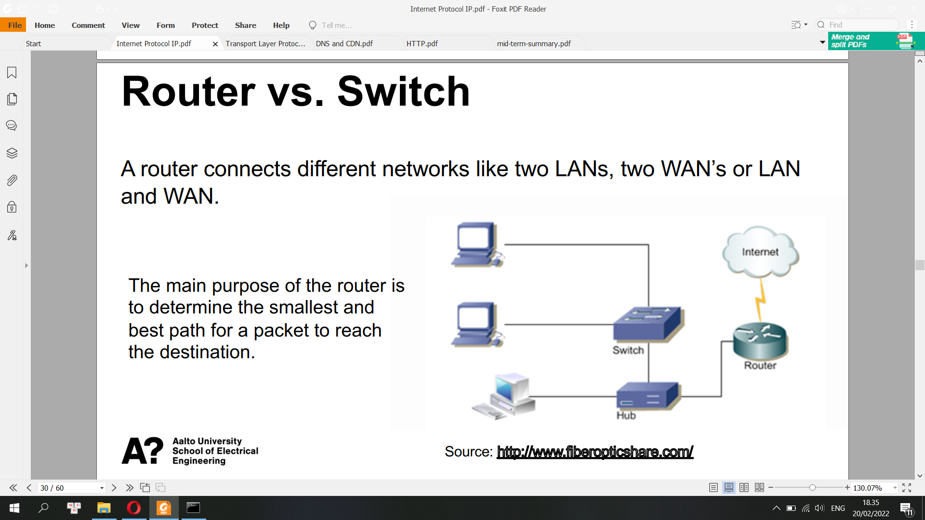

IP Routing

• Routers examine the destination IP address of a packet , determine the next-hop address, and forward the packet.

• Routers use routing tables to determine a next hop address to which the packet should be forwarded.

Port forwarding

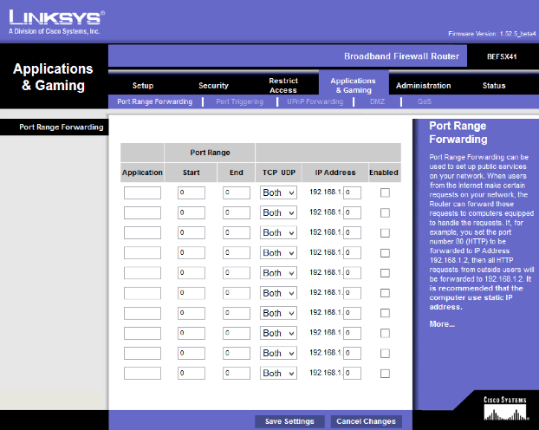

Routing Table

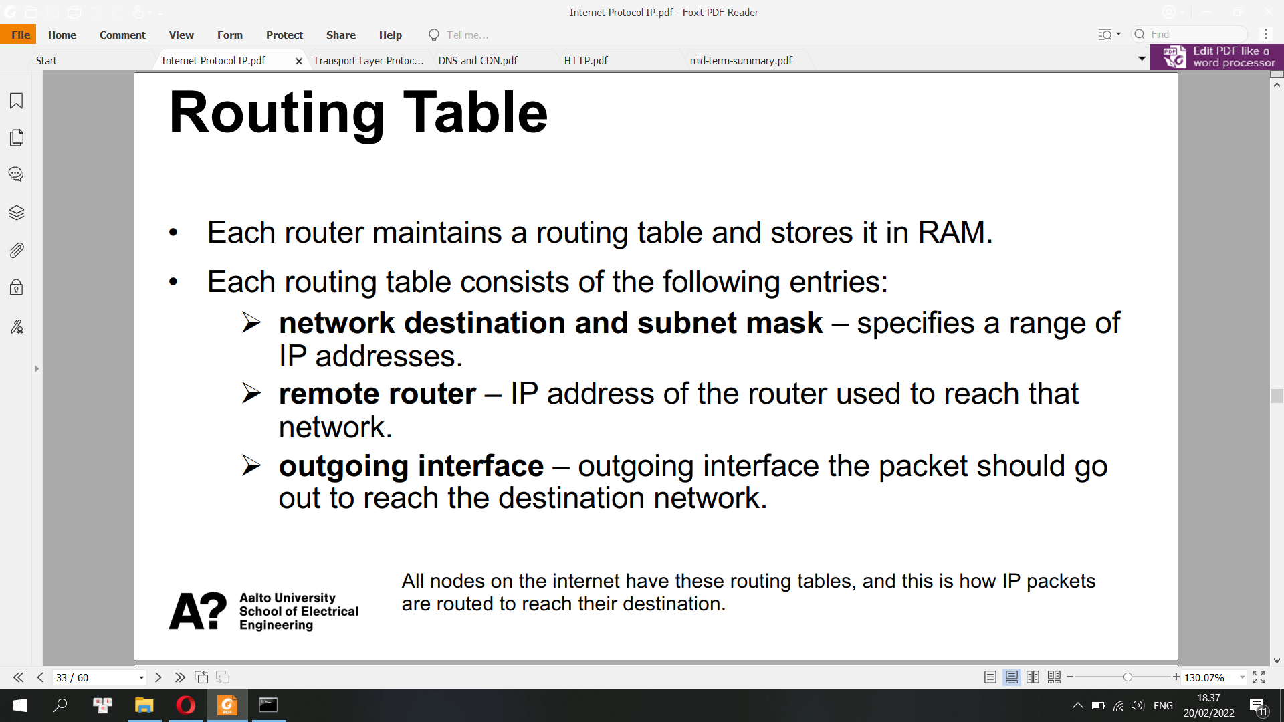

Default Gateway

A default gateway is the node in a computer network using the Internet protocol suite that serves as the forwarding host (router) to other networks when no other route specification matches the destination IP address of a packet.

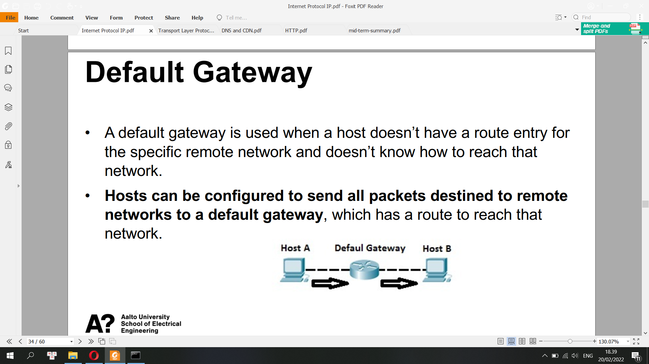

**Address Resolution Protocol (ARP)**

The Address Resolution Protocol (ARP) is a communication protocol used for discovering the link layer address, such as a MAC address, associated with a given internet layer address, typically an IPv4 address. This mapping is a critical function in the Internet protocol suite.

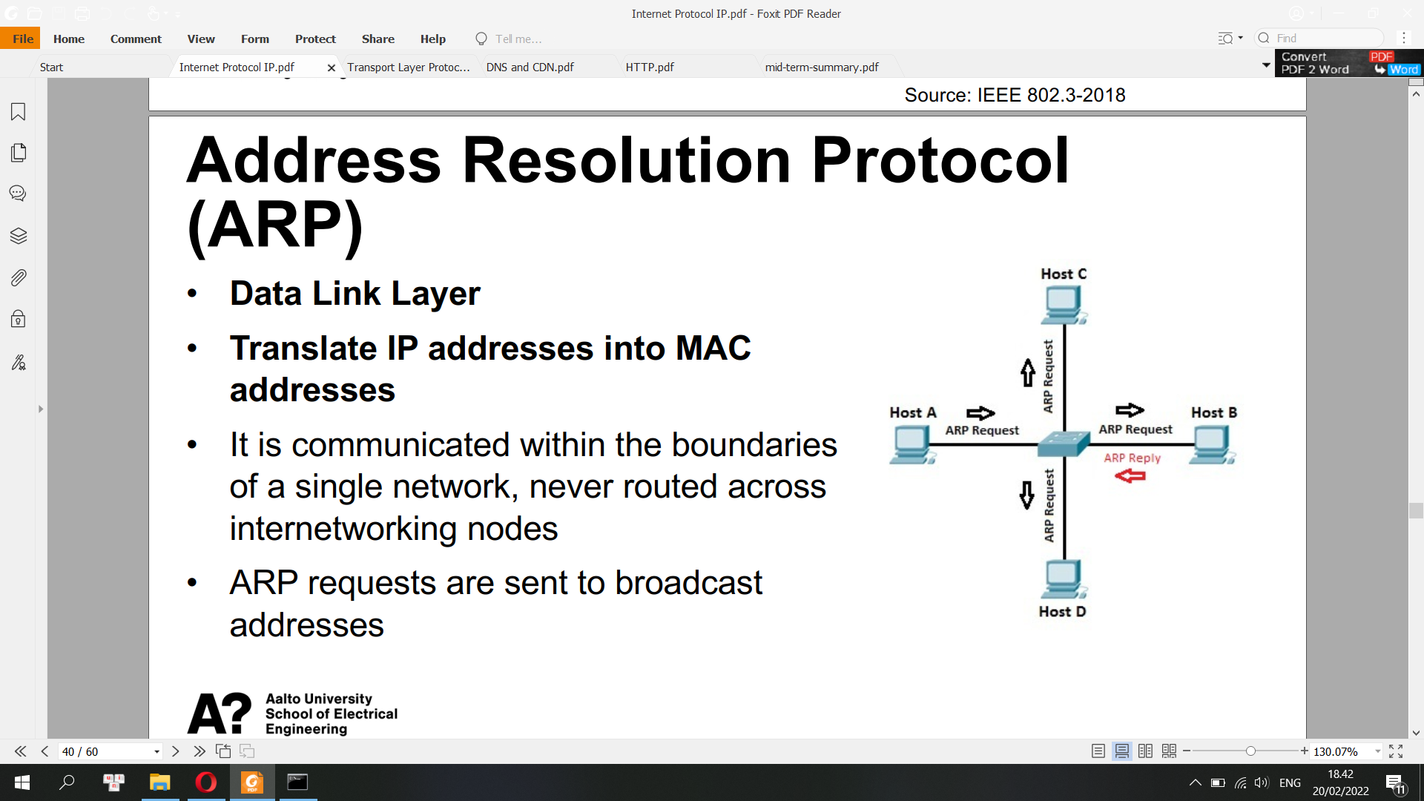

ARP caches

• All operating systems maintain ARP caches that are checked before

sending an ARP request message.

• The addresses will stay in the cache for a couple of minutes.

• Command line %arp -a

**Process of IP Routing**

**Host 1:**

1) Create an IP packet with its own IP address (192.168.1.1) as the source, and H2 (192.168.2.2) as the destination

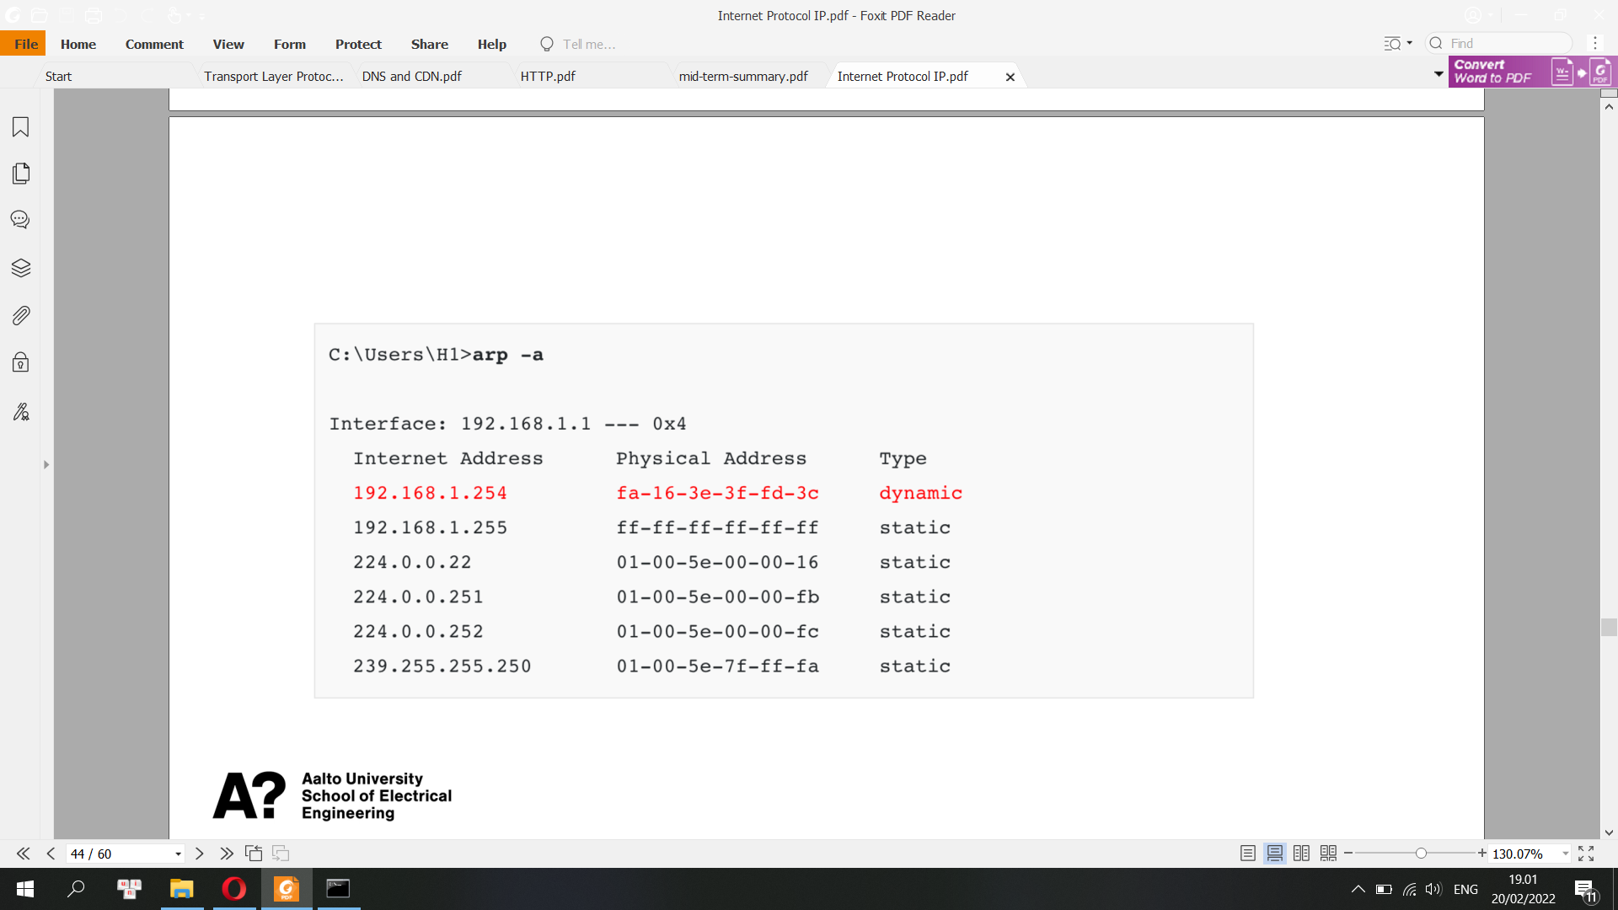

2) Check if the destination is local or remote (e.g. check own IP, subnet mask, destination IP)

3) Build an Ethernet frame, enter its own source MAC address, and check the destination MAC address of the default gateway

4) Send an ARP request if MAC address is not known. After that, form an Ethernet frame that carries an IP packet and send it to Router 1

**Router 1:**

1) Check if FCS (Frame Check Sequence) of the Ethernet frame is correct or not. If FCS is incorrect, the frame is dropped.

2) If FCS is correct, check if the destination MAC address is

• The address of the interface of the router, or

• A broadcast address of the subnet that the router interface is connected to, or

• A multicast address that the router listens to

3) If MAC address matches in previous step, de-encapsulate the IP packet out of the Ethernet frame

4) Check if the header checksum of the IP packet is correct. If not, drop the IP packet.

5) Check its routing table to see if there is a match for the destination IP address

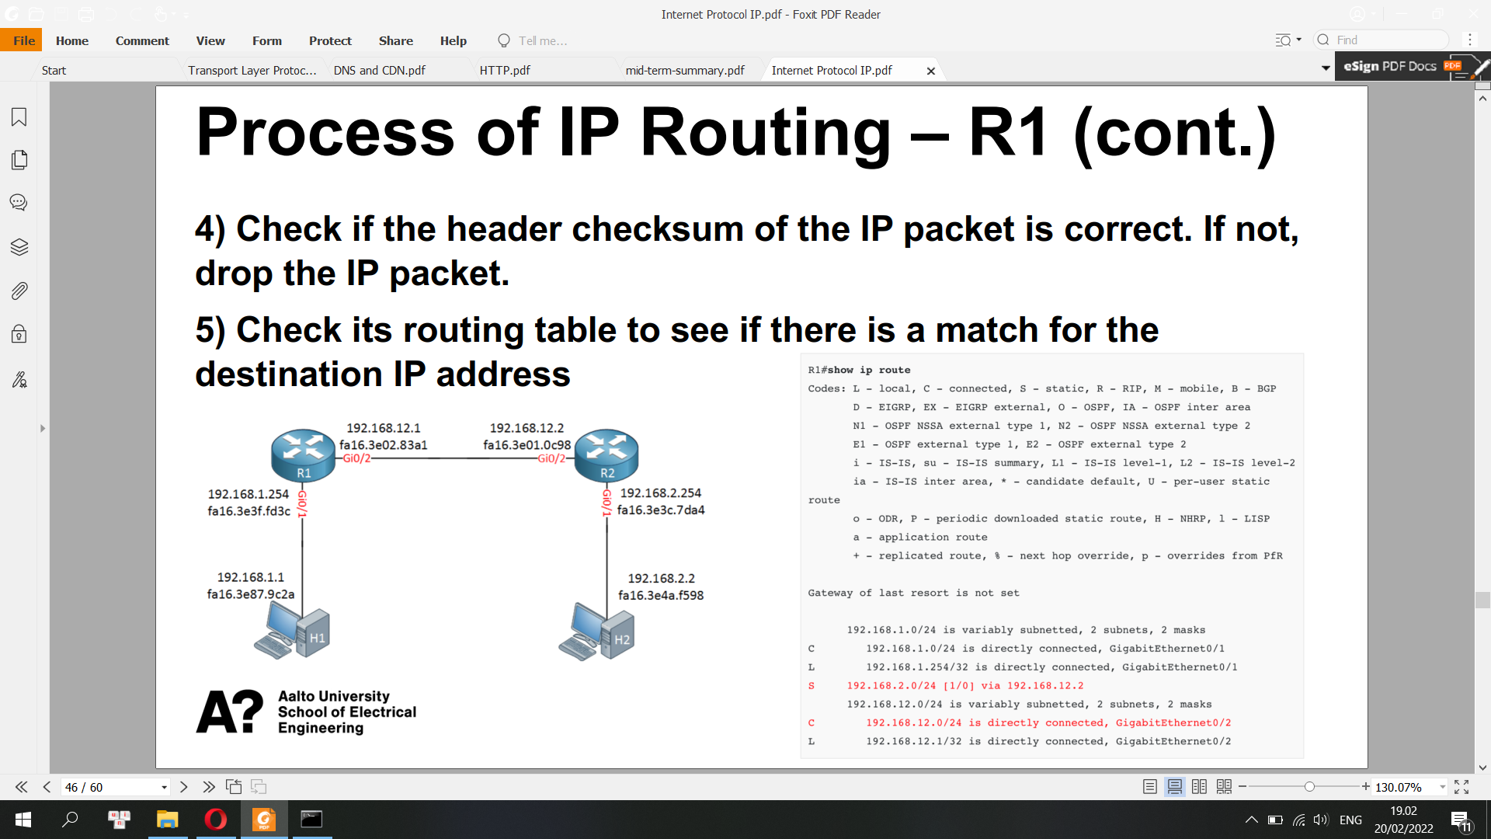

6) Decrease the TTL field by one and recalculate the header checksum

7) Check its ARP table to see if there is an entry for 192.168.12.2. If not, send an ARP req

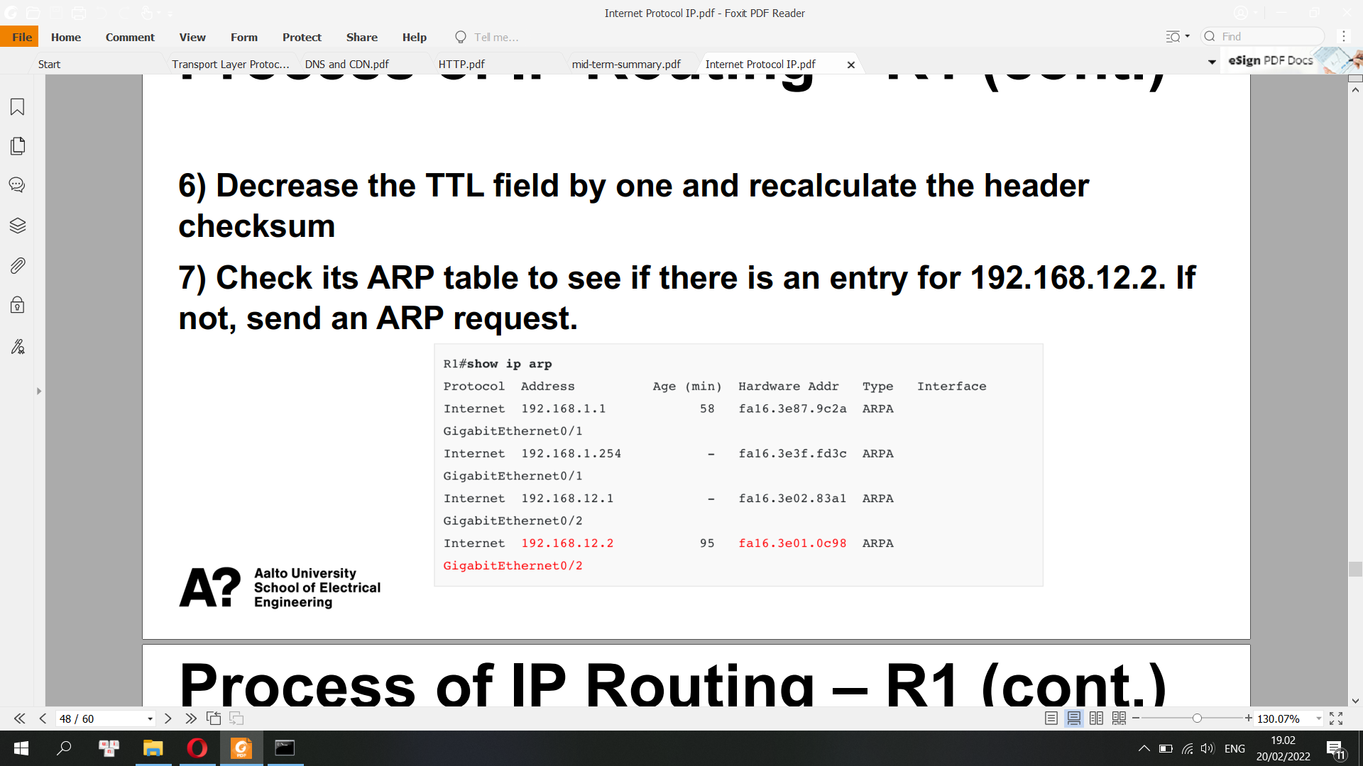

8) Build a new Ethernet frame with its own MAC address of Gi0/2 as source and R2 as the destination. Encapsulate the IP packet into the new Ethernet frame

**Router 2:**

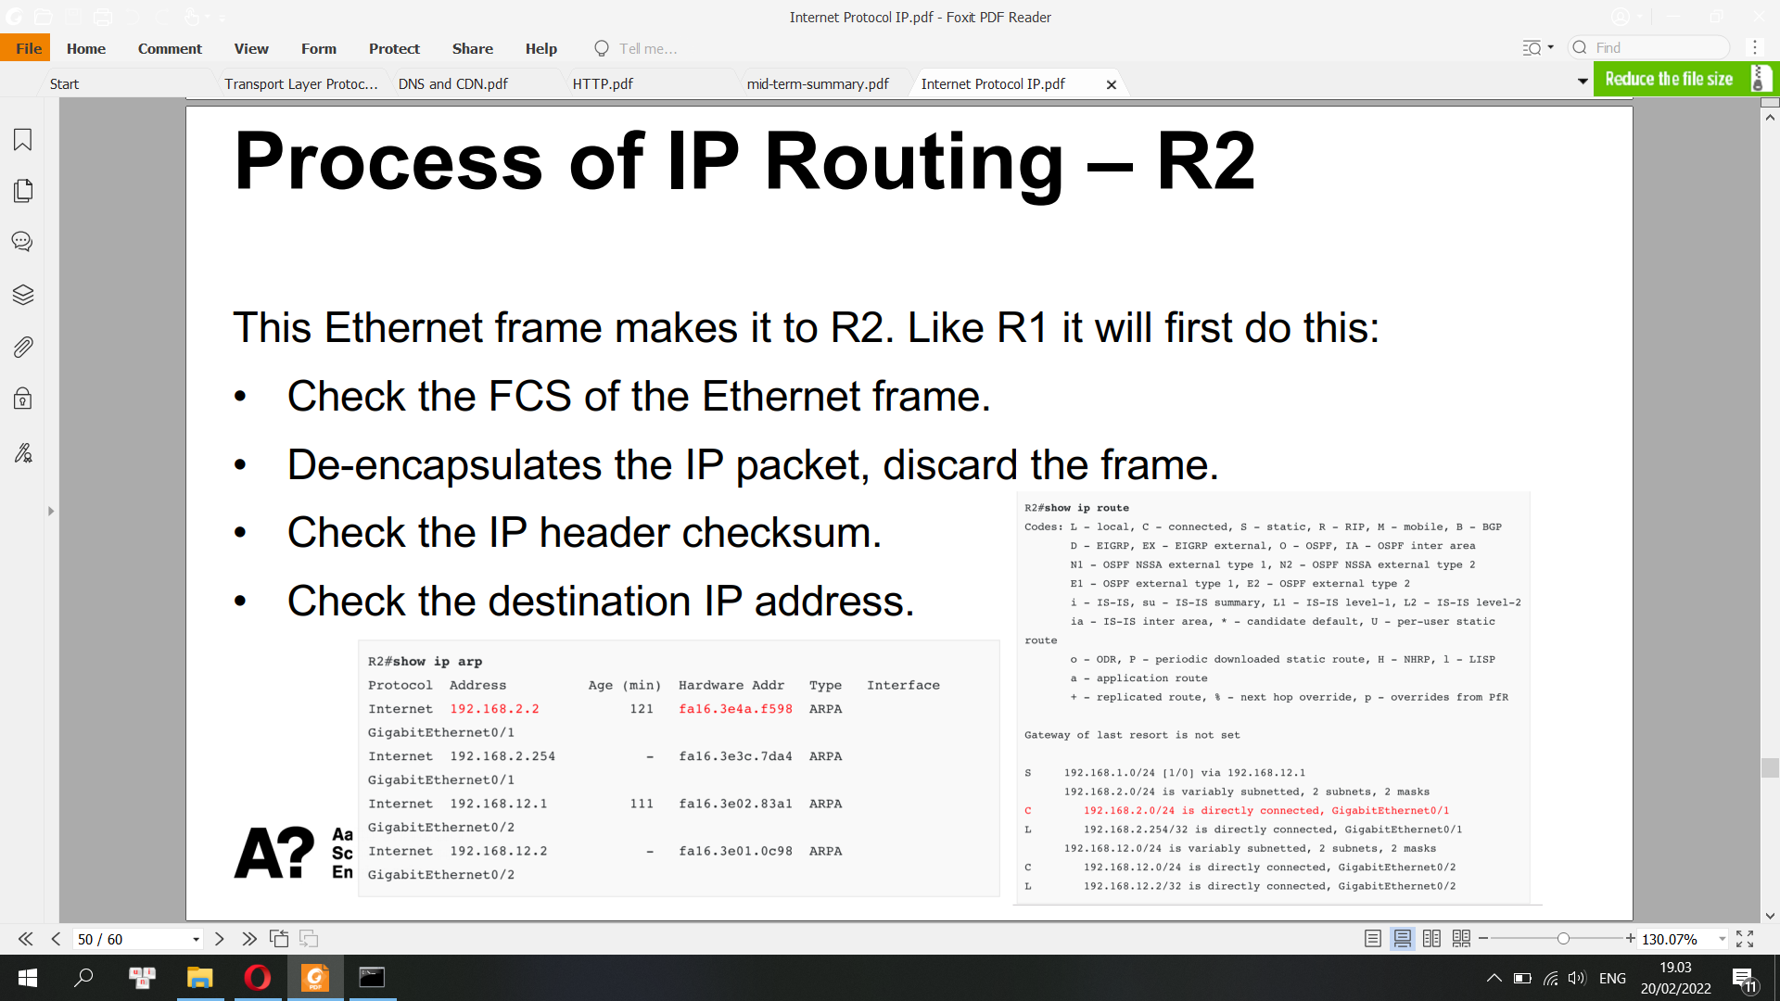

**Host 2:**

Host 2 receives the Ethernet frame and will:

• Check the FCS

• Find its own MAC address as the destination MAC address.

• De-encapsulates the IP packet from the frame.

• Finds its own IP address as the destination in the IP packet.

**Internet Control Message Protocol (ICMP):**

The Internet Control Message Protocol (ICMP) is a supporting protocol in the Internet protocol suite. It is used by network devices, including routers, to send error messages and operational information indicating success or failure when communicating with another IP address, for example, when an error is indicated when a requested service is not available or that a host or router could not be reached.[2] ICMP differs from transport protocols such as TCP and UDP in that it is not typically used to exchange data between systems, nor is it regularly employed by end-user network applications

• Used by network tools like Ping and Traceroute

• Host-to-host protocol, used for sending IP layer error and status messages

ICMP messages

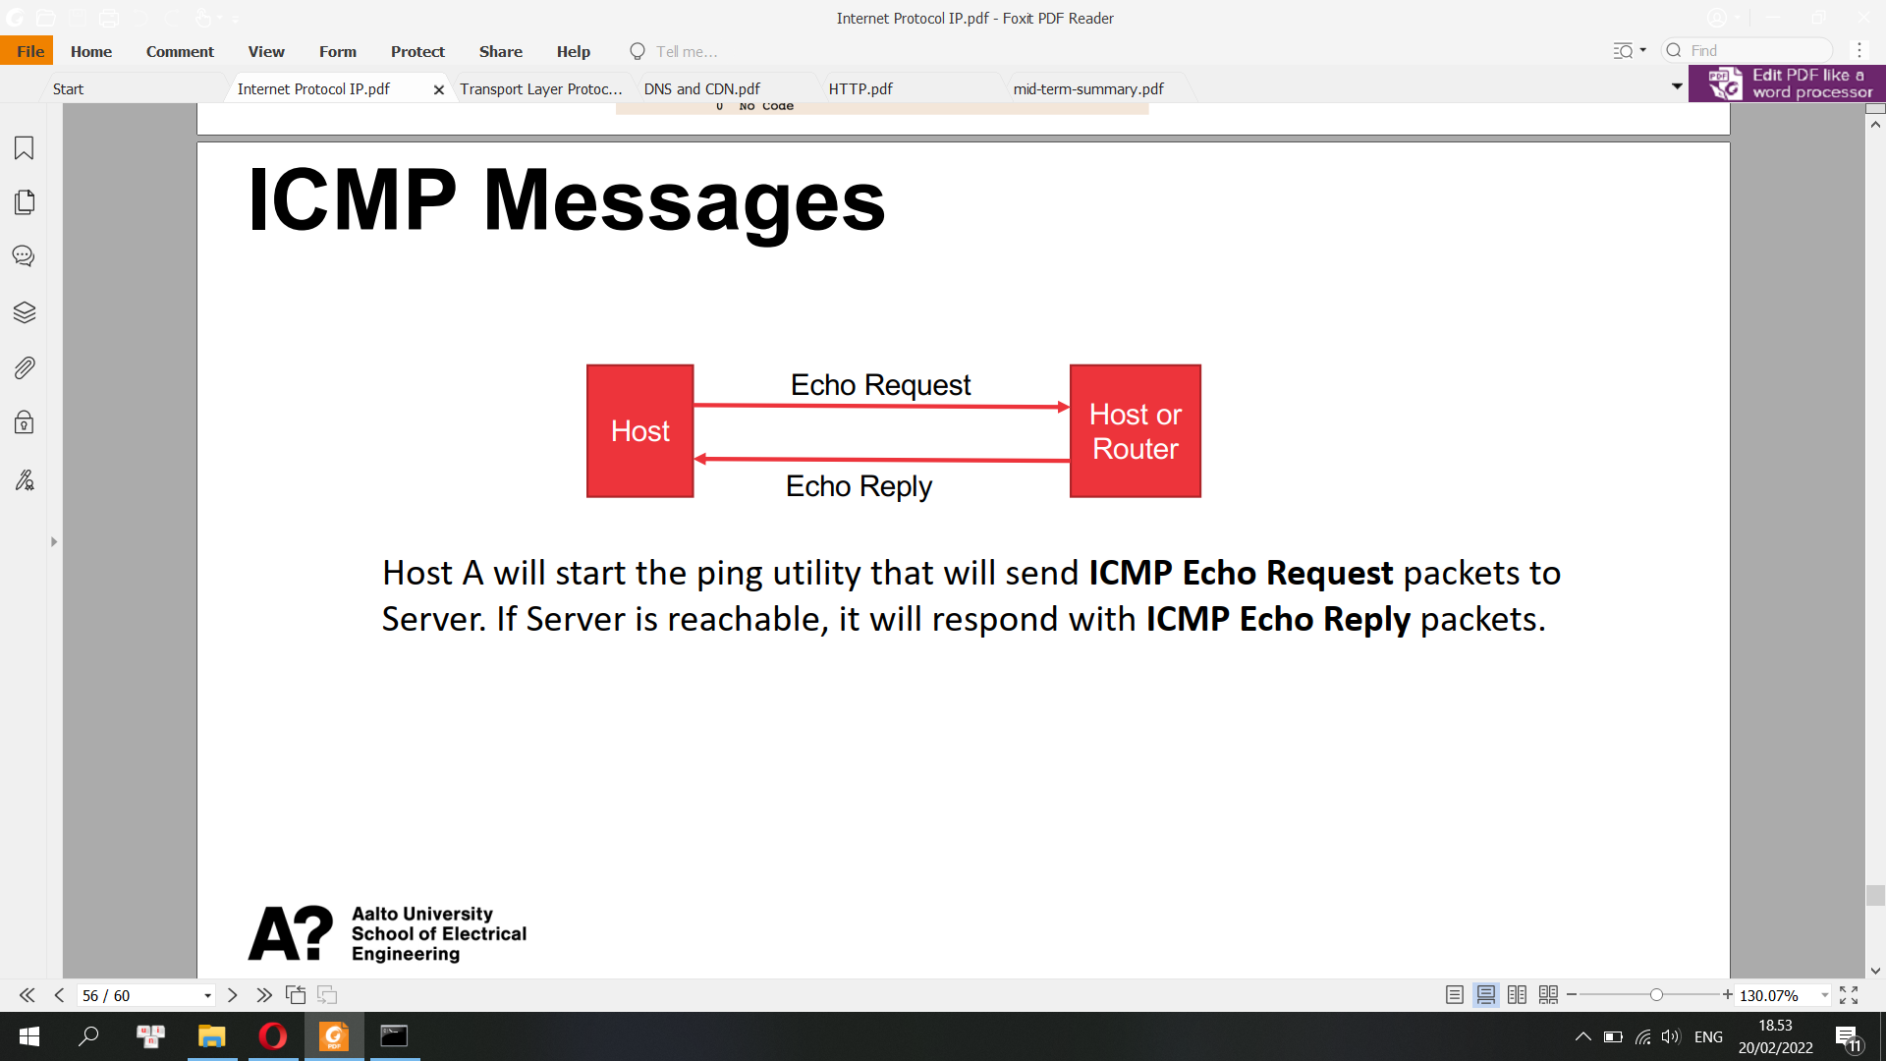

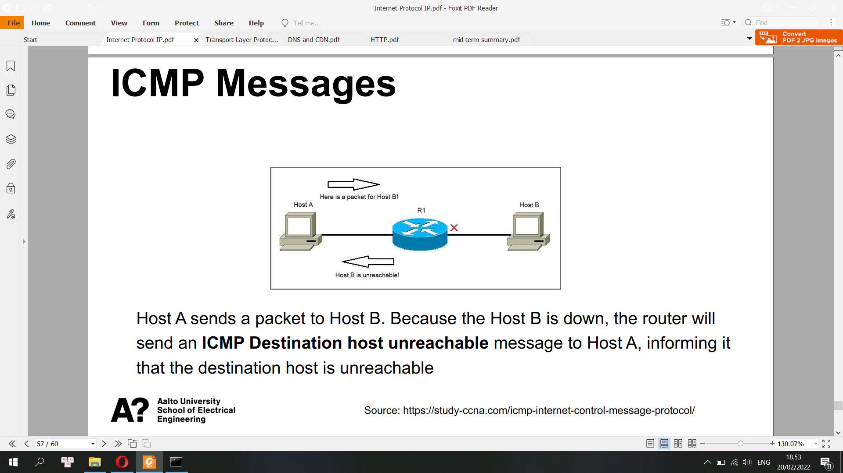

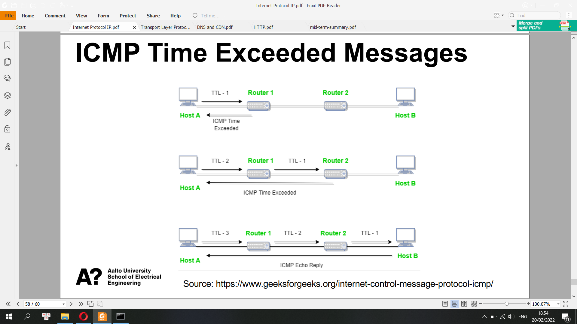

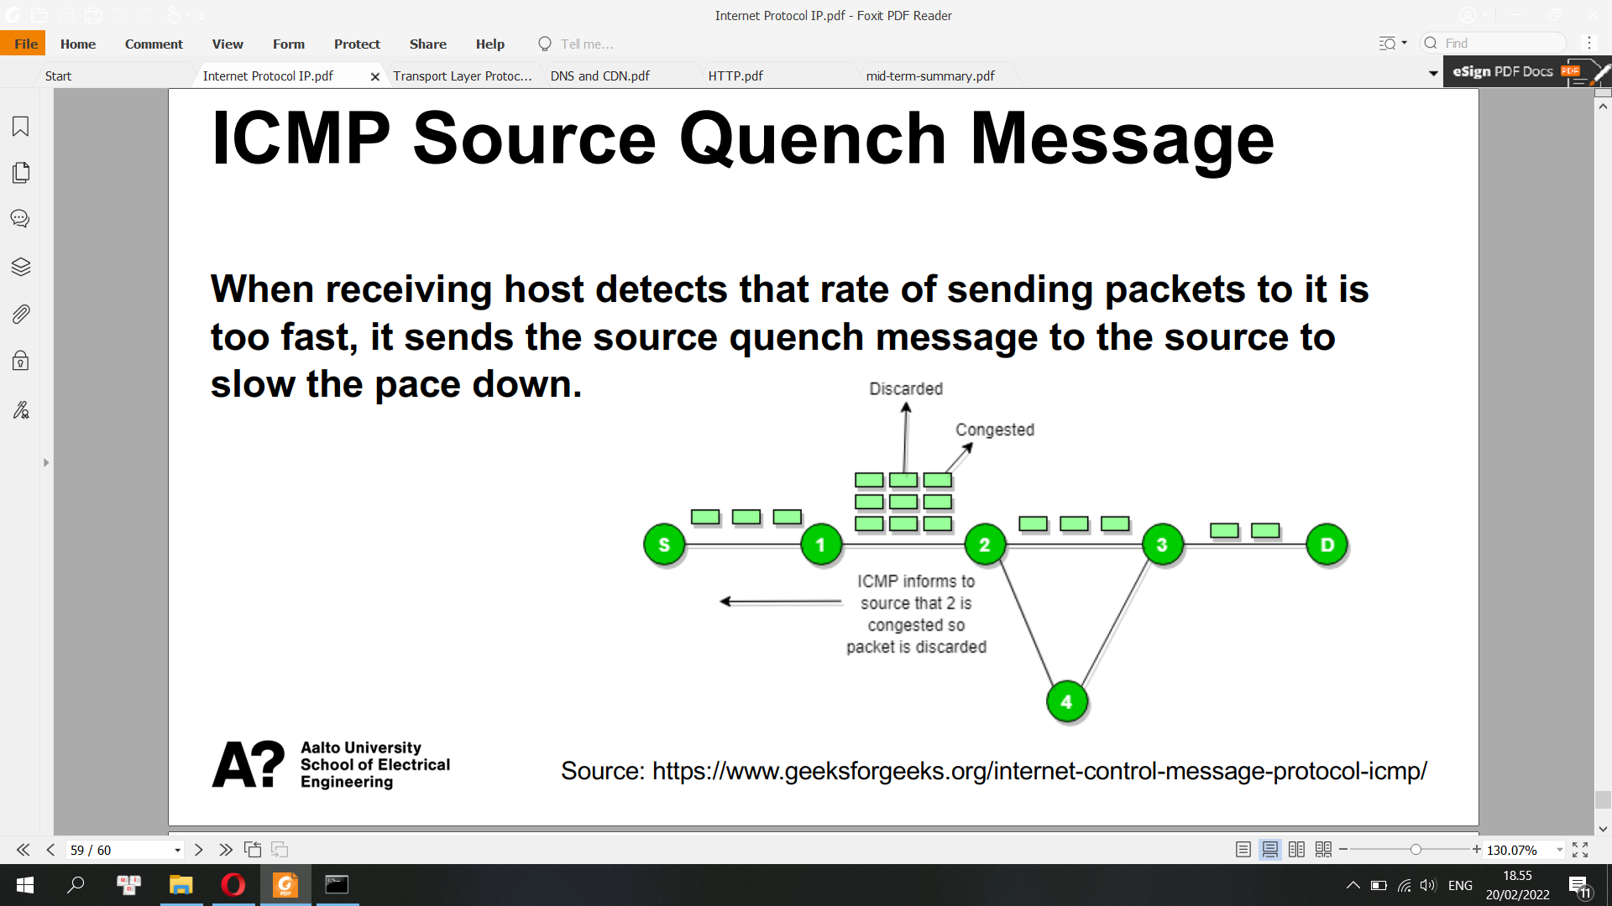

**Self-test: IP (Internet Protocol)**

**For example, for the network 192.168.30.0 255.255.255.0, what would be the broadcast address?**

**The broadcast address for a network has all host bits on.**

**Answer: 192.168.30.255 will be the broadcast address**

Example: IPv4 address 192.128.64.7/24

192.128.64.7 is the IP address and 24 is the subnet mask. The /24 corresponds to the subnet mask 255.255.255.0. The IP address consists of 4 decimals – called octets – which are separated by points. One octet contains 8 bits, which is why IPv4 is a 32-bit address. Each octet can represent a number between 0 and 255. In this case, the whole of the last octet consists of host bits. Therefore, in this example, the broadcast address would be 192.128.64.255 – so all host bits at 1.

**What can 255.255.255.255 be used for?**

0.0.0.0 – Represents the “default” network, i.e. any connection

255.255.255.255 – Represents the broadcast address, or place to route messages to be sent to every device within a network

127.0.0.1 – Represents “localhost” or the “loopback address”, allowing a device to refer to itself, regardless of what network it is connected to

169.254.X.X – Represents a “self-assigned IP address”, which a device will assign itself if it is unable to receive an IP address from a DHCP server

**Which actions could be taken by a router if a specific match is not made to a route in the routing table?**

a) The packet will be discarded

b) The packet will be sent back to the source

c) The packet will be flooded out all interfaces

d) Neighbouring routers are polled to find the best path

*e) The packet will be forwarded to a default route if one is present*

=> answer (e) is correct. If no matching entries can be found, the packet is sent to the defined default gateway. If more than one match is found in the routing table entries, the metric is used and the route with the fewest hops typically is selected.

**If a company needs 12 public IP address, something like 190.5.1.1/k, what should be the value of k?**

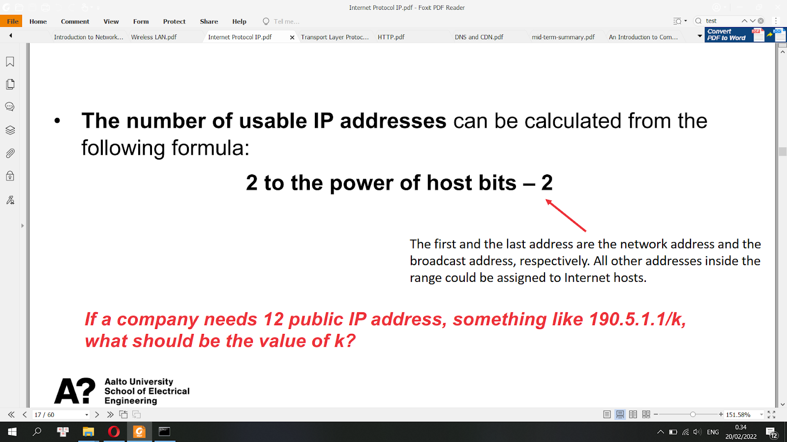

12 public + 2 bit of network and broadcast = 14 < 16 = 2^4  
=> needs last four bits => k = 32 - 4 = 28

**Transport Control Protocols (TCP)**

**TCP/UDP Ports**

• TCP/UDP extends host-to-host delivery to process-to-process delivery

• Port <-> server process

• Ports are identified for each protocol and address combination by 16-bit unsigned

numbers, known as port number.

• One IP address à 65535 TCP Ports and another 65535 UDP Ports

• Socket: <host, port>

• Socket address: <IP address, port number>, e.g. 192.168.0.10:80

• Client must know server’s port

• Port numbers 0 – 1023 are well-known ports. These are allocated to server services by the Internet Assigned Numbers Authority (IANA), e.g. web servers normally use port 80 and SMTP servers use port 25.

• Ports 1024-49151 – Registered Port: these can be registered for services with the IANA and should be treated as semi-reserved.

• Ports 49152-65535: these are used by client programs and you are free to use these in client programs.

IP provides unreliable service. It makes its best effort to deliver segments between communicating hosts, but it makes no guarantees.

• It does not guarantee segment delivery

• It does not guarantee orderly delivery of segments

• It does not guarantee the integrity of the data in the segments

**UDP**

• UDP is unreliable, in that there is no UDP-layer attempt at timeouts, acknowledgment and retransmission; applications written for UDP must implement these.

• UDP is also unconnected, or stateless; if an application has opened a port on a host, any other host on the Internet may deliver packets to that ⟨host, port⟩ socket without preliminary negotiation.

• UDP packets can be dropped due to queue overflows either at an intervening router or at the receiving host.

**UDP Socket Flow**

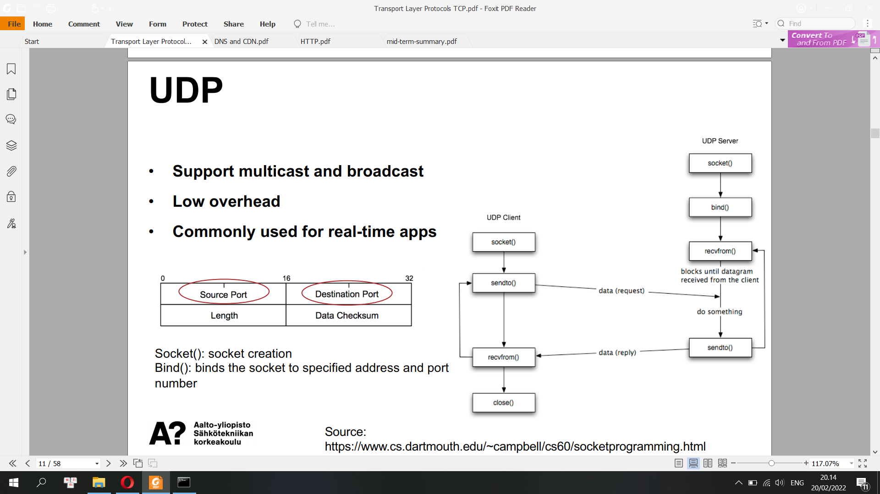

TCP extends IP with the following features

• Connection-orientation

• Stream-orientation

• Reliability

• Throughput management

**Connection-oriented and Three-way handshake**

**A send SYN**

**B send Syn + Ack**

**A send Ack**

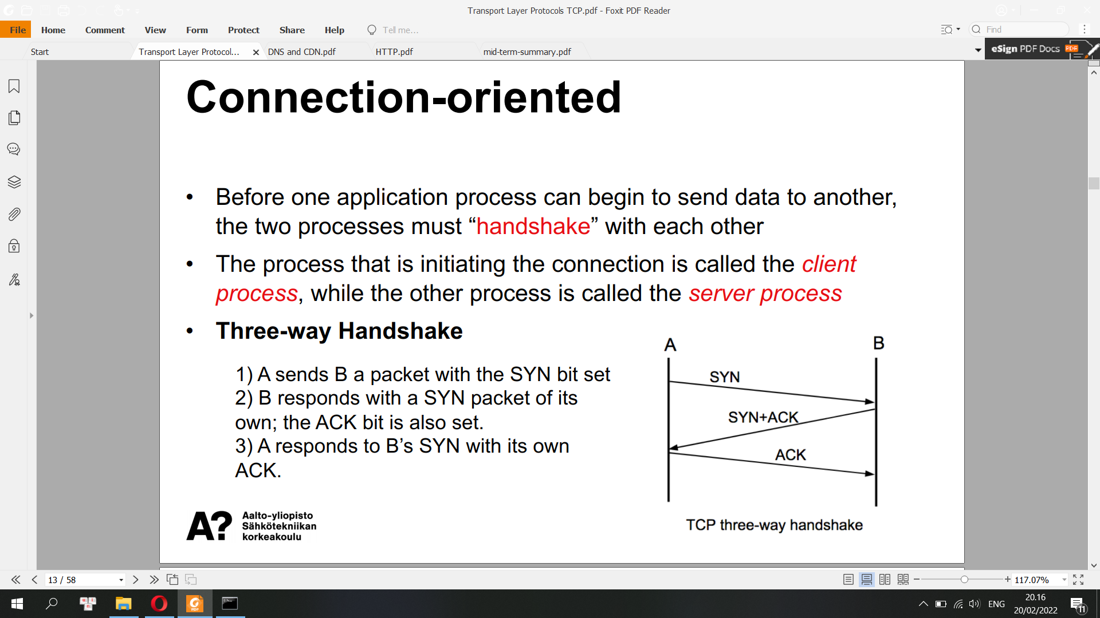

**TCP Header**

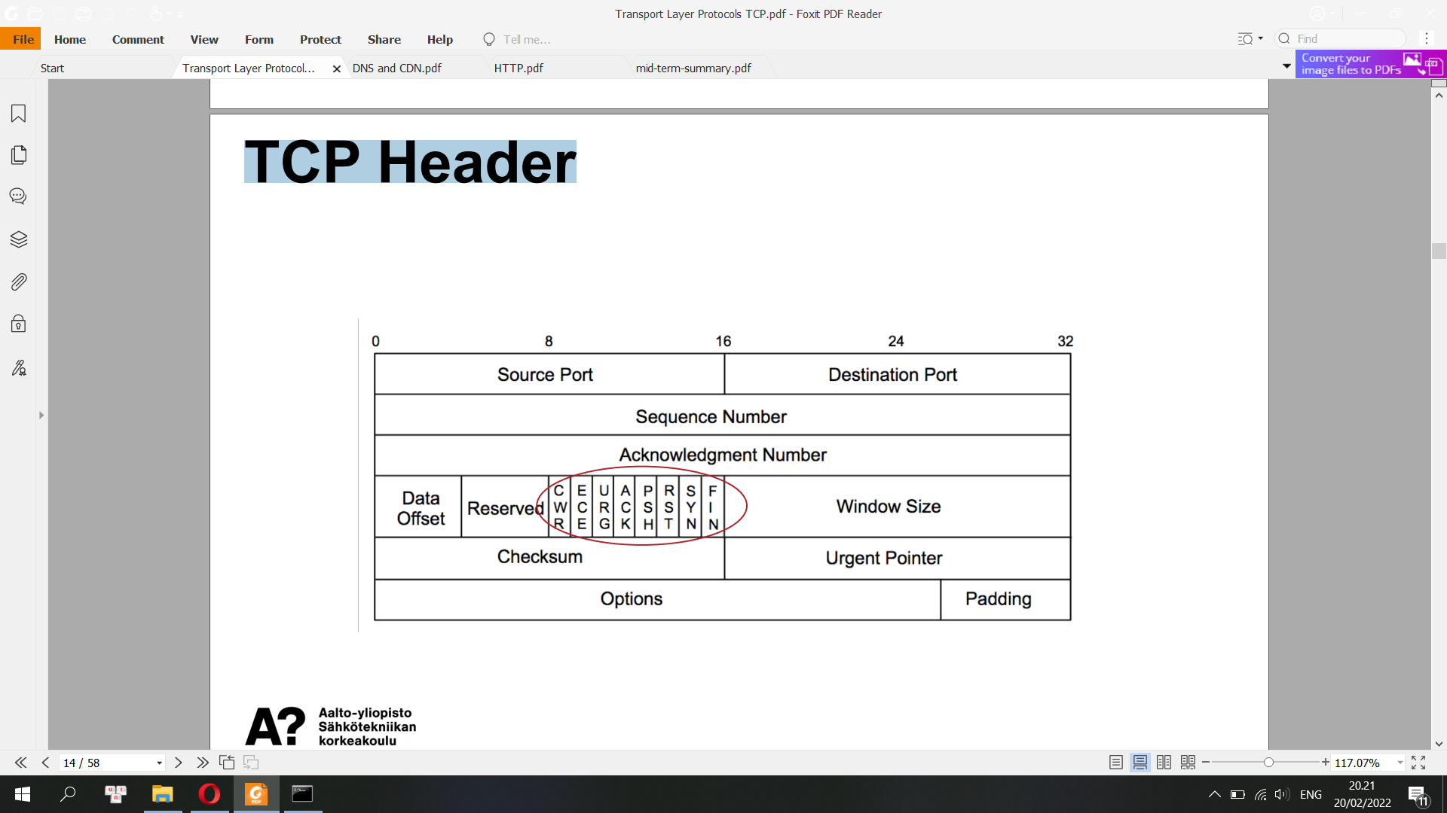

* Source port: this is a 16 bit field that specifies the port number of the sender.
* Destination port: this is a 16 bit field that specifies the port number of the receiver.
* Sequence number: the sequence number is a 32 bit field that indicates how much data is sent during the TCP session. When you establish a new TCP connection (3 way handshake) then the initial sequence number is a random 32 bit value known as ISN (Initial Sequence Numbers). The receiver will use this sequence number and sends back an acknowledgment. Protocol analyzers like wireshark will often use a relative sequence number of 0 since it’s easier to read than some high random number.
* Acknowledgment number: this 32 bit field is used by the receiver to request the next TCP segment. This value will be the sequence number incremented by 1.
* Data Offset: this is the 4 bit data offset field, also known as the header length. It indicates the length of the TCP header so that we know where the actual data begins.
* Reserved: these are 3 bits for the reserved field. They are unused and are always set to 0.
* Flags: there are 9 bits for flags, we also call them control bits. We use them to establish connections, send data and terminate connections:

- CWR and ECE: part of the explicit congestion notification mechanism

- URG: urgent pointer. When this bit is set, the data should be treated as priority over other data.

**- ACK: used for the acknowledgment.**

- PSH: this is the push function. This tells an application that the data should be transmitted immediately and that we don’t want to wait to fill the entire TCP segment.

- RST: this resets the connection, when you receive this you have to terminate the connection right away. This is only used when there are unrecoverable errors and it’s not a normal way to finish the TCP connection.

**- SYN: we use this for the initial three way handshake and it’s used to set the initial sequence number.**

**- FIN: this finish bit is used to end the TCP connection. TCP is full duplex so both parties will have to use the FIN bit to end the connection.** This is the normal method how we end an connection.

* Window Size : the 16 bit window field specifies how many bytes the receiver is willing to receive. It is used so the receiver can tell the sender that it would like to receive more data than what it is currently receiving. It does so by specifying the number of bytes beyond the sequence number in the acknowledgment field.
* Checksum: 16 bits are used for a checksum to check if the TCP header is OK or not.
* Urgent pointer: these 16 bits are used when the URG bit has been set, the urgent pointer is used to indicate where the urgent data ends.
* Options: this field is optional and can be anywhere between 0 and 320 bits.

**TCP Socket Flow**

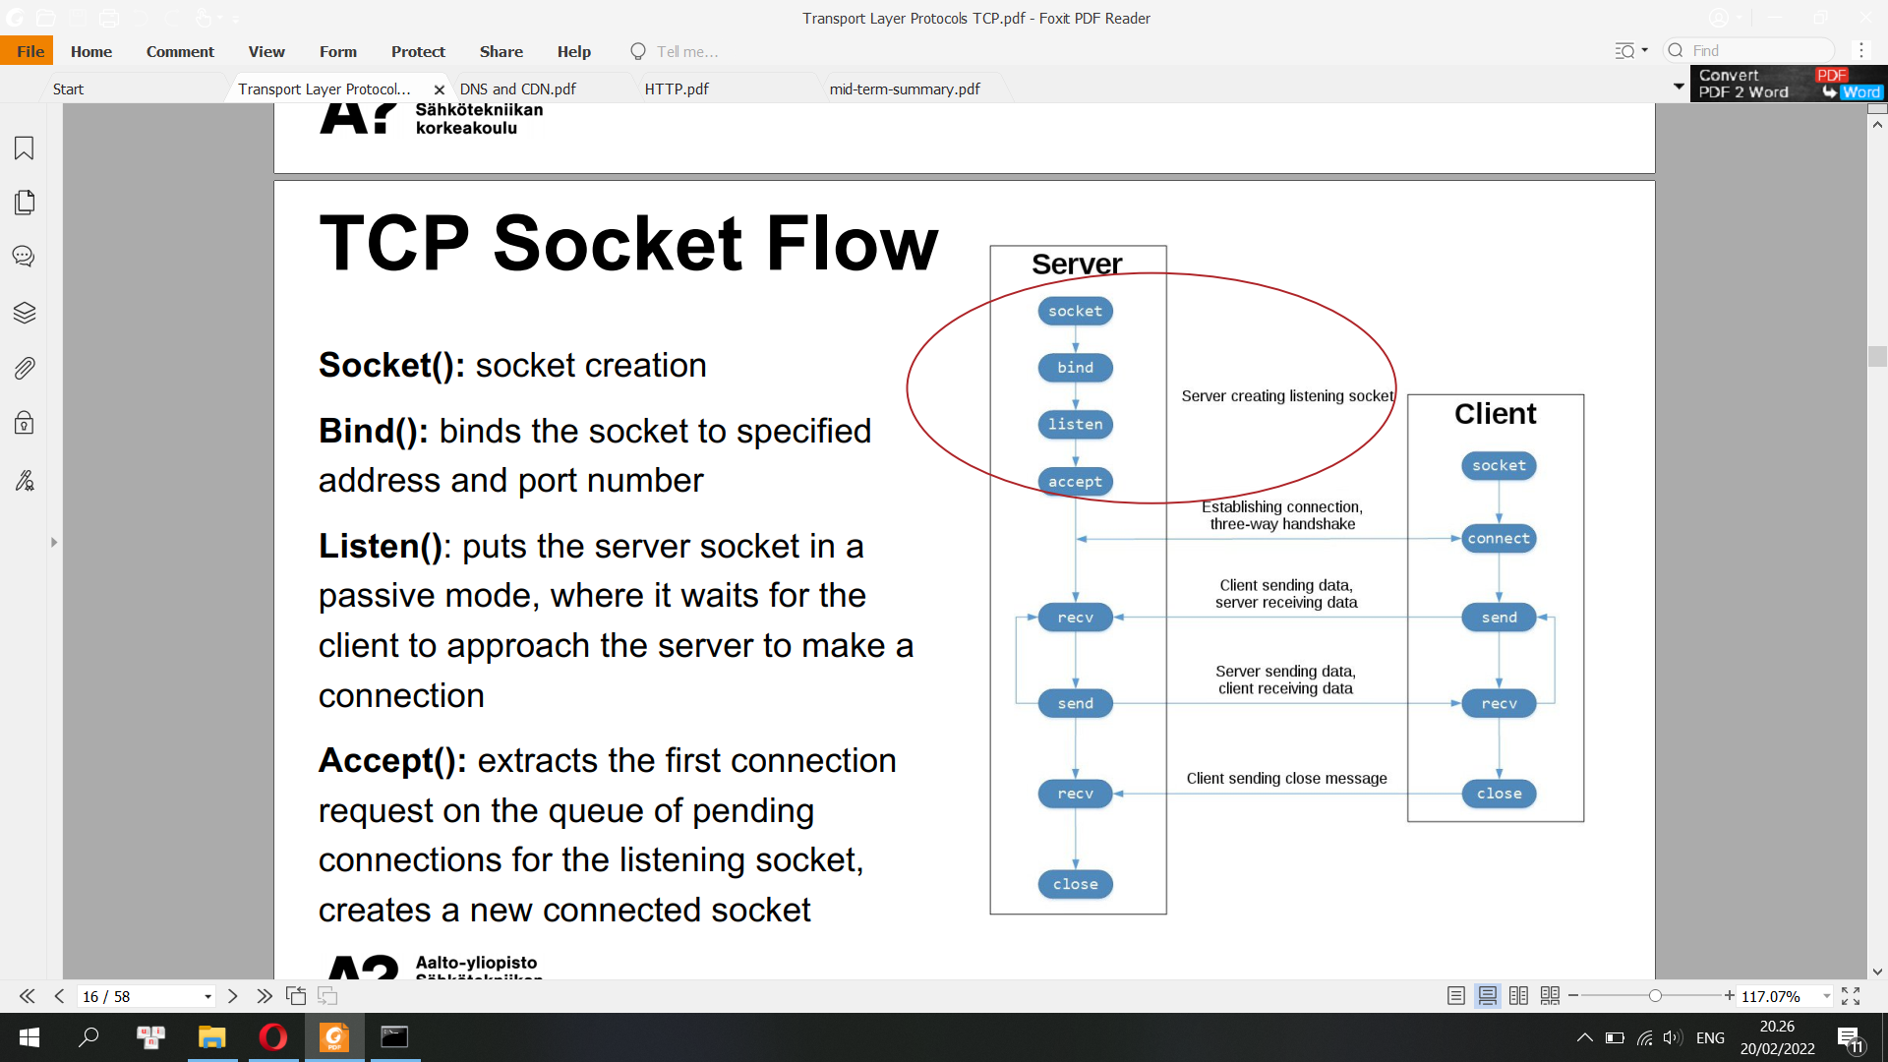

TCP Connection:

<Client IP, Client TCP Port, Server IP, Server TCP Port>

• Client port numbers are dynamically assigned, and can be reused once the session is closed.

• There can be multiple TCP connections between two hosts. These connections should use different TCP Ports.

• TCP protocol runs only in the end systems and not in the intermediate network elements (routers and link-layer switches), the intermediate network elements do not maintain TCP connection state

Data Exchange via TCP

• A TCP connection provides a full-duplex service

• A TCP connection is always point-to-point between a single sender and a single receiver

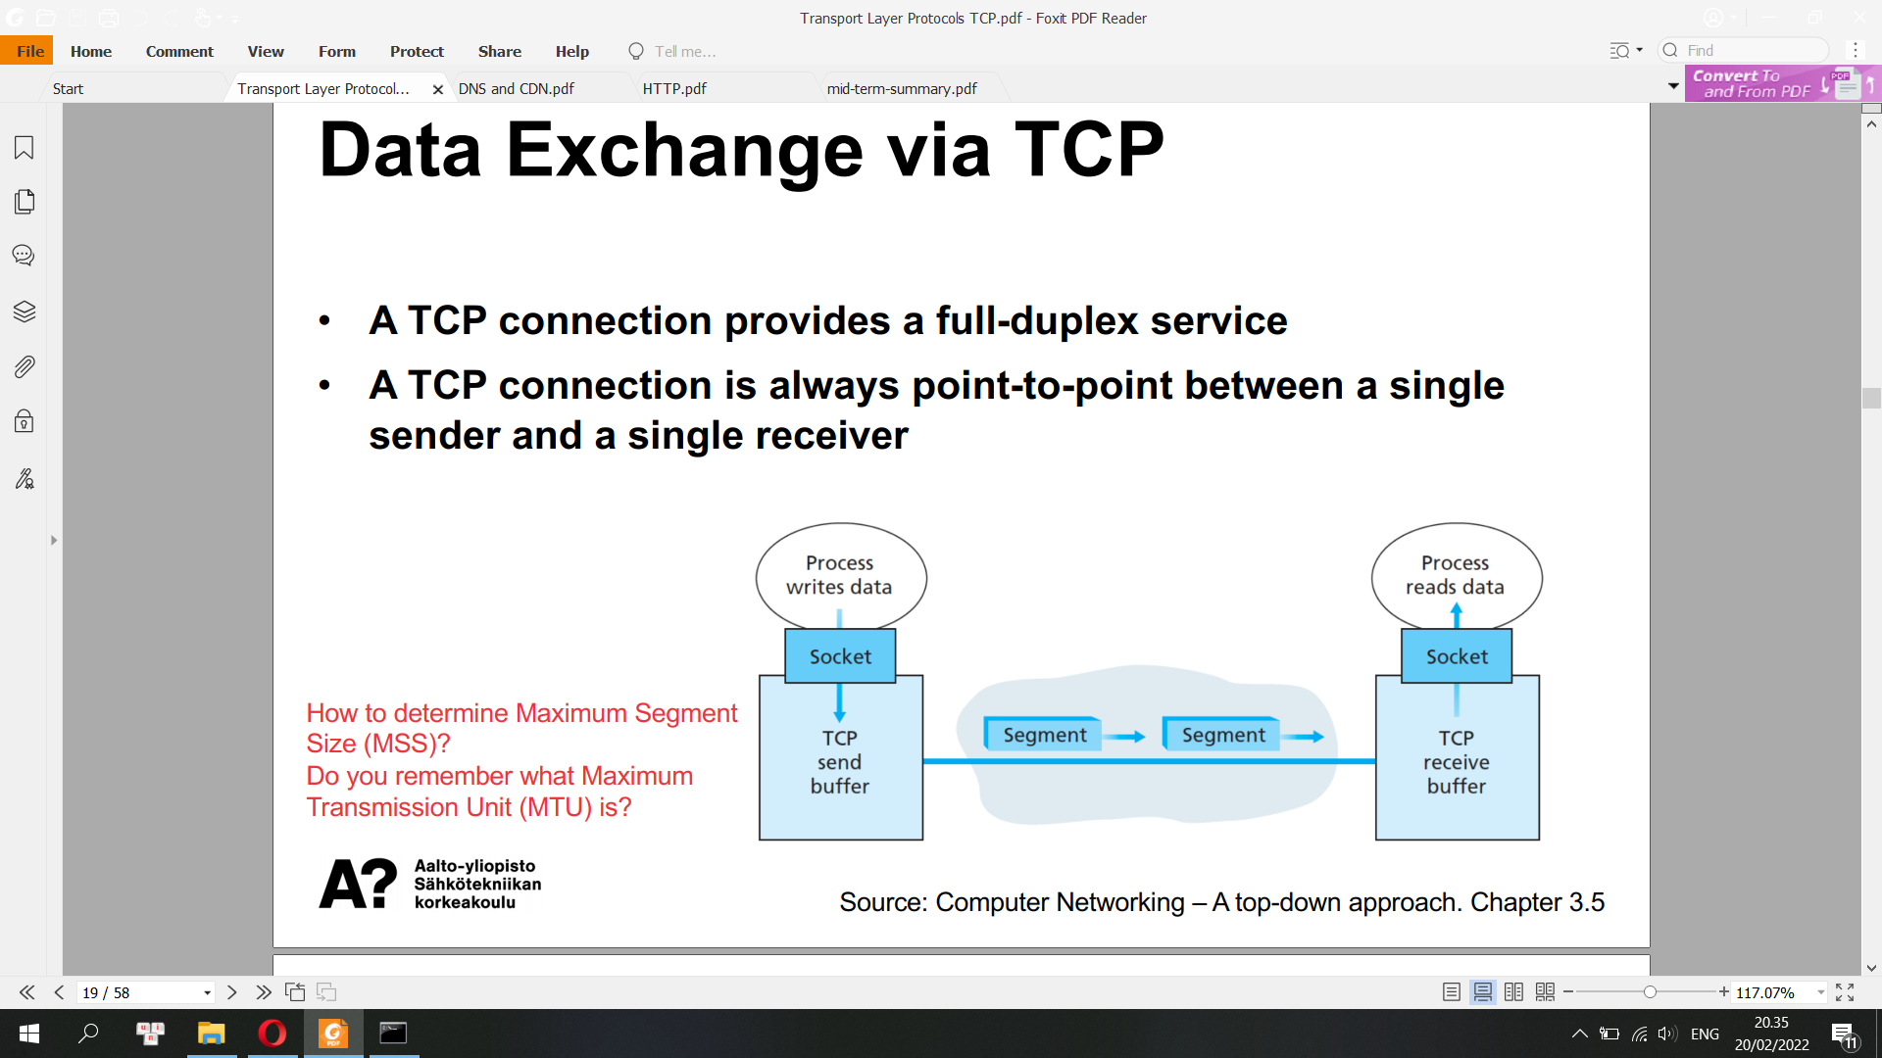

**How to close a TCP connection?**

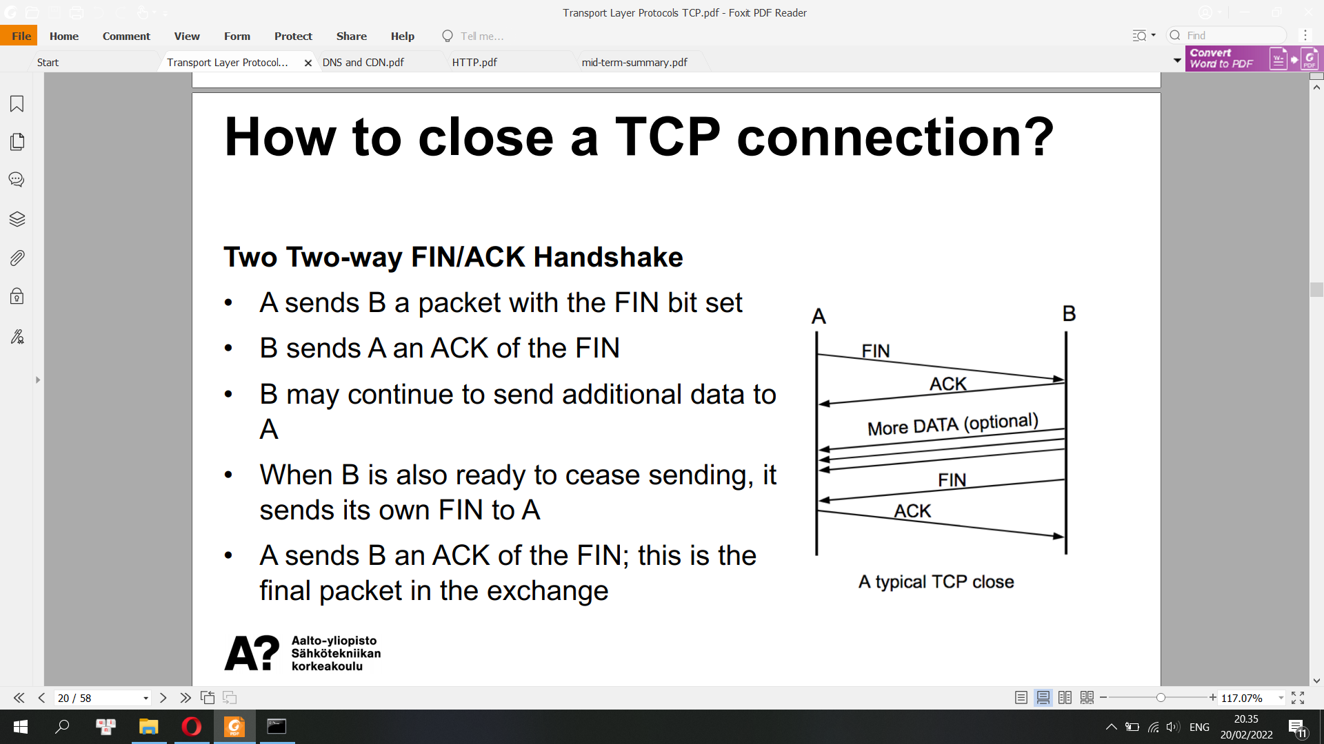

**A: FIN  
B: ACK  
B: may send more data  
B: FIN**

**A: ACK**

**Reliability**

• TCP numbers each packet, and keeps track of which are lost and retransmits them after a timeout.

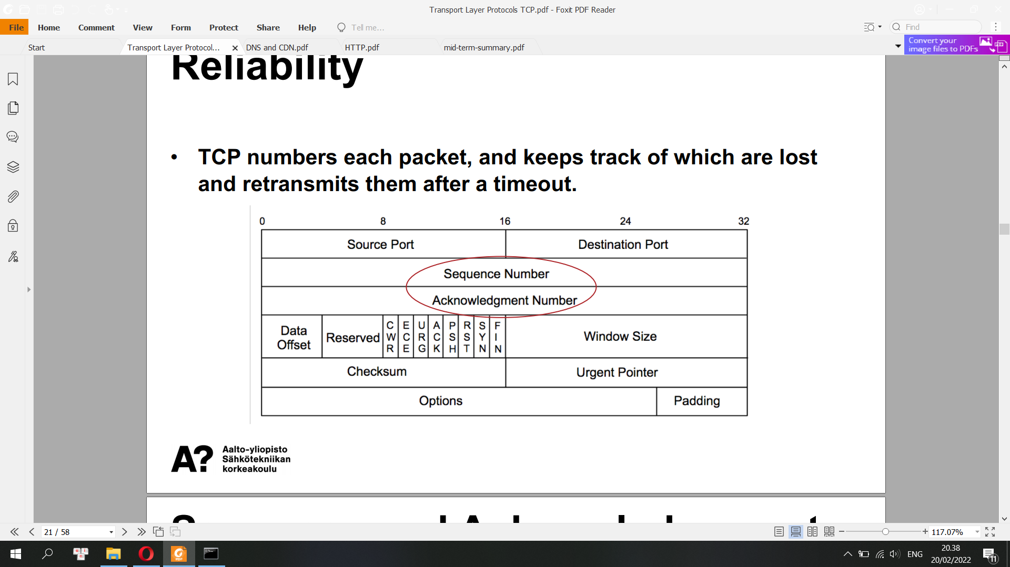

Sequence number:  
every segment has a sequence number. But in the above examples, we can see that some packets don’t have sequence numbers. That is because they are ack segments.

Note that the ACK segment does not consume any sequence numbers if it does not carry data. An ACK segment, if carrying no data, consumes no sequence number.

the TCP sequence number is 32 bits long

the most significant byte of the number is sent first

TCP sequence numbers count bytes rather than packets

the sequence number in the header is the sequence number of the first byte in the data

if there is no data, the sequence number is still set to the sequence number of the next byte that could be sent

since a TCP connection is bidirectional, a different initial sequence number (ISN) is used in each direction: each peer picks the ISN it will use in sending data

All bytes in a TCP connection are numbered, beginning at a randomly chosen initial sequence number (ISN). The SYN packets consume one sequence number, so actual data will begin at ISN+1. The sequence number is the byte number of the first byte of data in the TCP packet sent (also called a TCP segment). The acknowledgement number is the sequence number of the next byte the receiver expects to receive. The receiver ack'ing sequence number x acknowledges receipt of all data bytes less than (but not including) byte number x.

The sequence number is always valid. The acknowledgement number is only valid when the ACK flag is one. The only time the ACK flag is not set, that is, the only time there is not a valid acknowledgement number in the TCP header, is during the first packet of connection set-up.

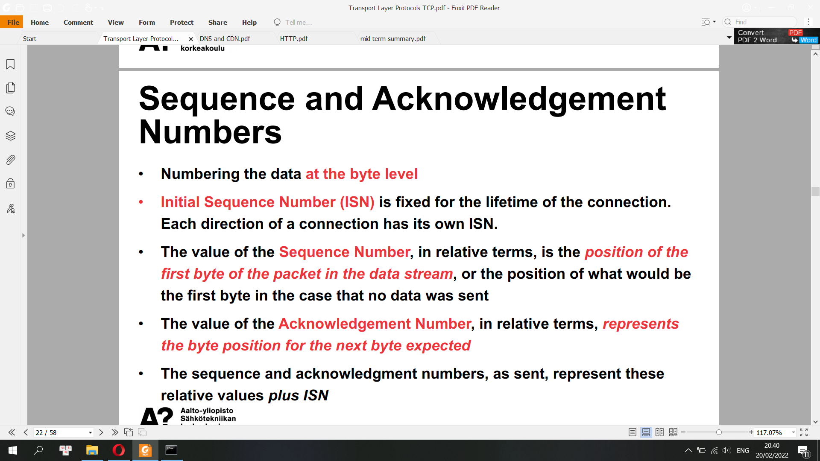

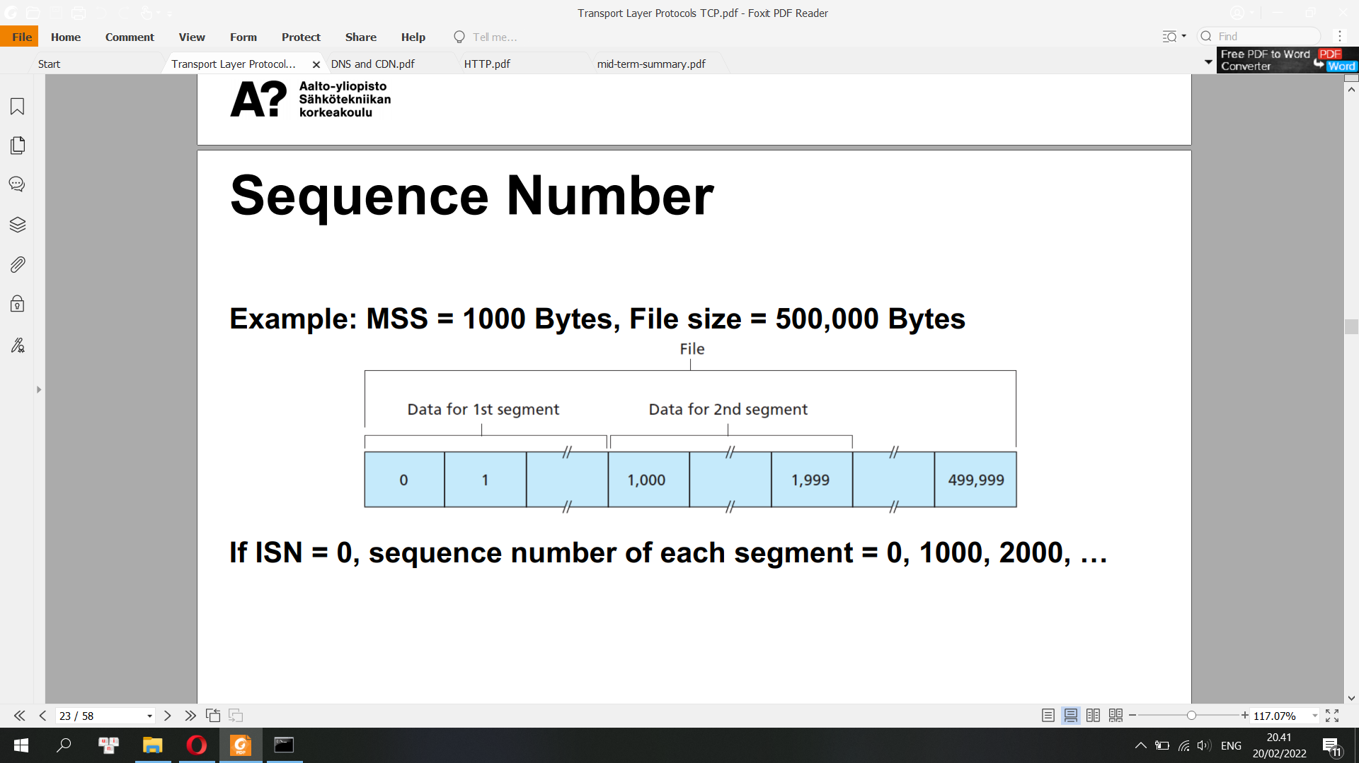

• Both sides of a TCP connection randomly choose an ISN. It may be any value between 0 and 4,294,967,295, inclusive.

• Protocol analyzers like Wireshark will typically display relative sequence and acknowledgement numbers in place of the actual values

TCP provides cumulative acknowledgements (i.e. TCP only acknowledges bytes up to the first missing byte in the stream)

**TCP Timeout and Retransmission**

• When TCP sends a segment containing user data (this excludes ACK-only packets), it sets a timer. If that timer expires before the segment data is acknowledged, the segment is

retransmitted.

• The length of timeout interval is adapted to RTT

• Acknowledgements are sent for every arriving data packet (unless Delayed ACKs are implemented)

In telecommunications, round-trip delay (RTD) or round-trip time (RTT) is the amount of time it takes for a signal to be sent plus the amount of time it takes for acknowledgement of that signal having been received. This time delay includes propagation times for the paths between the two communication endpoints.[1] In the context of computer networks, the signal is typically a data packet. RTT is also known as ping time, and can be determined with the ping command.

**TCP Flow Control**

• Window size indicates the number of bytes that a receiver is willing to accept.

• Flow-control service is used for eliminating the possibility of the sender overflowing the receiver’s buffer

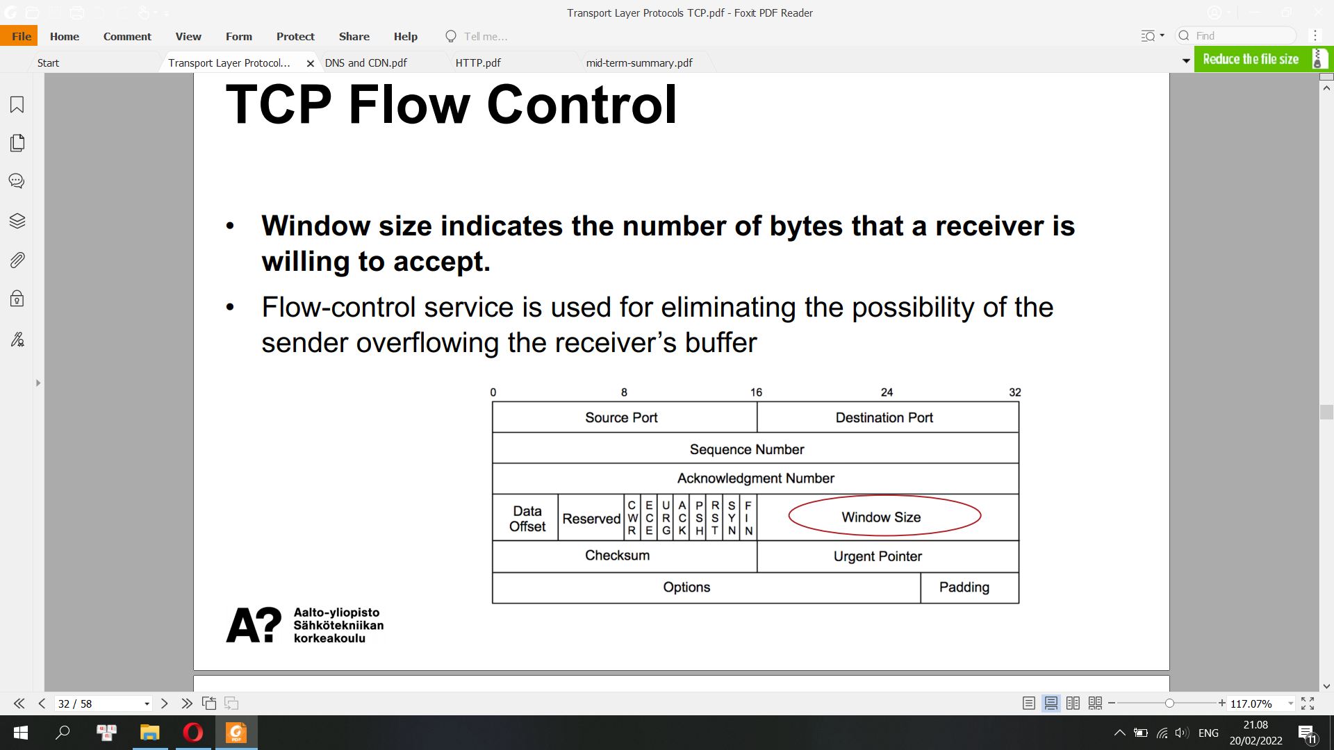

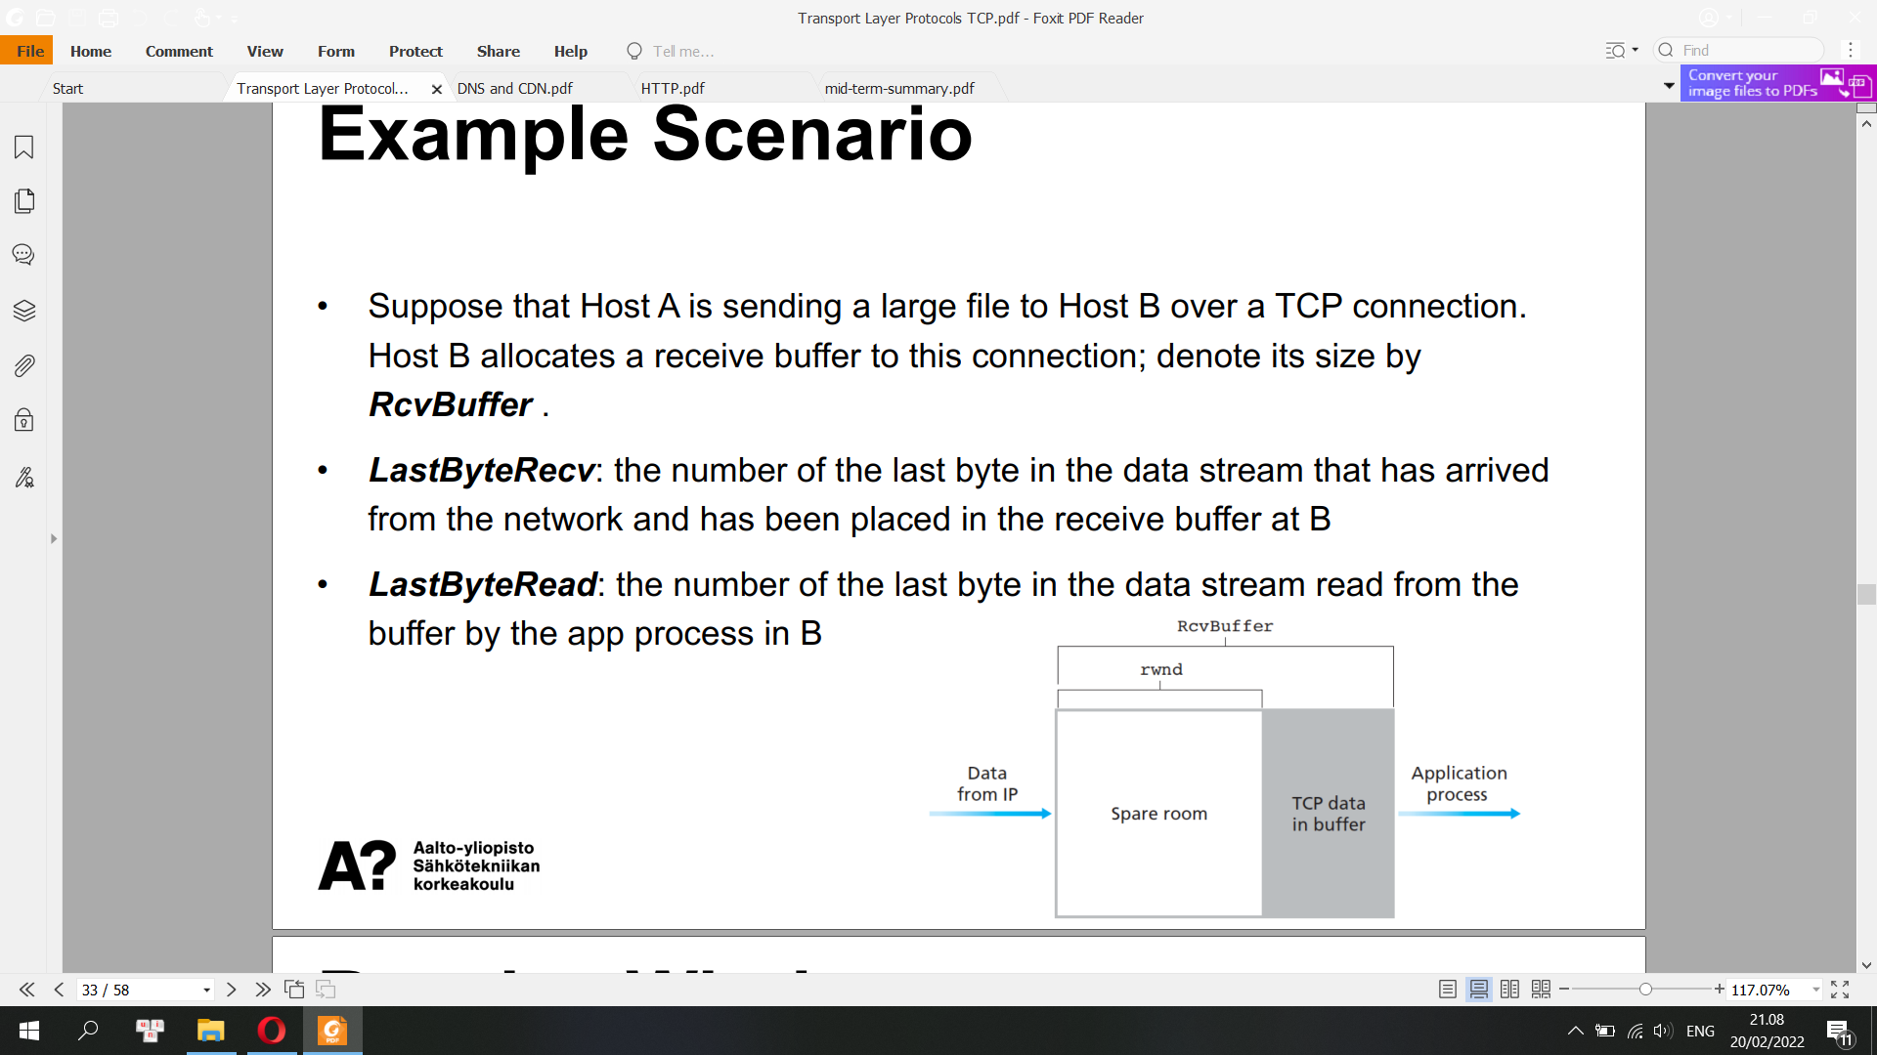

Receive Window

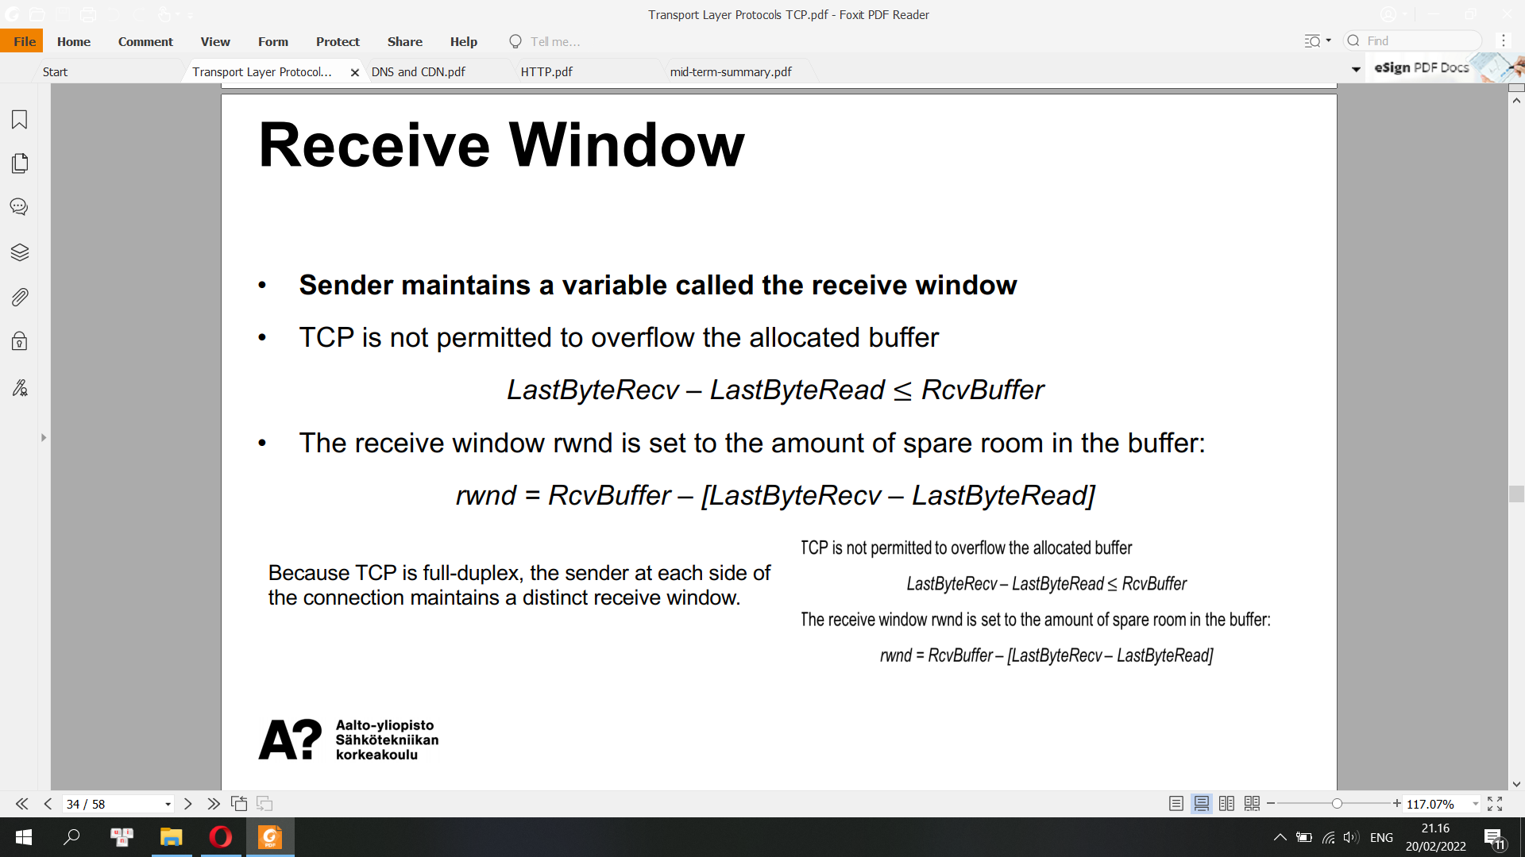

**How does the connection use the variable rwnd to provide the flowcontrol service?**

**Sliding Window**

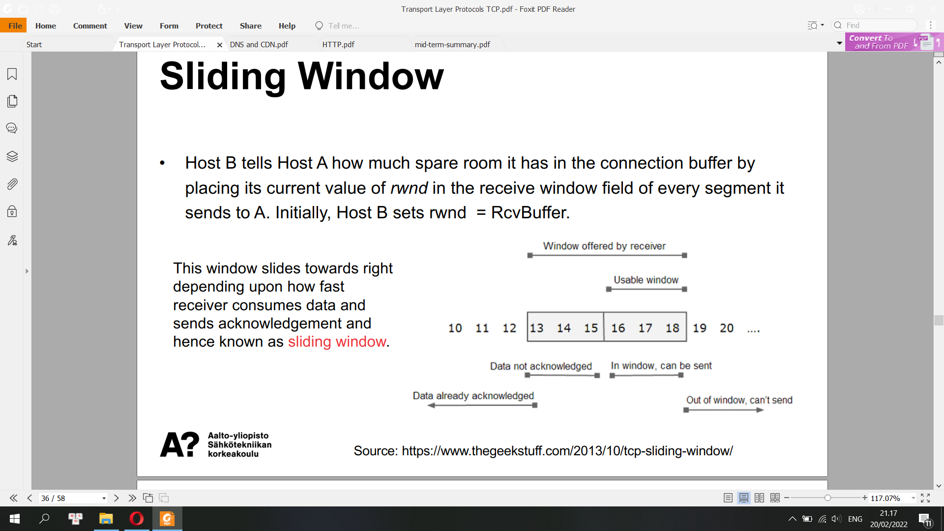

TCP Window Scale Option

• TCP window scale option is needed for efficient transfer of data when the bandwidth-delay product is greater than 64KB.

E.g. 1.5Mbps x 0.513s = 96 KB

• Effective window size = receive window size x window scale

**Congestion control**

• End-to-end congestion control, since IP layer provides no explicit feedback to end systems regarding congestion

• Each sender limits the rate at which it sends traffic into its connection as a function of perceived network congestion

If a TCP sender perceives that there is little congestion on the path between itself and the destination, then the TCP sender increases its send rate;

If the sender perceives that there is congestion along the path, then the sender reduces its send rate

Congestion Window

• Sender maintains a variable called congestion window, denoted cwnd.

• The amount of unacknowledged data at a sender may not exceed the minimum of cwnd and rwnd

LastByteSent – LastByteAcked ≤ min{cwnd, rwnd}

• A lost segment implies congestion, and hence, the TCP sender’s rate should be decreased when a segment is lost.

• Loss events: a timeout event, receipt of duplicated acks for a given segment

• TCP uses acknowledges to trigger (or clock) its increase in congestion window size

**TCP Congestion-Control Algorithm**

Three Major Components:

• Slow Start

• Congestion Avoidance

• Fast recovery (recommended for TCP senders, but not required)

**Slow start**

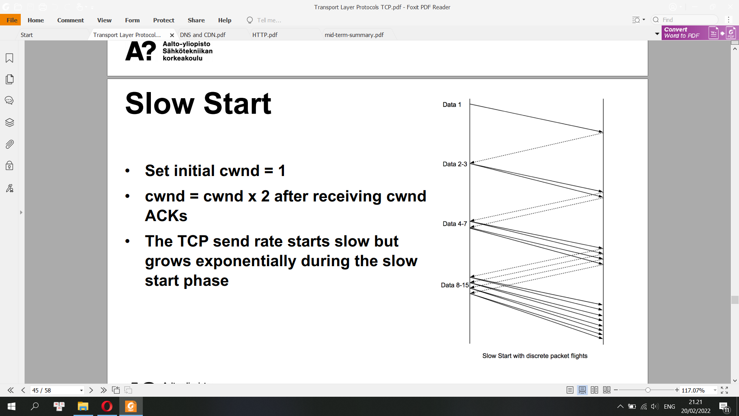

When should the exponential growth end?

• If there is a loss event indicated by a timeout, the TCP sender sets the value of cwnd to 1 and begins the slow start anew. Also set ssthresh (‘slow start threshold’) to cwnd/2

When cwnd reaches or surpasses ssthresh, slow start ends and TCP transitions into congestion avoidance mode

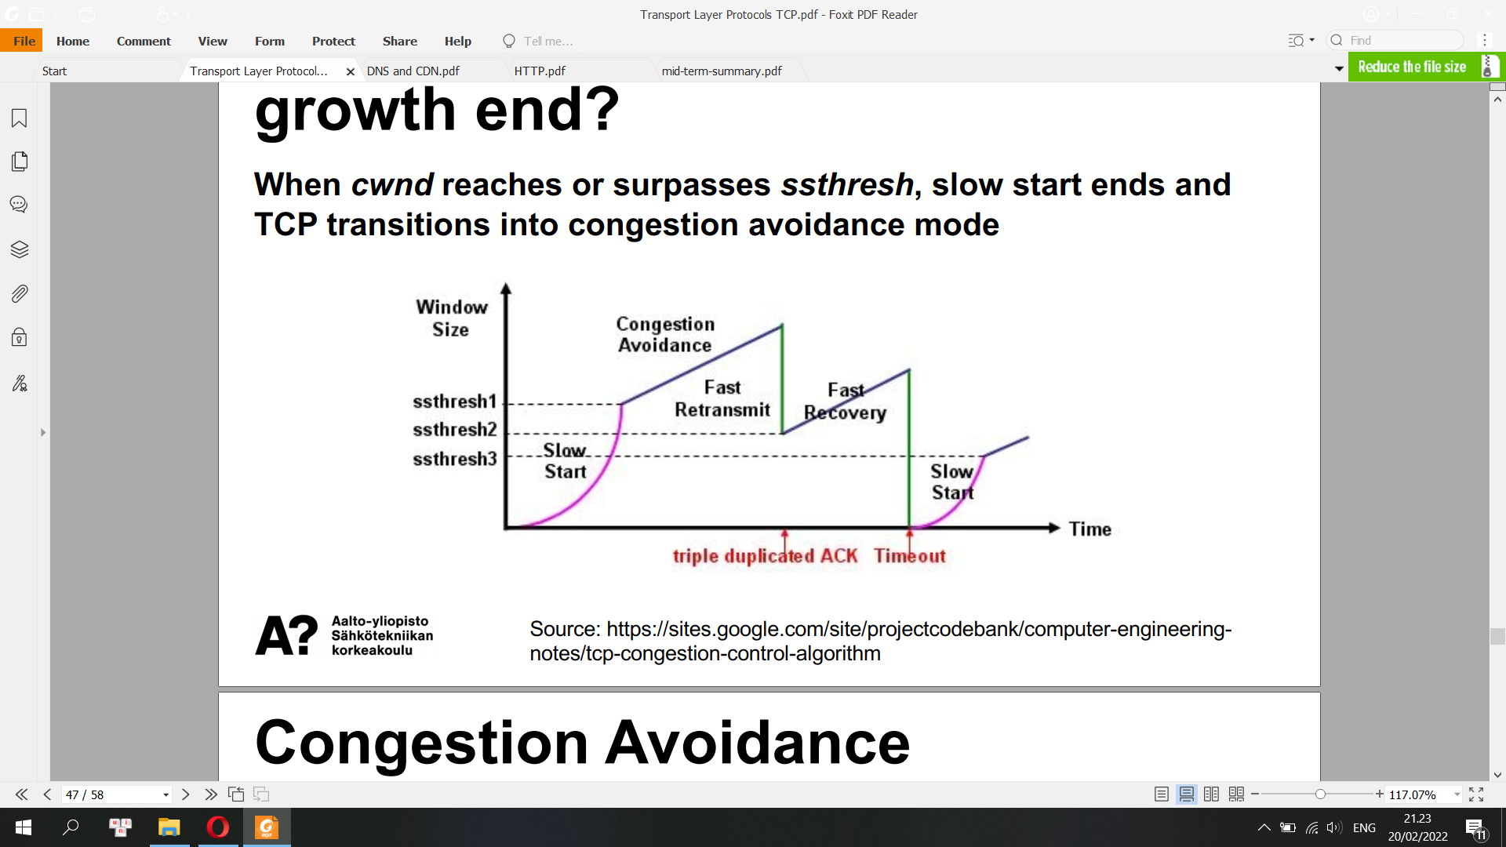

**Congestion Avoidance**

• cwnd = cwnd + 1 MSS whenever a new ACK arrives

• If congestion was indicated by a timeout, cwnd is reset to 1 segment, which automatically puts the sender into slow start mode

• If congestion was indicated by duplicate Acknowledgements the fast retransmit and fast recovery algorithms are invoked

**Fast Recovery**

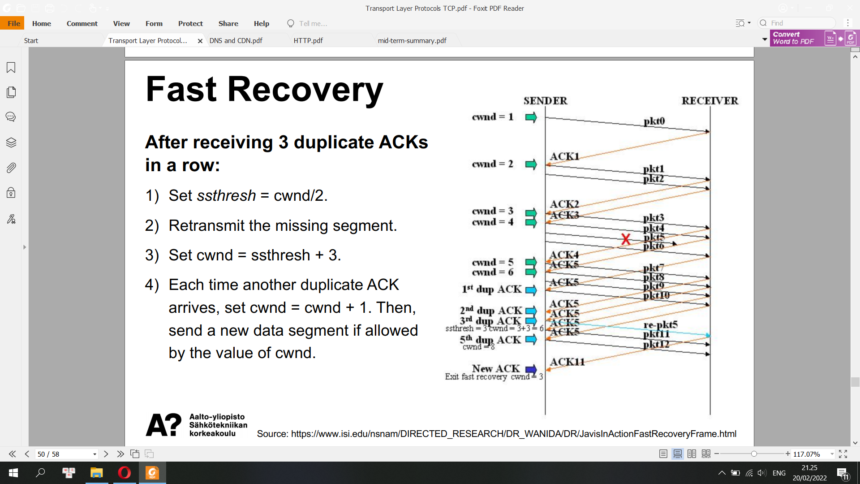

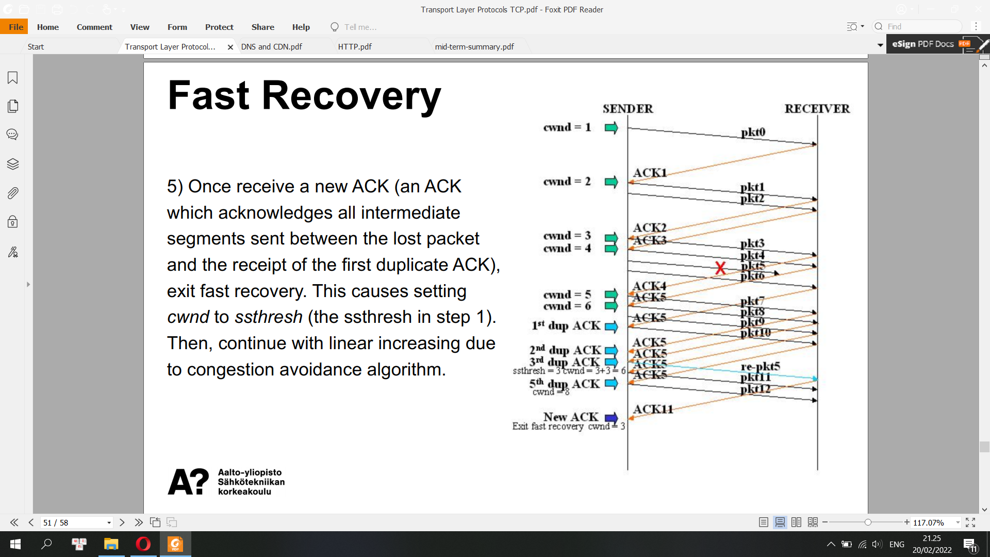

**Selective Acknowledge (SACK)**

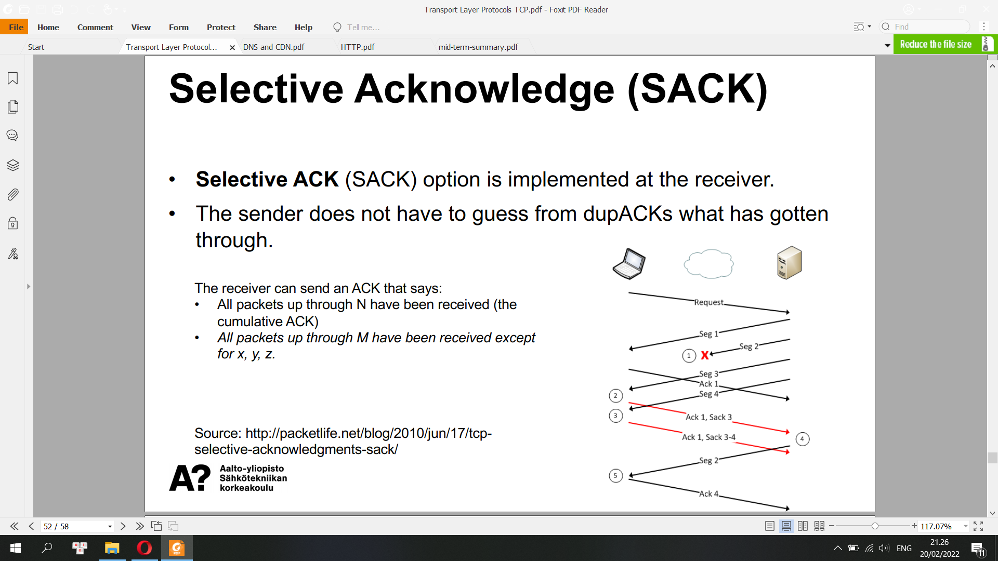

**Head-of-Line Blocking in TCP**

Head-of-line blocking (HOL blocking) in computer networking is a performance-limiting phenomenon that occurs when a line of packets is held up by the first packet. Examples include input buffered network switches, out-of-order delivery and multiple requests in HTTP pipelining.

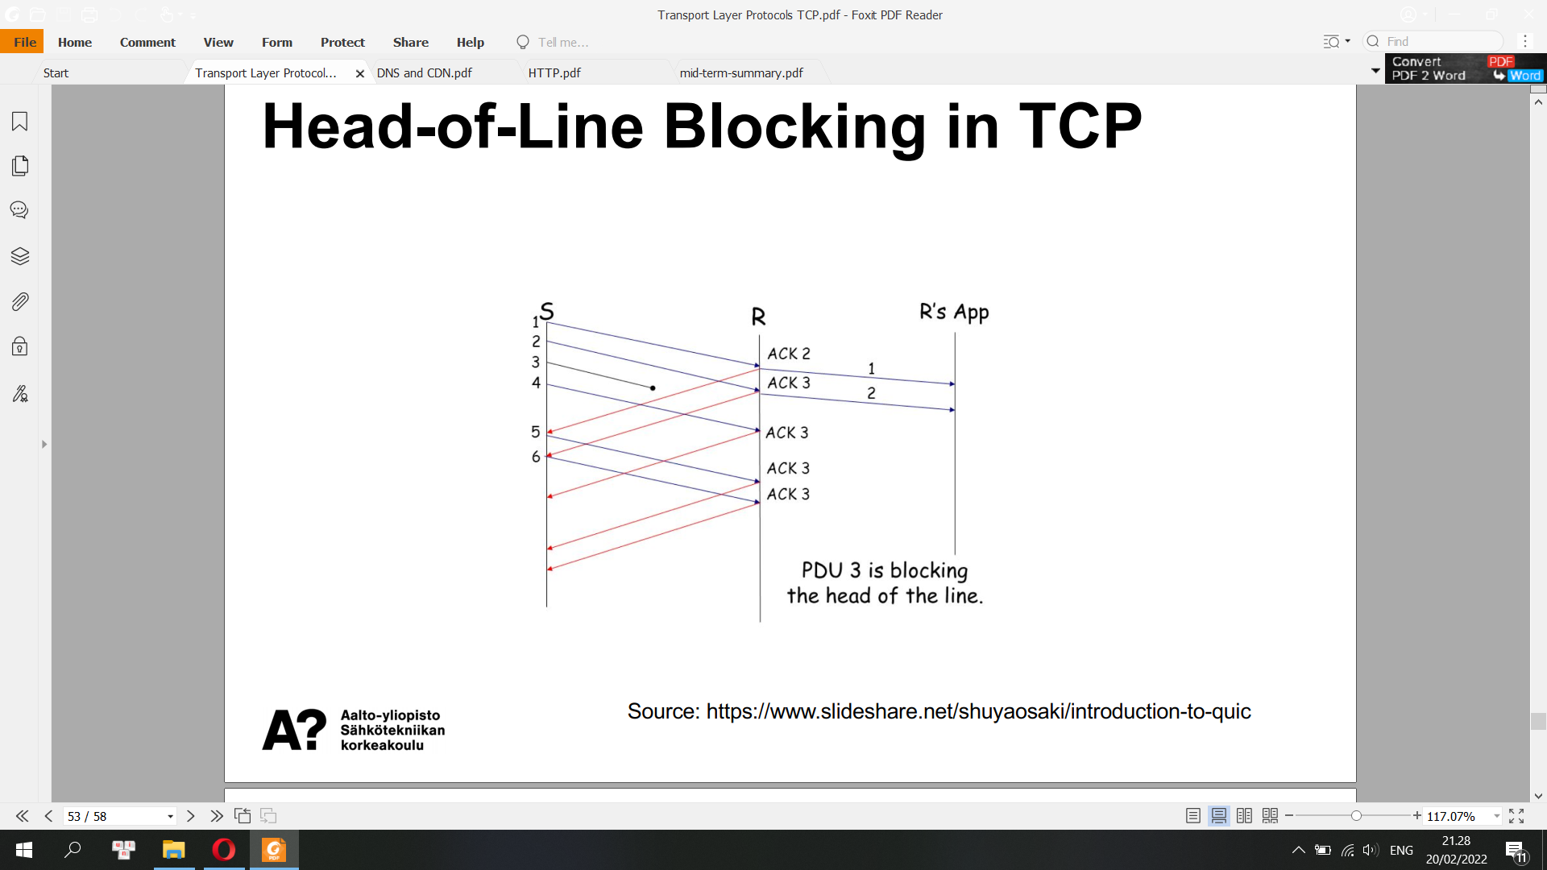

In telecommunications, a protocol data unit (PDU) is a single unit of information transmitted among peer entities of a computer network. A PDU is composed of protocol-specific control information and user data. In the layered architectures of communication protocol stacks, each layer implements protocols tailored to the specific type or mode of data exchange.

For example, the Transmission Control Protocol (TCP) implements a connection-oriented transfer mode, and the PDU of this protocol is called a segment, while the User Datagram Protocol (UDP) uses datagrams as protocol data units for connectionless communication.

**TCP vs UDP**

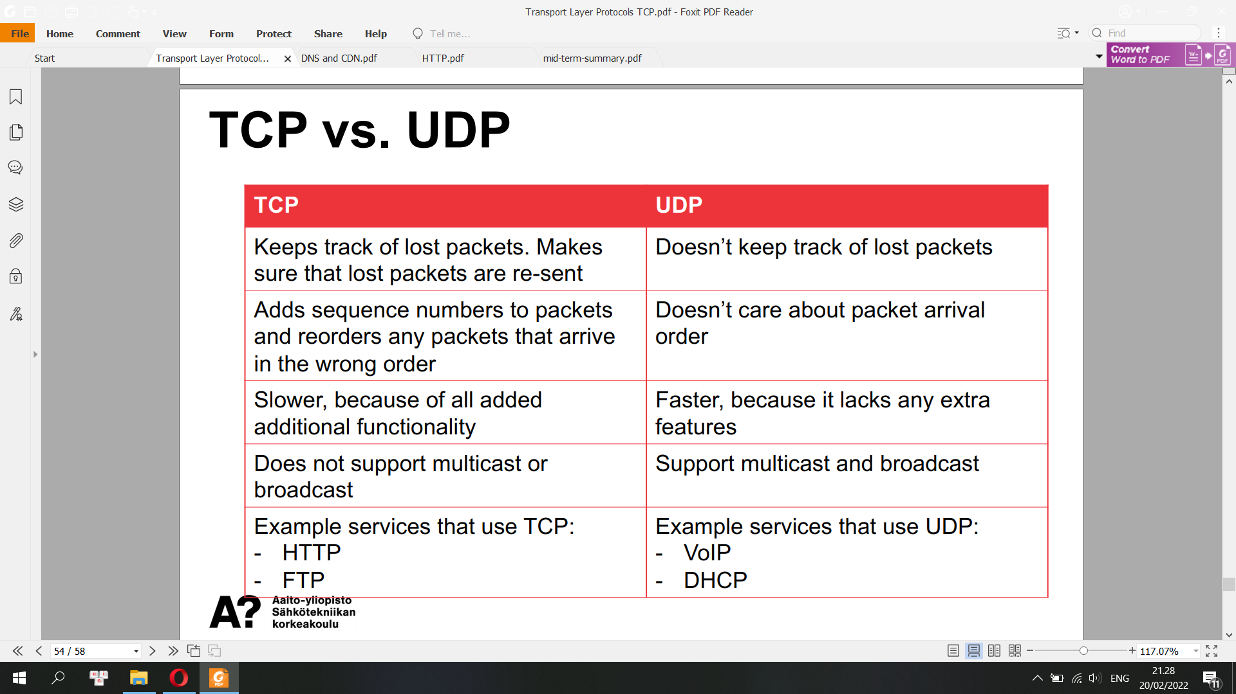

**Types of Sockets**

• Datagram sockets: connectionless sockets which use UDP

• Stream sockets: connection-oriented sockets which use TCP, SCTP or DCCP

• Raw sockets: the transport layer is bypassed and the packet headers are made accessible to the application. There is no port number in address, only IP address

**State machine for congestion control algorithm**

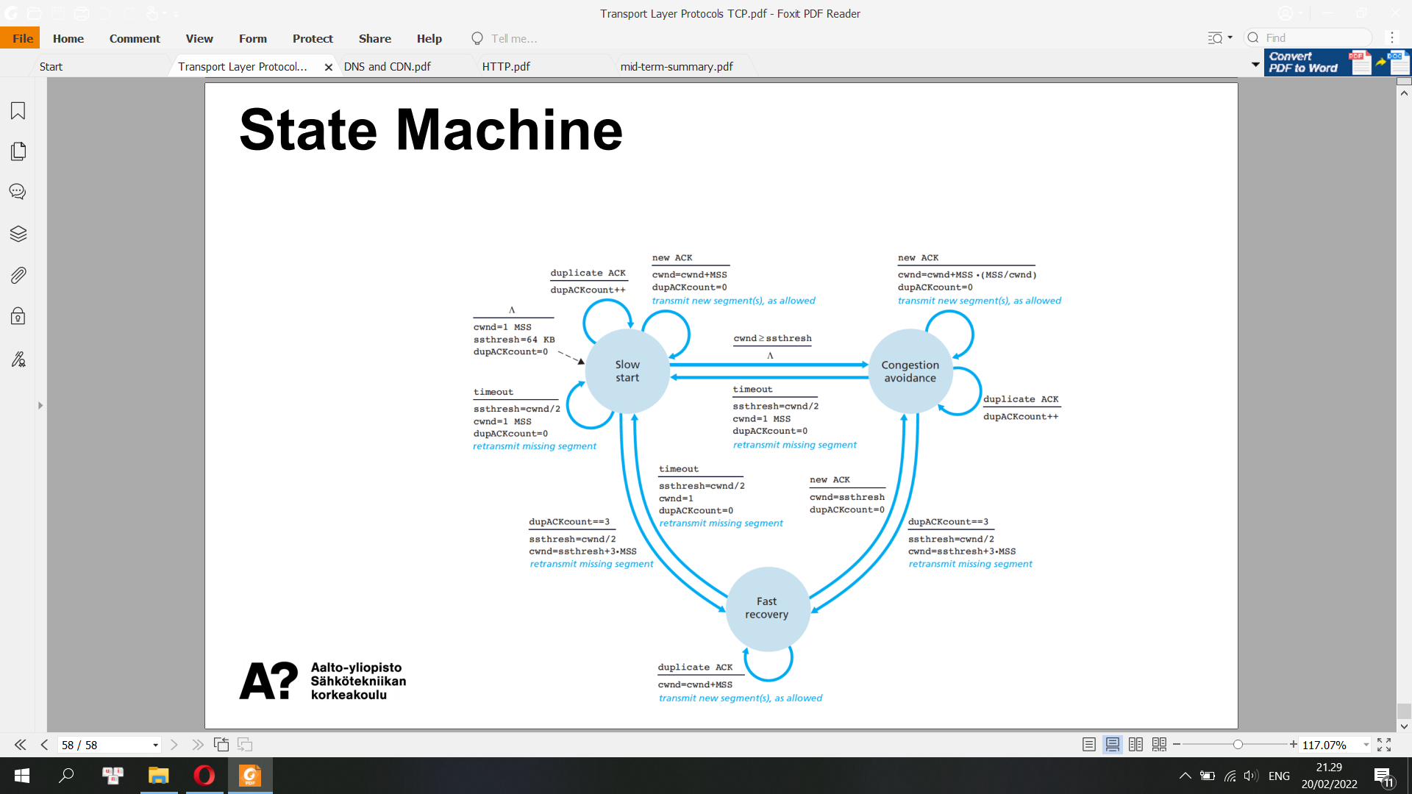

**Self-test: TCP**

**1) Suppose that Host A has received all bytes numbered 0 through 535 from B and suppose that it is about to send a segment to Host B. What should be the acknowledge number of the segment it sends to B?**

In other words, host A is waiting for byte 536 and all the subsequent bytes in host B's data stream. So host A puts 536 in the acknowledgment number field of the segment it sends to B.

**2) Suppose that Host A has received one segment from Host B containing bytes 0 through 535 and another segment containing bytes 900 through 1,000. For some reason Host A has not received bytes 536 through 899. In the next segment sent from A to B, what should be the value of the acknowledge number field?**

In this example, host A is still waiting for byte 536 (and beyond) in order to recreate B's data stream. Thus, A's next segment to B will contain 536 in the acknowledgment number field. Because TCP only acknowledges bytes up to the first missing byte in the stream, TCP is said to provide cumulative acknowledgements.

**Host A received the third segment (bytes 900 through 1,000) before receiving the second segment (bytes 536 through 899). Thus, the third segment arrived out of order. The subtle issue is: What does a host do when it receives out-of-order segments in a TCP connection?**

Interestingly, the TCP RFCs do not impose any rules here, and leave the decision up to the people programming a TCP implementation. There are basically two choices: either (i) the receiver immediately discards out-of-order bytes; or (ii) the receiver keeps the out-of-order bytes and waits for the missing bytes to fill in the gaps. Clearly, the latter choice is more efficient in terms of network bandwidth, whereas the former choice significantly simplifies the TCP code. However, we focus on the former implementation, that is, we assume that the TCP receiver discards out-of-order segments.

**3) Assume that ISN = 0 on both sides. In terms of the sequence and acknowledge numbers, SYNs count as 1 byte, as do FINs. Can you calculate the seg and ack values of each segment?**

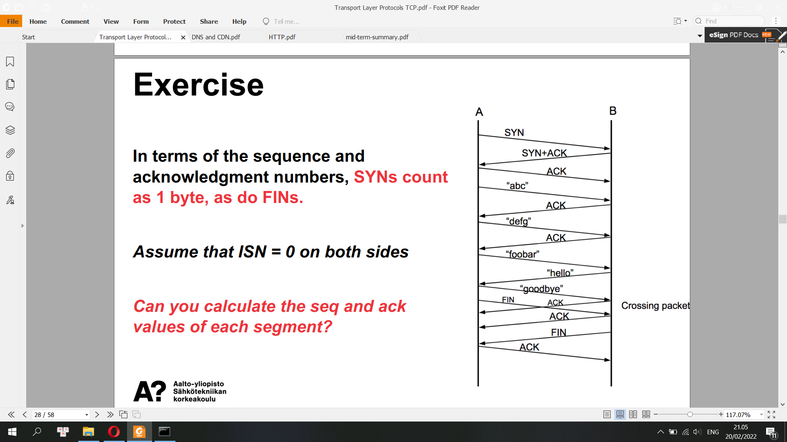

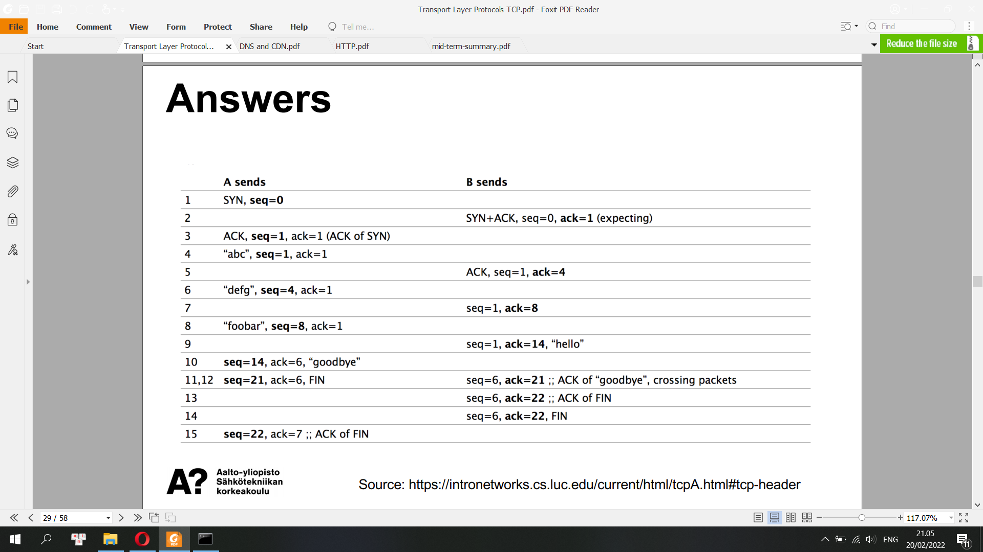

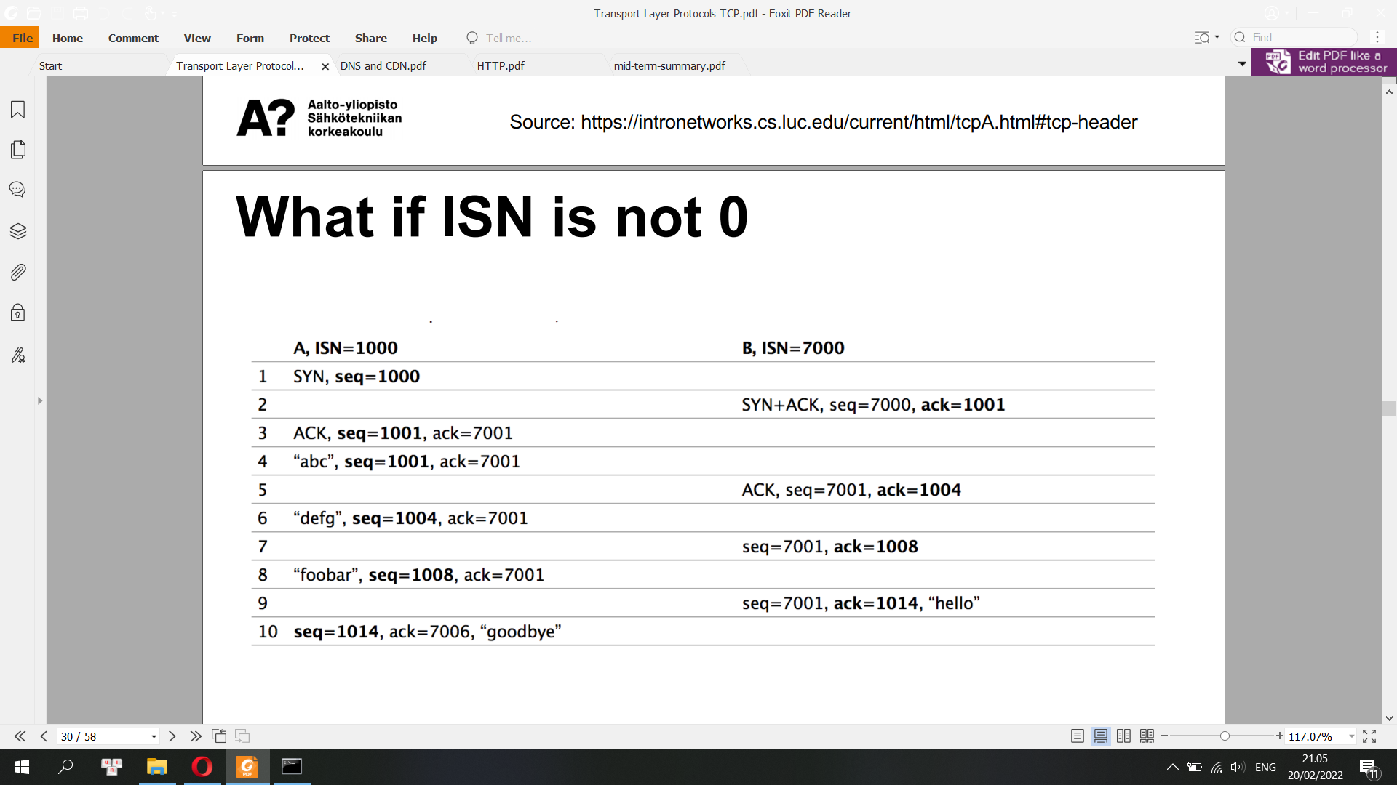

**4) What is receive window rwnd? How does the connection use the variable rwnd to provide the flow control service?**

The Receiver Window (rwnd) is a variable that advertises the amount of data that the destination side can receive. It is the window size part in TCP header

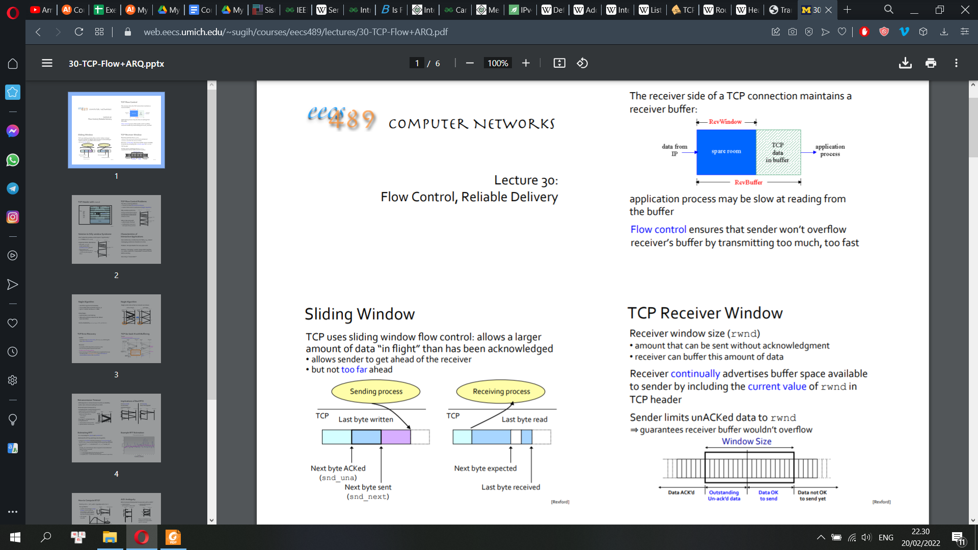

**5) What is congestion window cwnd? How to tune the value of cwnd in slow start**

**and congestion avoidance modes, respectively? When should the connection transition from slow start mode into congestion avoidance mode, and vice versa?**

**What would happen if senders collectively send too fast or too slowly?**

Congestion Window (cwnd) is a TCP state variable that limits the amount of data the TCP can send into the network before receiving an ACK.

* How to tune the value of cwnd in slow start and congestion avoidance modes:

- In slow start:

+ Set initial cwnd = 1

+ cwnd = cwnd x 2 after receiving cwnd ACKs

+ The TCP send rate starts slow but grows exponentially during the slow start phase

- In congestion avoidance mode:

+ cwnd = cwnd + 1 MSS whenever a new ACK arrives

+ If congestion was indicated by a timeout, cwnd is reset to 1 segment, which automatically puts the sender into slow start mode

+ If congestion was indicated by duplicate Acknowledgements the fast retransmit and fast recovery algorithms are invoked.

- Fast recovery mode:

After receiving 3 duplicate ACKs in a row:

1) Set ssthresh = cwnd/2.

2) Retransmit the missing segment.

3) Set cwnd = ssthresh + 3.

4) Each time another duplicate ACK arrives, set cwnd = cwnd + 1. Then, send a new data segment if allowed by the value of cwnd.

5) Once receive a new ACK (an ACK which acknowledges all intermediate segments sent between the lost packet and the receipt of the first duplicate ACK), exit fast recovery. This causes setting cwnd to ssthresh (the ssthresh in step 1). Then, continue with linear increasing due to congestion avoidance algorithm.

* When should the connection transition from slow start mode into congestion avoidance mode, and vice versa:

- When cwnd reaches or surpasses ssthresh, slow start ends and TCP transitions into congestion avoidance mode

- If congestion was indicated by a timeout, cwnd is reset to 1 segment, which automatically puts the sender into slow start mode

**6) What are the limitations of TCP?**

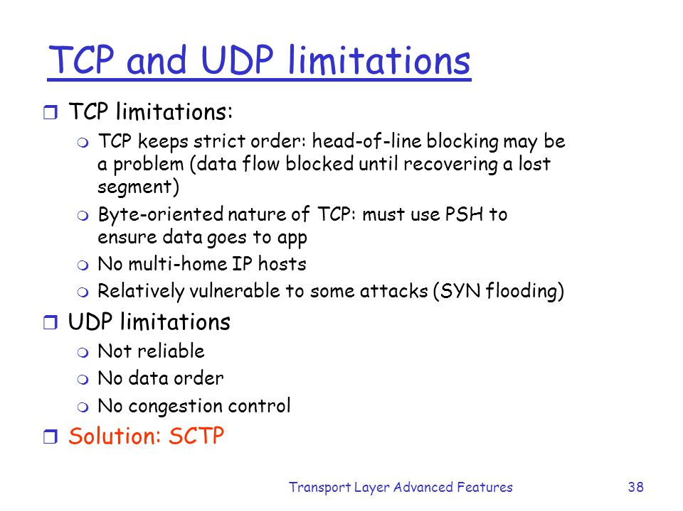

**How does the connection use the variable rwnd to provide the flow control service?**

It tells the sender the maximum speed at which the data can be sent to the receiver device. The sender adjusts the speed as per the receiver’s capacity to reduce the frame loss from the receiver side

**What would happen if senders collectively send too fast or too slowly?**

Overview of Flow control and congestion control

**I. Flow Control in TCP**

Flow control deals with the amount of data sent to the receiver side without receiving any acknowledgment. It makes sure that the receiver will not be overwhelmed with data. It’s a kind of speed synchronization process between the sender and the receiver. The data link layer in the OSI model is responsible for facilitating flow control.

Let’s take a practical example to understand flow control. Jack is attending a training session. Let’s assume he’s slow in grasping concepts taught by the teacher. On the other hand, the teacher is teaching very fast without taking any acknowledgment from the students.

After some time, every word that comes out from his teacher is overflowing over Jack’s head. Hence, he doesn’t understand anything. Here, the teacher should be having information about how many concepts a student can handle at a time.

After some time, Jack requested the teacher to slow down the pace as he was overwhelmed with the data. The teacher decided to teach some of the concepts first and then wait for acknowledgment from the students before proceeding to the following concepts.

Similar to the example, the flow control mechanism tells the sender the maximum speed at which the data can be sent to the receiver device. The sender adjusts the speed as per the receiver’s capacity to reduce the frame loss from the receiver side.

Flow control in TCP ensures that it’ll not send more data to the receiver in the case when the receiver buffer is already completely filled. The receiver buffer indicates the capacity of the receiver. The receiver won’t be able to process the data when the receiver buffer is full:

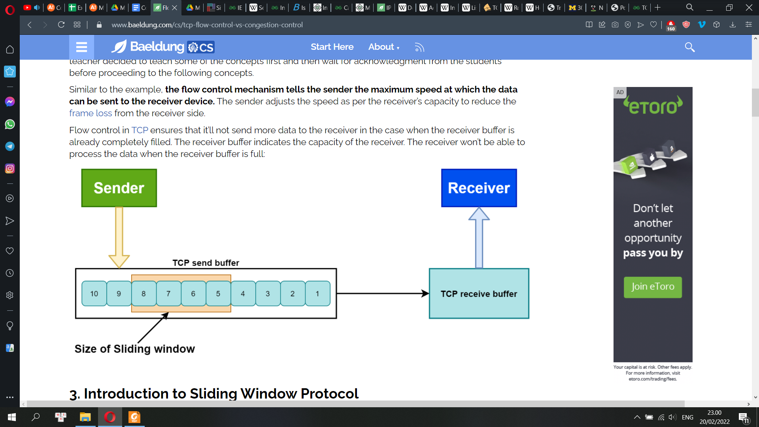

**II Congestion Control**

Congestion control is a mechanism that limits the flow of packets at each node of the network. Thus, it prevents any node from being overloaded with excessive packets. Congestion occurs when the rate of flow of packets towards any node is more than its handling capacity.

When congestion occurs, it slows down the network response time. As a result, the performance of the network decreases. Congestion occurs because routers and switches have a queue buffer, holding the packets for processing. After the holding process completes, they pass the packet to the next node, resulting in congestion in the network.

There are three phases that TCP uses for congestion control: slow start, congestion avoidance, and congestion detection:

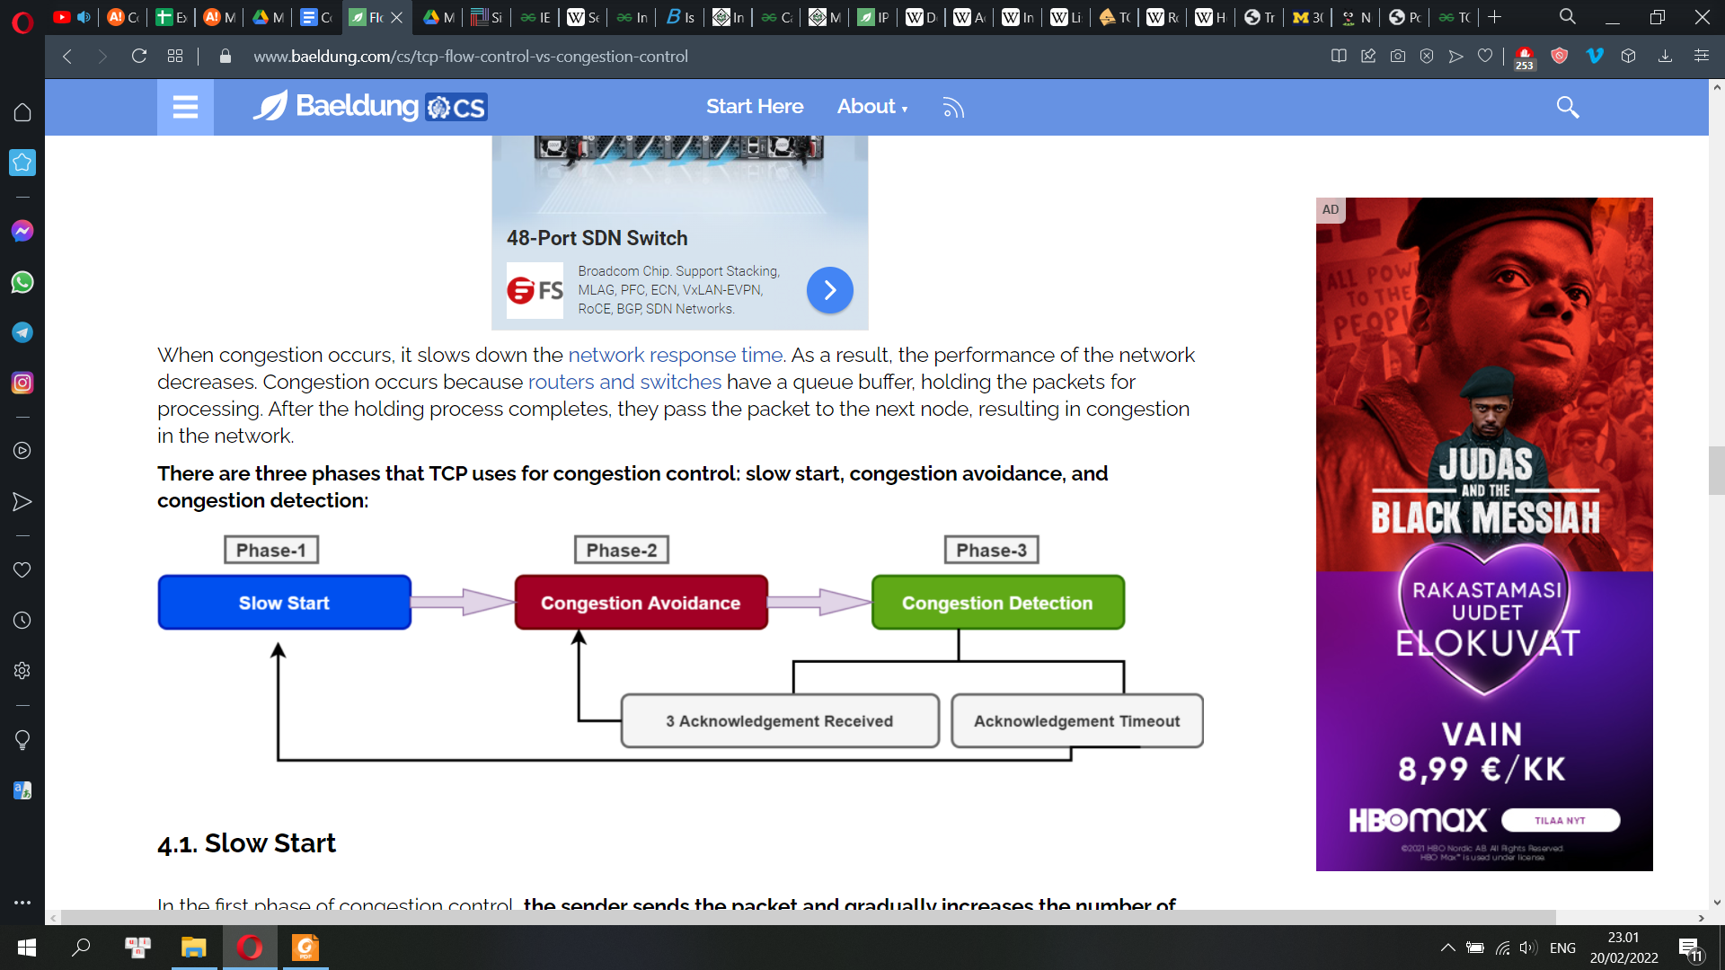

**TCP Congestion Control**

**1) How does a TCP sender limit the rate at which it sends traffic into its connection?:**

The congestion window indicates the maximum amount of data that can be sent out on a connection without being acknowledged. If a TCP sender perceives that there is little congestion on the path between itself and the destination, then the TCP sender increases its send rate; if the sender perceives that there is congestion along the path, then the sender reduces its send rate.

**2) How does a TCP sender perceive that there is congestion on the path between itself and the destination?**: TCP uses a congestion window in the sender side to do congestion avoidance. The congestion window indicates the maximum amount of data that can be sent out on a connection without being acknowledged. TCP detects congestion when it fails to receive an acknowledgement for a packet within the estimated timeout.

**3) What algorithm should the sender use to change its send rate as a function of perceived end-to-end congestion?:** slow start, congestion avoidance and fast recovery algorithms

**How to determine Maximum Segment Size (MSS)?**

In order to notify MSS to the other end, an inter-layer communication is done as follows:

* The Network Driver (ND) or interface should know the Maximum Transmission Unit (MTU) of the directly attached network.
* The IP should ask the Network Driver for the Maximum Transmission Unit.
* The TCP should ask the IP for the Maximum Datagram Data Size (MDDS). This is the MTU minus the IP header length (MDDS = MTU - IPHdrLen).
* When opening a connection, TCP can send an MSS option with the value equal to: MDDS - TCPHdrLen. In other words, the MSS value to send is: MSS = MTU - TCPHdrLen - IPHdrLen

**Do you remember what Maximum Transmission Unit (MTU) is?**

A maximum transmission unit (MTU) is the largest packet or frame size, specified in octets (eight-bit bytes) that can be sent in a packet- or frame-based network such as the internet. The internet's transmission control protocol (TCP) uses the MTU to determine the maximum size of each packet in any transmission.

**(Hypertext Transfer Protocol) HTTP**

HTTP is an application layer protocol for distributed, collaborative, hypermedia information system.

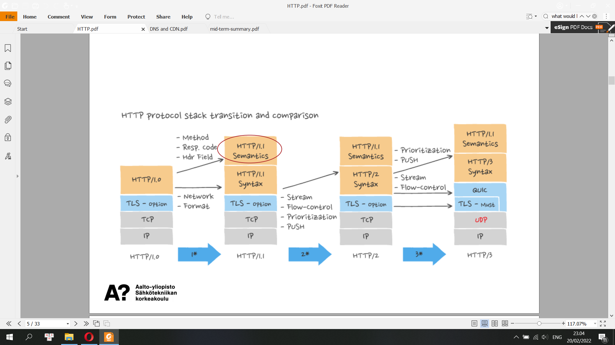

Transport Layer Security (TLS), the successor of the now-deprecated Secure Sockets Layer (SSL), is a cryptographic protocol designed to provide communications security over a computer network. The protocol is widely used in applications such as email, instant messaging, and voice over IP, but its use in securing HTTPS remains the most publicly visible.

The TLS protocol aims primarily to provide cryptography, including privacy (confidentiality), integrity, and authenticity through the use of certificates, between two or more communicating computer applications. It runs in the application layer and is itself composed of two layers: the TLS record and the TLS handshake protocols.

The familiar Hypertext Transfer Protocol (HTTP) is most often associated with the World Wide Web. This is one of the transfer protocols in use on the internet. Others include File Transfer Protocol (FTP) and Simple Mail Transfer Protocol (SMTP). HTTP is by far the most used transport protocol for web services, and it plays a crucial role in REST.

The HTTP specification describes messages that represent requests from a client to a server and responses from a server to a client. A message from a client to a server indicates a method (i.e., an action) that is desired for a specific resource designated by a URI, (Universal Resource Identifier). URIs are simply formatted strings which identify by name, location or some other characteristic, a resource located on the internet.

HTTP methods include GET, PUT, POST, DELETE, HEAD, TRACE, and CONNECT. To create web services using BIS, only the first four methods are important.

**HTTP Semantics**

“This document defines the semantics of HTTP/1.1 messages, as expressed by request methods, request header fields, response status codes, and response header fields, along with the payload of messages (metadata and body content) and mechanisms for content negotiation.”

**Resources**

• Resources are identified with Uniform Resource Identifiers (URIs)

• A URI is a sequence of characters that identifies a logical or physical resource.

• Multiple URIs may refer to same resource

• Separate from their representation(s)

**URI**

Two types of URIs:

• Uniform Resource Locators (URLs) e.g., http://www.google.com

• Uniform Resource Names (URNs)

• URN does not state which protocol should be used to locate and access the resource. It labels the resource with a persistent, location-independent unique identifier. The generic form of any URI is scheme:[//[user:password@]host[:port]][/]path[?query][#fragment]

**REST Resource Naming Guide**

• A resource can be a singleton or a collection

/customers /customers/{customerId}

• A resource may contain sub-collection resources

/customers/{customerId}/accounts/{accountId}

**REST (Representational State Transfer)**

REST is an architectural style with six constraints:

• Client-server architecture

• Uniform interface

• Stateless

• Layered System

• Cacheable

• Code on Demand (optional)

**Representation**

• A "representation" is information that is intended to reflect a past, current, or desired state of a given resource, in a format that can be readily communicated via the protocol, and that consists

of a set of representation metadata and a potentially unbounded stream of representation data.

• Example:

• Resource: Person

Service: contact information (GET)

Representation:

+ Name, address, phone number

+ JSON or XML format

**Client-server architecture**

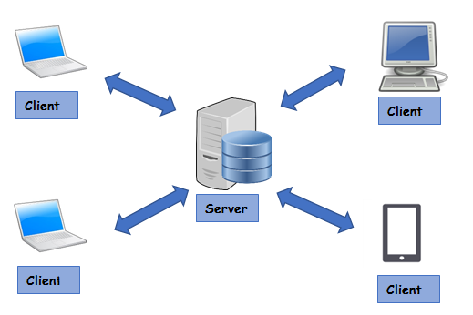

**Uniform Interface**

• Defines the interface between client and server

• Simplifies and decouples the architecture

• For us this means:

+ HTTP verbs

+ URIs (resource name)

+ HTTP response

**HTTP is stateless**

• Server contains no client state

• Each request contains all of the information necessary to understand the request, and all session state data should then be returned to the client at the end of each request

• Server will not store anything about latest HTTP request client made. It will treat each and every request as new.

• Statelessness ensures that each request can be treated independently

**Layered System**

• Client can’t assume direct connection to server

• Allow software or hardware intermediaries (e.g. proxies,

gateways, and firewalls) between client and server

• Improves scalability

**Cacheable**

• Server responses (representations) are cacheable

• Services must be designed to produce accurate cache control metadata and return it in response messages.

• Response messages are marked as cacheable or non-cacheable, either with explicit message metadata or as part of the contract definition.

• An optional consumer-side or intermediary cache repository enables the consumer to reuse cacheable response data for later request messages.

• Request messages must be comparable to determine whether or not they are equivalent.

**Code on demand (the only optional constraint)**

• REST allows client functionality to be extended by downloading and executing code in the form of applets or scripts

• Allow logic within clients (such as Web browsers) to be updated independently from server-side logic

• For example: Jave applets, JavaScript

**HTTP Request Methods**

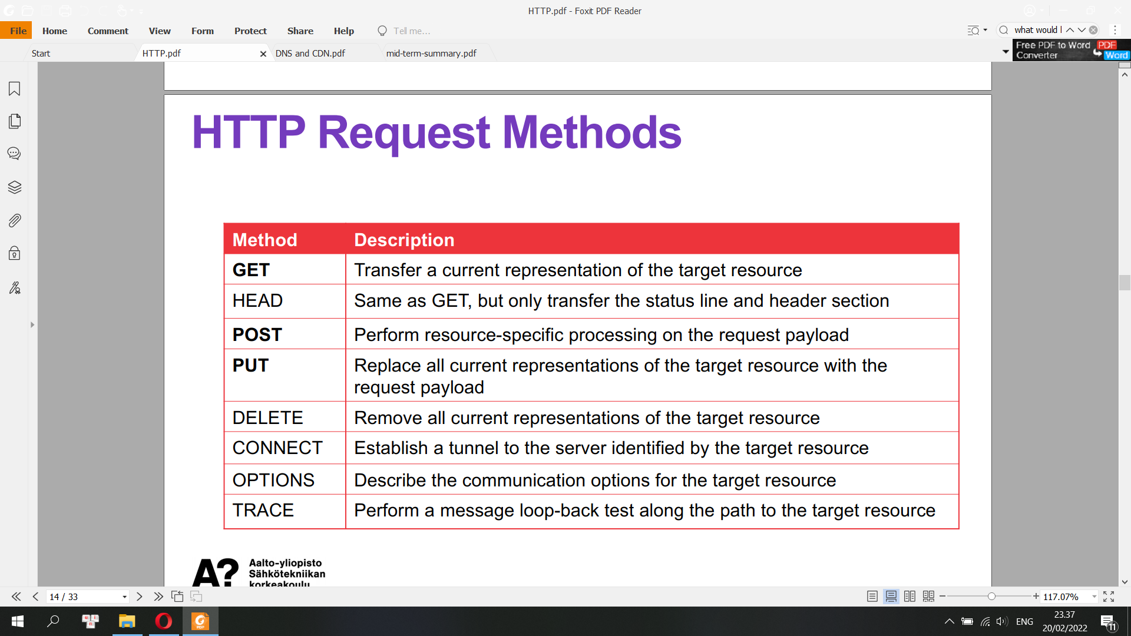

**Request Header Fields**

“A client sends request header fields to provide more information about

the request context, make the request conditional based on the target

resource state, suggest preferred formats for the response, supply

authentication credentials, or modify the expected request processing.”

-- RFC7231

• Controls (e.g. Cache-Control)

• Conditionals (e.g. if-match)

• Content Negotiation(e.g. Accept, Accept-Encoding)

• Authentication Credentials

• Request Context (e.g. from, user-agent)

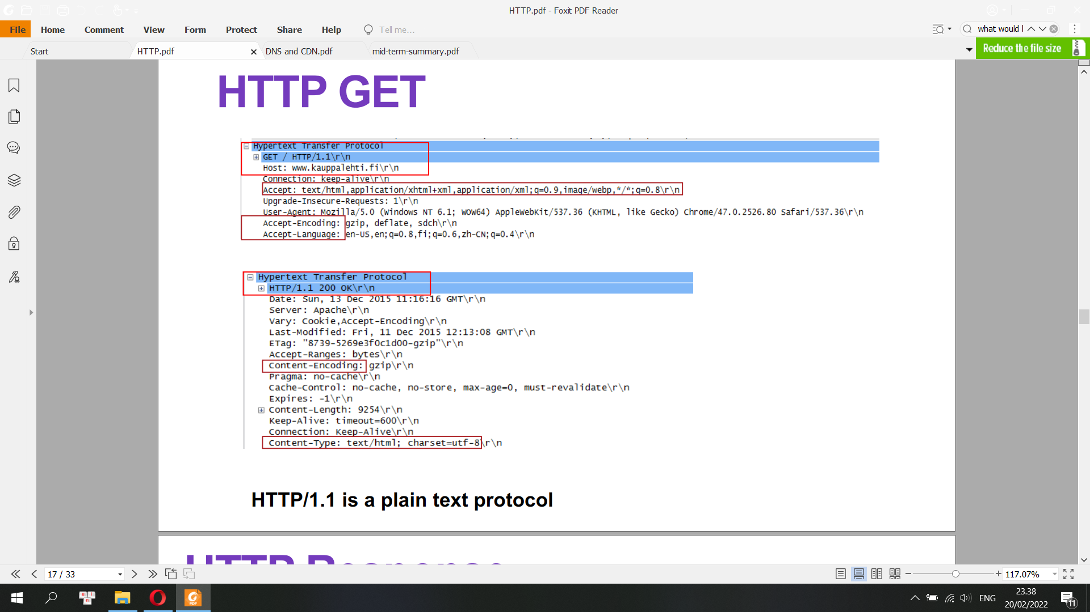

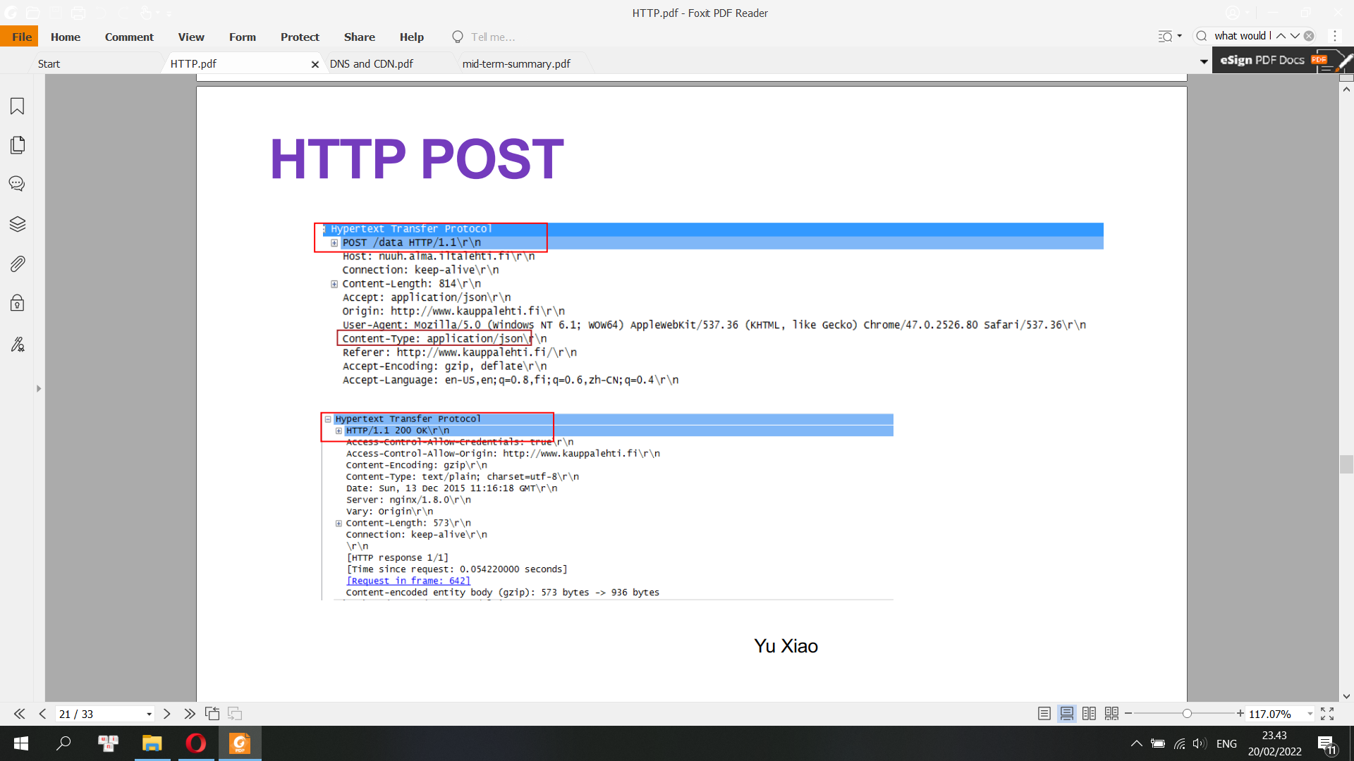

• The POST request method requests that a web server accepts the entity enclosed in the body of the request message as a new subordinate of the web resource identified by the URI

• POST changes the state of the server

• Examples: submitting a web form

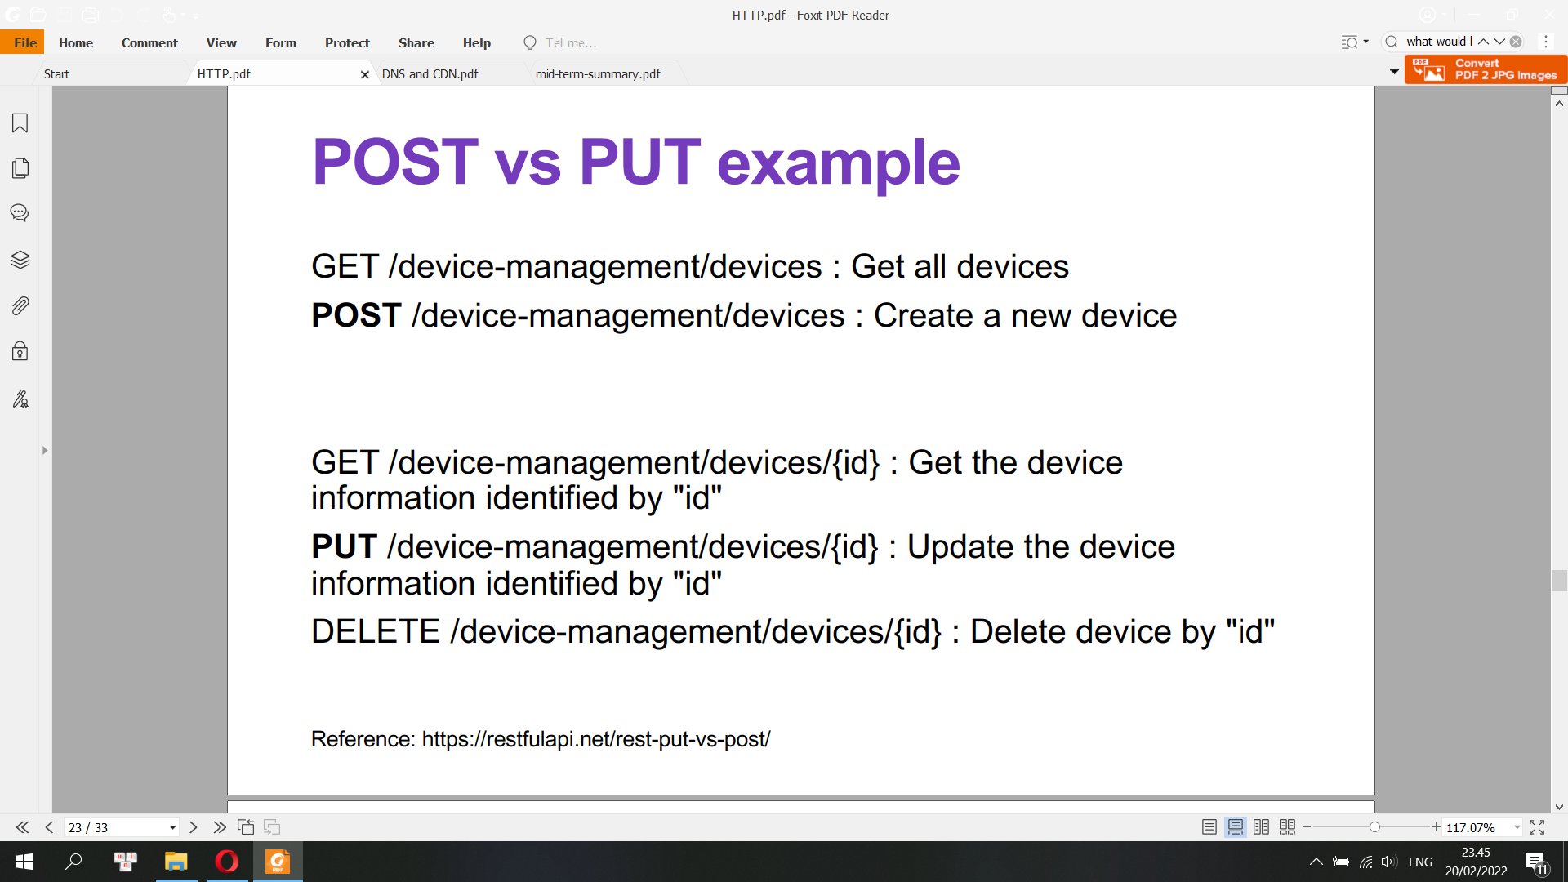

• The PUT method requests that the enclosed entity be stored under the supplied URI

• If the URI refers to an already existing resource, it is modified; if the URI does not point to an existing resource, then the server can create the resource with that URI

**HTTP Response**

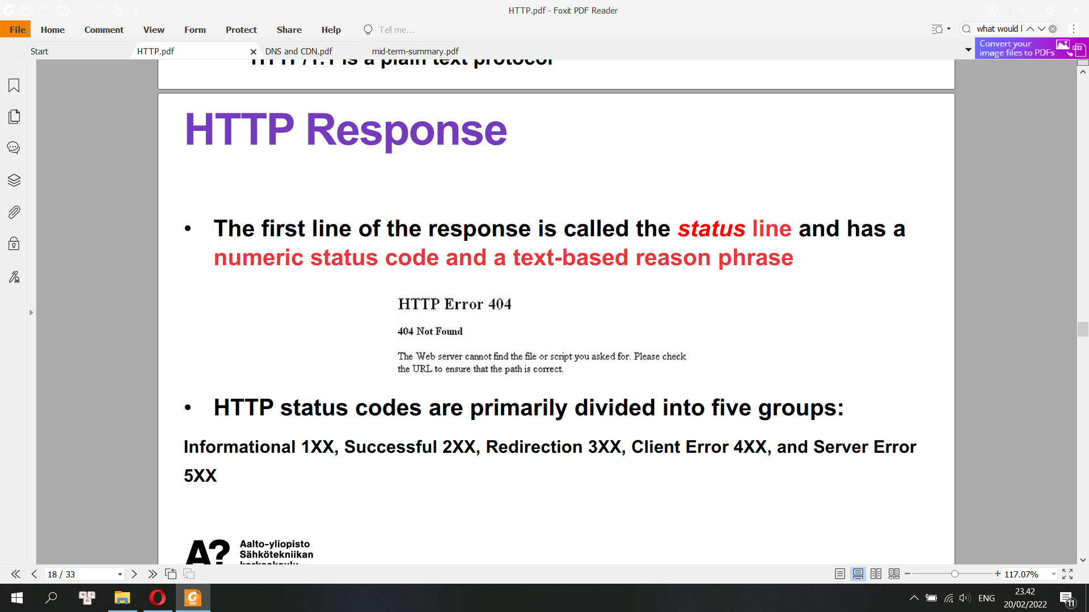

**Response Header Fields**

These header fields give information about the server, about further access to the target resource, or about related resources.

• Control Data (e.g. directs caching, or instructs the client where to go next)

• Validator Header Fields

• Authentication Challenges

• Response Context

**HTTP/1.1 vs. HTTP/2**

• Both HTTP/1.1 and HTTP/2 run on top of TCP

• HTTP/2 maintains high compatibility for methods, status code, URI’s and header fields with HTTP/1.1

• HTTP/2 supports all the core features of HTTP/1.1, but aims to be more efficient in several ways

• HTTP/2 is a binary protocol, instead of a plain text protocol

Plain text protocols are pretty simple to debug. You print out their contents and you can see exactly what happened.

Binary protocols are a bit harder, simply because they need translation before you read them. But they have one huge advantage in that they are much more compact, and thus far more efficient.

**HTTP Pipelining**

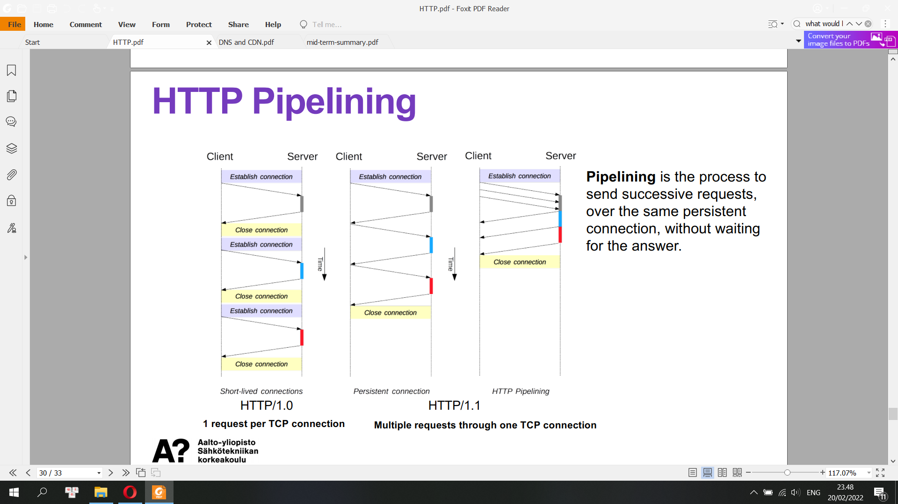

Pipelining is the process to send successive requests, over the same persistent connection, without waiting for the answer.

**Head of Line Blocking**

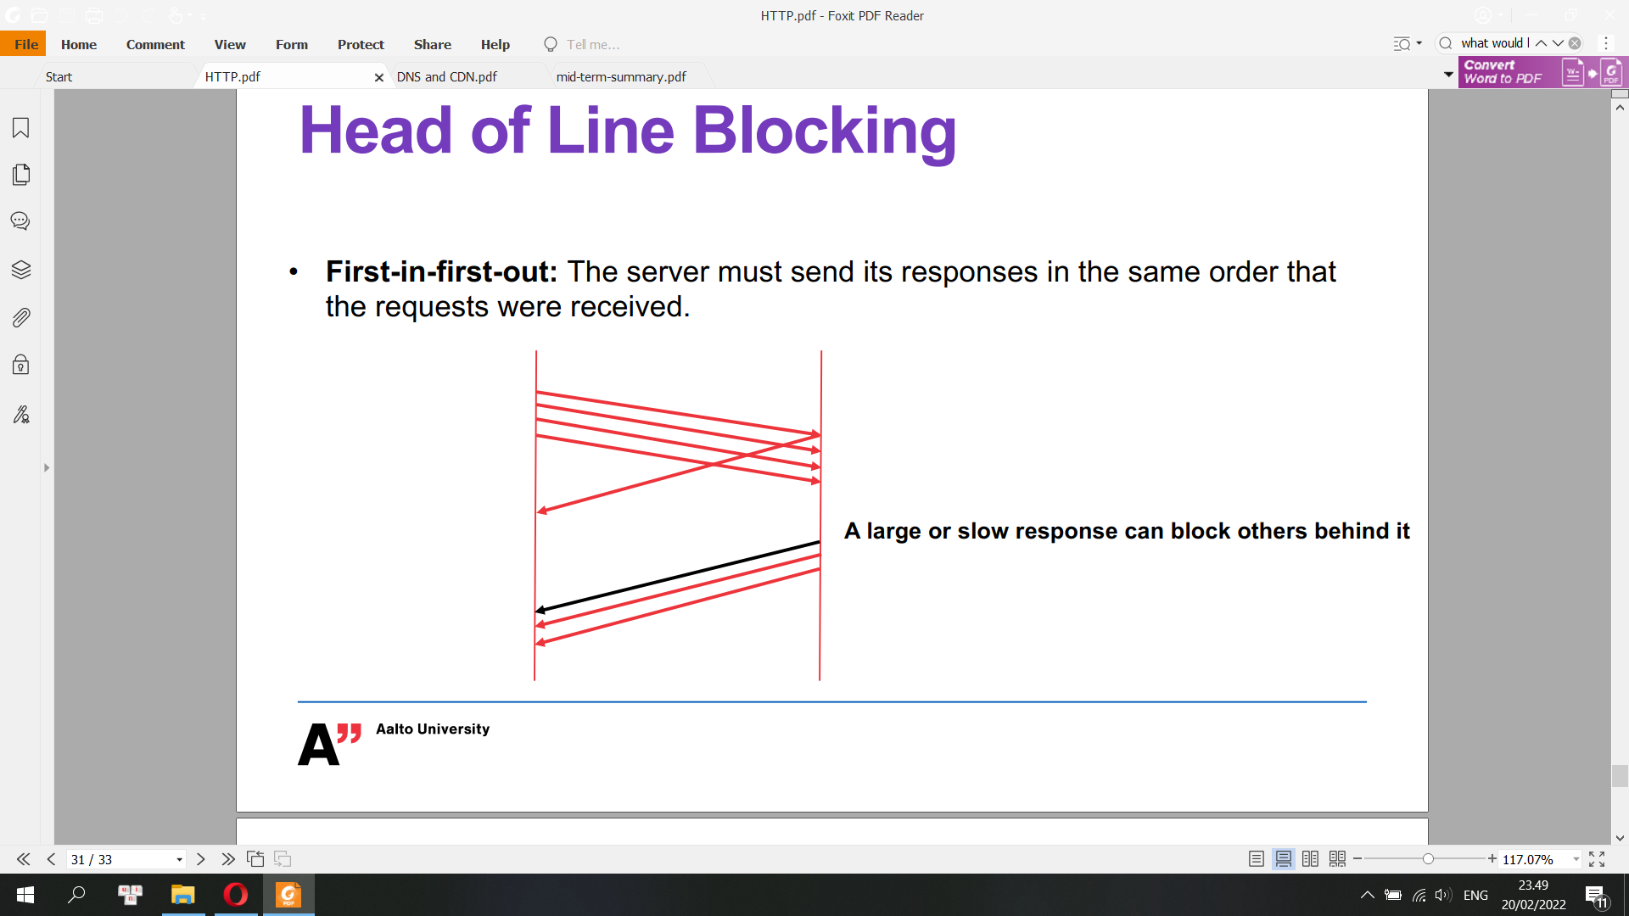

**Primary Goals of HTTP/2**

• Reduce latency by enabling full request and response multiplexing. Multiplexing allows your Browser to fire off multiple requests at once on the same connection and receive the requests back in any order.

• Minimize protocol overhead via efficient compression of HTTP header fields

• Add support for request prioritization and server push.

HTTP/2 prioritization is requested by the client (browser) and it is up to the server to decide what to do based on the request.

HTTP/2 Server Push allows an HTTP/2-compliant server to send resources to a HTTP/2-compliant client before the client requests them. Server Push is a performance technique aimed at reducing latency by loading resources preemptively, even before the client knows they will be needed

**Self-Test HTTP**

**• HTTP request methods: GET, PUT, POST**

**• HTTP response status line**

**• Is HTTP stateless or not?**

**• What is head of line blocking?**

**<Check all above>**

**Domain Name System (DNS) and Content Delivery Network (CDN)**

Domain Names

• Domain names -> resources (e.g., computers, websites)

• Paths in an inverted tree

• An inverted tree is made up of nodes and links between nodes

• Each node is connected to its parent by a single link

• One node can be parent to arbitrarily many children

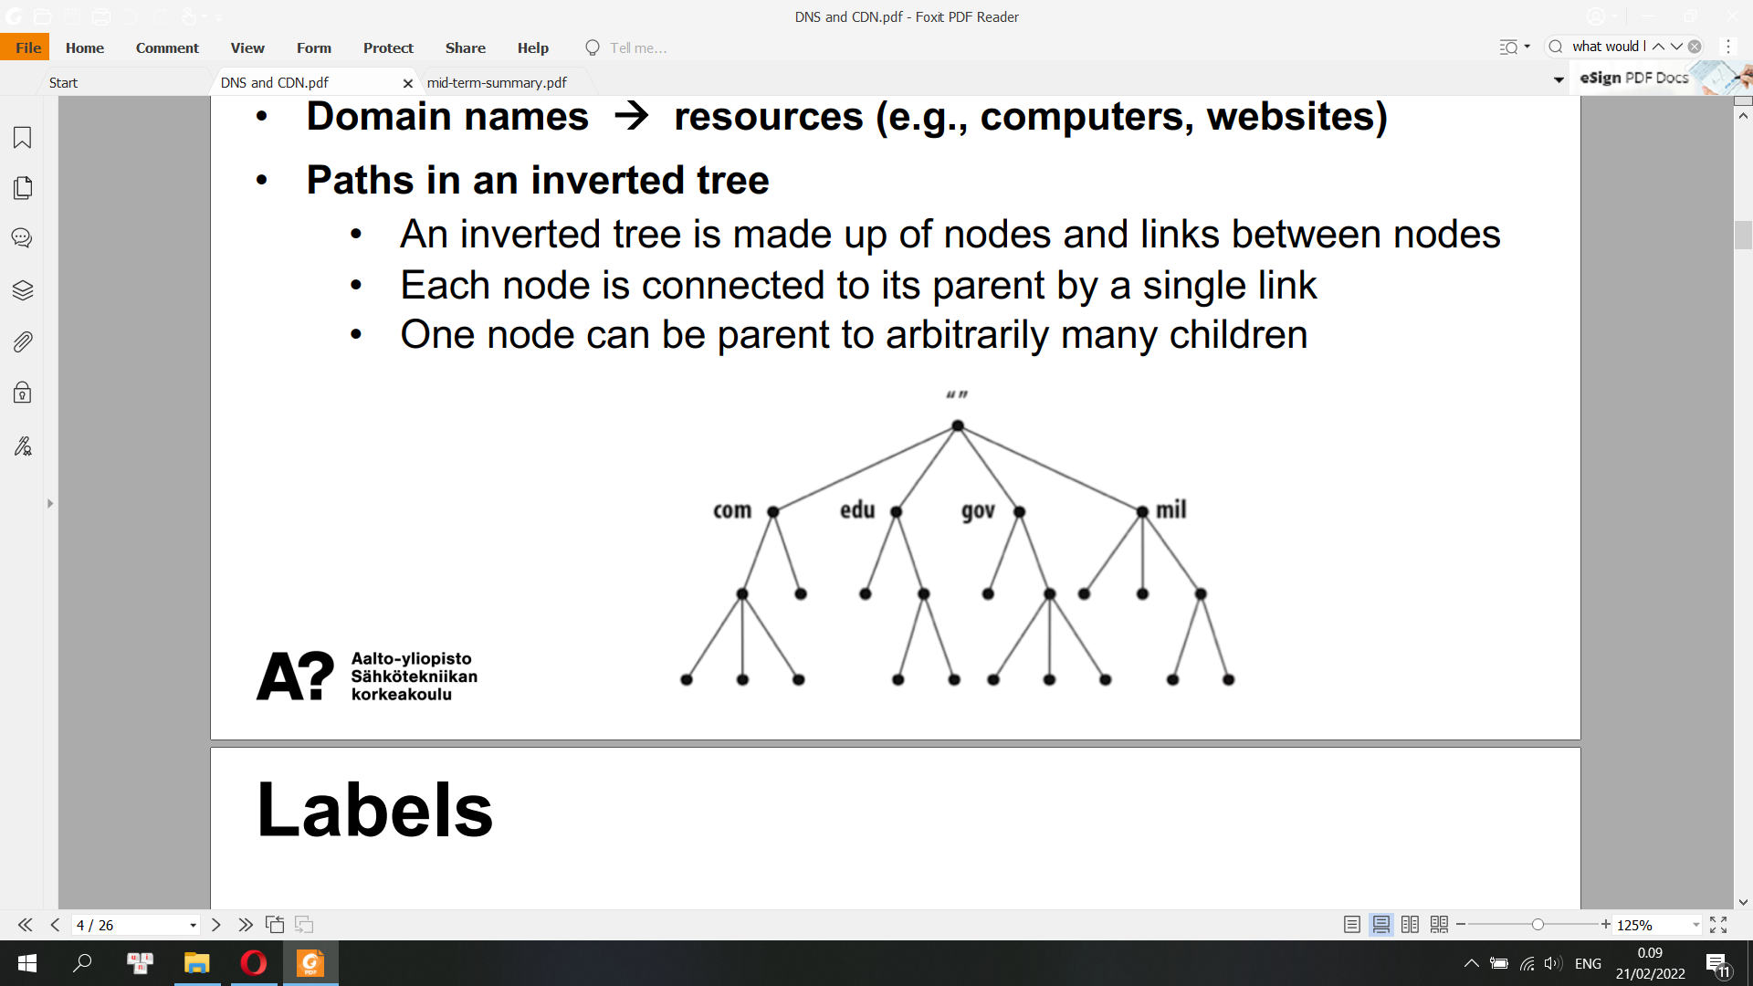

**Labels**

• Each node has a label, between 0 and 63 bytes in length

• The root node (at the top) has a special, reserved label, written “” (for a zero-length label)

• Otherwise, the main restriction is that all of the children of a node have different labels

• Domain name: the series of labels from the node to the root, read with dots separating the labels

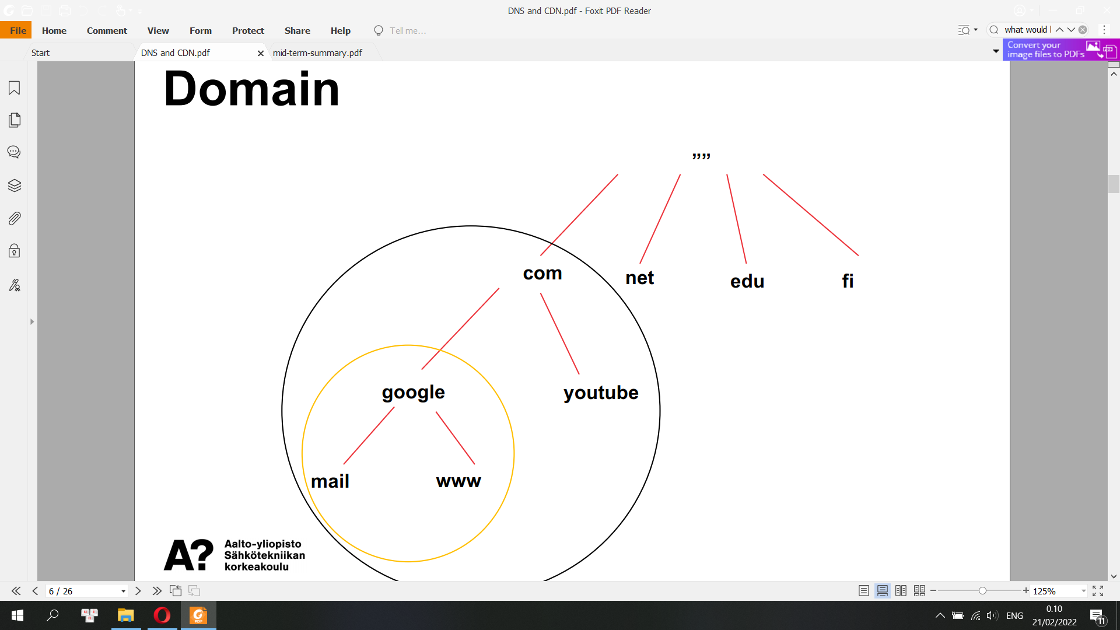

**Domain Name System (DNS)**

The Domain Name System (DNS) is the Internet's system for mapping alphabetic names to numeric Internet Protocol (IP) addresses

• Application layer protocol, responsible for mapping domain names into IP addresses

• DNS protocol relies on UDP by default, but can also work over TCP as a fallback when firewalls block UDP.

• DNS is a distributed database

• Resolver: A DNS client that sends DNS messages to obtain information about the requested domain name space

• A DNS name server is a server that stores the DNS records for a domain; A DNS name server responds with answers to queries against its database

**DNS Zones**

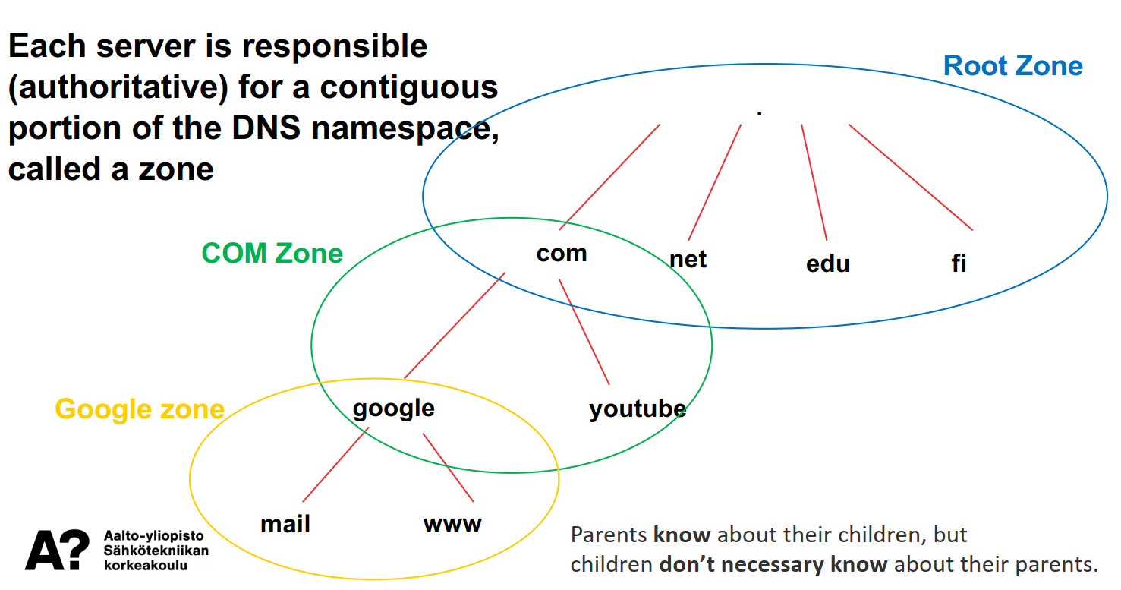

**Recursive Query**

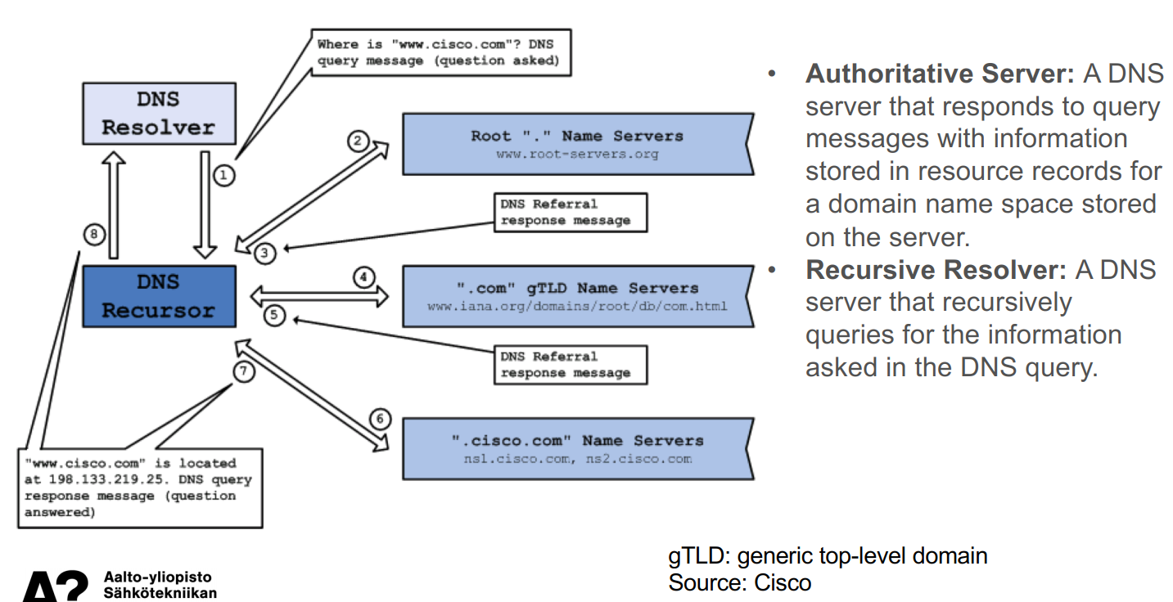

**DNS Messages**

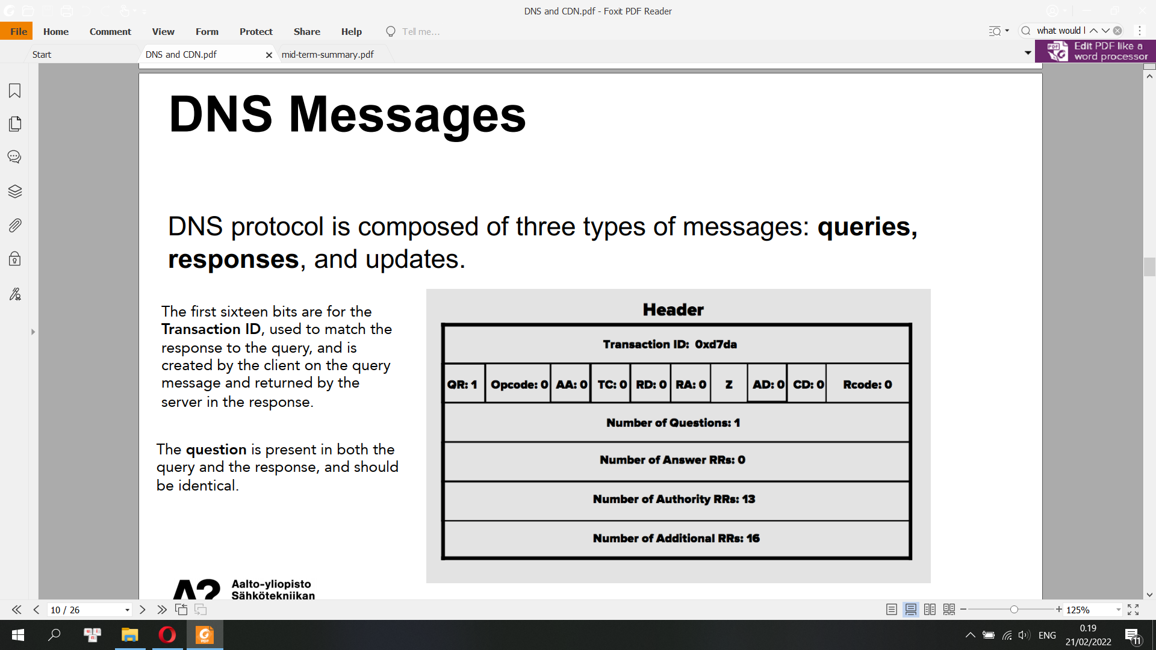

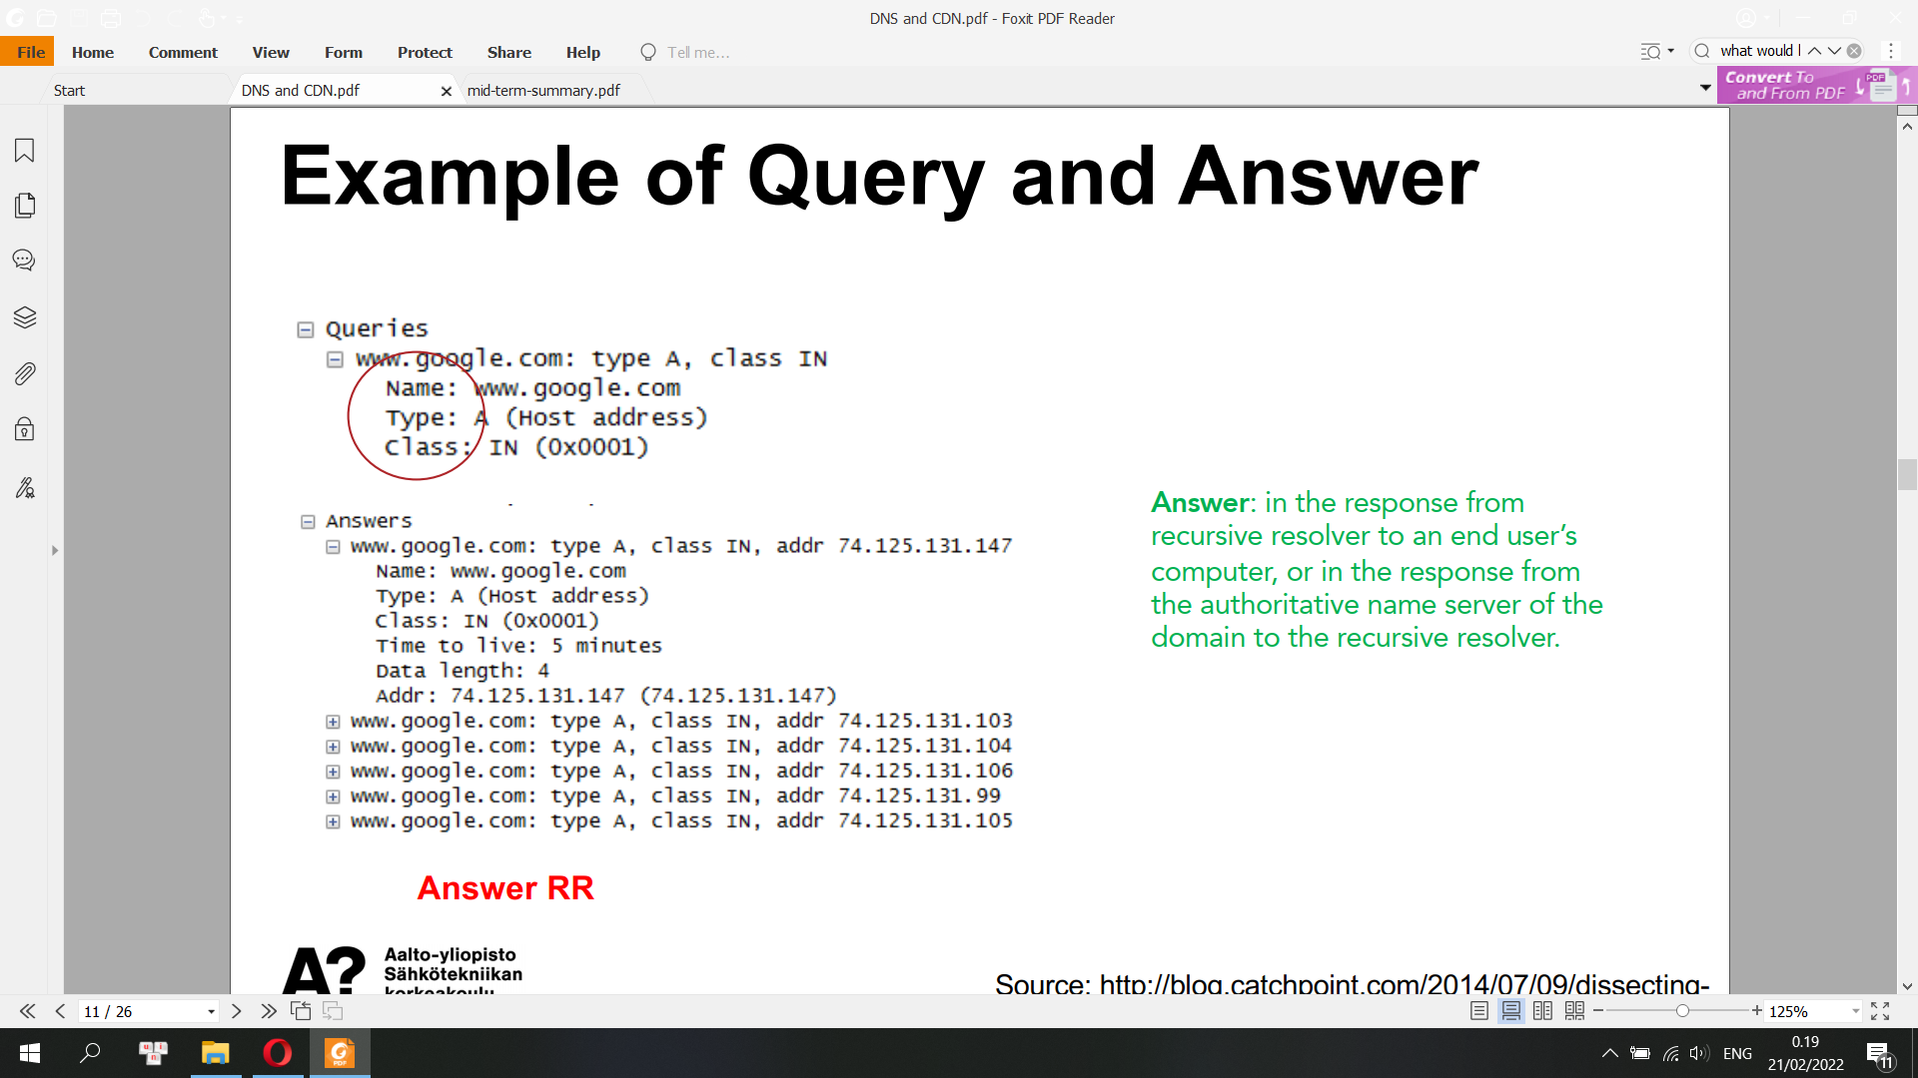

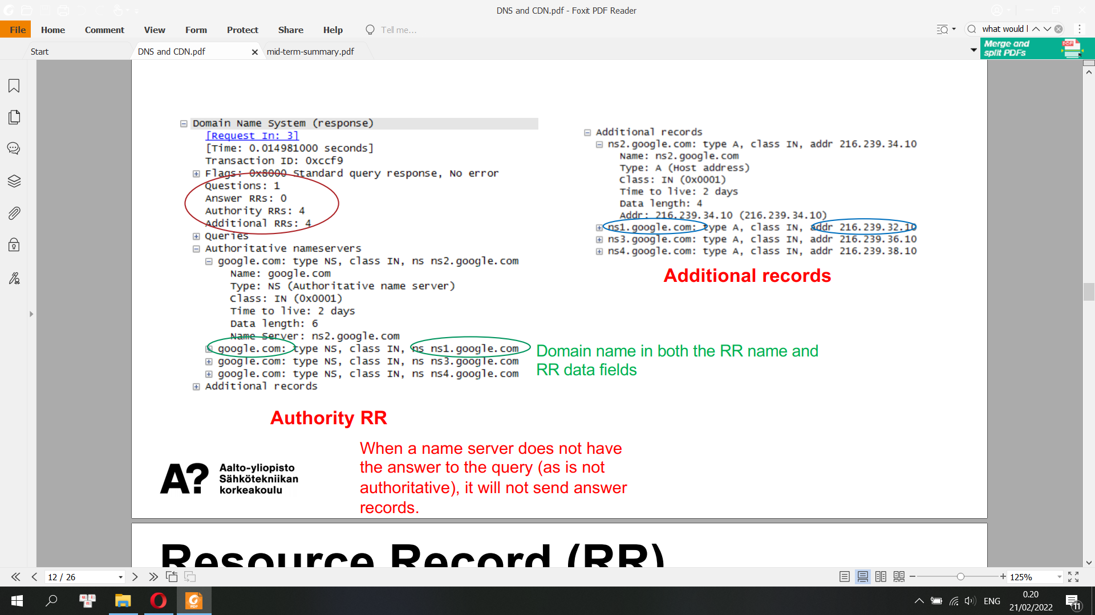

**Resource Record (RR)**

• A resource record is a format used in DNS message that is composed of NAME, TYPE, CLASS, TTL, RDLENGTH, and RDATA.

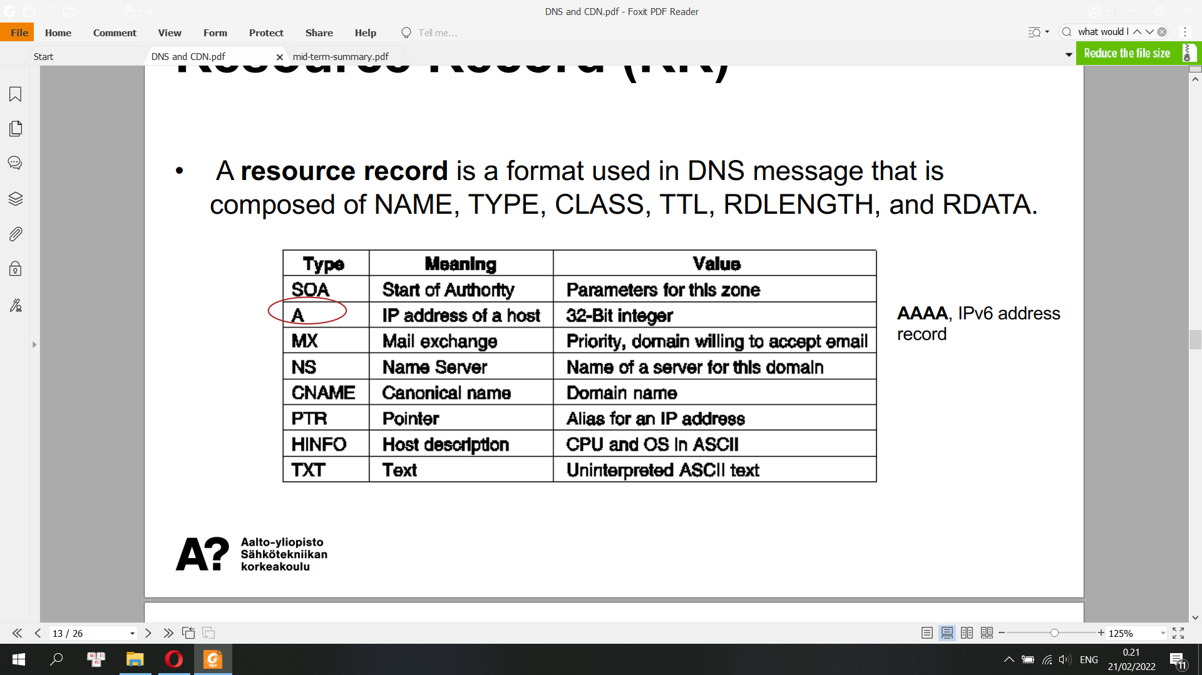

**DNS Caching**

• Temporarily storing the results of recently browsed websites’ DNS queries on a local file for faster retrieval

• DNS clients and DNS server both use caching to speed up the domain name lookup process and to ease traffic on the root servers

• In the context of a DNS record, Time to Live (TTL) is a numerical value that determines how long a DNS cache server can serve a DNS record before reaching out to the authoritative DNS server and getting a new copy of the record

**Host Names**

• A hostname is a domain name that has at least one associate IP address. (e.g. www.aalto.fi)

• A valid domain name may not necessarily be valid as a hostname

**Anycast Addressing**

• Anycast addresses are allocated from the unicast address space. Assigning a unicast address to more than one interface makes a unicast address an anycast address. Example:

ipv6 address 2002:0db8:6301::/128 anycast

• Anycast Address can not be used as source address of IPv6 packet

• The routing algorithm selects the single receiver from the group based on least-expensive routing metric (e.g. #hops, distance, latency, efficiency, cost)

An anycast address is an address allocated to a set of interfaces that typically belong to different routers. When a packet is destined to an anycast address, it is delivered to the closest interface that has this anycast address, where the term “closest” is determined by the routing protocol. An anycast address must be assigned to a router not a host and cannot be used as a source address

**Content Delivery Network (CDN):** is a group of geographically distributed servers that speed up the delivery of web content by bringing it closer to where users are. ... CDNs cache content like web pages, images, and video in proxy servers near to your physical location. CDN makes your website load fast all around the world

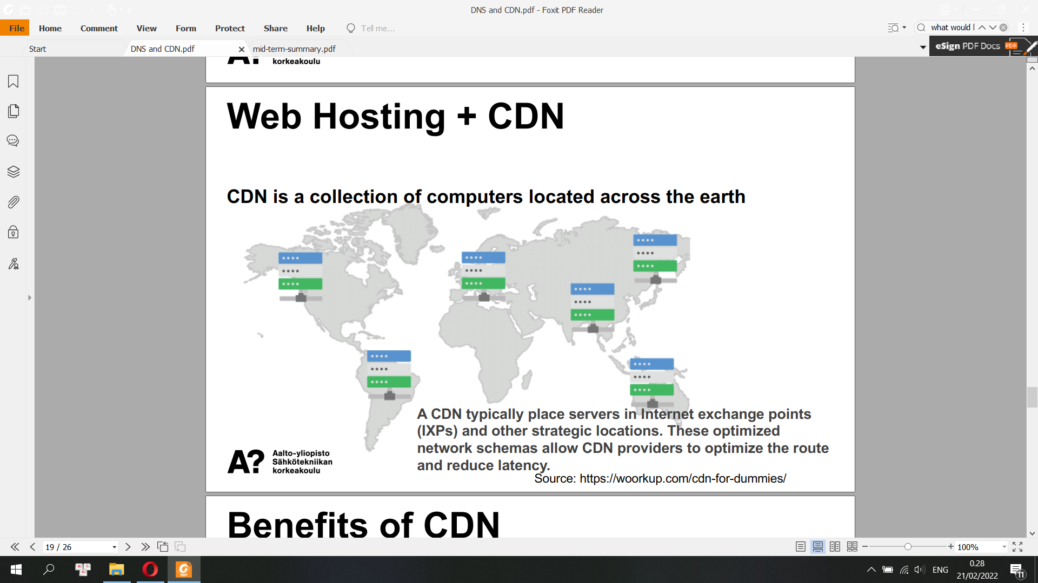

Benefits of CDN

• With a CDN requests to your website are always routed to the nearest available server.

• A CDN improves the latency by pulling static content files from the origin server into the distributed CDN network in a process called caching.

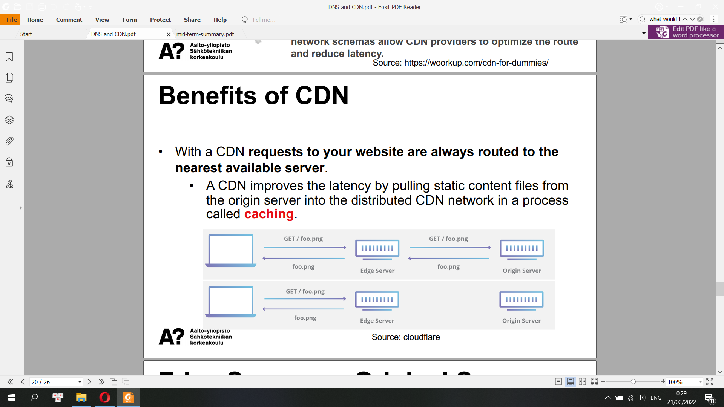

**Edge Server vs. Original Server**

• This interplay between edge servers handling static content and origin servers serving up dynamic content is a typical separation of concerns when using a CDN.

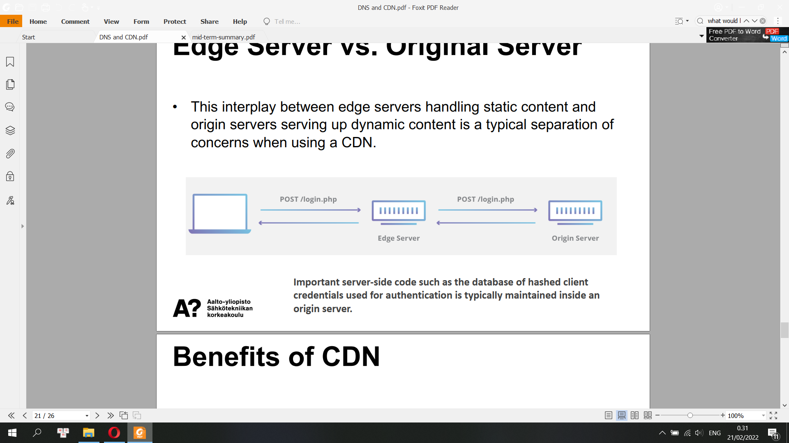

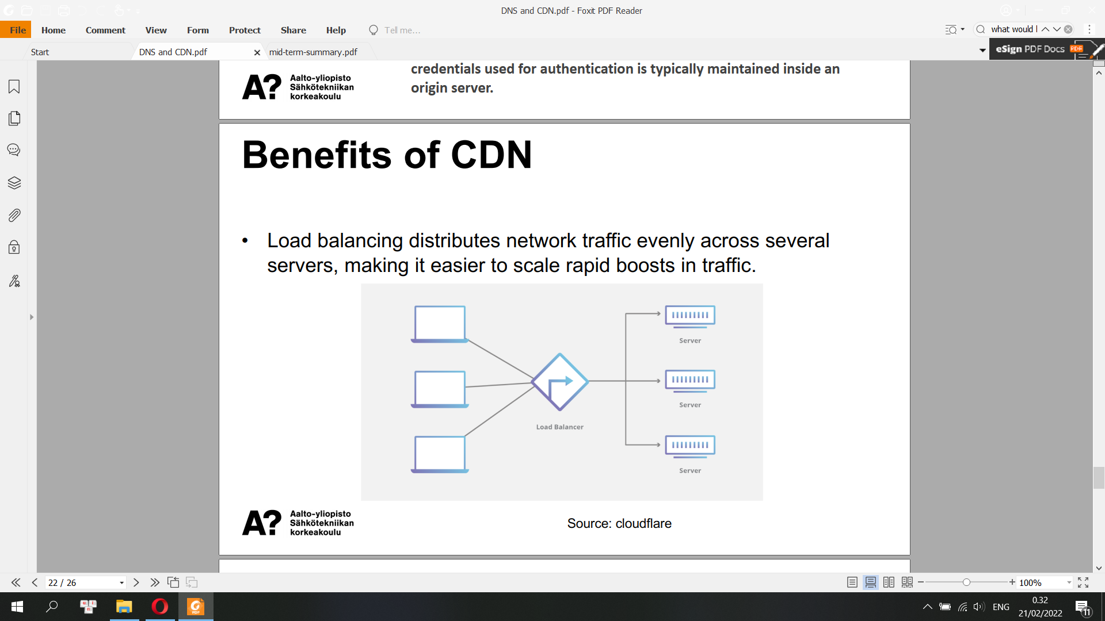

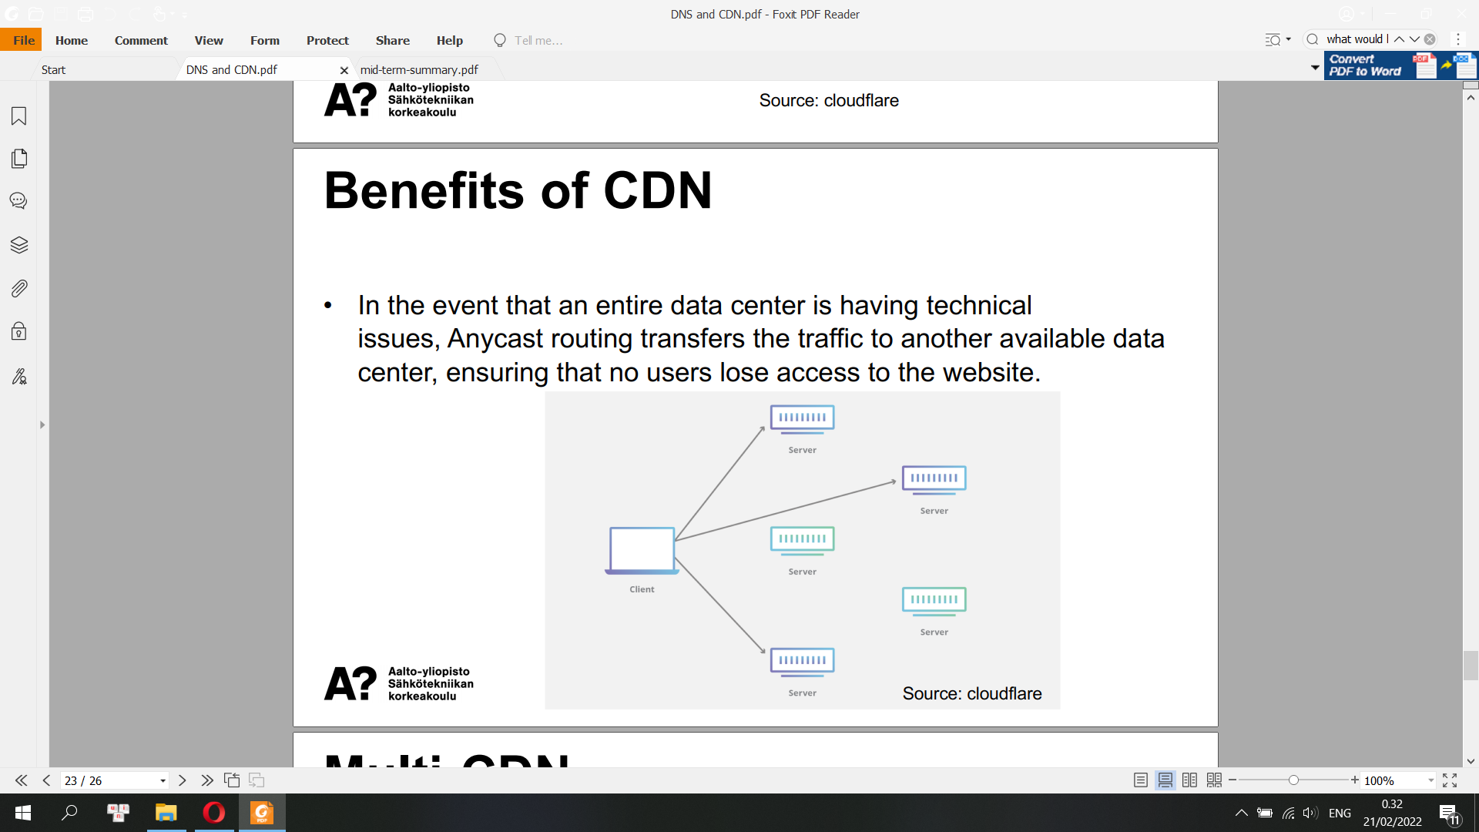

**Multi-CDN**

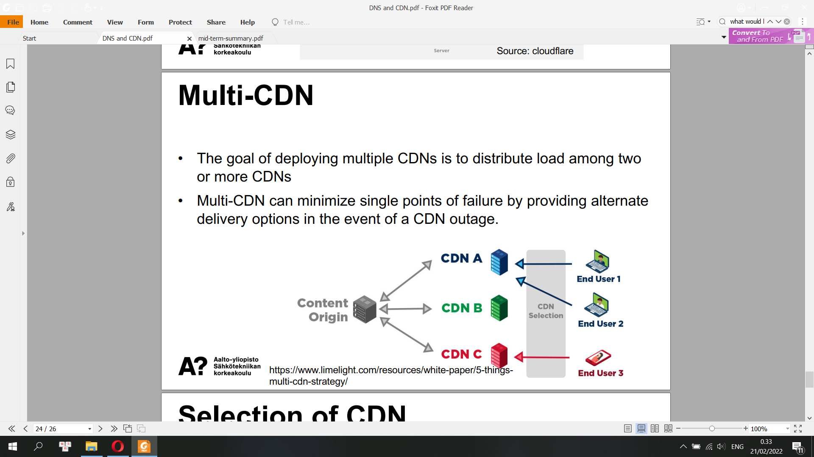

**Selection of CDN**

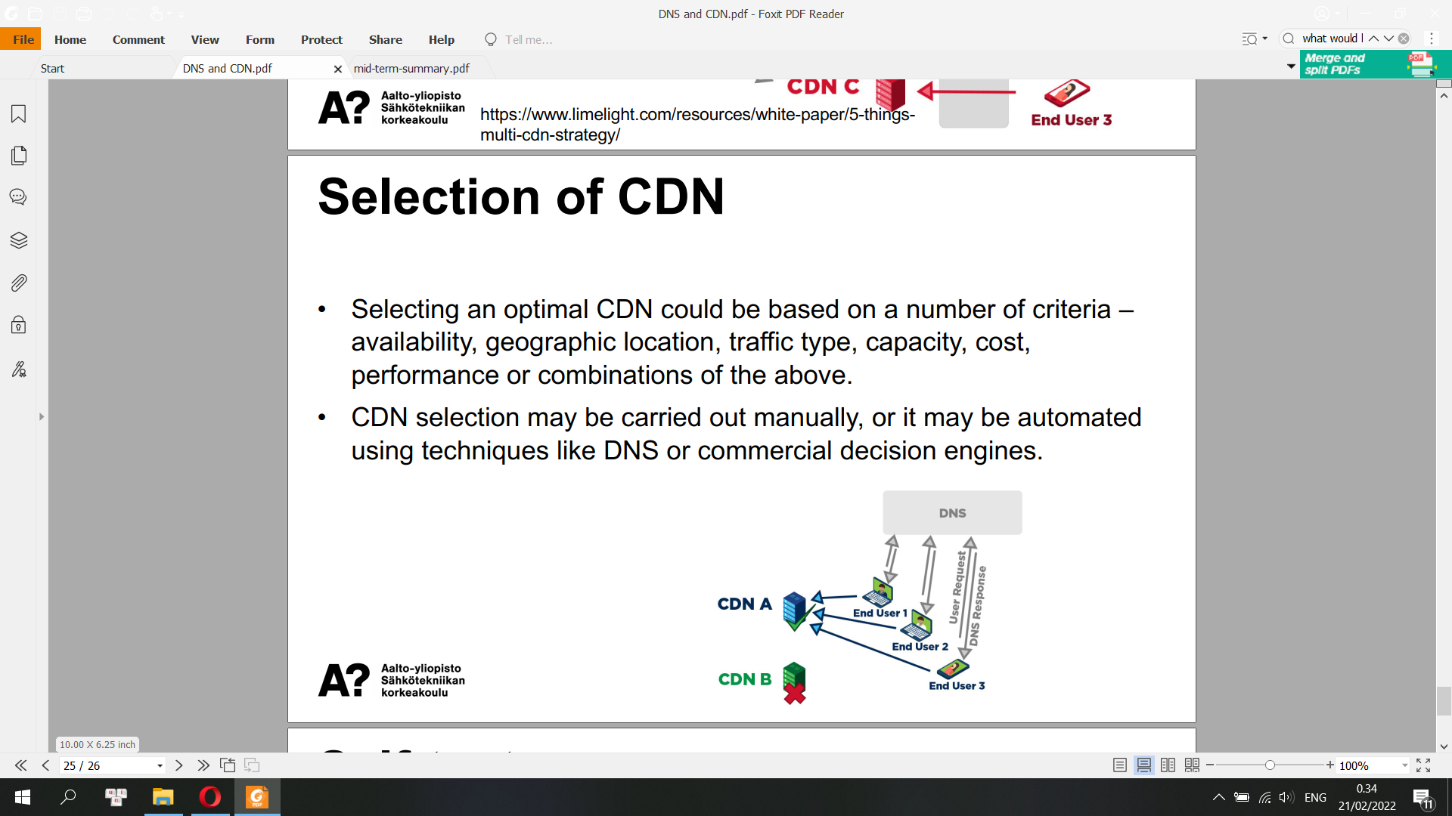

**Self-Test DNS and CDN**

**• What is DNS responsible for?**

**• Can you describe the process of recursive query?**

**• What are the benefits of CDN?**

**• What is anycast?**

**<Check above>**

**Dynamic Host Configuration Protocol (DHCP)**

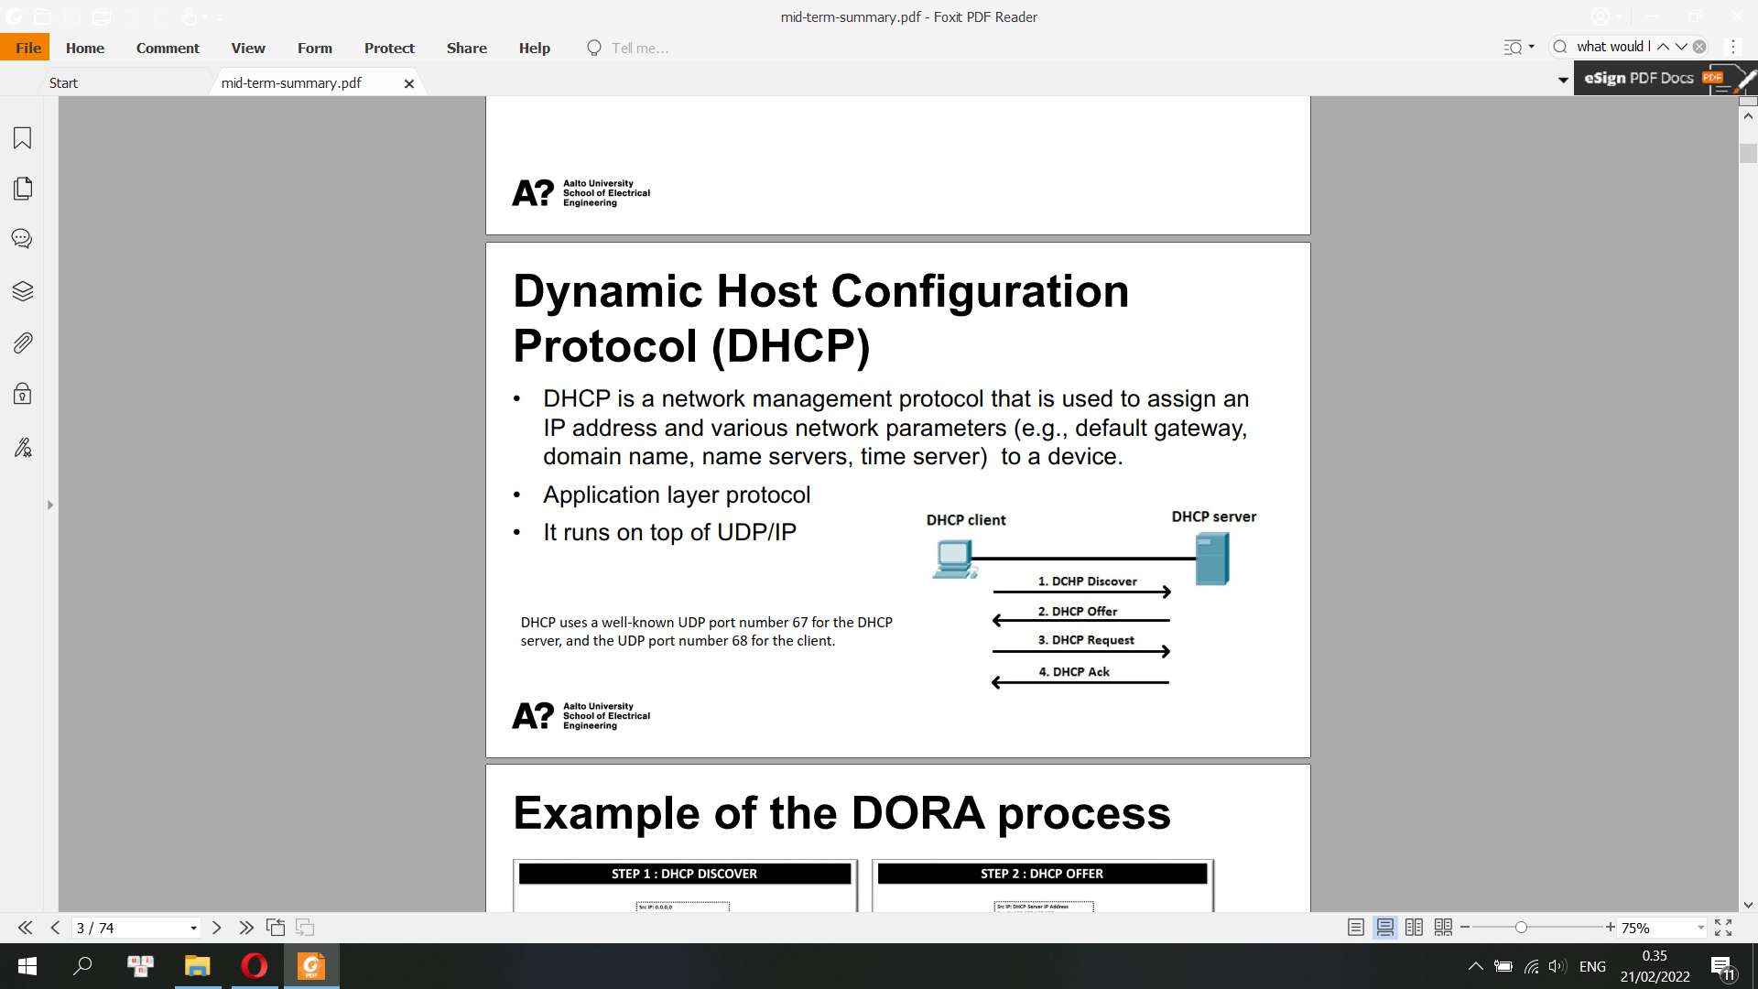

A DHCP client-to-server communication consists of three kinds of interaction between the two peers:

**Broadcast-based DORA (Discover, Offer, Request, Acknowledgement). This process consists of the following steps:**

The DHCP client sends a DHCP Discover broadcast request to all available DHCP servers within range.

A DHCP Offer broadcast response is received from the DHCP server, offering an available IP address lease.

The DHCP client broadcast Request asks for the offered IP address lease and the DHCP broadcast Acknowledgement at the end.

If the DHCP client and server are located in different logical network segments, a DHCP relay agent acts a forwarder, sending the DHCP broadcast packets back and forth between peers.

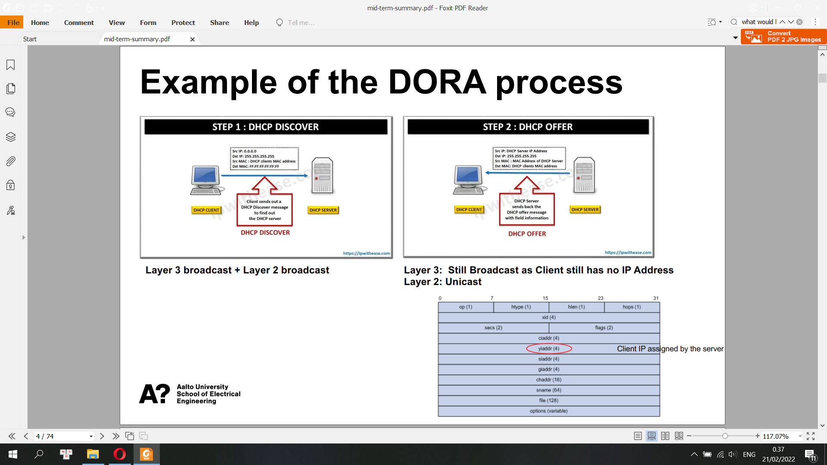

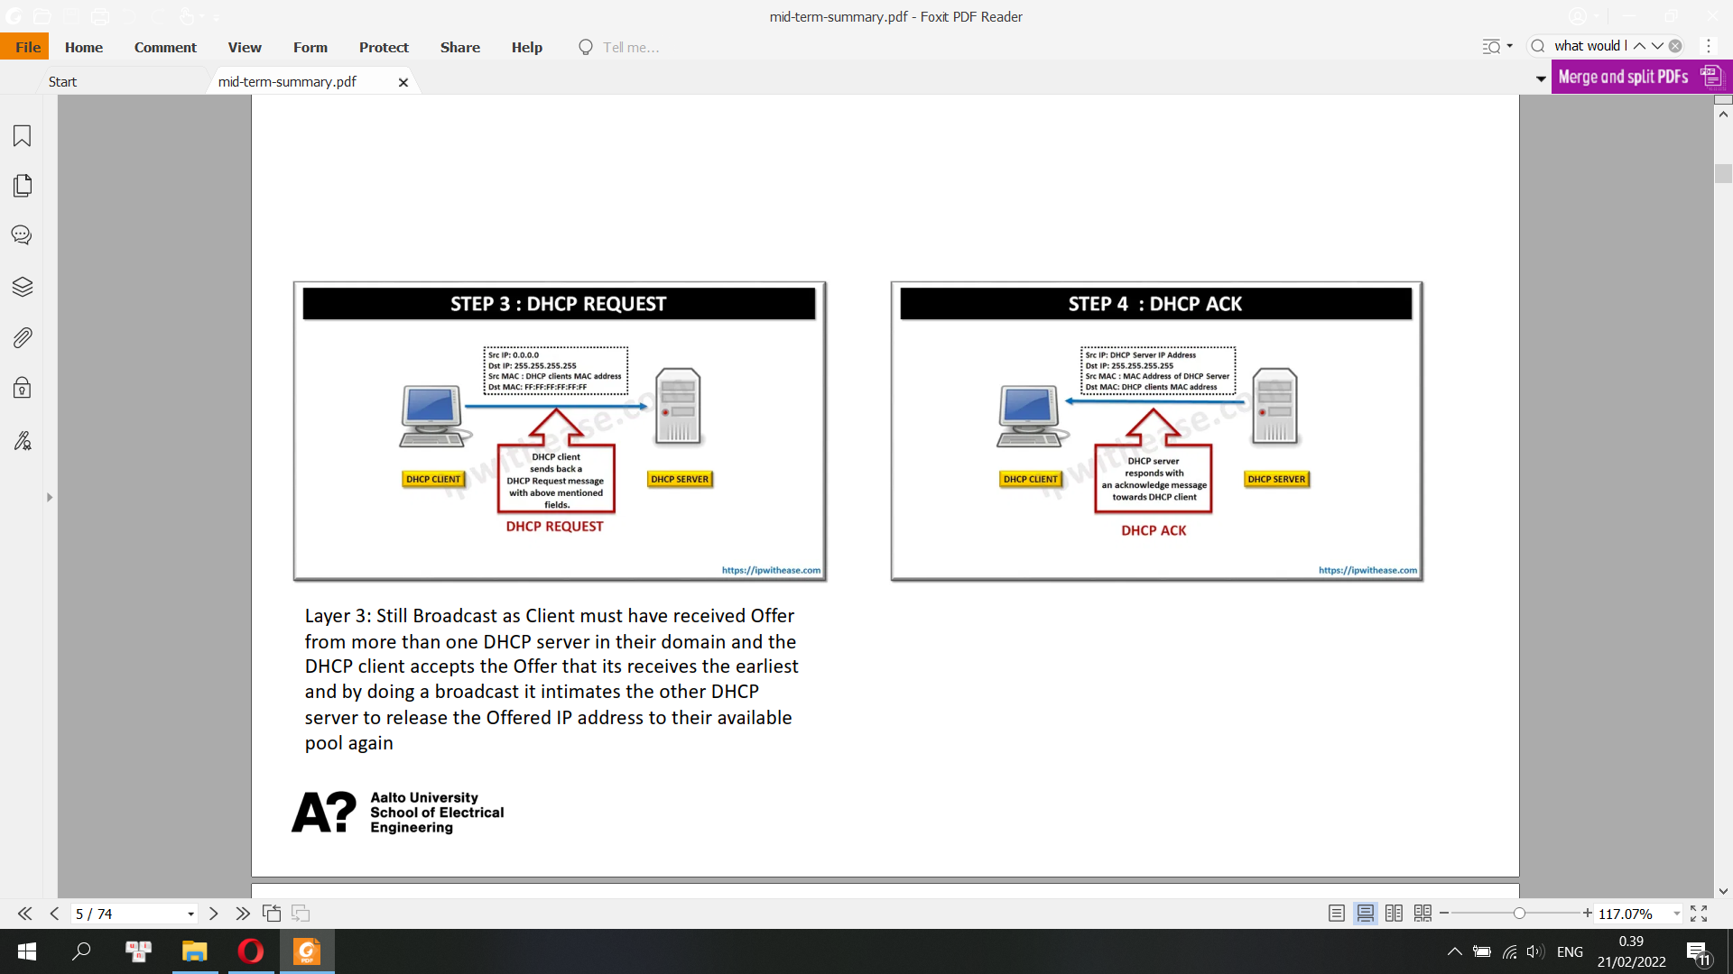

DHCP

1: A DHCP client sends a broadcast packet (DHCP Discover) to discover DHCP servers on

the LAN segment.

2: The DHCP servers receive the DHCP Discover packet and respond with DHCP

Offer packets, offering IP addressing information.

3: If the client receives the DHCP Offer packets from multiple DHCP servers, the first DHCP

Offer packet is accepted. The client responds by broadcasting a DHCP Request packet,

requesting the network parameters from the server that responded first.

4: The DHCP server approves the lease with a DHCP Acknowledgement packet. The packet

includes the lease duration and other configuration information.

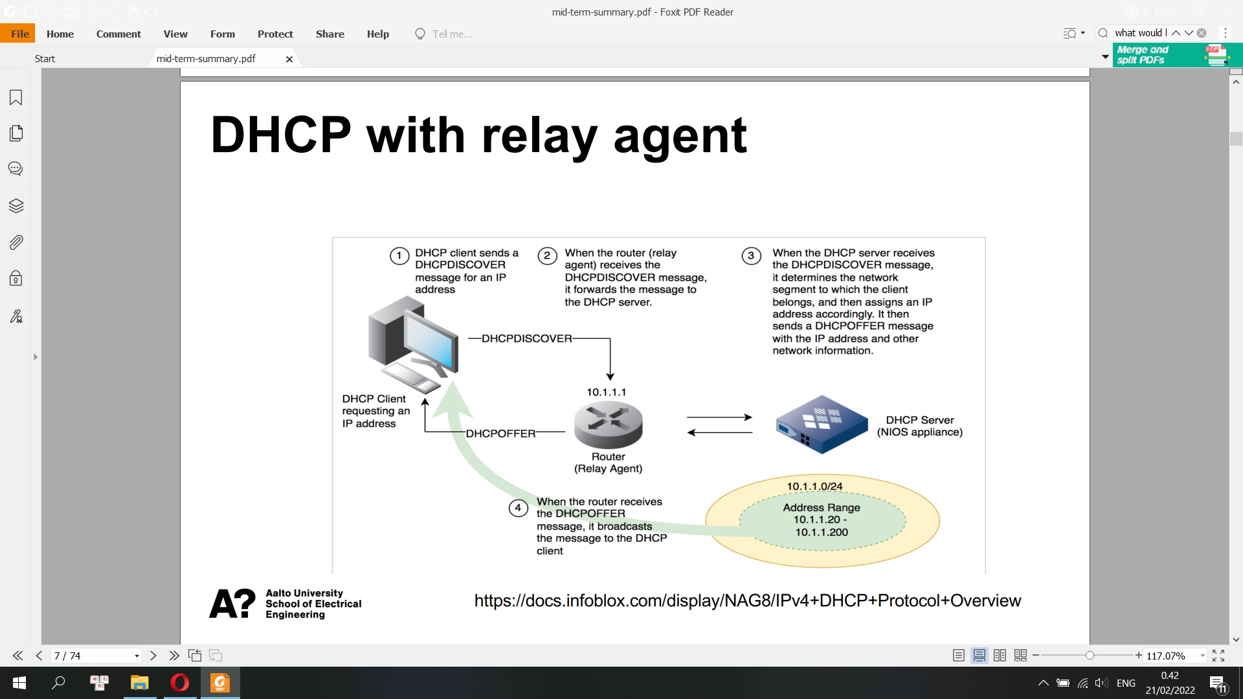

**DHCP v6**

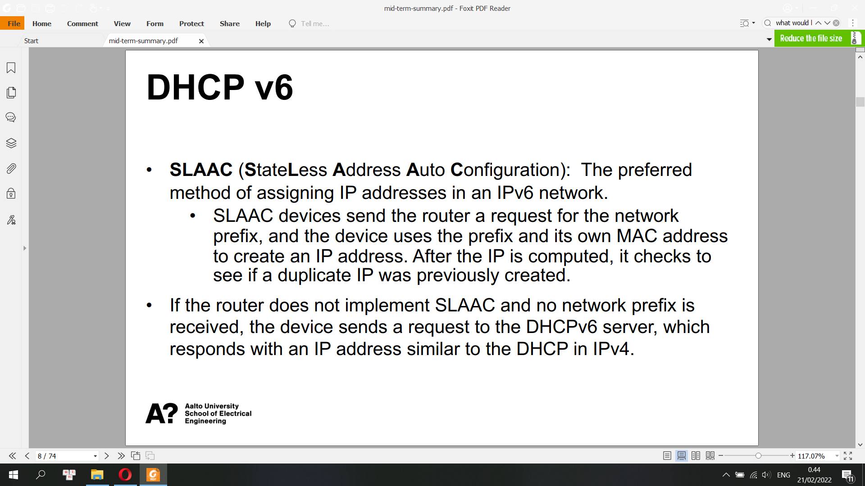

IPv6 Interface Identifier

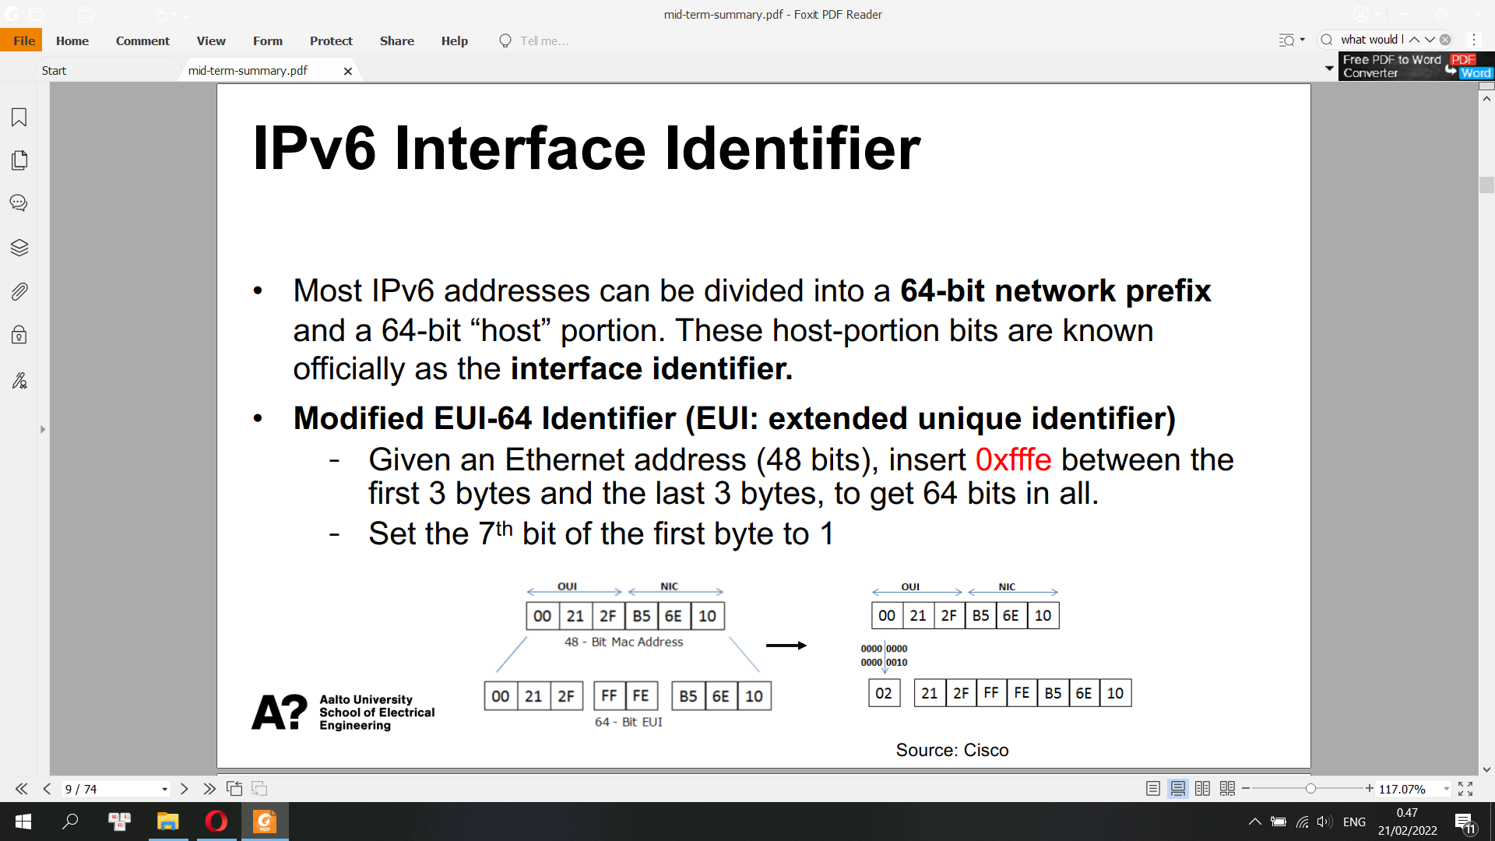

Stateful DHCPv6

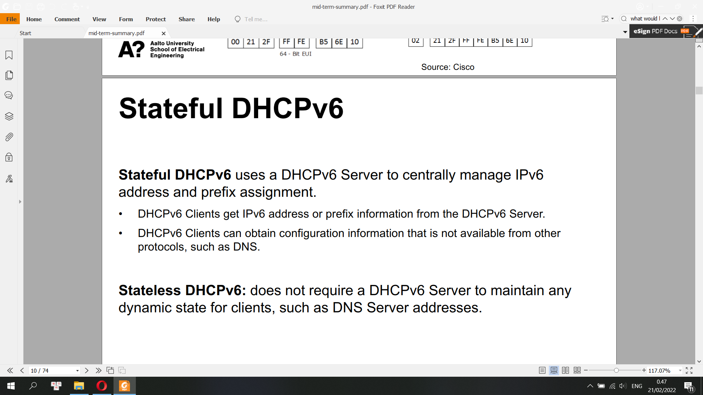

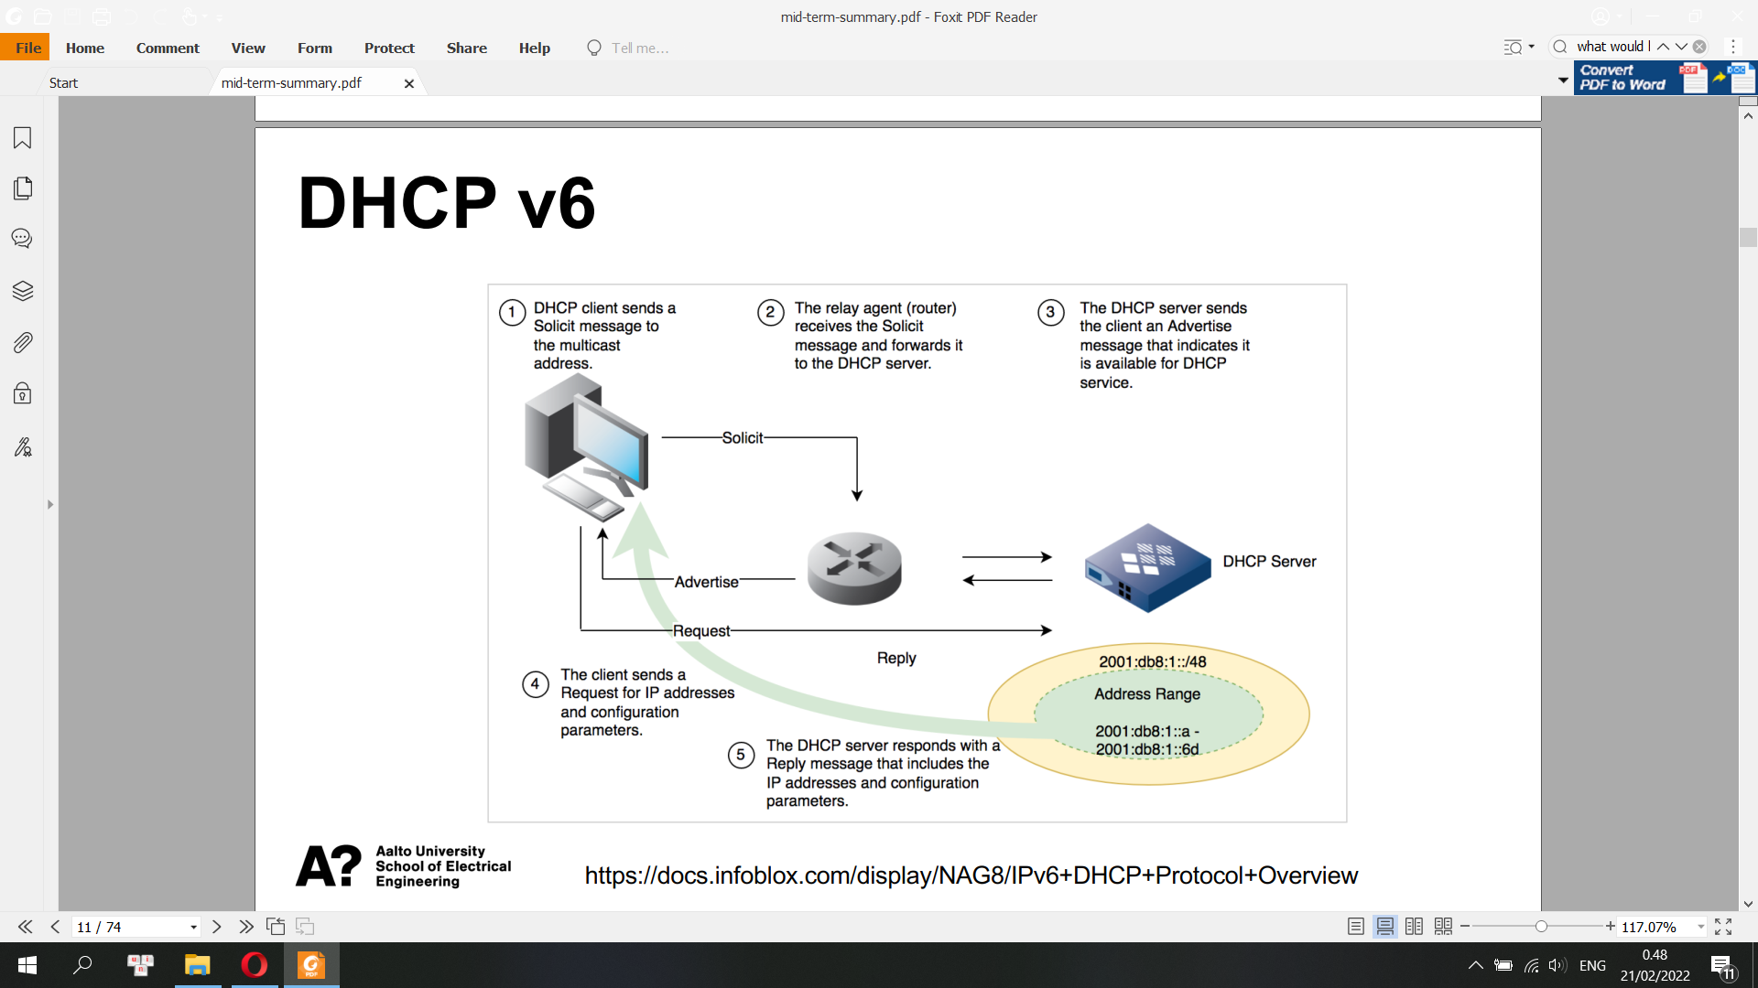

**Normal DHCPv6 Message Exchange**

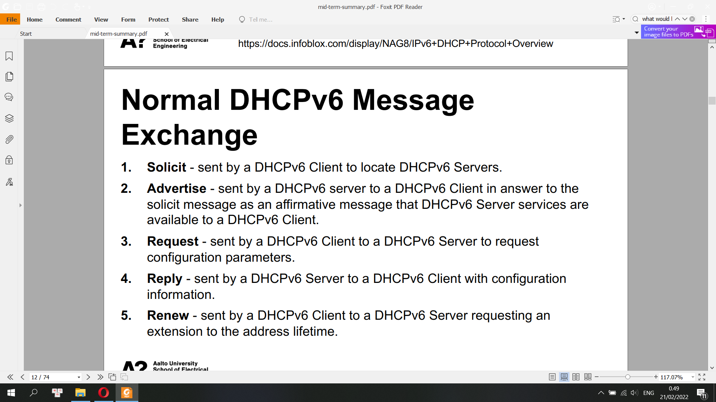

**Stateless DHCP v6**

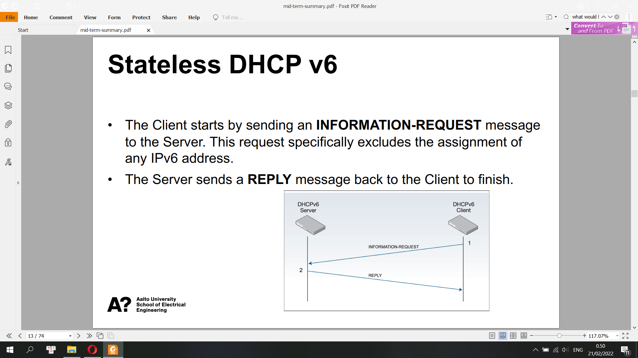

**NAT (Network Address Translation)**

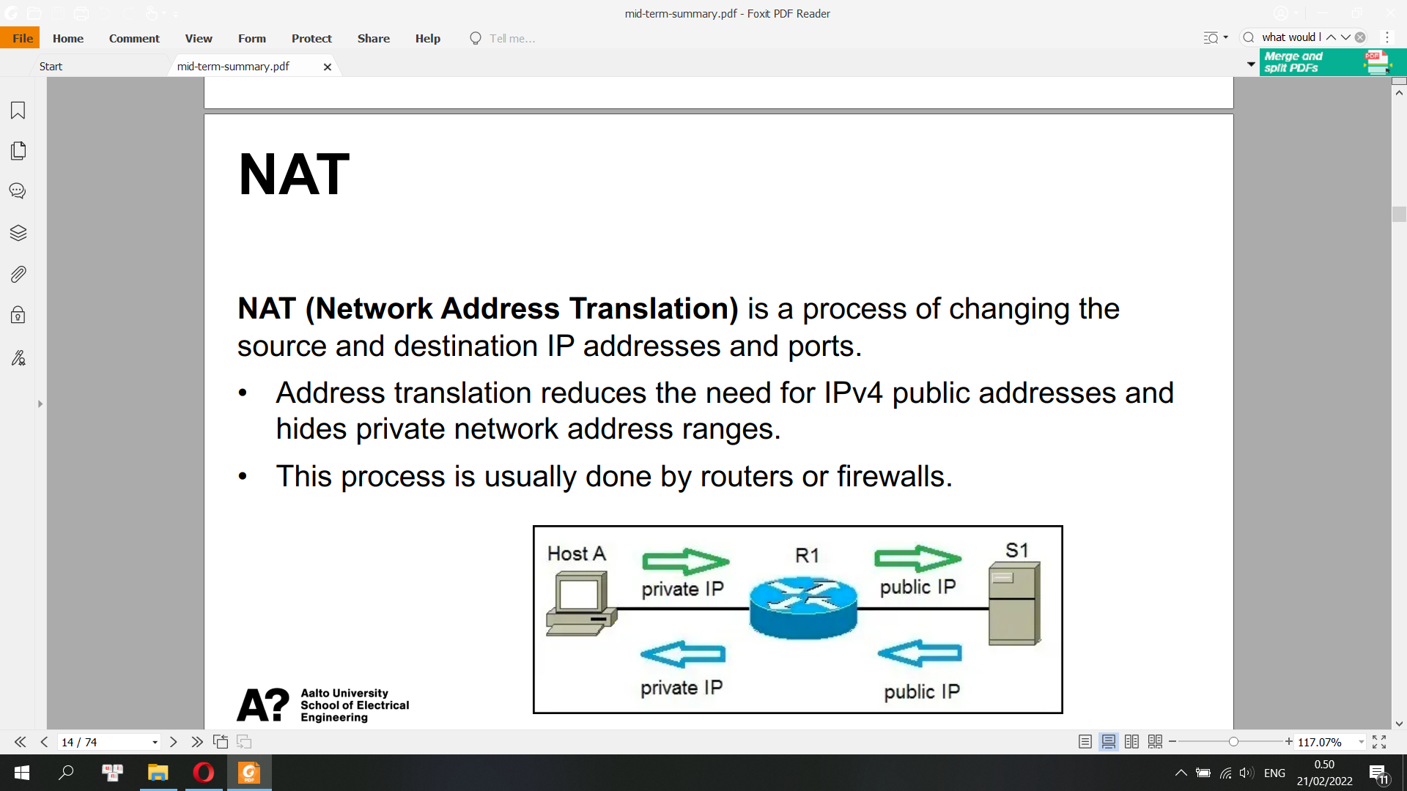

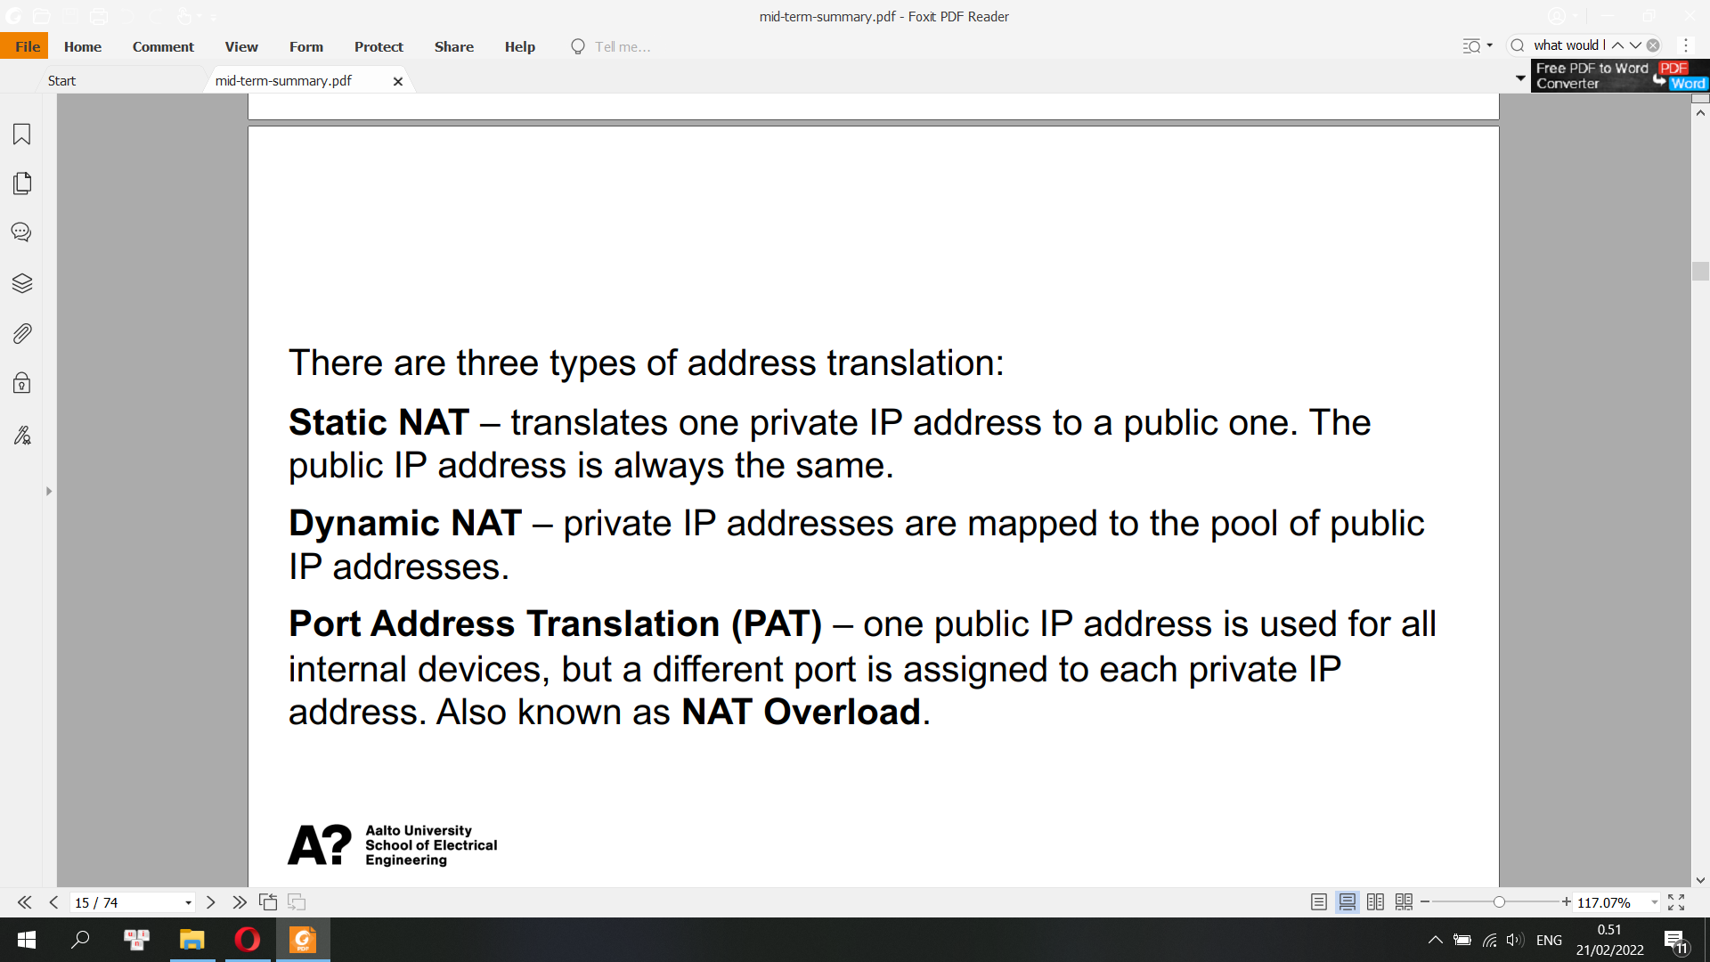

**TCP Congestion Control: How to perceive congestion?**

• Bottleneck

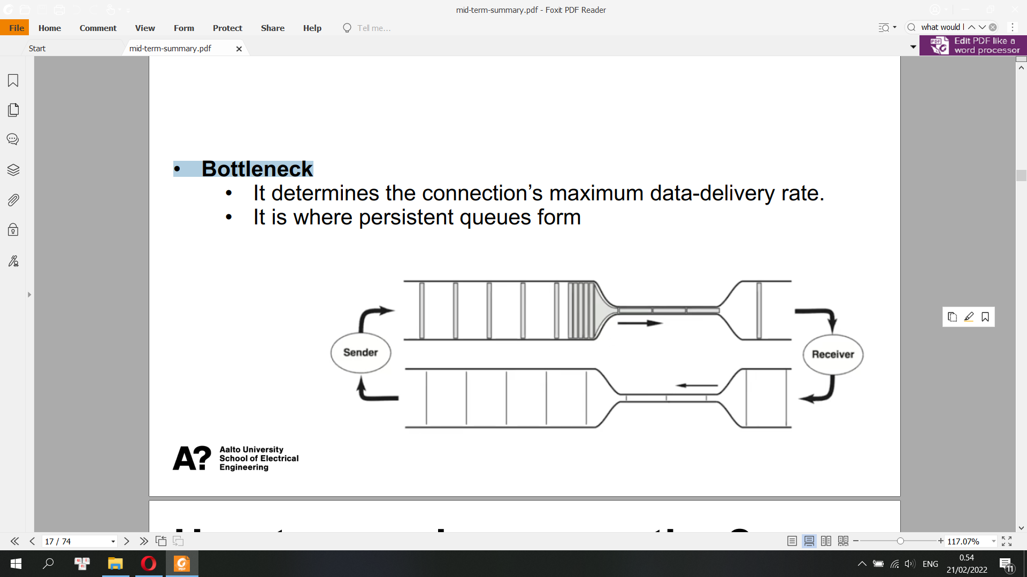

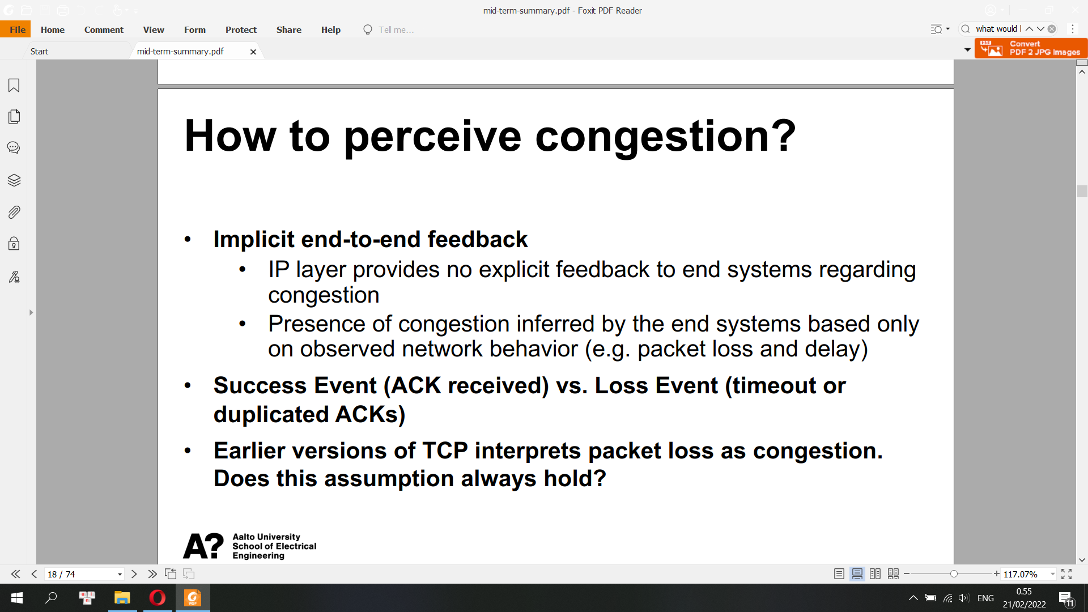

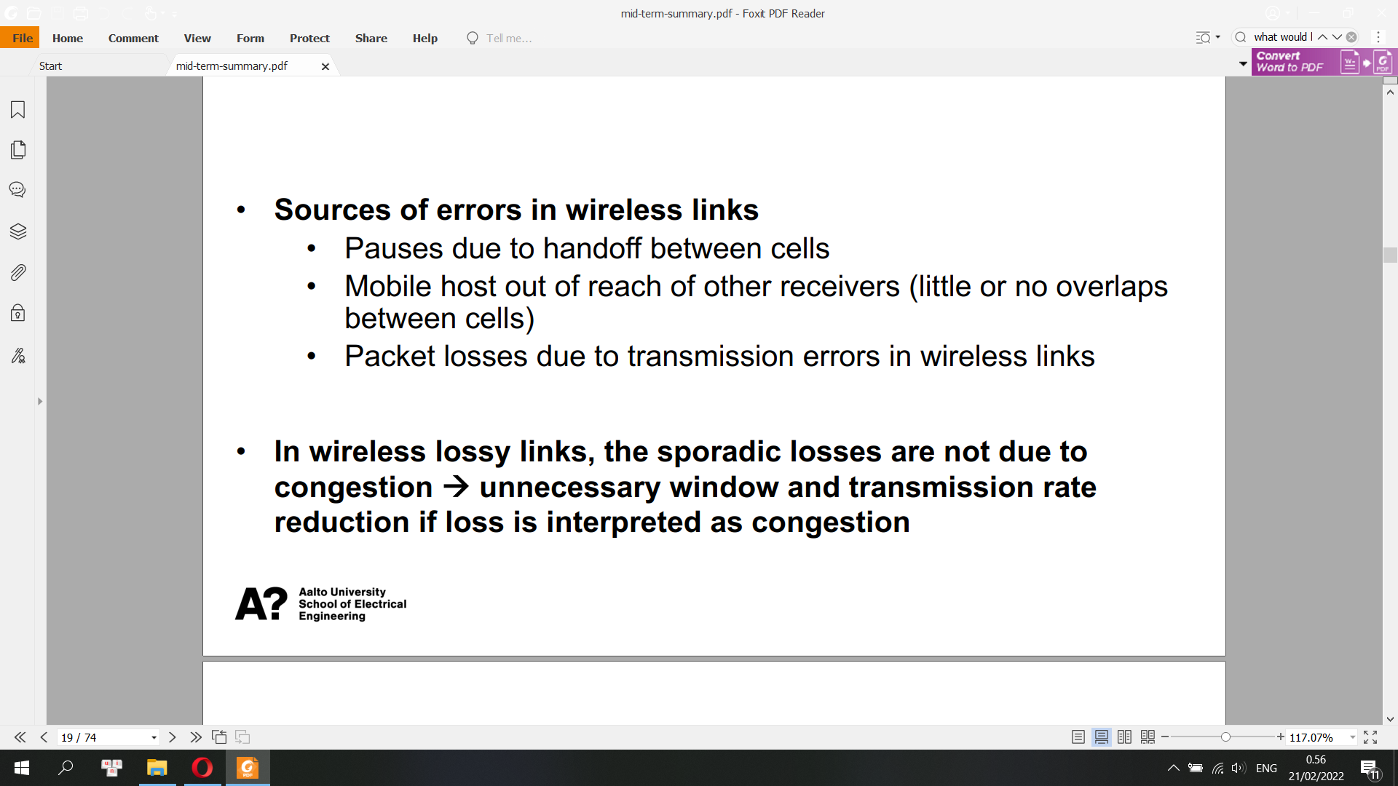

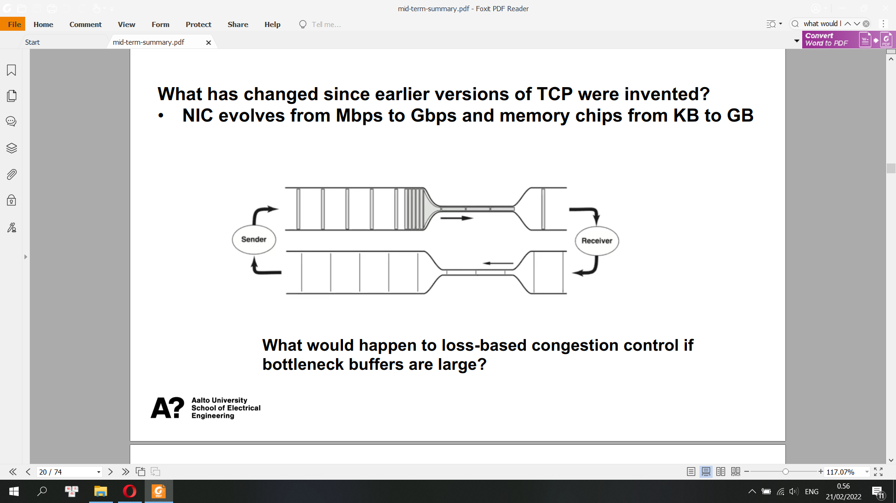

**What is Bufferbloat?**

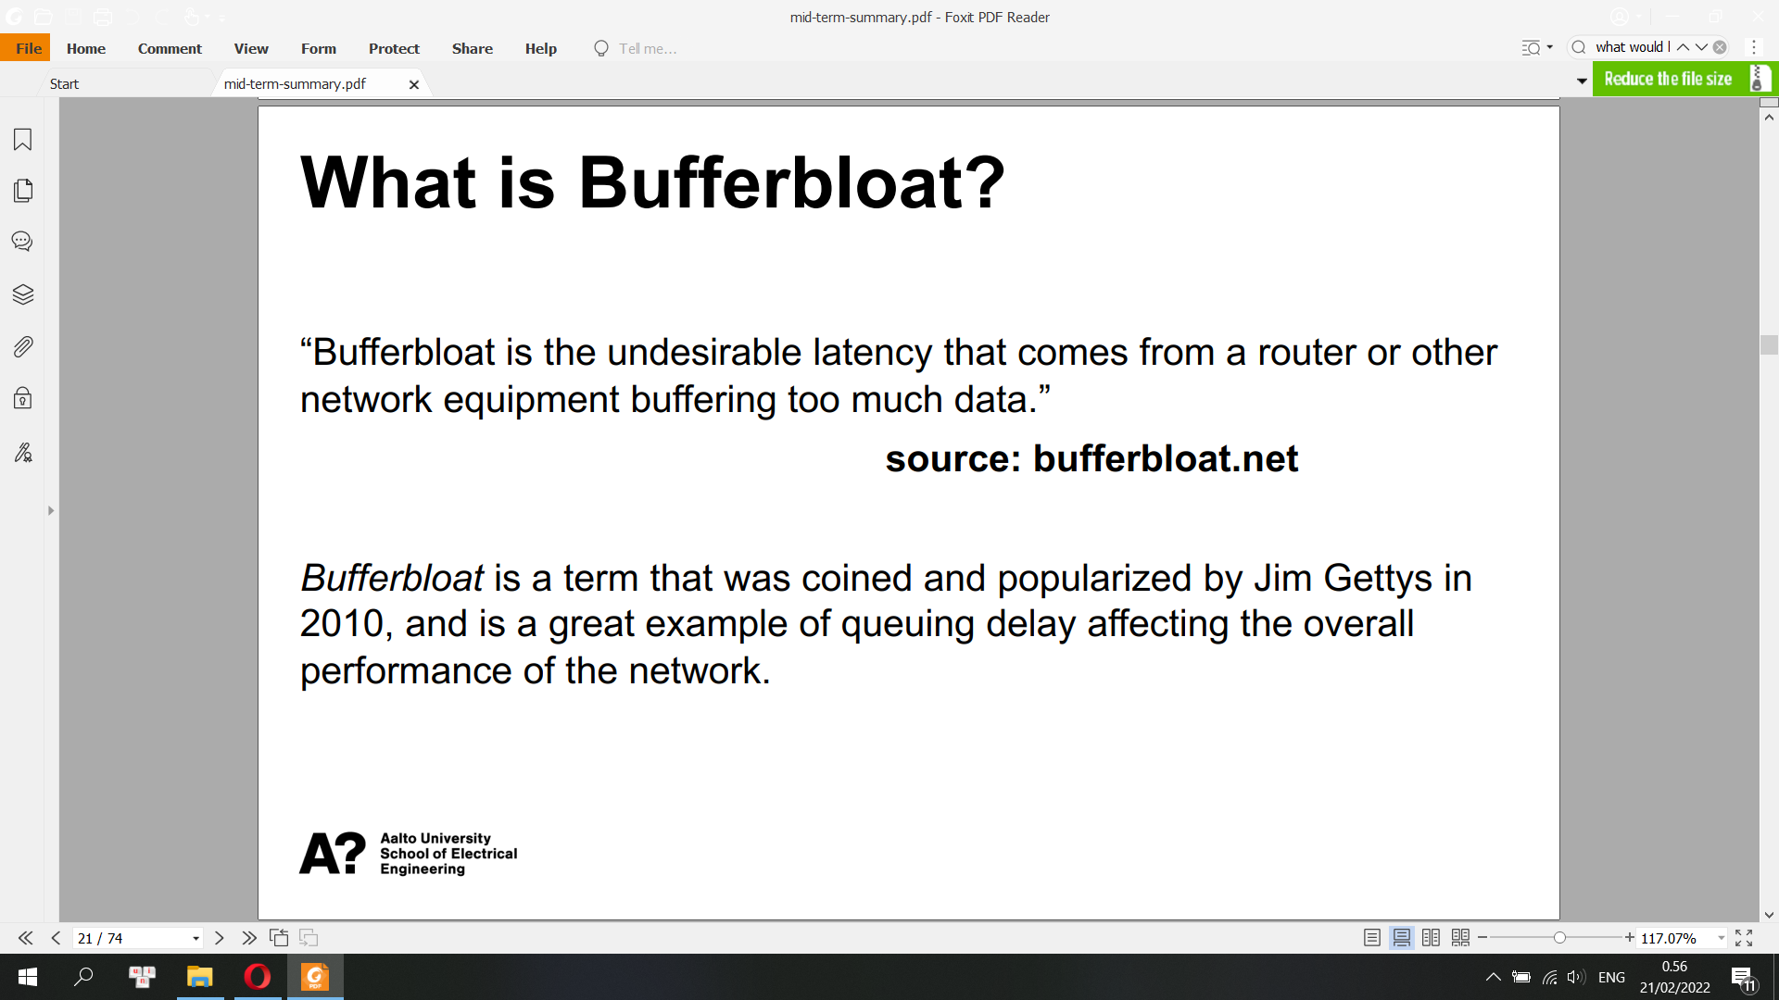

**Latency and Bandwidth**

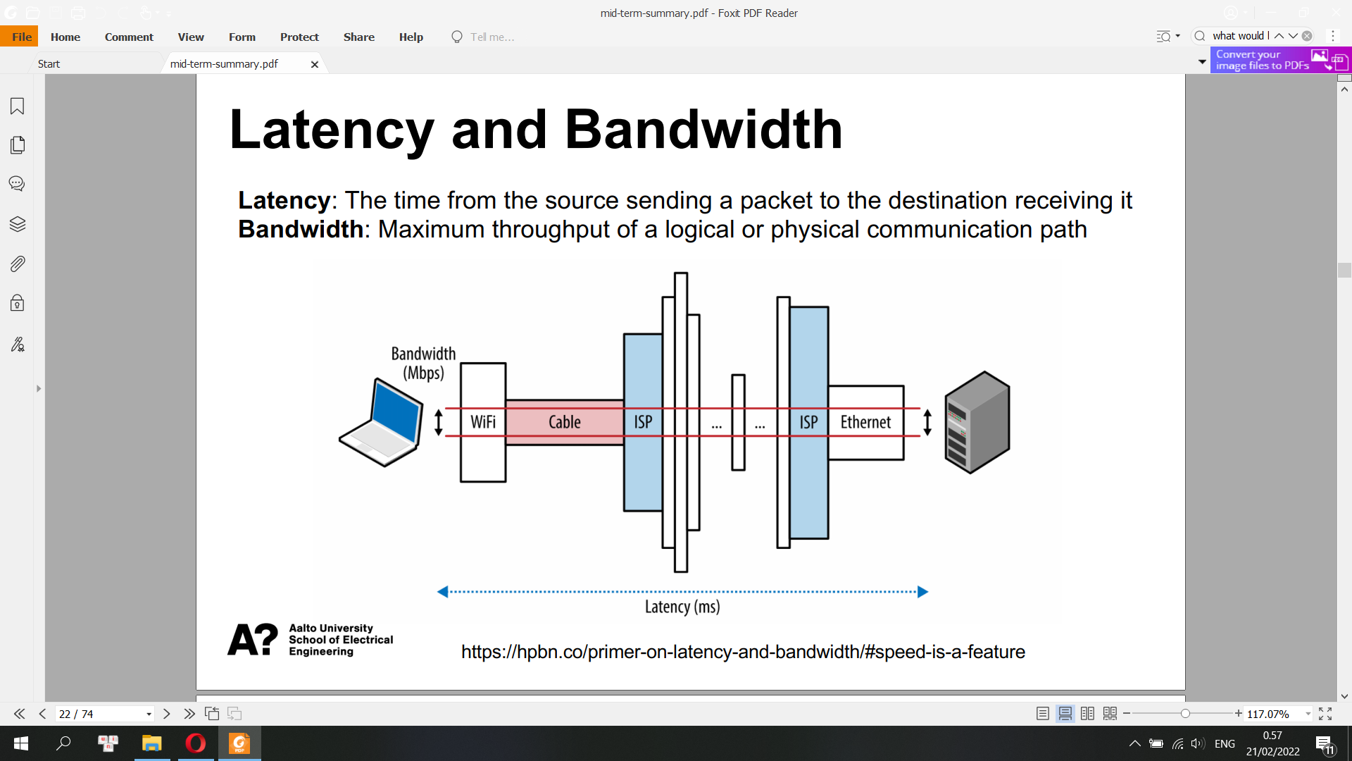

• Propagation delay: Amount of time required for a message to travel from the sender to receiver, which is a function of distance over speed with which the signal propagates.

• Transmission delay: Amount of time required to push all the packet’s bits into the link, which is a function of the packet’s length and data rate of the link.

• Processing delay: Amount of time required to process the packet header, check for bit-level errors, and determine the packet’s destination.

• Queuing delay: Amount of time the packet is waiting in the queue until it can be processed.

If the packets are arriving at a faster rate than the router is capable of processing, then the packets are queued inside an incoming buffer.

• Congestion wasn’t reported until after a prolonged period of queueing, resulting in greater packet loss

• Packet loss alone is not a good proxy to detect congestion

TCP BBR Bottleneck Bandwidth and Round-trip propagation time

Design Criteria of BBR

• Make network full but buffer empty à Maintain the data rate at the bottleneck bandwidth and the pipe is full

• BBR looks at the path’s bottleneck bandwidth and an estimate of the RTT to determine congestion in a network